Portable Backscatter X-Ray Imager

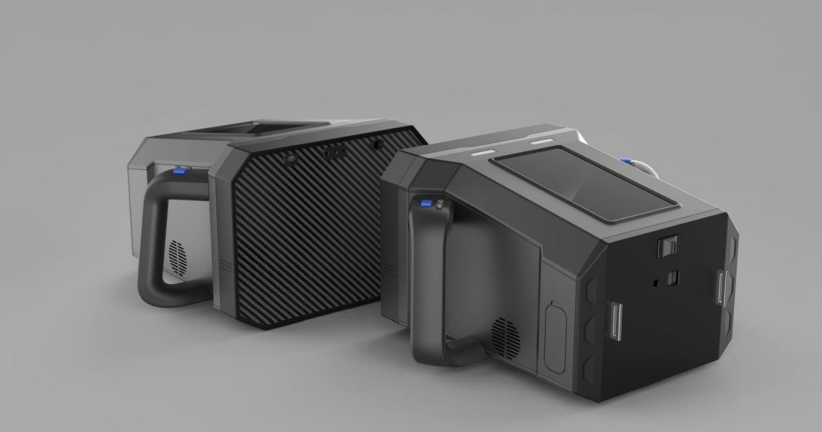

Product introduction:

TBIPBS140portable backscatter imager uses X-ray backscatter imaging technology, combined with intelligent image processing algorithm with independent intellectual property rights, it can detect objects hidden in internal space or inter layer through various object surfaces. It is mainly used in public security, border defense, confidentiality, anti-drug, customs, special service, justice, etc. It can quickly check the drugs, explosives, ceramic knives, secret record, currency, smuggled goods and other contraband hidden in the sealed space and inter layer of vehicles, ships, furniture, packages, garbage cans, mailboxes, etc.

Technical parameters:

Operating System: Linux system Size:35.3mm×275mm×188mm Weight(with battery):5.6kg Sources Maximum Power: 7W
Sources High Voltage Potential: 140kV(max) Penetration: ≥ 5mm thick steel plate
Penetration Line Resolution: 0.8mm(diameter) solid copper wire behind 5mm aluminum plate
Spatial Resolution: 2mm (diameter) line pair in the air background
Line Resolution: 1mm (diameter) polyethylene rod in the air background
Line Detection: 0.6mm (diameter) copper wire in the background of polythene plate Single Radiation Dosage: 3.6 μ Sv
Radiation Leakage: 0.1 μ Sv/h@5cm；

Radiation Leakage of Contact Position: 0.21 μ Sv/h；
Operating Temperature: -10 to +50 ℃ Single Scan Time: ≤30s
Scan Speed: 2cm/s~20cm/s Detection Distance: 0-50cm
Screen: 7-inch QLED quantum dot display screen, resolution of 1920×1080; Image Storage Capacity: ≥ 20000 images
Continuous Working Time:.≥ 6 hours Equipment Noise: ≤48 dB (A)@1m
Components: X-ray source, detector, display screen, camera,flash lamp, lazer, 2 rechargeable lithium battery, charger, shoulder strap, carrying case.

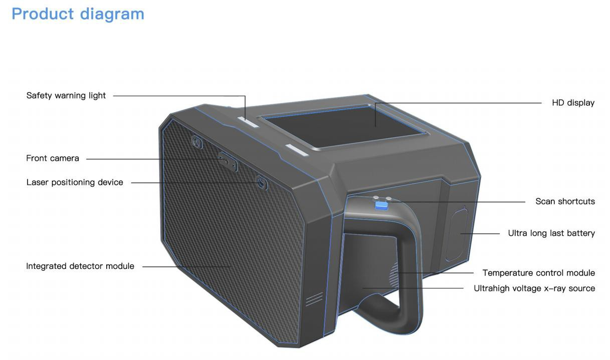

Qualifications:

- 5 national invention patents and 5 utility model patents.
- It belongs to the shortlisted products of the Police Equipment Procurement Center of the Ministry of Public Security.
- It has the radiation safety license of X-ray device
- It has passed the inspection of "Safety and Police Electronic Product Quality Inspection Center of the Ministry of Public Security"

