10.08KW Solar Power Off Grid System

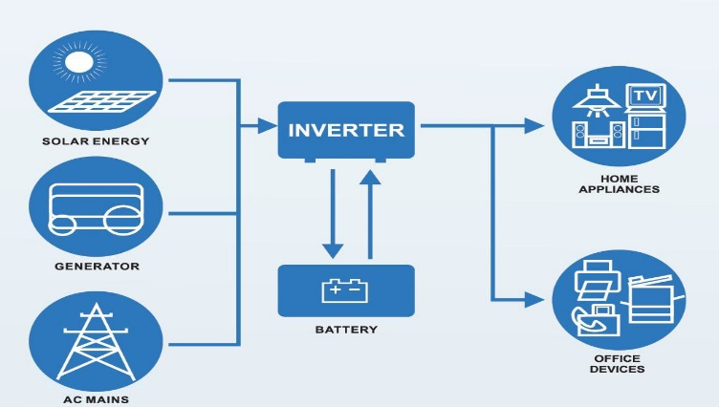
Average power capacity:58.766kwh per day (PSH=5.83Hrs) Batteries power capacity:5.42kwh per day

Model: TBIBSM10.08KW-Off
Type: Off Grid
Output Power: 10.08KW

Date: 2023/9/27

Output Voltage: 220V 50/60hz Single phase

Quotation Valid: 10 Days

Item Article Pitcure Specification Quantity
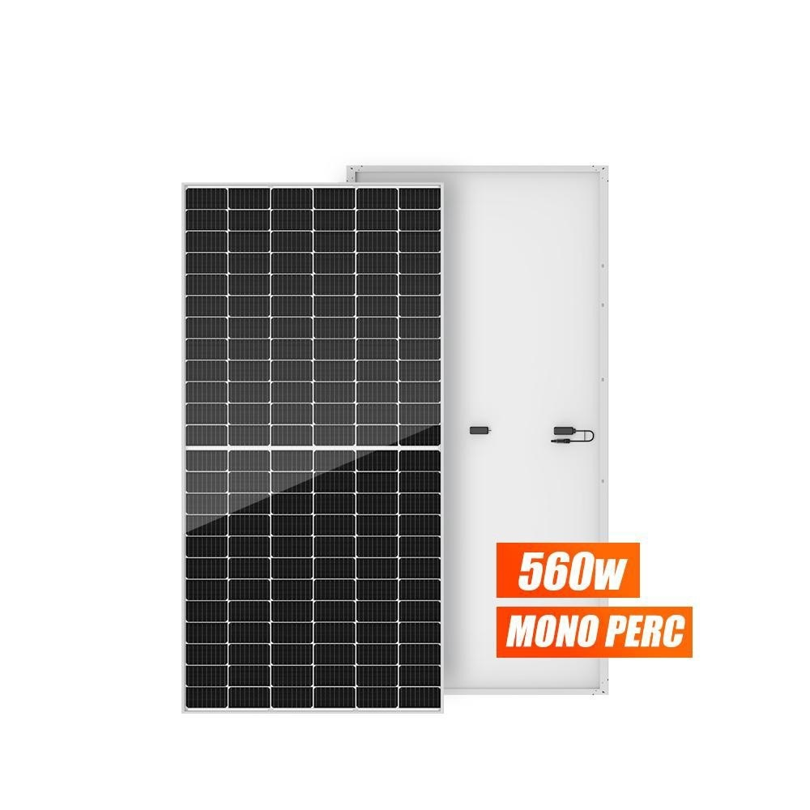

BSM560M10-72HPH
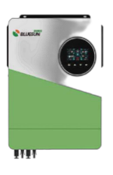
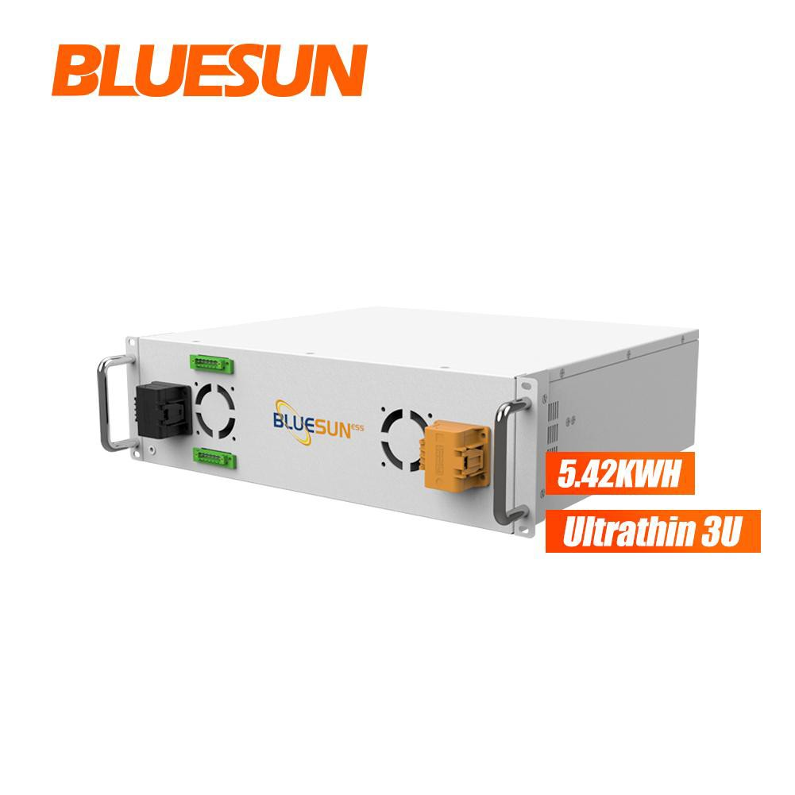
- (Mono Perc 560W) Warranty: 25 Years

BSM-10200LV-48
- (10.2KW Off Grid Inverter)
Warranty: 2 Years
Power: 560W Weight: 28.6kg
Size: 2278*1134*35mm

Power: 10.2KW Single Phase Weight: 14.8kg
Size: 530*420*160mm

18

1

Lithium Battery
- Low Voltage
Warranty: 10 Years
51.2V 106Ah
Capacity: 5.427KWH Weight: 48KG

1

WiFi Monitor
4
Warranty: 10 Years

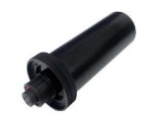
PV Cable
5
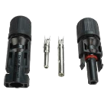
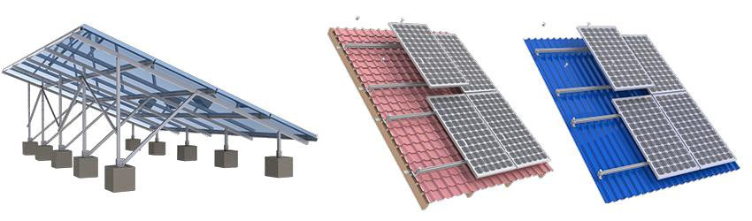
Warranty: 25 Years

Monitor System 1

PV 4 mm2 200

MC4 Connector
6
Warranty: 25 Years
Rated current: 30A Rated voltage: 1000VDC

9

Roof top /ground Mounting System for 18 pieces of panels
7
(Including all parts)
Warranty: 25 years

Price based on: Complete set solar system Total EXW HeFei Price US$5,136.18

payment term: 50% TT in advance, pay the balance before shipping Delivery time : within 30 working days after receiving the deposit Package: Standard export package, Composite material box.

10.08KW Solar Power On Grid System

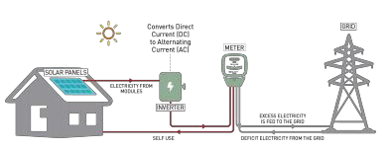
Average power capacity:58.766kwh per day (PSH=5.83Hrs)

Model: BSM10.08KW-On
Type: On Grid
Output Power: 10.08KW

Date: 2023/9/27

Output Voltage: 220V 50/60hz Single phase

Quotation Valid: 10 Days

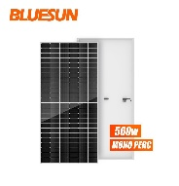
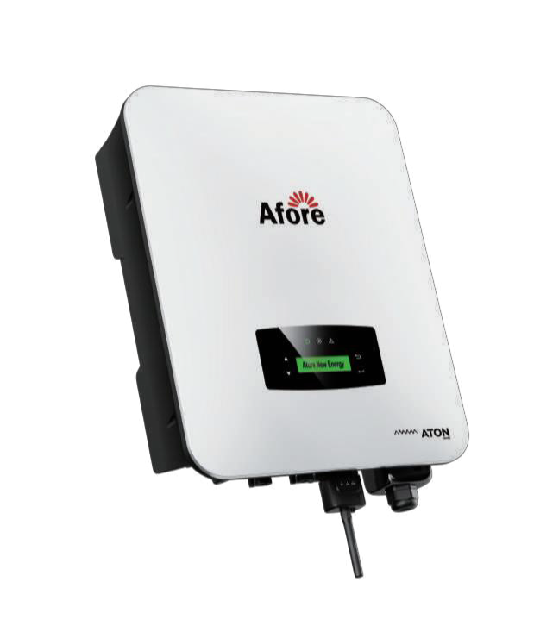
Item Article Pitcure Specification Quantity Unit Price Amount

BSM560M10-72HPH
- (Mono Perc 560W) Warranty: 25 Years
Power: 560W Weight: 28.6kg

Size: 2278*1134*35mm

18

HNS10000TL
- (10KW On Grid Inverter ) Warranty: 10 Years
Power: 10KW Single Phase Weight: 19kg

Size: 510*370*167mm

1

WiFi Monitor
3
Warranty: 10 Years

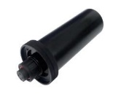
PV Cable
4
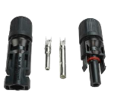
Warranty: 25 Years

Monitor System 1

PV 4 mm2 200

MC4 Connector
5
Warranty: 25 Years
Rated current: 30A Rated voltage: 1000VDC

9

Roof top /ground Mounting System for 18 pieces of panels
6

(Including all parts)
Warranty: 25 years

Price based on: Complete set solar system

1

Total EXW HeFei Price US$4,221.18

Payment term: 50% TT in advance, pay the balance before shipping Delivery time : within 30 working days after receiving the deposit Package: Standard export package, Composite material box.
Many Thanks For Your Attentions And Business!

