Electric Car Quotation Description: High Speed Electric Car
Model: TBIEC-360 2023

Model | EC-360-A  Economic Version | EC-360-B  Honor Version | EC-360-C  Top Version
Vehicle Body Size L*W*H (mm) | 3517*1495*1660 mm
Wheel Base (mm) | 2495
Wheel Track (mm) | 1310/1300
Climbing Capacity（%） | ≤30 | ≤30 | ≤30
Ground Clearance (mm) | 130
Maximum Speed（km/h） | 100 km/h | 100 km/h | 100 km/h
Maximum Traveling Range ( km ) | 130 KM | 130 KM | 200 KM
Driver Position | Left Hand Steering
NO.of Seats | Four seats/ Five doors
Location of Charging Port | Front Grille,Built in Type
FOB PRICE less then 4 add $500
FOB QINGDAO | US$8,000.00 | US$8,500.00 | US$9,500.00
Motor Information
Motor Power (KW) | 30 KW | 30 KW | 30 KW
Motor Type | AC Motor
Driving Type | FWD
Peak Torque （N.m） | 81.8 N.m | 108 N.m | 132 N.m
Battery Information
Battery Type | Ternary lithium battery | Ternary lithium battery | Ternary lithium battery
Battery Capacity | 11.9 KWH | 11.9 KWH | 18.50 KWH
Number of Battery | 1 | 1 | 1
Normal Charge Times（hr） | 6-7 | 6-7 | 9-10
Input Voltage （VAC） | 220±15%

Gearbox
Gear Number | 3（E/D/N/R）
Gearbox Type | Fixed Gear Ratio
Chassis & Steering
Front Suspension Type | Mcpherson Independent Suspension
Rear Suspension Type | Torsion beam non - independent suspension
Body Type | Unitary construction body
Brake System & Wheels
Front Brake Type | Disc Brake
Rear Brake Type | Drum Brake
Parking Brake Type | Hand Brake
Tyre Size | 155/65 R14 | 155/65 R14 | 165/55 R15
Wheel Hub Type | Aluminium alloy
Safety Configuration & Driving Assistance
Lock Brake System | ABS
Brake Assist System | Vacuum Hydraulic Type
Rear View Camera | ● | ● | ●
Safety Belt | Front/ Rear
Bumper | Front/ Rear
Anti-collision Buffer | ● | ● | ●
Side Impact Beam | ● | ● | ●
Danger Alarm | ● | ● | ●
Hand Brake Power Off | ● | ● | ●
Auto Power Off Fully Charge | ● | ● | ●
Overvoltage Protection | ● | ● | ●
Undervoltage Protection | ● | ● | ●
Over current Protection | ● | ● | ●
Overheat Protection | ● | ● | ●
Charging Leakage Protection | ● | ● | ●
Output Short Circuit Protection | ● | ● | ●
Warning Horn | ● | ● | ●
Electric Power Window | ● | ● | ●
Rearview Mirror | ● | ● | ●
Central Lock | ● | ● | ●
Remote Key | ● | ● | ●

Interior Collocation
Front Seats Headrest | ● | ● | ●
Inner Mirror | ● | ● | ●
Read Lamp | ● | ● | ●
High Speed/Low Speed Mode | ● | ● | ●
Steering Wheel Material | ABS
LCD Panel | 9 In | 9 In | 9 In
Real-time Status | ● | ● | ●
Seat Material | Fabric Seat
Front Seats Adjustable | ● | ● | ●
Rear Seats Removable | ● | ● | ●
Big Angle Door Open | ● | ● | ●
Warm Air Glass Defrosting | ● | ● | ●
Sun Shield | ● | ● | ●
Cup Holder | ● | ● | ●
Lamp Configuration
Daytime Running Lamps | ● | ● | ●
Steering Lamp | ● | ● | ●
Headlamp Adjustment | ● | ● | ●
Clearance Lamp | ● | ● | ●
Combination Headlight | ● | ● | ●
Combination Tail Lamp | ● | ● | ●
Light Combination Switch | ● | ● | ●
Reversing Light | ● | ● | ●
Multimedia & Air-conditioning
Multimedia Touch Screen | 9 Inch | 9 Inch | 9 Inch
Local Video Player | ● | ● | ●
Local Music Player | ● | ● | ●
Radio | ● | ● | ●
Phone Charging Interface | ● | ● | ●
Bluetooth Music/ Phone | ● | ● | ●
Mobile Internet | ● | ● | ●
Mobile Wifi | ● | ● | ●
12V External Power Supply | ● | ● | ●
Multilingual Menu Operation | ● | ● | ●
Air-conditioning | ● | ● | ●

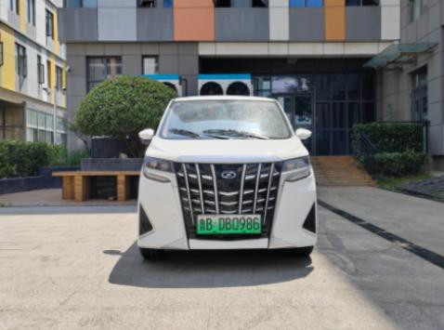

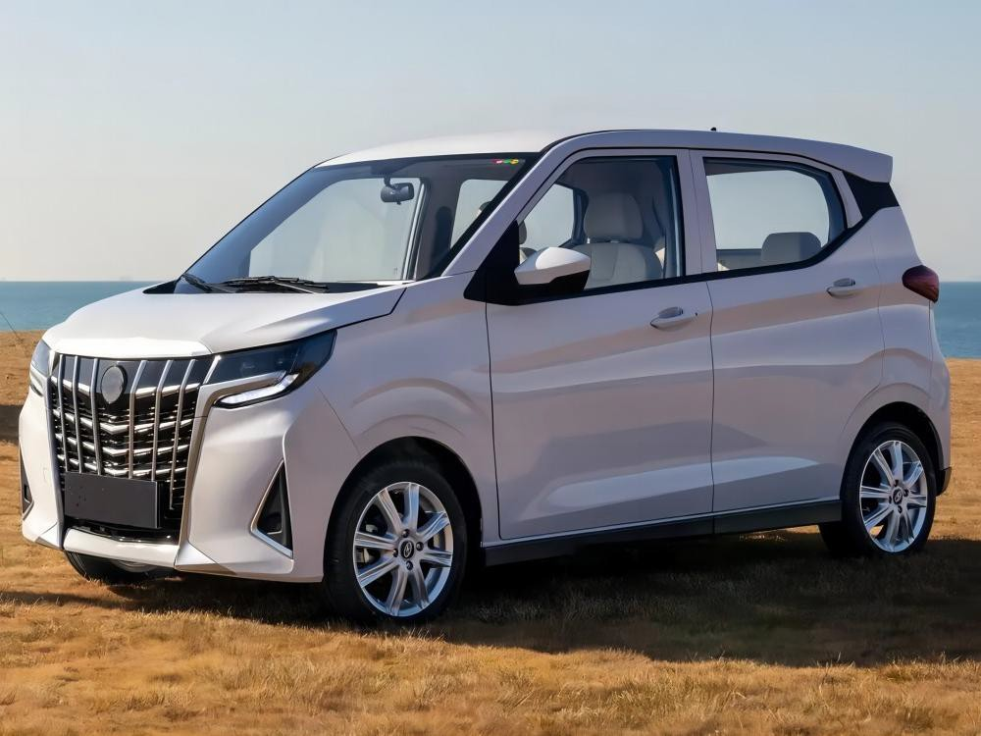Front Front-left

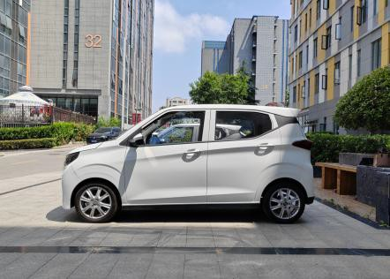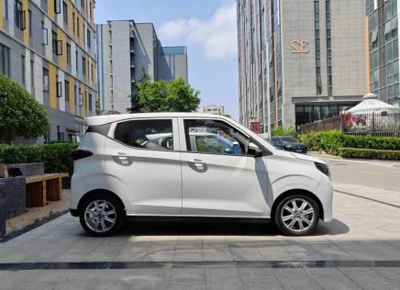

Side Side

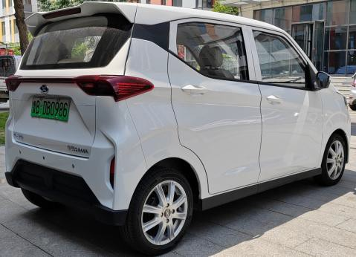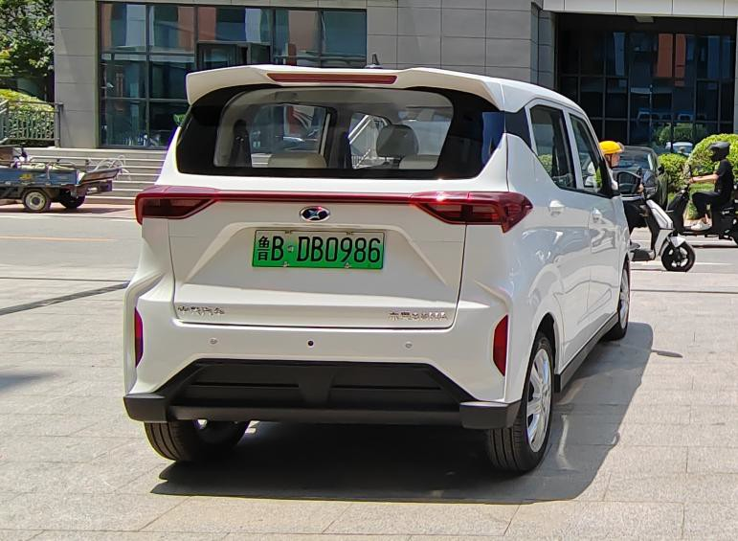

Rear Rear-right

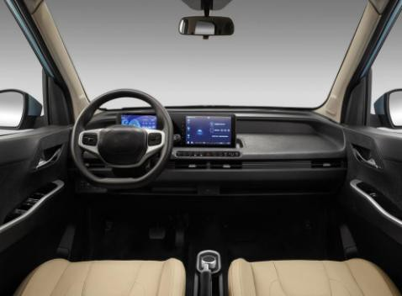

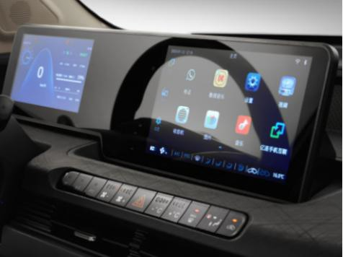Cockpit Instrument

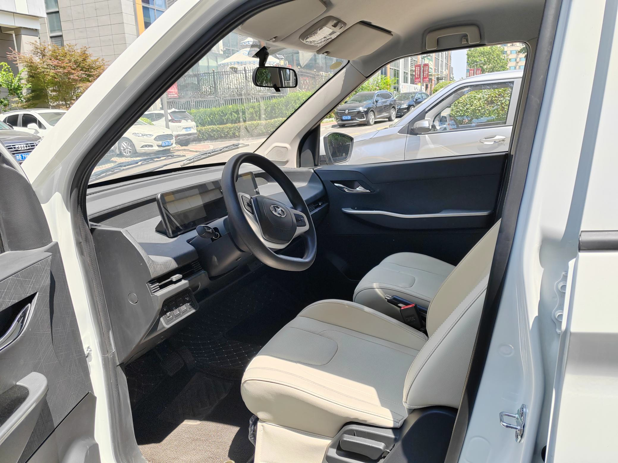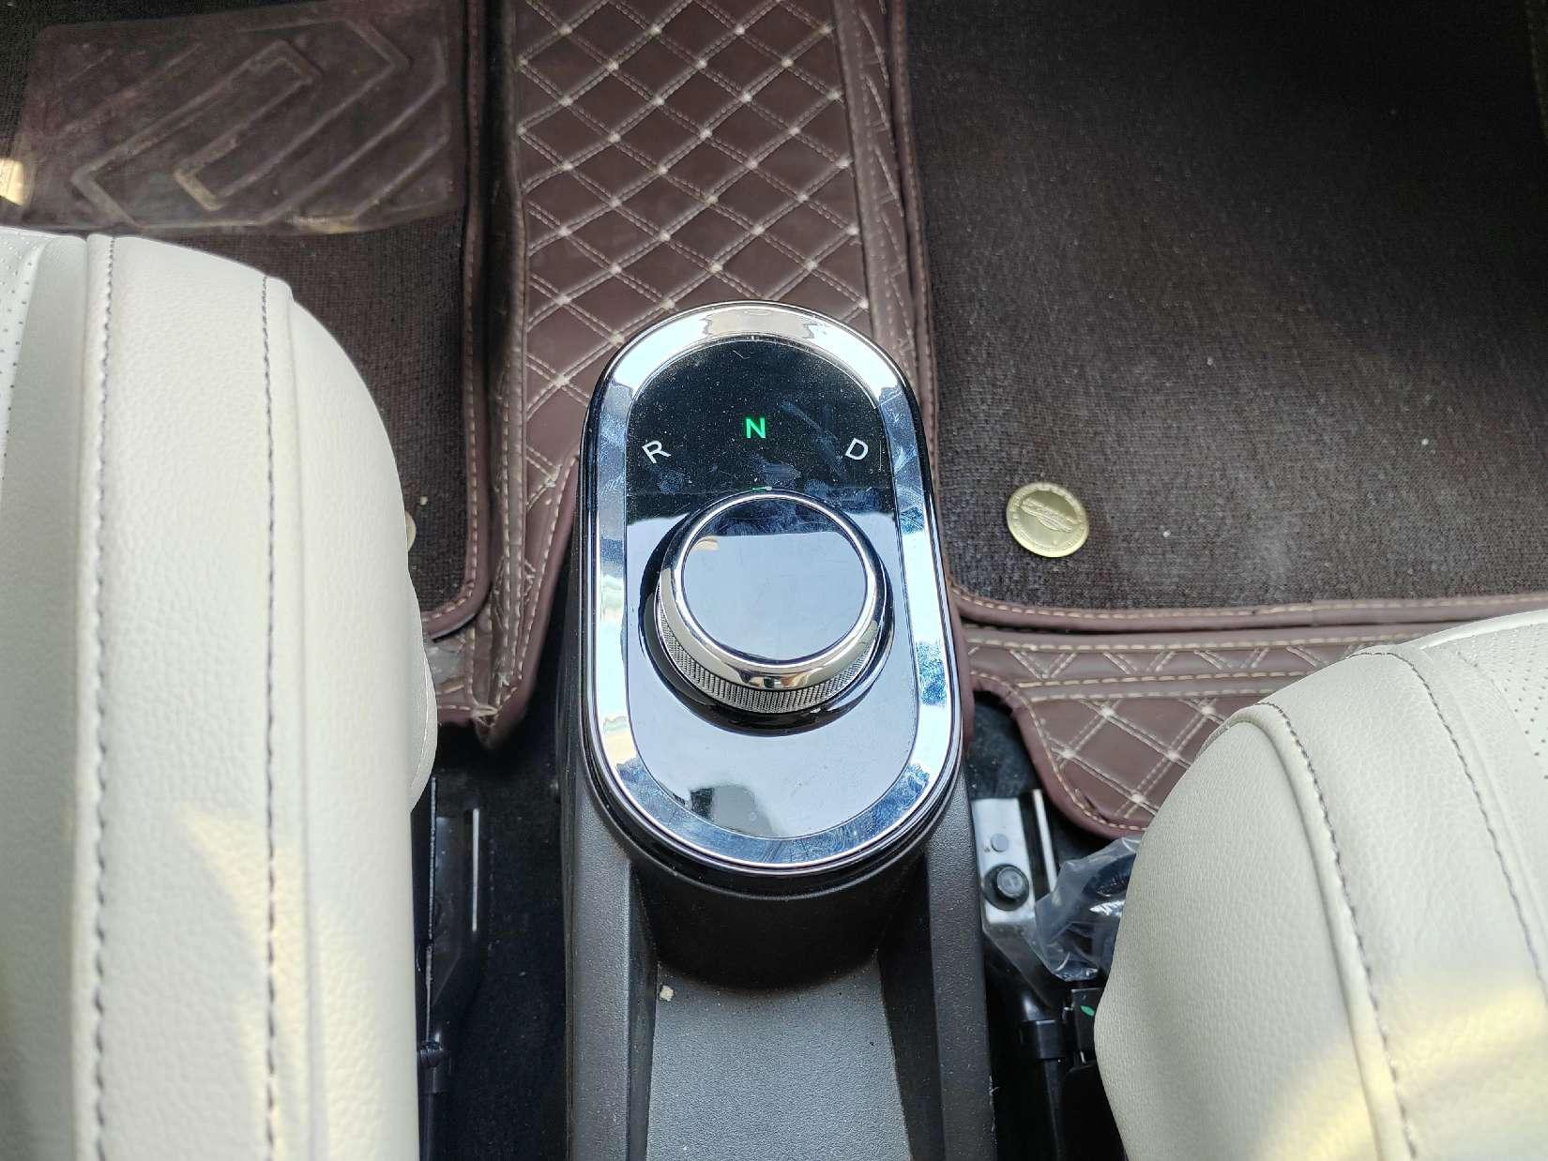

Gear Switch Front Seats

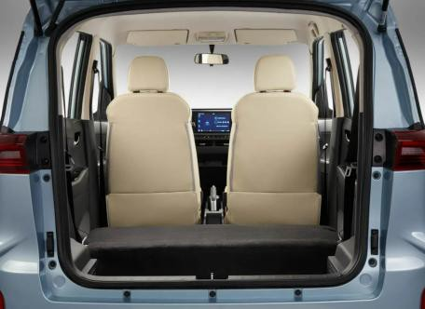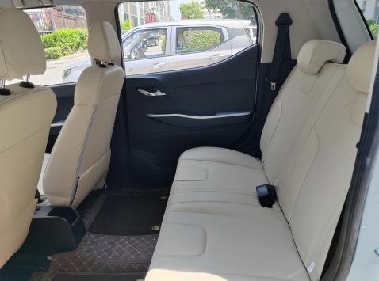

Rear Seats Trunk

LCL (Less Than Container Load)
Package Size: | 3517*1495*1660mm | Gross Weight: | 1000 kgs
Package Way | Fixed inside steel frame,then covered with plywood.
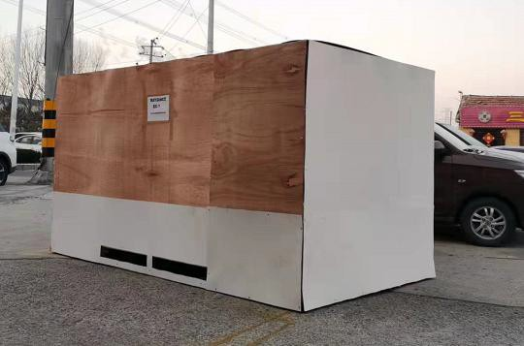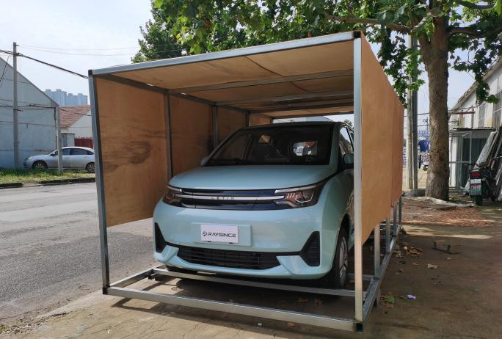
Full Container Loading
20 ft container | 2 pc | 40 ft container | 4 pcs
Package Way | Fixed by steel frame,then fixed on the container ground with nylon tape

.

