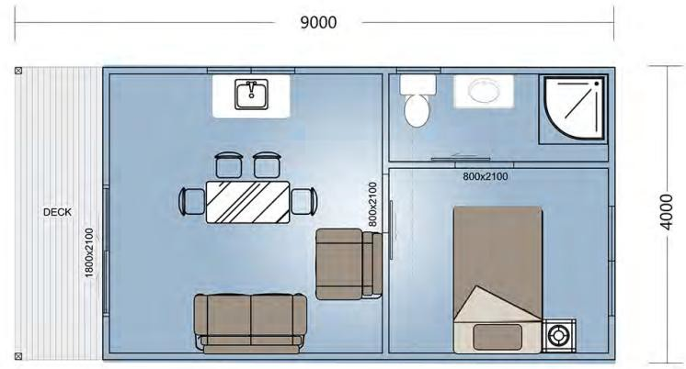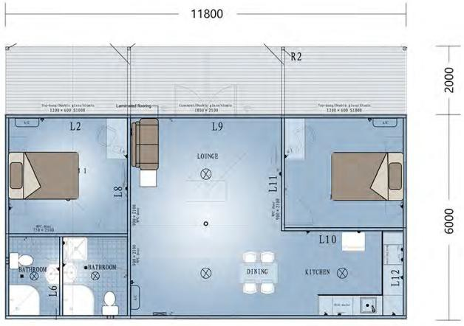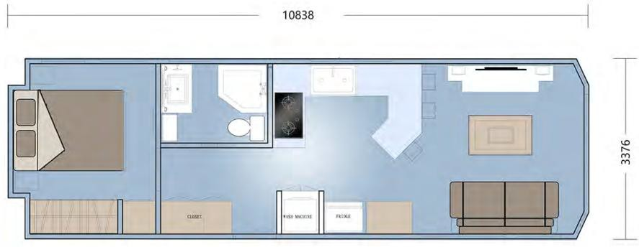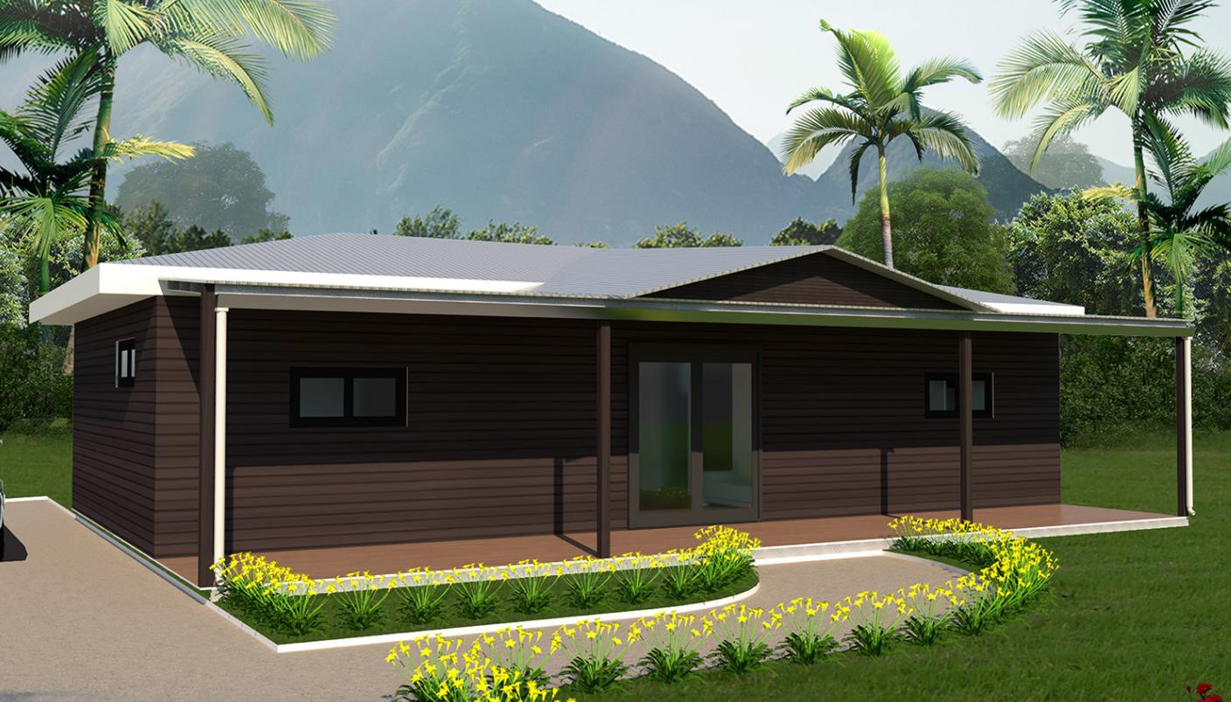

\

Price list of Foldable house

Foldable house models | Picture | Floor plan | Bld area (m2) | Deck (m2) | Price (USD) /FOB
735# | 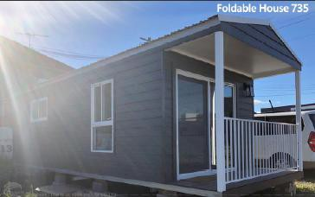 | 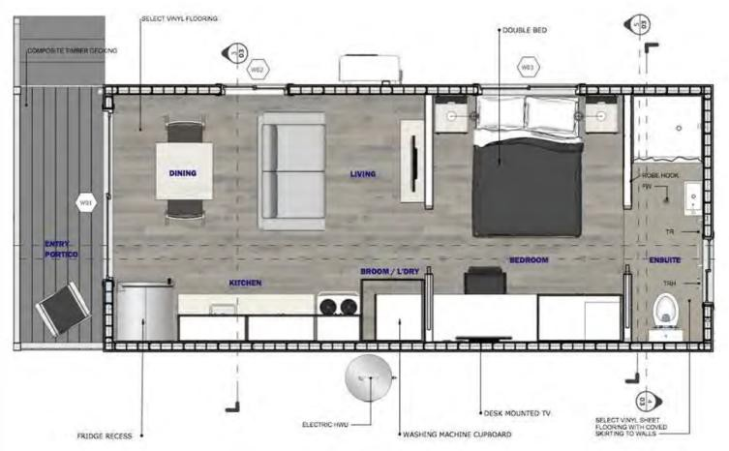 | 27.43 | 4.14 | 18,600
806# | 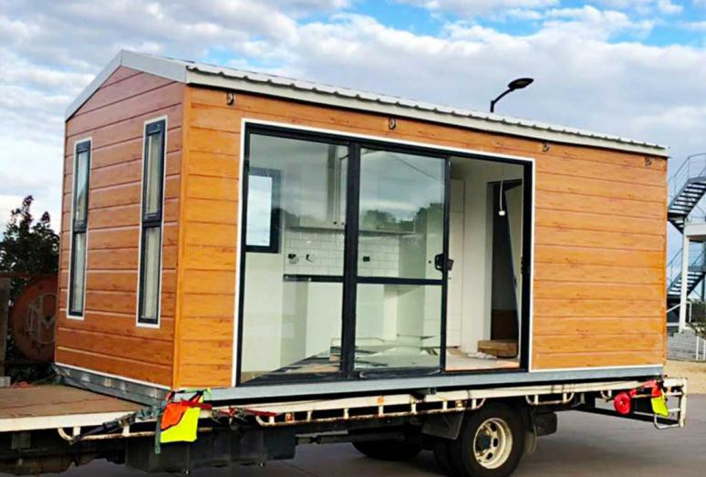 | 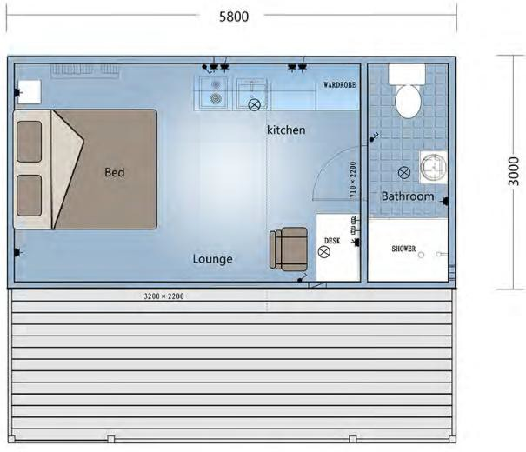 | 17.4 | 11.6 | 15,600
929# | 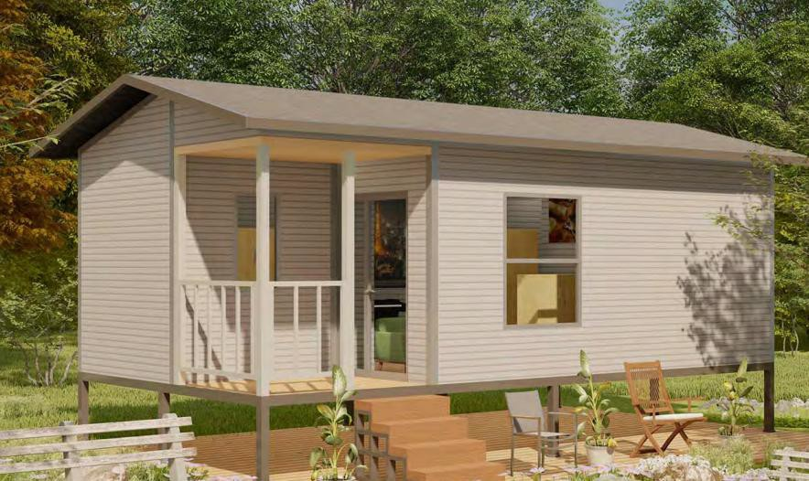 | 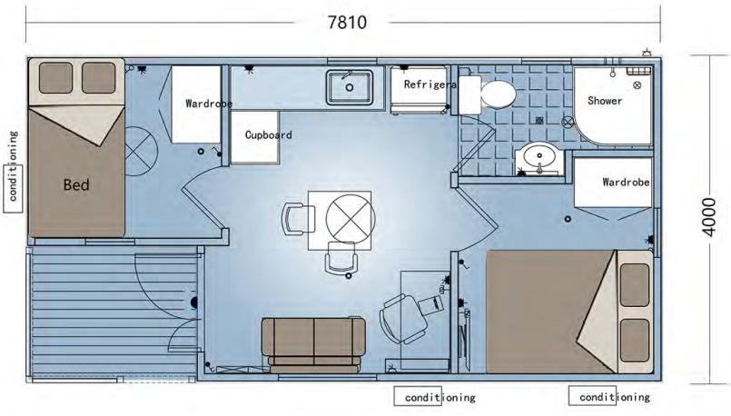 | 31.24 |  | 19,500
939# | 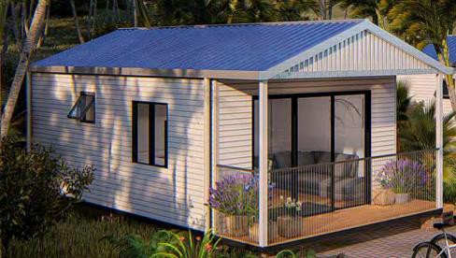 |  | 28 | 8 | 17,600
819# |  |  | 70.8 | 23.6 | 37,700
802# | 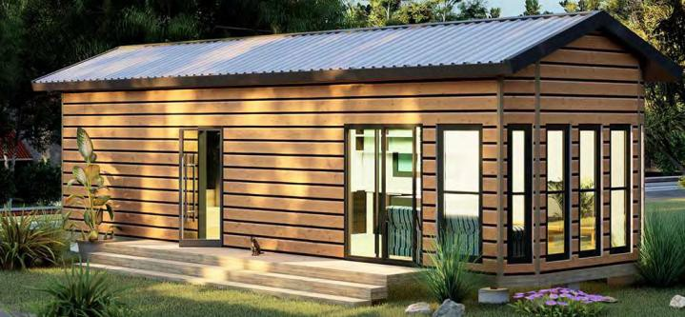 |  | 36.6 |  | 25,600
713# | 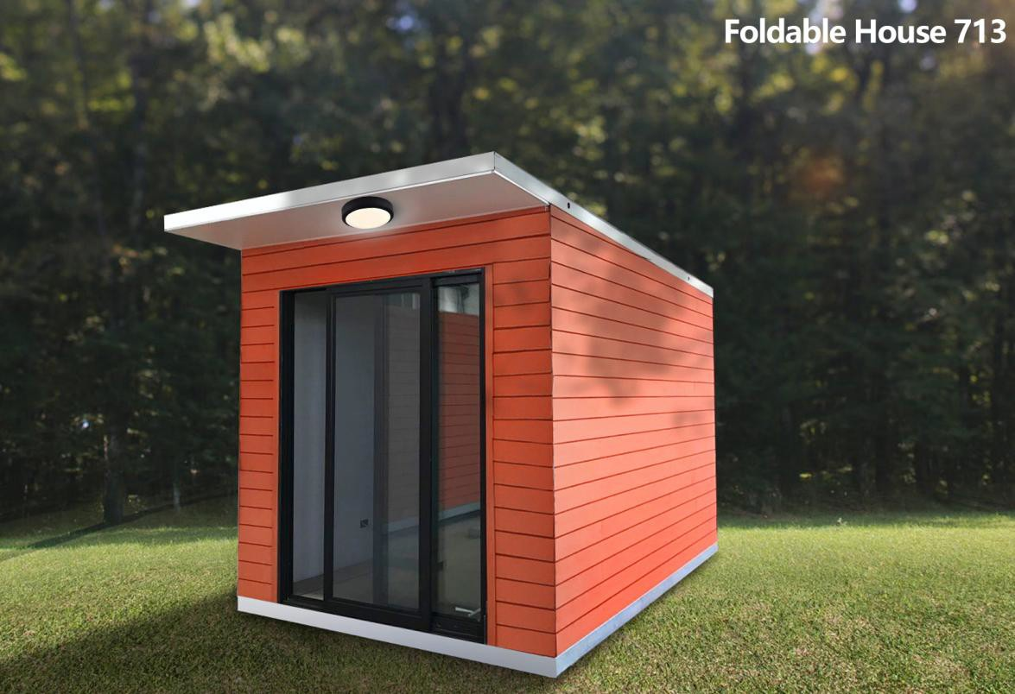 | 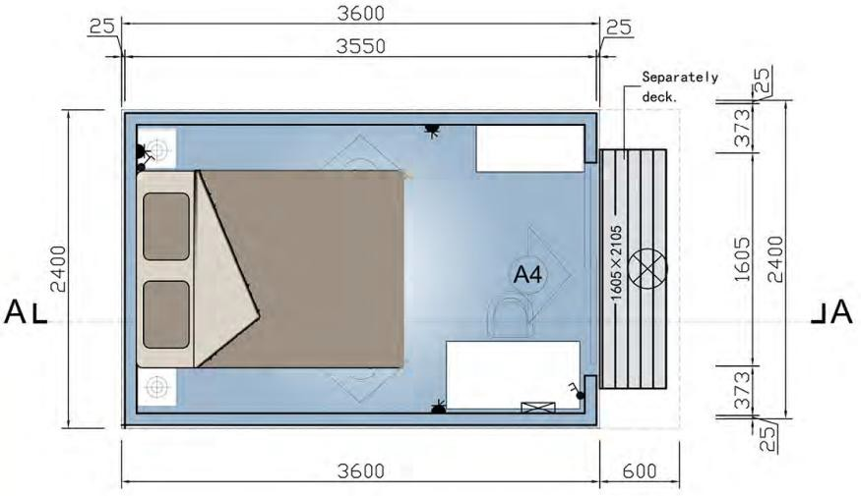 | 8.64 |  | 4,980

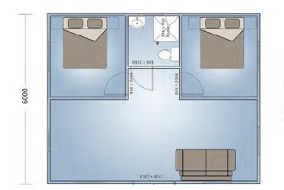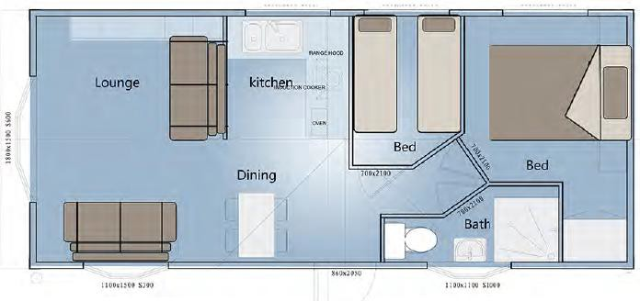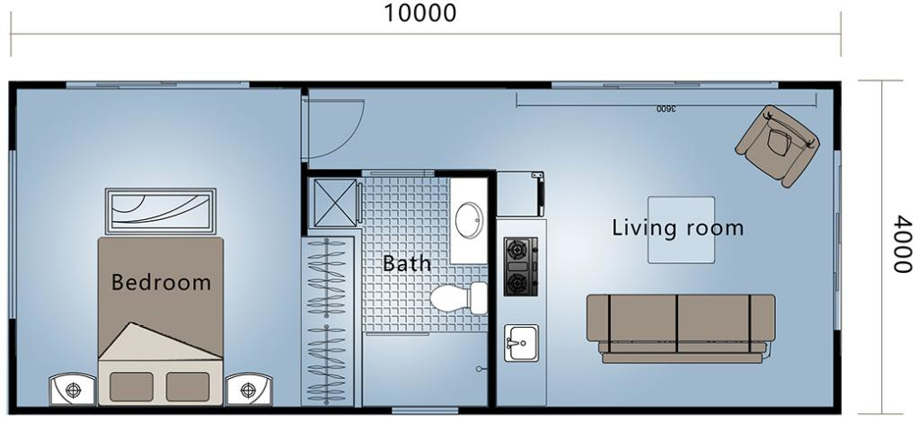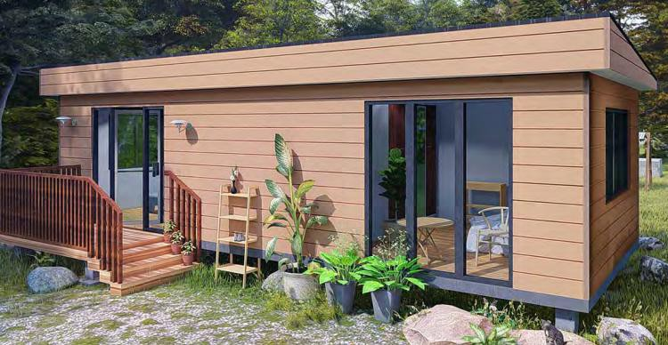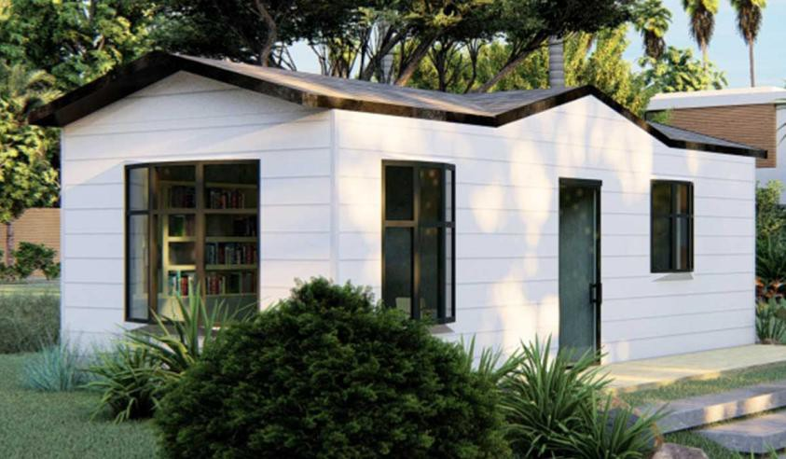
52# | 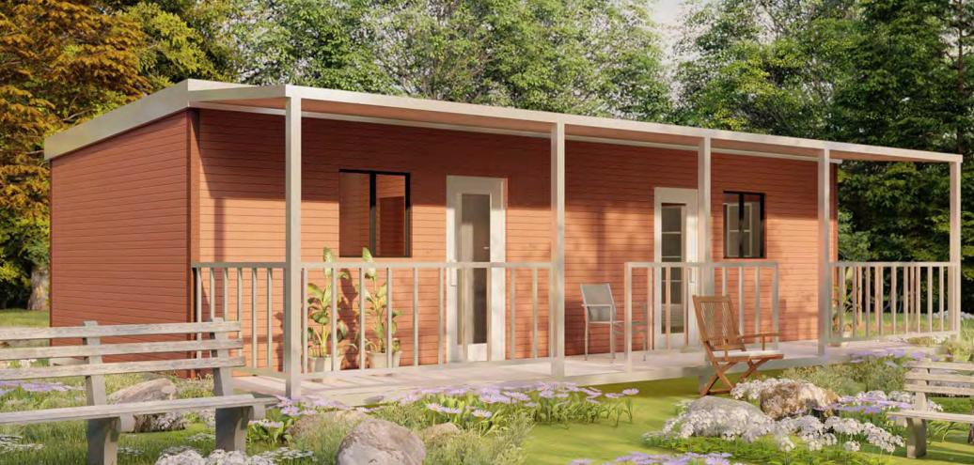 | 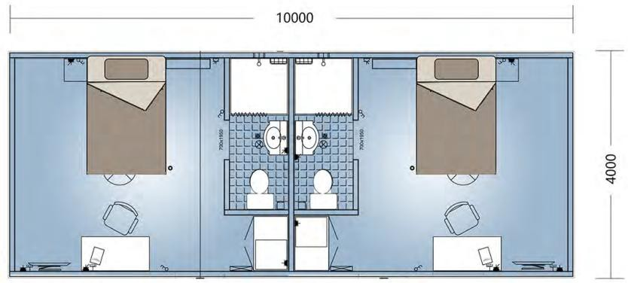 | 40 |  | 25,000
152# | 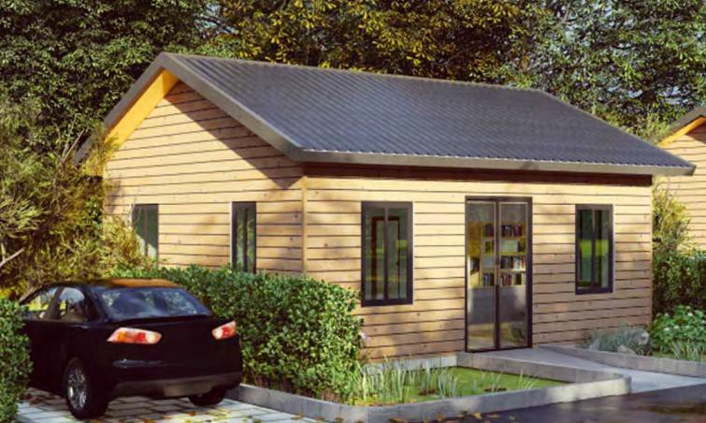 |  | 45 |  | 22,250
705# |  |  | 30.24 |  | 19,500
MH4094 | 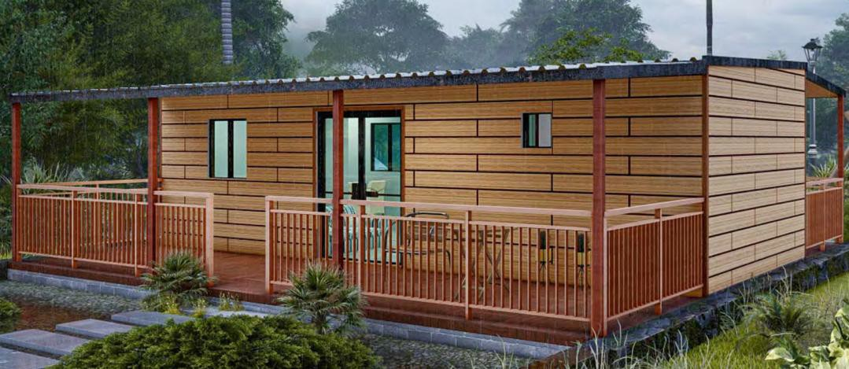 | 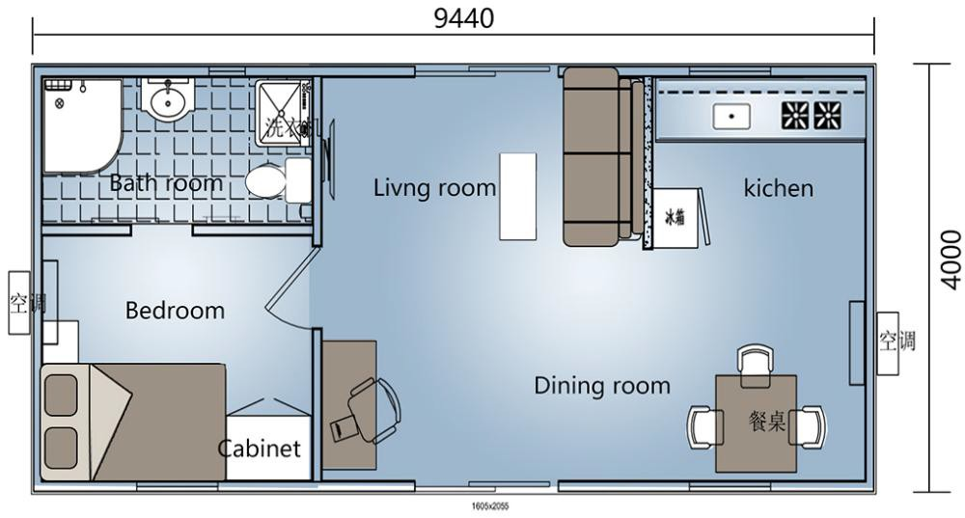 | 37.6 | 47.2 | 35,166
2130# |  |  | 40 |  | 25,500
2117# | 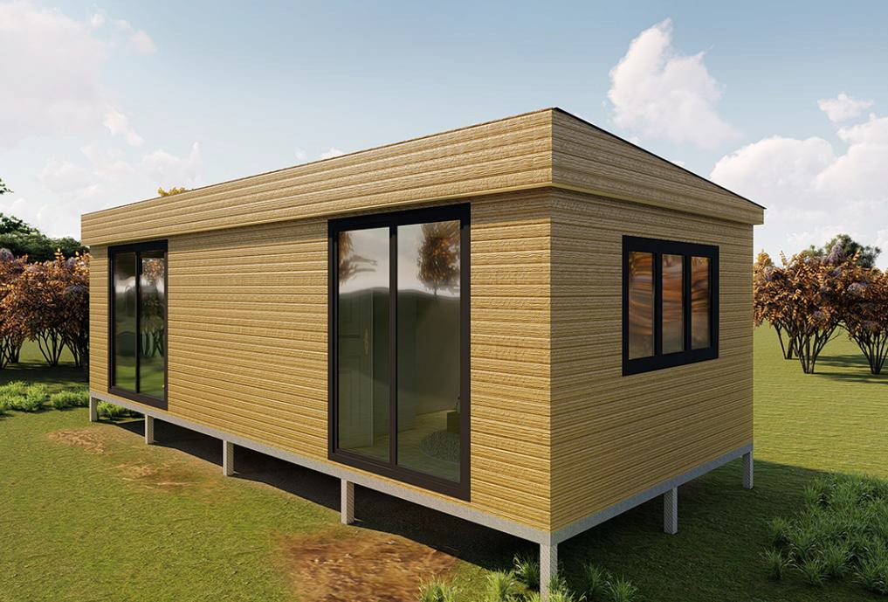 |  | 40 |  | 25,500
2222# | 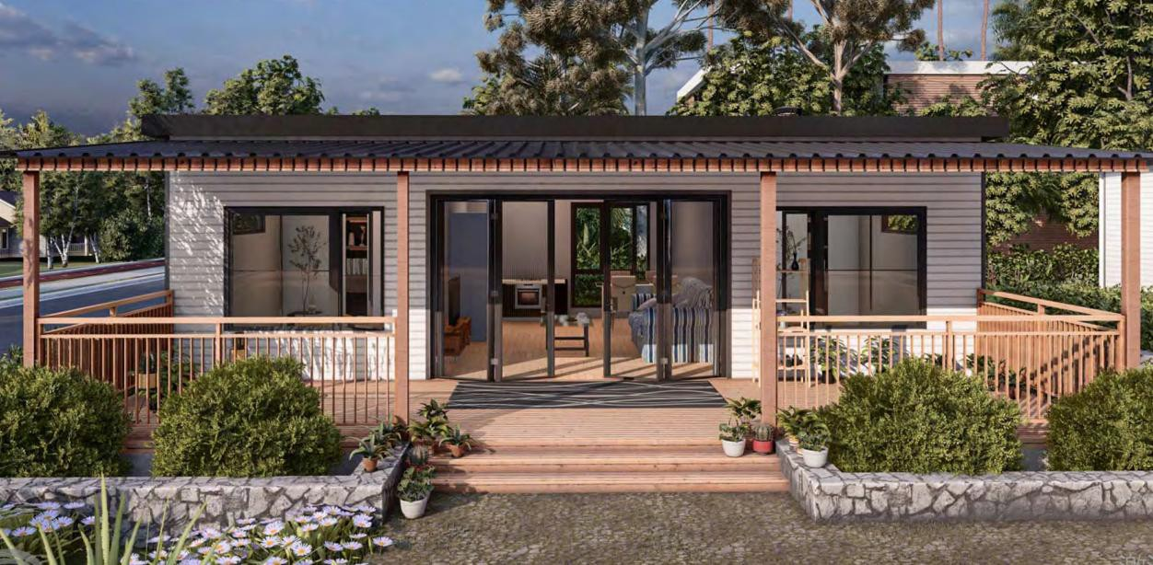 | 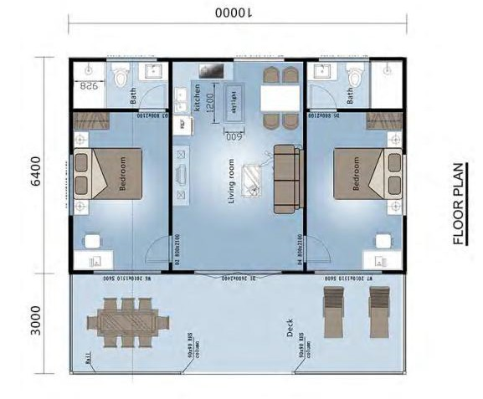 | 64 | 30 | 35,000

Building materials

- RHS floor structure based on engineer's design.

- External & Internal wall Frame: AS1397 89mm*41 mm*0.75mm G550, High tensile Steel wall frames, with full assembly details incorporating a simple coding system enabling easy construction, both side with 10mm fiber cement sheet

- 89mm*41mm*0.75mm G550, High tensile Steel roof trusses & associated roof members, ready to assemble & attach to external walls with all fixings & detailed set-out plans.

- Steel Batten 22 mm steel roof battens & batten 22mm steel ceiling battens

- High tensile Corrugated colored roof sheets in 0.42mm thickness, gable flashings, ridge capping, valleys, barge capping & all fixings if applicable.

- Wall cladding: 8mm fiber cement board as cladding

- Interior lining: 8mm fiber cement board

- Aluminum sliding windows & sliding doors including standard fly screens to Australian Standards and as per plan specifications in black color.

- Glass wool R2.5 to main roof area unless otherwise specified.

- Glass wool R3.5 breathable insulations to all exterior walls & gable ends if applicable

- Entrance door-Aluminum sliding door

- Bathroom door -alum. door with steel frame and weather seal

- Internal doors-plywood interior door.

- Flooring: 9mm Laminated flooring

- Cornering: 90mm coved plasterboard cornice

- Skirting -MDF skirting

- Robe & Linen cupboard support -gypsum board cornering.

- 9mm gypsum board ceiling

- 8mm cfc soffit lining

- All P/C items: toilet, shower and washbasin w/mirror

- Power points as per plan

- Joinery as per plan

The above materials are just for reference, different design, different materials. Please contact sales@asiandragonintl.com for more information.

Items not included

- Site works - site clearing or cutting and rubbish removal.
- Council fees and lodgments of plans.
- External and internal stairs and balustrade.
- All on site construction and labor.

