QUOTATION SHEET NO:NC20230426
Project name: White Cabin |  |  |  | Size: Long 7000mm Wide 2300mm High 2550mm
HS code:9406900090 |  |  |  | Date:2023-04-26
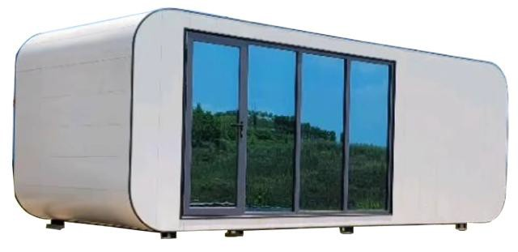

No  . | Item | Specification | Quantity | Picture | Unit price  （USD) | Total(USD）
1 | White Apple Cabin  （Without  Electrical Systems） | 7000*2300*2550mm  empty inside without tempered glass | 2 | 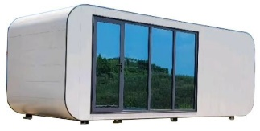 | 11600 | 23200
EXW Price: 23,200 USD (2 units)
1 |  | 50%TT down payment before production,50%TT balance payment before ship
2 |  | Design drawings are for reference only
3 |  | one 40HQ can load 1 unit
4 |  | The price is only valid within 15 days.
5 |  | within 30 working days after the receipt of down payment

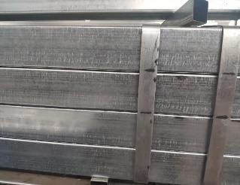
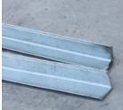
Materials for standard unit container house
NO | Items | Materials | Descriptions | Image
1 | steel frame | Bottom Main Beam | 60x80x3 mm galvanized square tube | 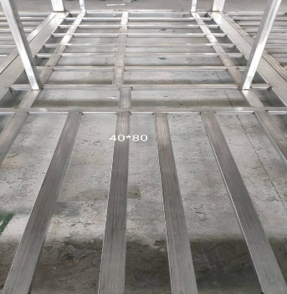  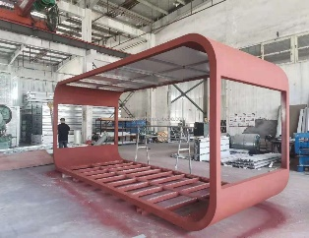
2 |  | Bottom Cross Beam | 50x50x3 mm galvanized square tube
3 |  | Bottom connection beam | 80*40*2mm steel tube
4 |  | Column | 60x80x3mm galvanized square tubel
5 |  | L type slot | 30*30mm 65*65mm galvanized steel
6 | Roof | External | Thickness of 0.5mm Steel Plate | 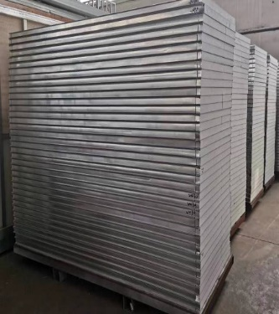
 |  | Insulation layer | Thickness of 50mm EPS sandwich panel Density 20kg/m³
 |  | Interior | Thickness of 0.5mm Steel Plate
 |  | Ceiling | 0.3 mm steel ceiling
7 | Wall Waterproof | External | 0.5 mm GI steel | 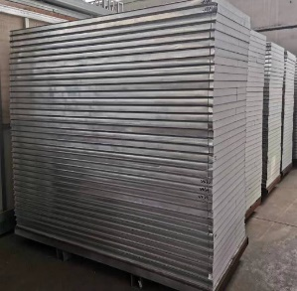
 |  | Insulation layer | Thickness of 50mm EPS sandwich panel Density 20kg/m³
 |  | Interior | 0.5 mm GI steel

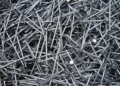
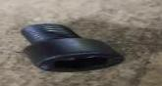
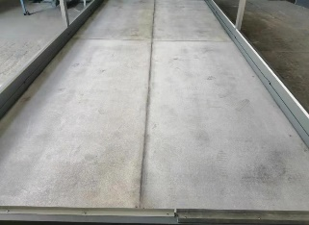
8 | Floor Waterproof | Base flooring | Thickness of 16mm waterproof  （cement） Board
Auxiliary parts
1 | Decoration Line | PVC decoration accessories | for ceiling edge, |  | 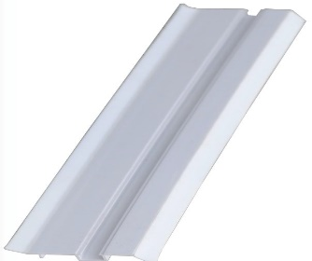
 |  |  | for floor edge,
 |  |  | for roof joint corner
 |  |  | for corner post,
2 | Glue | Because packing and transportation, Please use them yourselves after the installation | Brand New | Full Sets | 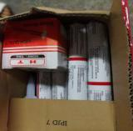
3 | Screw | Brand New | Flat head Drilling screw 4.8*38 |  | 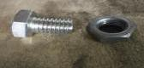
 |  |  | Hexagonal drilling screw 5.5*65
 |  |  | outside hexagonal screw 12*20
 |  |  | Blind nut 14

QUOTATION SHEET NO:vk20231116
Project name: 2024 Space capsule | Size: Long 8800mm Wide 2800mm High 2500mm
HS code:9406900090 | Date:2023-11-16
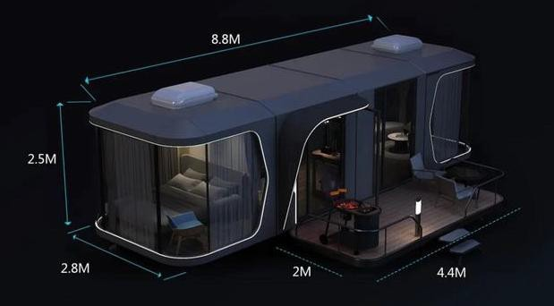

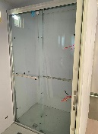
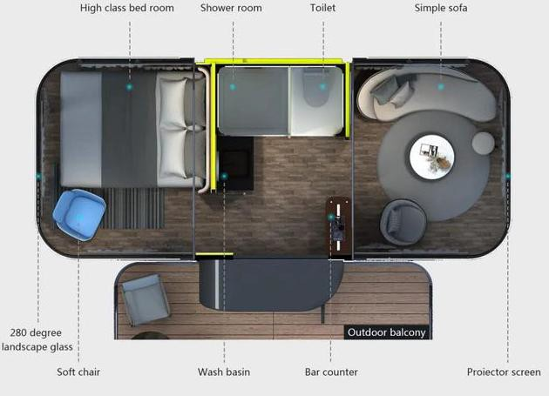

No  . | Item | Specification | Quantity | Picture | Unit price  （USD) | Total(USD）
1 | Space capsule (Electrical  Systems） | 8800*2800*2500mm  empty inside | 1 | 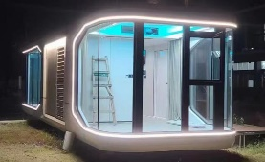 | $37,250.00 | $37,250.00
2 | Wooden plastic terrace | galvanized steel and wpc materials 2000mm*4400mm | 1 | 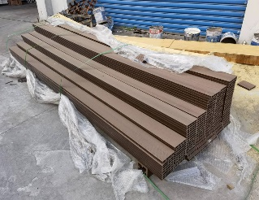 | $700.00 | $700.00
3 | Toilet | Toilet, water mark certificated | 1 | 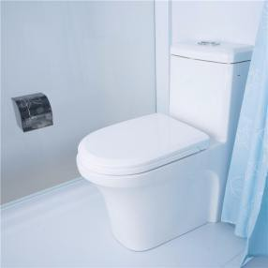 | $110.00 | $110.00
4 |  | glass shower door | 1 | 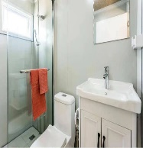 | $450.00 | $450.00

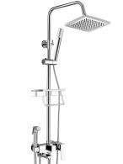
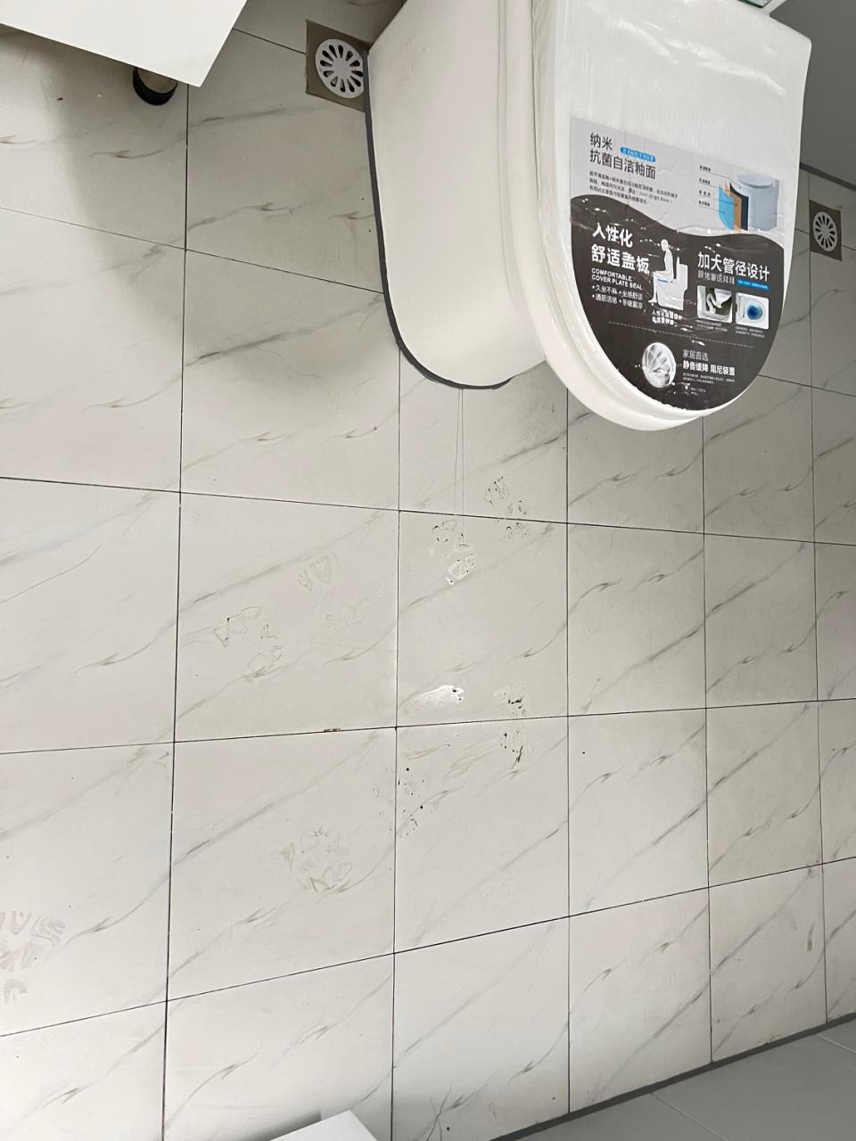
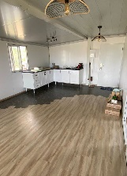
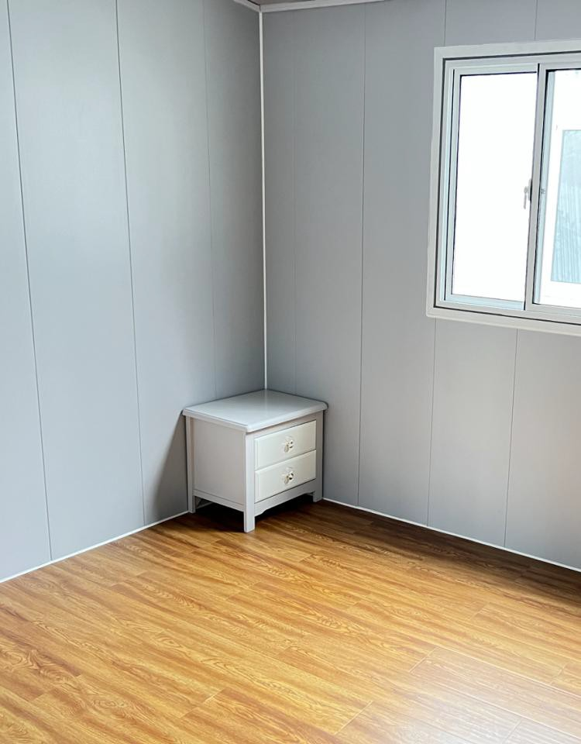
5 | Shower room | partition wall | 1 | 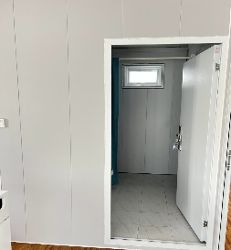 | $110.00 | $110.00
6 |  | With shower nozzle cold&hot head  tiles floor installed in advance | 1 |  | $420.00 | $420.00
7 |  | pre-installed water pipr | 1 | 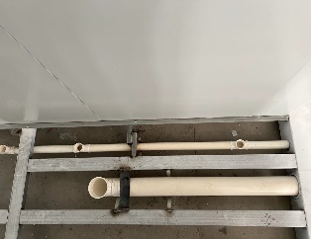 | $110.00 | $110.00
8 | Hand basin | with mixer-tap | 1 | 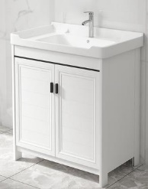 | $110.00 | $110.00
9 | Floor | Laminate Flooring  （Two colors can be selected） | 1 |  | $320.00 | $320.00
1 |  | 50%TT down payment before production,50%TT balance payment before ship
2 |  | Design drawings are for reference only
3 |  | The price is only valid within 15 days.
4 |  | within 30 working days after the receipt of down payment
Materials for standard unit container house
NO | Items | Materials | Descriptions |  | Image

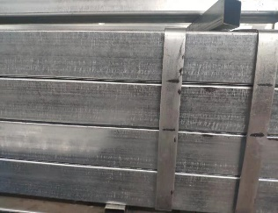
1 | steel frame | Bottom Main Beam | 60x80x3 mm galvanized square tube
2 |  | Bottom Cross Beam | 50x50x3 mm galvanized square tube
3 |  | Bottom connection beam | 80*40*2mm steel tube
4 |  | Column | 60x80x3mm galvanized square tubel
5 |  | L type slot | 30*30mm 65*65mm galvanized steel
6 | Roof | External | Thickness of 0.5mm Steel Plate | 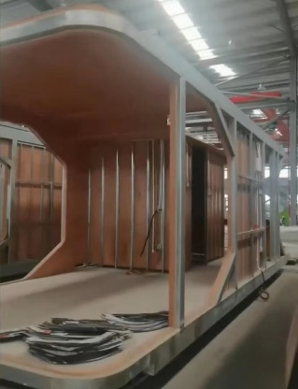
 |  | Insulation layer | Thickness of 50mm EPS sandwich panel Density 20kg/m³
 |  | Interior | Thickness of 0.5mm Steel Plate
 |  | Ceiling | 0.3 mm steel ceiling
7 | Wall Waterproof | External | 0.5 mm GI steel
 |  | Insulation layer | Thickness of 50mm EPS sandwich panel Density 20kg/m³
 |  | Interior | 0.5 mm GI steel

8 | Floor Waterproof | Base flooring | Thickness of 16mm waterproof  （cement） Board+12mm laminated floor
Auxiliary parts
1 | Decoration Line | PVC decoration accessories | for ceiling edge, |  | 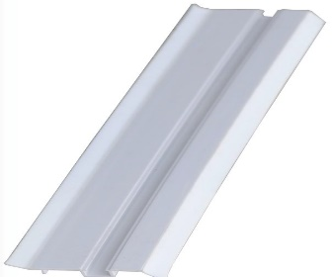
 |  |  | for floor edge,
 |  |  | for roof joint corner
 |  |  | for corner post,
2 | Glue | Because packing and transportation, Please use them yourselves after the installation | Brand New | Full Sets
3 | Screw | Brand New | Flat head Drilling screw 4.8*38
 |  |  | Hexagonal drilling screw 5.5*65
 |  |  | outside hexagonal screw 12*20
 |  |  | Blind nut 14

