NEW MULTIPURPOSE Mi-171E
TRANSPORT HELICOPTER

TECHNICAL AND COMMERCIAL PROPOSAL

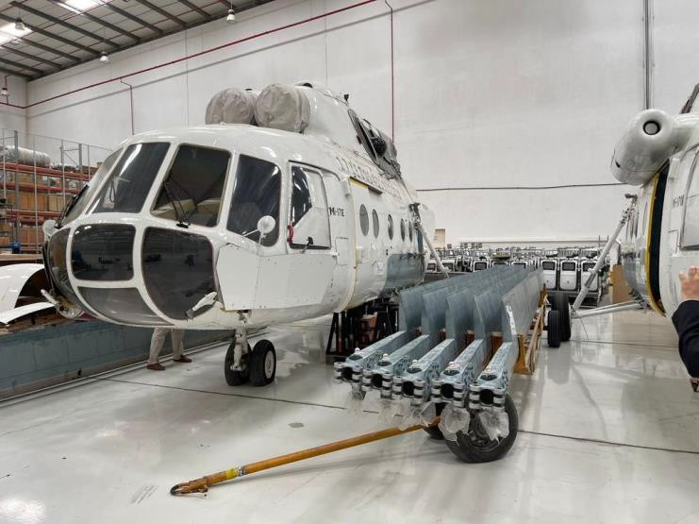The МI-171Е helicopters original photos

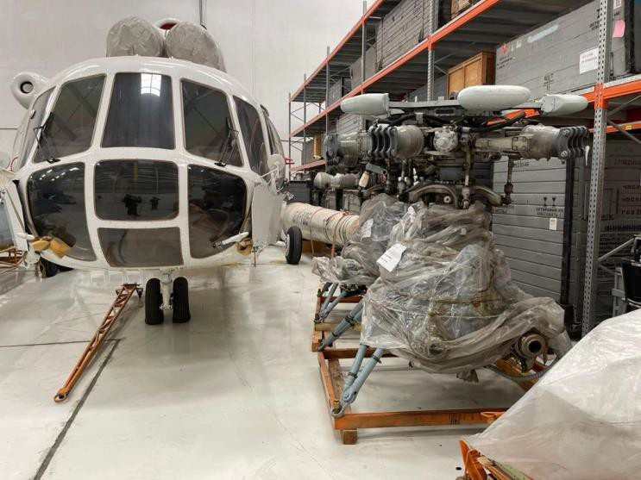

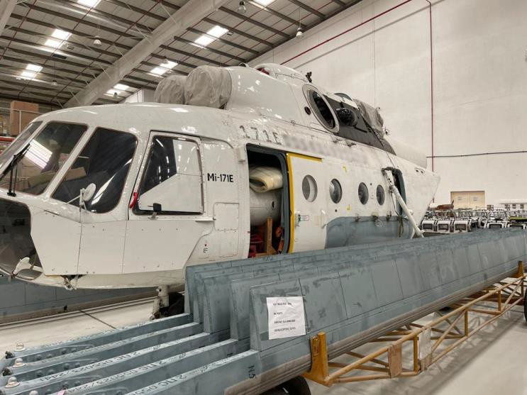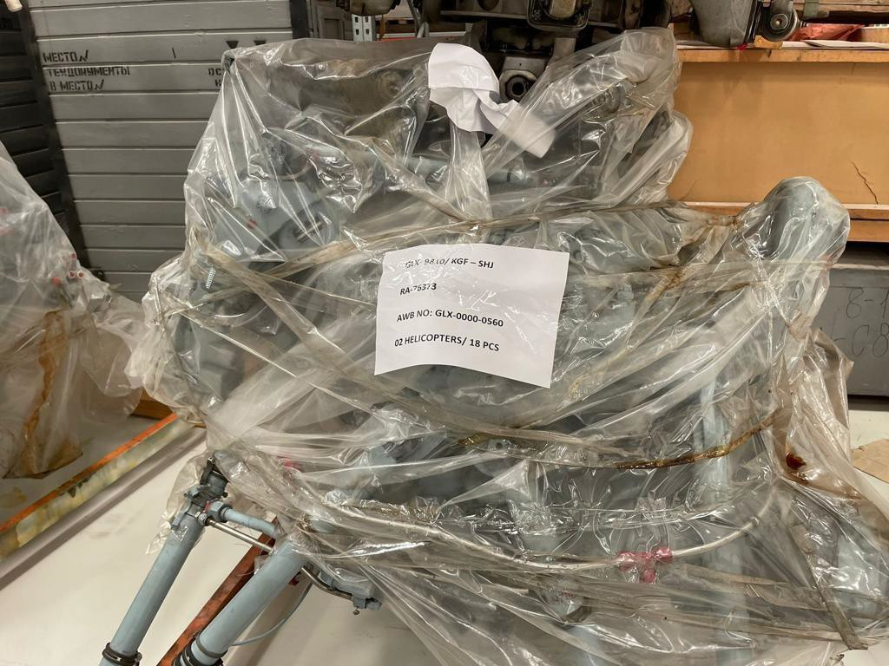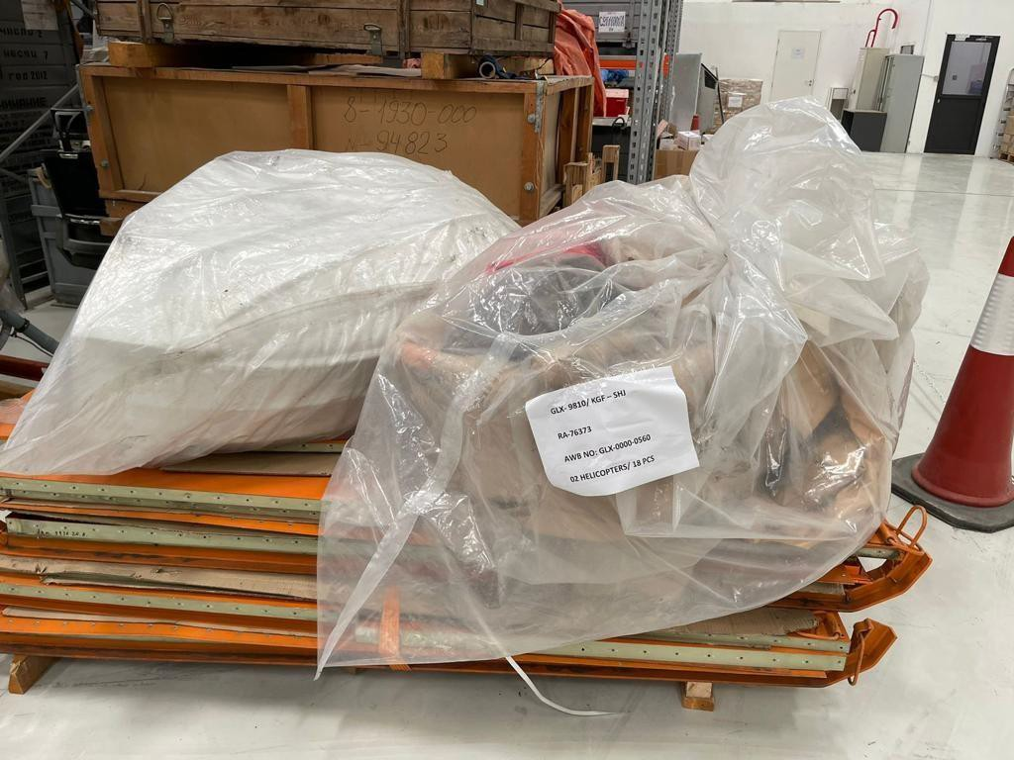

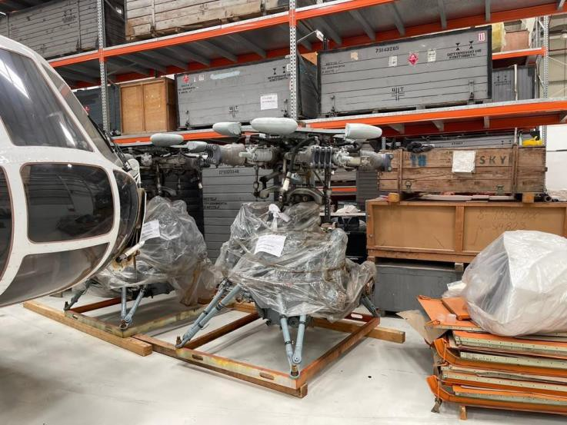

CONTENTS | Page
1 GENERAL INFORMATION | 3
2 MAIN PERFORMANCE DATA | 5
2.1 Weight parameters | 5
2.2 Geometrical Data | 6
2.3 Load data in main version of application | 8
2.4 Cargo compartment | 9
3 Mi-171E SPECIFICATION | 11
4 OPTIONAL EQUIPMENT | 19
5 SERVICE LIFE AND OVERHAUL | 20
6 COMMERCIAL CONDITIONS | 20
6.1 Helicopter and equipment | 20
6.2 Helicopters and Equipment Warranty | 21
6.3 Terms of payment | 21

- GENERAL INFORMATION

The Mi-171E is a transport single-rotor helicopter. The helicopter is powered by two TV3-117VM gas turbine engines equipped with dust protection devices (DPD).

The Mi-171E helicopter is a universal transport. Its spacious cargo cabin (23 m3) enables to carry up to 4 tons of cargo including wheeled vehicles. Moreover, the helicopter can be used for service passengers transportation and medical evacuation. It takes few minutes to install 36 seats or up to 12 stretchers.

Two side doors and a hydraulically driven rear ramp facilitate loading/unloading of cargoes and passengers. In case of emergency 36 people can leave the helicopter within 15 seconds.

The Mi-171E can also fly with an open ramp which allows to carry long-length loads inside the cabin and perform paratroopers dropping.

To transport bulky cargoes the helicopter is fitted with a 4-ton capacity external sling.

To increase the range of flight up to four 915-litre capacity auxiliary fuel tanks can be installed inside the cabin. Thus the range of flight can be increased up to 1,600 km.

On customer's request the helicopter can be equipped with a 300-kg or 150-kg capacity hoist, as well as with other additional equipment.

The helicopters can be used for carrying:
- Carrying up to 20 person + 3 crewmembers;
- Carrying cargo inside fuselage (up to 4 metric tons);
- Carrying cargo on external sling load up to 4,5 metric tons;
- SAR operation;
- Night Flight operations;
- Fire fighting;
- Medevac.

The minimum crew: Pilot (Captain) and Copilot. Another crewmember (a flight engineer or a loadmaster) may be added to the crew.

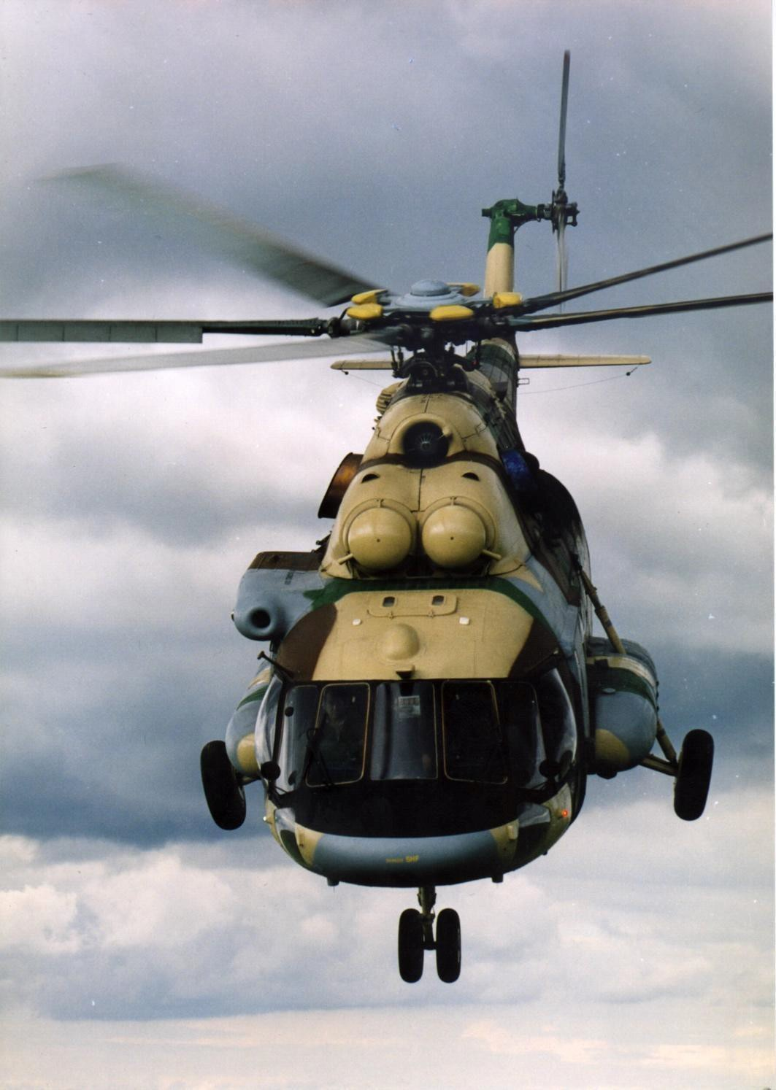

Fig 1-1. Mi-171E multipurpose helicopter

MAIN PERFORMANCE DATA

Weight parameters (ISA)

The performance presented here are given for the helicopter operated under standard atmospheric conditions.

Weight
Normal takeoff weight 11100 kg
Maximum takeoff weight 13000 kg

Payload:
normal 2000 kg
maximum inside the cargo compartment 4000 kg
on the external cargo sling (if installed) 4500 kg

Maximum indicated air-speed of horizontal flight at altitudes of 0 to 1000 m: at normal takeoff weight 250 km/h
at maximum takeoff weight 230 km/h

Minimum indicated airspeed of horizontal flight:
at altitudes up to 5000 m 60 km/h

Cruising indicated airspeed at altitudes of 0 to 1000 m:
at normal takeoff weight 220 to 240 km/h
at maximum takeoff weight 205 to 215 km/h

Service ceiling in ground effect (Anti-Ice and DPD are switched off): at normal takeoff weight 11100 kg 6000m
at maximum takeoff weight 13000 kg 4800m

Hovering ceiling out of ground effect (Anti-Ice and DPD are switched off): at normal takeoff weight 11100kg 4500 m
at maximum takeoff weight 13000kg 1500 m

Practical ceiling:
at normal takeoff weight 6000 m
at maximum takeoff weight 4800 m

Geometrical data

General data at normal takeoff weight of 11100 kg Helicopter length:
without main and tail rotors 18,989 m
with rotating main and tail rotors 25,352 m

Helicopter height:

without tail rotor 4,865 m
with rotating tail rotor 5,544 m
Ground clearance 0,445 m

Main Rotor

Main rotor diameter 21,294 m
Number of main rotor blades 5
Direction of main rotor rotation
(as viewed from below) counter-clockwise

Tail Rotor

Tail rotor diameter 3,908 m
Number of tail rotor blades 3
Direction of tail rotor rotation
(as viewed from the side of tail rotor) counter-clockwise

Landing Gear

Main landing gear wheel track 4,510 m
Landing gear wheel base 4,281 m

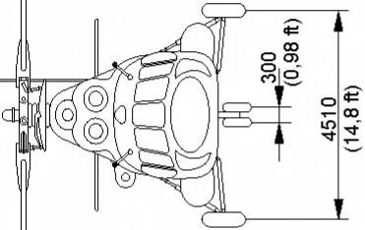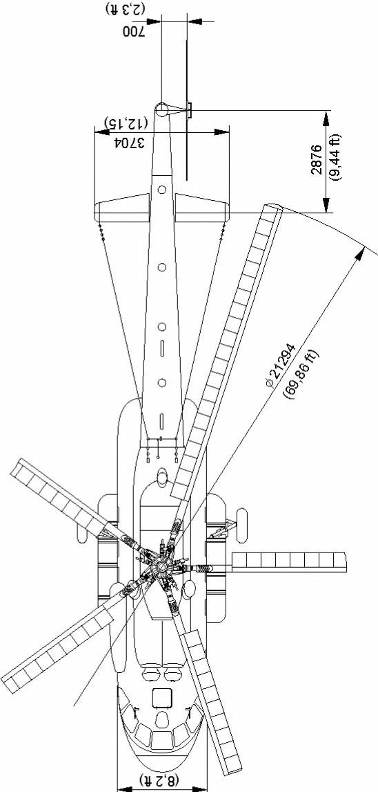2
(X) N
0a, (X).
<") N

a, 2
(aX,) <")•
(~X) ~N

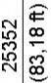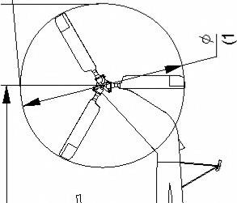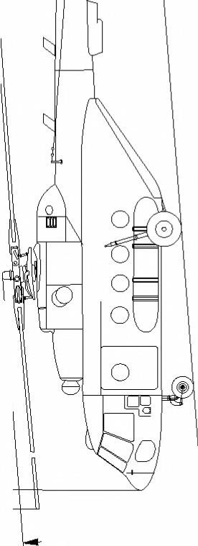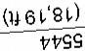

9SLV
ODS~

Load data in main version of application

Table 2.1.
N | Load components | Transport versions of application
 |  | Cargo up to 4000 kg  inside the cargo compartment | Cargo up to 4500 kg on  external sling load system
1 | Empty helicopters in standard  complement | 6445 | 6445
2 | Empty helicopters with operational items (particular weight is specified in  the Log book of helicopter) | 7514 | 7514
3 | Full load | 5486 | 4754
 | a) Operational items (with crew) | 332 | 354
 | pilots (2) | 160 | 160
 | flight engineer | 80 | 80
 | oil | 72 | 72
 | unusable fuel | 20 | 20
 | passenger seats | - | -
 | carpets on the floor | - | -
 | external sling load | - | 22
 | b)fuel (density 0,774 kg/l) | 1396 | 1396
 | in service fuel tank | 346 | 346
 | in main fuel tanks | 1050 | 1050
 | c)payload | 3758 | 3000
 | - passengers (26 persons) | - | -
 | baggage (15 kg per passenger) | - | -
 | cargo inside cargo compartment with
 | lashing items | 3758 | -
 | cargo on external load with sling and | - | 3000
 | cable
4 | Takeoff weight of helicopters (with  KO-50 heater) | 13000 | 12264

Notes:
    - Fuel mass does not include 54 kg of fuel, which comprises:
4 kg (trapped fuel) is included in the weight of empty helicopters;
20 kg (unusable fuel) is included in the weight of operational items; 30 kg – weight of fuel, used on the ground prior to helicopters takeoff.
    - Mass of one crew member – 80 kg.
    - The breakdown of weights and CG positions of equipment and loading components, as well as the calculation of CG at takeoff and of extreme CG positions of helicopter in flight are given in the Weight and Balance Instructions.
    - If necessary, the oxygen equipment for the crew (3 sets) with total weight of 11,5 kg
+ one set with two masks may be installed, which are included in load (medevac role).

2.4 Cargo compartment Basic Data
Volume, cu. m 25.0
Length (on the floor), m 5.34
Width, m 2.34
Height, m 1.8

Portside sliding widened door
doorway size 1,405x1,215 m

Starboard sliding door
doorway size 1,405x0,825 m

Rear ramp sizes 1,500x2,300 m

The cargo compartment is comfortable and provides all necessary comfort for passengers. Fire – resistant materials are used for the cabin. To maintain normal temperatures, air purity in the cabin, to reduce noise, the helicopter is equipped with air conditioning, ventilation or heating systems and it is made heat-and –sound proof.

Cargo Carrying
If necessary, the helicopter can carry loads in the cargo cabin. The cargo can be loaded into the cabin through the doors or through the open ramp.
Depending on the amount of cargo to be carried, the required number of the seats is folded to accommodate it. The cargoes are tied down to the tie-down fittings located on the floor.

Any long-size bulky loads can be carried on the external sling. The helicopter is provided with external sling load system of up to 4500 kg lifting capacity (fitted as option equipment, standard capacity is 3000kg).

The helicopter fuselage is an all-metal structure made up of a nose portion, central portion, tail boom and tail boom pylon. The stabilizer is installed on the tail boom to provide the required stability and controllability.

left sliding widened door - 1,405 x 1,215 m right sliding door size - 1,405 x 0,825 m

In the rear part of cargo compartment is installed hydraulic driven ramp (Fig 2-2).
The ramp is designed for rolling wheeled transport means, rapid airdrop and long-size loads carriage, embarkation disembarkation of stretches with injured.

Operation of ramp is performed by the independent hydraulic system. Hydraulic system is filled with АМГ-10 oil that fills the hydraulic cylinder that enables opening and closing of ramp. Ramp is locked by hydraulic lock and is operated automatically as well as by manual pump (in case of automatic failure). The ramp is a high performance advantage during loading and unloading.

Ramp opening time is 4,5 sec Ramp closing time is 5 sec

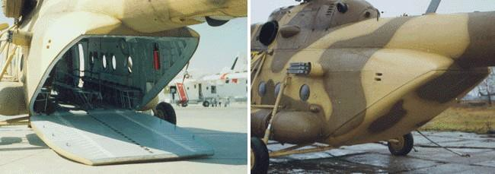

Fig. 2-2. Hydraulic driven ramp

Mi-171E SPECIFICATION

The present standard delivery set list includes the main vendor items, which are used in the helicopter.
The Supplier reserves the right to replace the equipment indicated in the Specification with equivalent advanced equipment.

Table 3-1

LIST OF MAJOR VENDOR ITEMS INSTALLED ON MI-171Е HELICOPTER
ПЕРЕЧЕНЬ ОСНОВНЫХ КОМПЛЕКТУЮЩИХ ИЗДЕЛИЙ УСТАНАВЛИВАЕМЫХ НА ВЕРТОЛЕТЕ МИ-171Е
№ |  | Тип изделия |  | Description | Unit/Ед. изм. | Q-ty  (Кол.)
1. Power plant and transmission
1. Силовая установка и трансмиссия
1.1 | 246-1517-000 |  | Tail gear box |  | pc | 1
1.2 | 8-1930-000 сер.02 |  | Main rotor hub |  | pc | 1
1.3 | 8-1950-000 |  | Swash plate |  | pc | 1
1.4 | 8A-1515-000 |  | Intermediate gear box |  | pc | 1
1.5 | 8A-1516-000 |  | Tail rotor drive shaft |  | pc | 1
1.6 | 8A-6311-00 |  | Fan |  | pc | 1
1.7 | 8A-6314-00 |  | Fan drive cardan shaft |  | pc | 1
1.8 | 8АМТ-1250-00 |  | Vibration damper |  | pc | 1
1.9 | АИ-9В |  | Engine |  | pc | 1
1.10 | ВР-14 |  | Main gear box |  | pc | 1
1.11 | РТ-12-6-2сер. |  | Temperature  control |  | pc | 2
1.12 | ТВ3-117ВМ |  | Engine |  | pc | 2
1.12.1 | ЭРД-3ВМ-2с |  |  |  | pc | 2
2. Fuel and oil equipment
2. Топливное и маслянное
оборудование
2.1 | 11ТФ30СМ-0 |  | Fuel filter |  | pc | 1
2.2 | 463Б |  | Electr. centrifugal pump |  | pc | 1
2.3 | 5349T |  | Cooler block |  | pc | 2
2.4 | 610200А |  | Solenoid valve |  | pc | 1
2.5 | 766300A-1-T |  | Float valve |  | pc | 1
2.6 | 768600МА |  | Fuel shut-off valve |  | pc | 3
2.6.1 | ЭПВ-150МТ 2сер. |  | electric actuator |  | pc | 3
2.7 | ЭЦН-91С |  | Electric centrifugal pump |  | pc | 2
3. Control and hydraulic system

3. Система управления и
гидравлическая система
3.1 | 246-3904-000 сер. 01 | Tail rotor | pc | 1
3.1.1 | 246-3925-00 | tail rotor blade (3 pc), set | pc | 1
3.2 | 8AT-2710-00 | Main rotor blades (5 pc), set | pc | 1
3.3 | 8Д2.966.017-2 | Hydraulic filter | pc | 2
3.4 | ЭMT-2M | Solenoid brake | pc | 3
3.5 | ФГ11БН | Filter | pc | 2
3.6 | ГA-172-00-2/T | Lock-out valve | pc | 1
3.7 | ГА-192T | Solenoid valve | pc | 6
3.8 | ГА-59/1 | Emergency power supply valve | pc | 1
3.9 | ГА-74M/5 | Solenoid operated two-position valve | pc | 2
3.10 | ГА-77В | Pump relief valve, automatic | pc | 2
3.11 | КАУ-115АМ | Hydraulic booster | pc | 4
3.12 | МП-100М-2сер. | Electric actuator | pc | 2
3.13 | МСТ-25A | Pressure switch | pc | 1
3.14 | МСТ-30A | Pressure switch | pc | 1
3.15 | НШ39M | Gear pump | pc | 2
3.16 | ОК-10А | Check valve | pc | 4
3.17 | ПР-15,875-2300-1-67 | Chain, 67 links | pc | 1
3.18 | РУ-2 | Stick | pc | 2
3.19 | СПУУ-52 | Tail rotor pitch limit system: | pc | 1
3.19.1 | БУ-32 | control unit | pc | 1
3.19.2 | ДОС | feedback transducer | pc | 1
3.19.3 | ИКД27Да-400-830 | pressure indicator set | pc | 1
3.19.4 | П-1 (П-1Тр) | temperature bulb | pc | 1
 | 4. Airframe, landing gear and pneumatic equipment
 | 4. Фюзеляж, шасси и пневмосистема
4.1 | 595х185 Модель 14 | Tire of nose LG | pc | 2
4.2 | 865х280 Модель 1А | Tire of main LG | pc | 2
4.3 | 8A-4101-00Б-1 | Main L.G. shock strut | pc | 1
4.4 | 8A-4101-00Б-2 | Main L.G. shock strut | pc | 1
4.5 | 8A-4201-00A | Nose L.G. shock strut | pc | 1

4.6 | АК-50T1 сер.3 | Compressor | pc | 1
4.7 | В8БП-000 | Heated windshield | pc | 2
4.8 | K2 116 | Wheel 595x185 | pc | 2
4.9 | KТ 97-310 | Wheel 865х280 | pc | 2
4.10 | KT97-220-1,-2 | Brake of wheel | pc | 2
4.11 | УП25/2 | Pressure reducing valve | pc | 1
4.12 | УПO3/2M | Pneumatic control unit | pc | 1
4.13 | В24-4301-100-7 | Tail bumper shock strut | pc | 1
5. Fire extinguishing, anti-icing,
heating and air conditioning equipment
 | 5. Противопожарнoe, противооблединительное, отопительное и
 | вентиляционное оборудование
5.1 | 1-4-4 | Fire extinguisher: | pc | 2
5.1.1 | 1-2-4-210 | bottle | pc | 2
5.1.2 | ПГКц | valve fire  extinguisher squib control head | pc | 8
5.1.3 | MA-250M | pressure gauge | pc | 2
5.2 | 1919T | Control shutter | pc | 2
5.2.1 | ЭПВ-50БТ сер.2 | electric actuator | pc | 2
5.3 | 8АТ-7420 | Tail rotor slip ring | pc | 1
5.4 | ДВ-302T | Electric fan | pc | 3
5.5 | ЭВ-0,7-1640 | Electric fan | pc | 4
5.6 | ОР1-2,0-20-30 | Fire extinguisher | pc | 2
5.7 | СО-121ВМ вар."A" | Ice detector | pc | 1
5.8 | ССП-ФK сер.2 | Fire detection and warning system | pc | 2
5.9 | ТСВ36М313 | Rotor slip ring | pc | 1
6. Electrical and commutation
equipment
 | 6. Электрическое и коммутационное оборудование
6.1 | АПД-78А | Auto unit for engine start | pc | 1
6.2 | АПД-9В | Start control panel | pc | 1
6.3 | АПШ-3М | Bus selector switch | pc | 2
6.4 | АЗП-А2 | Circuit breaker | pc | 1
6.5 | Б3УНП355Г | Protection unit | pc | 2
6.6 | БЧФ-208 | Phase-sequence unit | pc | 1

6.7 | БРН120Т5А-3С | Unit-regulator | pc | 2
6.8 | БСГО400А | Unit | pc | 1
6.9 | БТТ40БТ | Unit transformer | pc | 2
6.10 | ВУ-6Б | Rectifier | pc | 2
6.11 | ДМР-200Д | Deferential relay | pc | 1
6.12 | ДМР-200ВУ | Integrated device | pc | 2
6.13 | ЭПK-2T-60 | Windshield wiper | pc | 2
6.14 | ГТ40ПЧ8В | Generator | pc | 2
6.15 | ПМК-21ТВ сер.3 | Timer box | pc | 1
6.16 | ПТС-800БМ | 3-phase static inverter | pc | 1
6.17 | РМ-355Г | Gimbal | pc | 2
6.18 | РН-120У | Voltage regulator | pc | 1
6.19 | С-1 | Warning horn | pc | 1
6.20 | СНП-1 | Power fail relay | pc | 1
6.21 | СПО-9 | Static converter | pc | 1
6.22 | ТЭР-1М | Auto temperature control | pc | 6
6.23 | TН-115-7,5 | Transformer | pc | 1
6.24 | TP-100/2 | Transformer | pc | 2
6.25 | TP-115/36 | Step down, transformer | pc | 2
6.26 | TС310С04Б | Transformer | pc | 2
6.27 | ТФ1-75.150/1А | Transformer | pc | 2
6.28 | ТФ1-25.50.100/1A | Transformer | pc | 4
6.29 | ШРАП-500К |  | pc | 1
 | 7. Lights equipment
 | 7. Светотехническое оборудование
7.1 | ФПП-7М | Search / landing light | pc | 2
7.1.1 | ЛФЛ27-450-5 | light | pc | 2
7.2 | МСЛ-3 2с | Beacon alarm lamp | pc | 2
7.3 | ПБС-1 | Dome light | pc | 6
7.4 | СБК | Cabin light | pc | 1
7.5 | СМ-1Б | Light | pc | 1
7.6 | ОПС-57 | Formation light | pc | 3
7.7 | ХС-62 | Tail light | pc | 1
7.8 | БАНО-64 | Forward navigation light | pc | 2
7.9 | ФР-100 | Light | pc | 2

7.10 | П-39 | Dome light | pc | 8
7.11 | СУ-2 |  | pc | 4
8. Engines and gear box monitoring
equipment
 | 8. Приборы контроля двигателей и редуктора
8.1 | 2ИА-6 | Exhaust gas temperature indicating system, consists of: | pc | 1
8.1.1 | 2УТ-6К | double temperature  indicator | pc | 1
8.1.2 | 2УЭ-6Б сер. 2 | double electronic amplifier | pc | 1
8.1.3 | ПК-6 | block | pc | 2
8.2 | Д-1М У2 | Transmitter | pc | 2
8.3 | Д-2М У2 | Transmitter | pc | 2
8.4 | ИВ-500Е сер.2 | Vibration indicating system, consists  of: | pc | 1
8.4.1 | УсС-6 сер.2 | matching device | pc | 2
8.4.2 | МВ-03-1 | piezoelectric transducer | pc | 2
8.4.3 | БЭ-9Е сер.2 | electronic unit | pc | 1
8.5 | ИТЭ-1 | Tachometer | pc | 2
8.6 | ИТЭ-2 | Tachometer | pc | 2
8.7 | ИД-3 | Inductive sensor | pc | 1
8.8 | ИМД-8 | Induction pressure transmitter | pc | 2
8.9 | ИД-8 | Induction pressure trans-mitter | pc | 1
8.10 | МСТВ-2,5С | Pressure switch heat resistant and shakeproof | pc | 1
8.11 | П-77 вар.2 | Temperature  sensor | pc | 1
8.12 | САС-4-9 | Warning and caution system, consists of: | pc | 1
8.12.1 | БАП-1 | warning signal unit | pc | 2
8.12.2 | БУ-1 | caution signal unit | pc | 1
8.12.3 | БК-7 | switching unit | pc | 1
8.13 | ТСТ-282С | Thermometer | pc | 1

8.14 | ТУЭ-48 | Elect. resistance thermometer in assy: | pc | 1
8.14.1 | П-1 | temperature bulb | pc | 1
8.15 | УП-21-15 | position indicator in assy: | pc | 1
8.15.1 | ДС-11 | syncro control transmitter | pc | 1
8.15.2 | ИП-21-15 | condition indicator of airplane rotor elements | pc | 1
8.16 | УИ1-3К | Pressure indicator single-needle | pc | 1
8.17 | УИ3-3К | 3-point indicator | pc | 2
8.18 | УИ3-6К | 3-point indicator | pc | 1
 | 9. Fuel, hydraulic, pneumatic and electric systems monitoring equipment
9. Приборы контроля топливной,
гидравлической, пневматической и
 | электрической системы
9.1 | A-2 | Ammeter | pc | 3
9.2 | В-1 | Voltmeter | pc | 1
9.3 | ВФ-0,4-150 | Voltmeter | pc | 1
9.4 | ИД-100 | Inductive pressure gauge | pc | 2
9.5 | МА-60 | Pressure gauge | pc | 1
9.6 | MВУ-100K | Pressure gauge | pc | 1
9.7 | СД-29А | Pressure switch | pc | 3
9.8 | СКЭС-2027Б | Aviation electrical kerosene meter | pc | 1
9.9 | УИ1-100К | Pressure indicator (from DIM-100 set) | pc | 2
 | 10. Flight and navigation equipment
 | 10. Пилотажно-навигационное оборудование
10.1 | АЧС-1М или Revue Thommen B18-956.22.28.2.FR | Airborne clock | pc | 1
10.2 | АГБ-96Д | Gyro horizon | pc | 2
10.3 | AГБ-96Р | Gyro horizon | pc | 1
10.4 | АП-34Б сер.2 | Autopilot, consists of: | pc | 1

10.4.1 | 6C2.390.007-3 сер.1 | control panel | pc | 1
10.4.2 | 6С2.399.000 | control unit | pc | 1
10.4.3 | 6С2.553-002 | pitch, roll, yaw speed  force-balance transducers | pc | 2
10.4.4 | БУНПП-В сер.1 | flight-navigatuion instrument amplifiers block | pc | 1
10.4.5 | ДУС (1209 Г,Е,К) | rate gyro | pc | 3
10.4.6 | ИН-4 | trim indicator | pc | 1
10.4.7 | КВ-11 | altitude controller | pc | 1
10.5 | БФ-34 парт. А | Filter block | pc | 1
10.6 | БКК-18 | Attitude monitor | pc | 1
10.6.1 | БКК-18 | Gimbal | pc | 1
10.7 | БМП сер.2 | Mechanical transition unit | pc | 1
10.8 | БС-34-1 | Coupling unit | pc | 1
10.9 | БСГ | Operational status signal unit | pc | 1
10.10 | ВК-53Э-РВ сер. 5 | Erecting cut-out  switch | pc | 1
10.11 | ГМК-1ГЭ | Compass system, consists of: | pc | 1
10.11.  1 | АС-1 | synchronizer | pc | 1
10.11.  2 | БС-1 | coupling unit | pc | 1
10.11.  3 | ГА-6 | gyro unit | pc | 2
10.11.  4 | ИД-3 | sensor inductive | pc | 1
10.11.  5 | КМ-8 | compensator | pc | 1
10.11.  6 | ПУ-27Э | control panel | pc | 1
10.11.  7 | УГР-4-УК сер.3 | indicator | pc | 2
10.12 | ИКД27Да-220-780 | Pressure indicator set | pc | 2
10.13 | КИ-13КА | Liquid magnetic compass | pc | 1
10.14 | КЗСП | IAS controller | pc | 1
10.15 | ПВД-6M | Pitot-static tube | pc | 2
10.16 | УС-450К сер.2 | Speed indicator | pc | 2
10.17 | ВАР-30МК сер.4 | Rate-of-climb  indicator | pc | 2
10.18 | ВД-10К (ВK) сер.2 | Altimeter | pc | 2

 | 11. Вспомогательное оборудование
11.1 | АДИС-2-2 | Accelerometer | pc | 1
11.2 | АДИС-2-3 | Accelerometer | pc | 1
11.3 | АЛМАЗ-УПМ | Voice information reporting system | pc | 1
11.4 | БУР-1-2 сер.2 | Flight data recorder | pc | 1
11.4.1 | ПУ-25-1 | control panel | pc | 1
11.4.2 | ЗБН-1-3 сер 3 | protected recorder unit | pc | 1
11.4.3 | БСПИ-4-2 сер.2 | flight data recorder | pc | 1
11.4.4 | РА-37К | gimbal | pc | 1
11.5 | ДПСМ-1 | Transmitter | pc | 1
11.6 | ДВ-15МВ сер.2 | Altitude transmitter | pc | 1
11.7 | ИР-117М | EPR indicator: | pc | 1
11.7.1 | ДВК | altitude transmitter | pc | 1
11.8 | М11А | Modulus | pc | 2
11.9 | МУ-615А сер.1 | Angular displacement transmitter | pc | 8
11.10 | П-503Б | Voice recorder | pc | 1
11.11 | ТВ-19(T) | Thermometer, consists of: | pc | 1
11.11.  1 | ТВ-1 | electric thermometer indicator | pc | 1
11.11.  2 | П-9(Т) | temperature bulb | pc | 3
11.12 | ТВ-45К | Thermometer | pc | 1
11.13 | ЭКСР-46 | Flare pistol, consists of: | pc | 2
11.13.  1 | 7-К-991 | cassette | pc | 1
11.13.  2 | 7-П-662к | control panel | pc | 1
 | 12. Radio navigation equipment
 | 12. Радионавигационное оборудование
12.1 | А-037 исп.04 | Radio altimeter | pc | 1
12.2 | АРК-15М вар.14 | Automatic direction finder | pc | 1
 | 13. Radio communication equipment
 | 13. Радиосвязное оборудование
13.1 | ОРЛАН-85СТ | Radio station | pc | 1
13.2 | СПУ-7 лит.119 | Interphone system | pc | 1
13.3 | Прима-КВ | Radio station | pc | 1

OPTIONAL EQUIPMENT

№ | Обозначение Designation | Наименование/ Description | кол-во Q-ty
1 | КО-50 | Керосиновый обогреватель (верхнего расположения)/ Kerosene heater (overhead) | 1 pc
2 | 8АМТ-6102-6000,  8АМТ-6101-7000 | Протектирование подвесных топливных баков и расходного / Self-sealing for external fuel tanks and expendable | 1 set
3 | 8АМТ.9611.000.903 | Внешняя подвеска с гидравлическим весоизмерителем, с ограждениями, установочными деталями и 3-ей фарой / External load sling system with hydraulic weight indicator, guards, fixtures, and the 3rd headlight | 1 set
4 | ККО-ЛС2 | Комплект кислородного ККО-ЛС2 оборудования с маской КМ-32АГ, 3 к-та / KKO-ЛС2 oxygen equipment set with KM-32АГ mask | 1 set
5 |  | Адаптация кабины пилотов и внешнего светотехнического  оборудования под применение очков ночного видения / Cockpit and outer lights adaptation for night vision goggles | 1 set
6 |  | Бронеплиты для защиты экипажа, расходного топливного бака и агрегатов системы управления / Armour plates for the protection of the crew, expendable fuel tanks and flight control system components | 1 set
7 | Varta Ni-Cd | Аккумулятор Varta Ni-Cd / Varta Ni-Cd storage battery | 1 set
8 | «ОРЛАН-85СТ» | Радиостанция (резервная) / Radio Station (standby) | 1 set
9 | 8АТ-0388-100 | Правая уширенная дверь / Right enlarged door | 1 pc
10 | 171М.0700.0000.00  0 | Рампа электрогидравлическая с люком (взамен створок) / Electro hydraulic ramp with hatch (instead of clamshell doors) | 1 set
11 | ТУ-80АМТ-23 | Десантные сидения (20 шт.) / Troop seats (20 pc.) | 1 set
12 | 298.9420.150CБ | Дополнительный средний ряд десантных сидений, 10 мест / Additional middle raw of troop seats, 10 pc | 1 set
13 | 8АМТ.9626.1000СБ | Бортовая стрела с лебедкой ЛПГ-150 по левому борту / Portside cargo jib with ЛПГ-150 hoist | 1 set
14 |  | Спасательное оборудование для работы с ЛПГ-150 / Rescue equipment for ЛПГ-150 | 1 set
15 | 8АМТ-6840-00-01/0  2 | Экранно-выхлопное устройство / Exhaust-heat suppressors | 1 set
16 | СПУ-7 | Переговорное устройство / Interphone system | 1 set
17 | 8АМТ-6102-550 | Правый подвесной бак увеличенной емкости (взамен стандартного) / Starboard external fuel tank of enhanced capacity (unstead of standart) | 1 pс
18 | 8АМТ-0325-000 | Трос короткий для десантирования через левую сдвижную дверь / Short cable for rappeling through the portside sliding door | 1pc
19 | 8АМТ-0327-001 | Трос длинный для десантирования через правую сдвижную дверь / Long cable for rappeling through the starboard sliding door | 1pc

- SERVICE LIFE AND OVERHAUL
Table 5-1

Service life
 | Time befor 1st overhaul |  |  | TBO |  | Assigned service life
 | hrs | years | hrs |  | years | hrs | years
Fuselage | 1500 | 7 | 1500 |  | 7 | 7000 * | 25 **
Engine TV3-117VM | 2000 | 6 | 2000 |  | - | 6500 | -
Engine AI-9V | 1500 | 6 | 1500 |  | 6 | 6000 | -
Main gearbox VR-14 | 1000 | 6 | 1000 |  | 6 | 3000 | -
Main rotor hub | 1500 | 7 | 1500 |  | 7 | 3000 | -
All metal blade | - | - | - |  | - | 2000 | 7

COMMERCIAL CONDITIONS

Helicopter and equipment Price of Basic Helicopter

Denomination | Price per Unit FCA, EUR | Quantity Available | Total price EUR
Brand new MI-171E in standard transport version equipped with rear ramp, star board sliding door and widened port side sliding door, fuel tanks of increased capacity, main rotor blades of metal design, standard radio-communication, navigation and other equipment, TV3-117VM engines, with Individual set (1:1) of spare parts, tools and ground support, technical publications in English, painted in accordance with Buyer’s request. | € 19’749’000.- | 3  Units | € 59’247’000.-

Indicated above prices shown according to delivery terms FCA, Middle East (Incoterms' 2000).

The final prices will depend on time of delivery, additional equipment, terms of delivery, terms of payment and will be determined during the signing of contract.

Helicopters and Equipment Warranty

The Seller guarantees that the quality of the helicopter and equipment corresponds in full to the current Russian standards and technical conditions for Mi-171E helicopters manufacturing.

The guarantee period under the present proposal is as follows:

    - for the Helicopter - 12 (twelve) months since the date of signing of the Acceptance certificate or 300 (three hundred) flying hours, whichever occurs earlier;
    - for all the Equipment - 12 (twelve) months since the date of signing of the Acceptance certificate.

Terms of payment

Payment for the helicopter and equipment should be fulfilled as follows:

20% of the total cost of the goods shall be paid by the Buyer before the inspection, 88% shall be paid after the Seller provides an export license.
The final version of the order of payment will be settled during the delivery terms.

