APC Terrier LT-79

CEN LEVEL BR6

Making better protection more affordable, the Terrier LT-79 is a versatile vehicle with high-powered rifle round protection. Oﬀering user-friendly features for both oﬀensive and defensive situations this vehicle ideal for law enforcement The Terrier LT-79 has been rigorously tested to ensure its performance exceeds expectations. Some of its standout features include 60% grade-ability, 700mm fording depth 30% side slope and 700mm trench crossing.

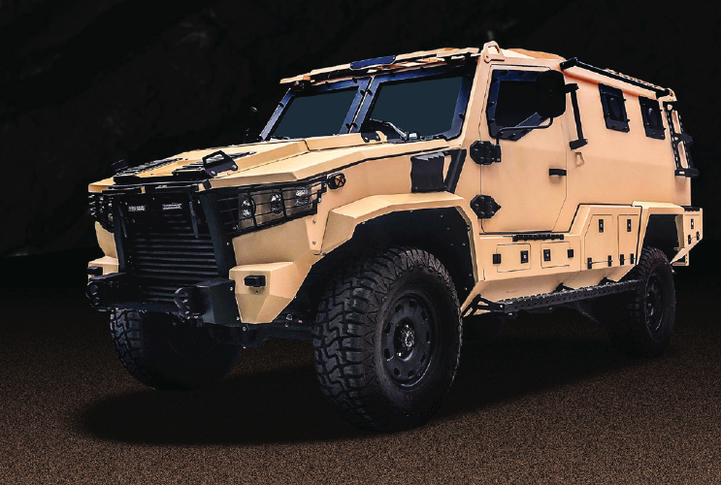

BASE SPECIFICATIONS

**ENGINE TYPE:** 4.5L V8 Turbo-diesel (195hp) Toyota

**TRANSMISSION TYPE:** 5-Speed Manual

**MAXIMUM TORQUE:** 430 Nm @ 1200 - 3200 rpm

**POWER:** 145 kW (195hp)

**MAX SPEED:** 100 km/h

**CRUISING RANGE:** 800 km

**BRAKE TYPE** Ventilated 6 Piston Disc Brakes /

**(FRONT/REAR):** 4 Piston Disc Brakes

**FUEL TANK CAPACITY:** 2 x 90 Liters

**CURB WEIGHT:** 5100 kg (Standard Equipment & Protection)

**PAYLOAD:** 1000 kg

**SEATING:** 2 + 6

**DOORS:** 3

**ROOF TURRET WITH HATCH OPTIONAL**

Heavy duty suspensions, axles, category leading ground clearance and independent cooling systems are just some of the features that increase the vehicle’s utility and usability. The Terrier LT-79 was designed to offer law enforcement teams a highly armored vehicle that stays within budget.

A unique Thought Design Process offers a choice of over forty customization options, ensuring that all our vehicles come with maximum flexibility. This process allows us to reduce both cost and production time, and lets us deliver a vehicle suited to your exact needs.

**RUNNING GEAR**

Drive-line Selectable 4x4

Steering LHD / RHD, Hydraulically Assisted

Suspension Front – coil springs with hydraulic shock absorbers

Rear – leaf springs with hydraulic shock absorbers

Rims 8.5 x 17” steel wheels

Tires 285/75 R17

Run Flats Standard

STIS Optional

Brakes Ventilated Disc, Rear Drum Brakes

**MOBILITY**

Max Speed 100 km/h

Turning Circle 14.4 m

Fuel Range 800 km

Grade-ability 70%

Static Side Slope 20%

Vertical Step 300 mm

Trench Crossing 600 mm

Fording Depth 600 mm

Approach Angle 43°

Departure Angle 36°

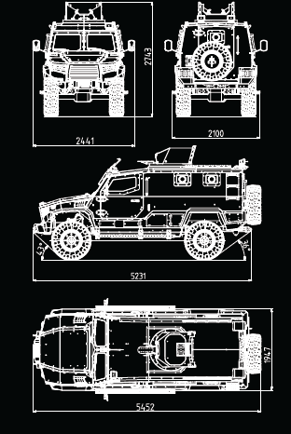

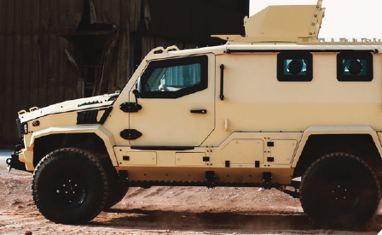

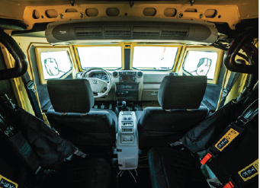

**PRICE : per Unit EUR 320,000.00 NETTO ab Werk Dubai**

**Price 100 Units : Euro 300,000.000- netto each**

**DELIVERYTIME ca.12 weeks from receipt of order**