# 2 Unit Perkins P1250P3

|  |  |  |  |  |  |  |  |  |
| --- | --- | --- | --- | --- | --- | --- | --- | --- |
| **No** | **Manufacturer** | **Serial No.** | **Year of Manufacturer** | **Running Hours** | **HZ** | **Rated Voltage** | **KVA** | **KW** |
| 1 | FG Wilson (Engineering) LTD | GWRPES6AMAP02362 | 2012 | About 2000 Hour | 50 | 400 | 1250 | 1000 |
| 2 | FG Wilson (Engineering) LTD | FGWRPES6AMAP02362 | 2012 | 1605 | 50 | 400 | 1250 | 1000 |

Two Perkins diesel engines available — one in a Container and one open type.

We can also perform a load bank test on both engines before they are shipped to ensure performance and reliability.

Price Quotation :

# ENGINE No. 1 Containerized

Price/Unit USD $180.000 (one hundred eighty thousand US Dollars)

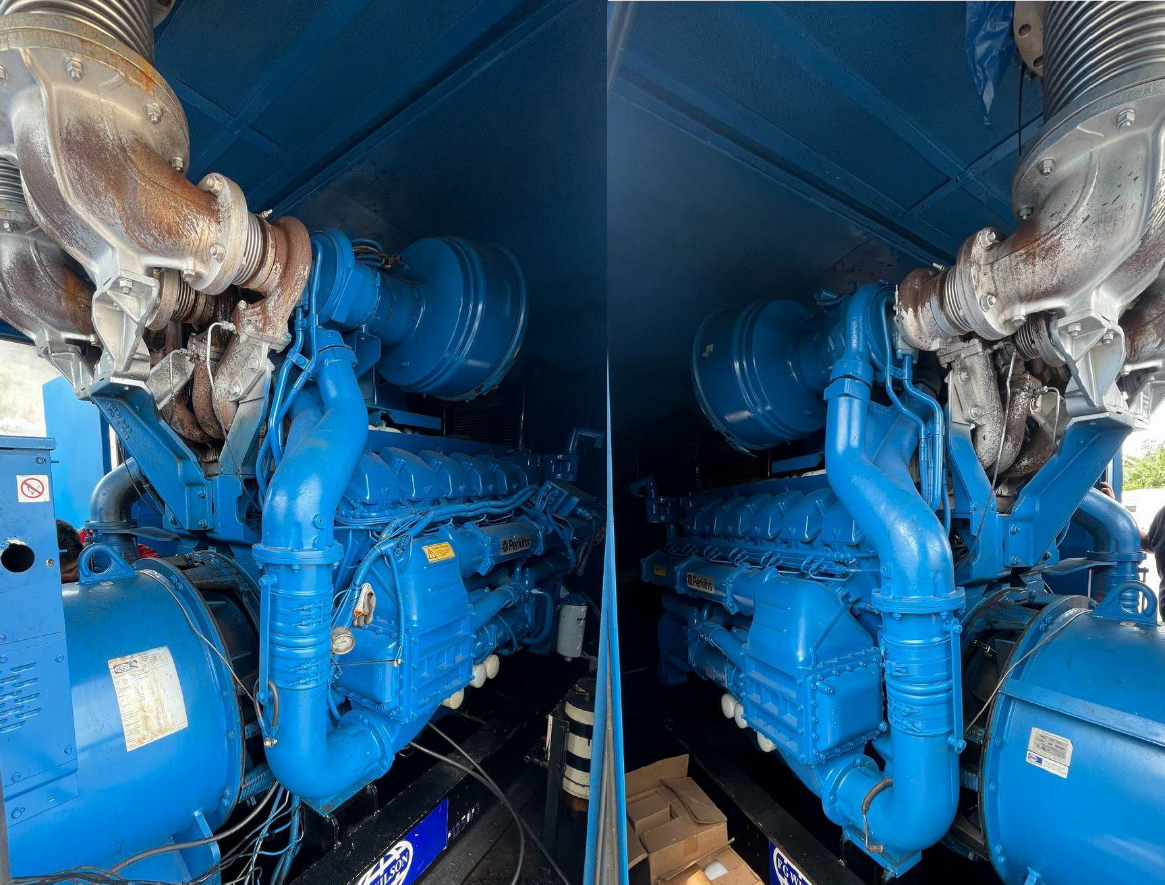

'FG Wilson rFnr,ille Mgj !Ill .

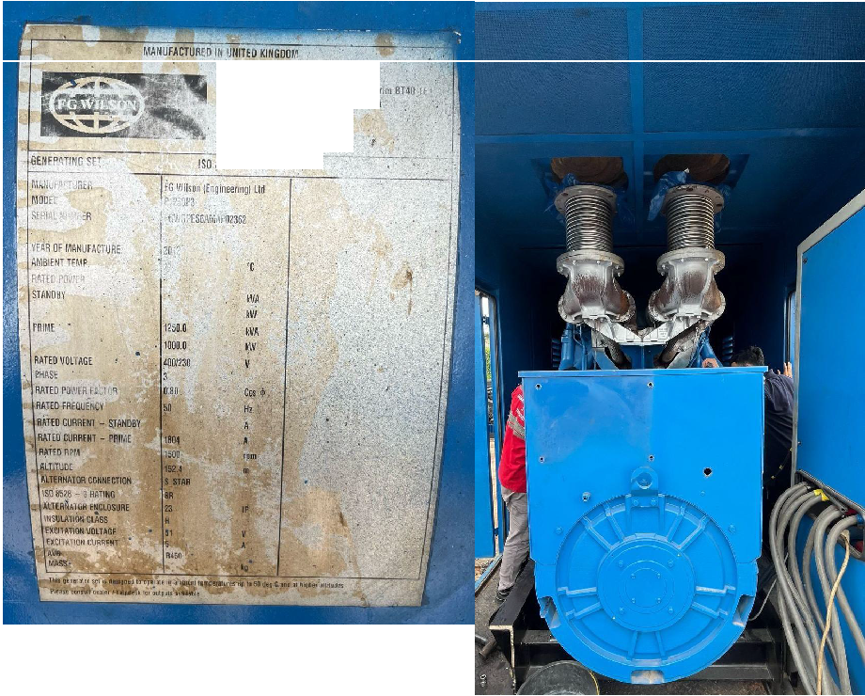

0Jd Gierl3f111 !><<d.Urn•.:"O.Anln<>tBU :H •

llnr1h em 1 land, U•iled Kt olli .

l 1: *44* (8) 28 2a251000

·" tit (01 2 {826111)

**"'''l'ot.F ;**

--:--- sn;u--:--·' **!lfl:cor.n** .

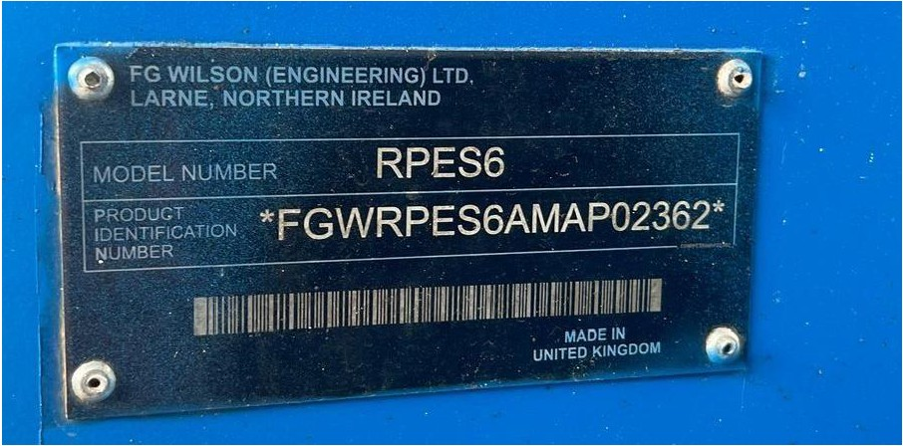

**ENGINE No. 2 Open**

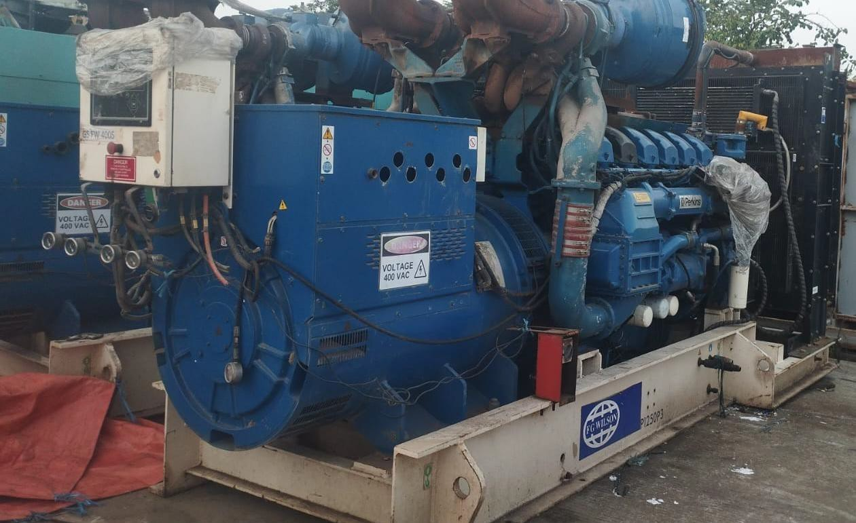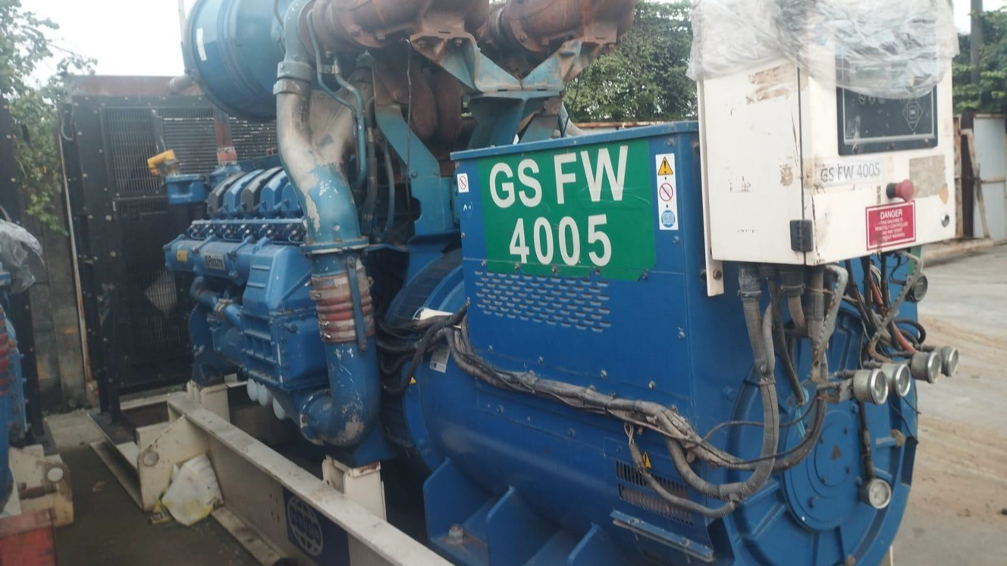

Price Quotation :

Price/Unit USD $170.000 (one hundred seventy thousand Us Dollars)

neer

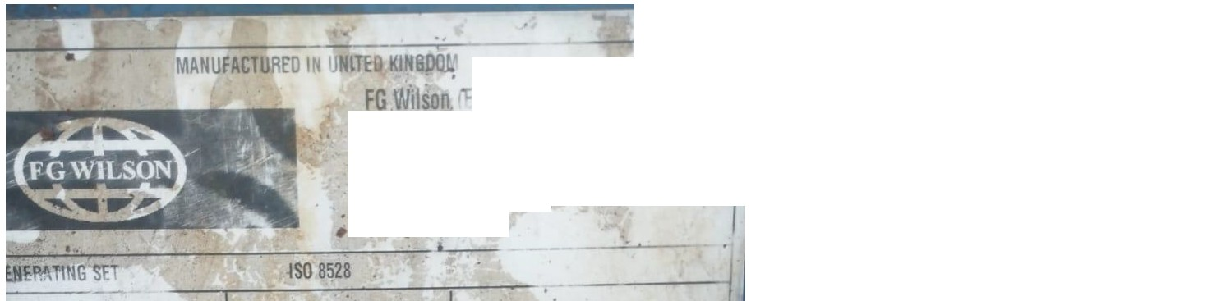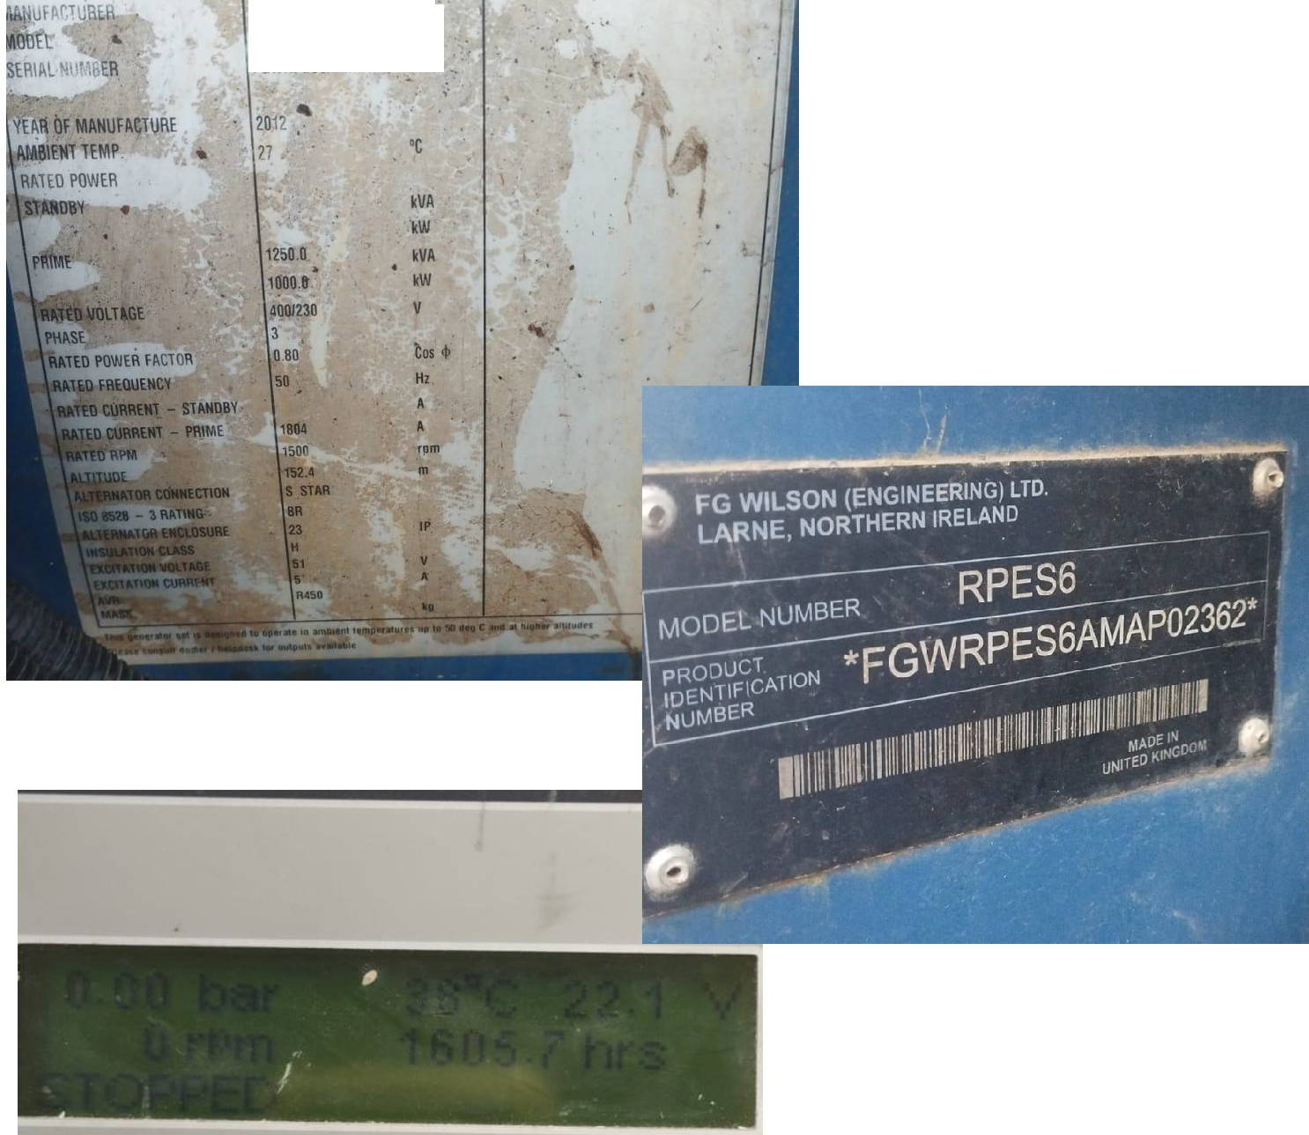

Old Glenarm huijd 1ame BT

Nurthem Iclan11 Un1tea I(

1J:· 4 (OJ 28 282&1000

Fax +44{0128 8261H1

* wwwJGV 'json com

FG Wilson (Engmeenng) Ltd .

P rroP3

f GWR?ES6AMAP023,62