**DIESEL/ HFO 18 V3 2/40 B asi c MAN**

unused only stored in MAN warehouse, never run

# Gross electrical output approx. 9,0 MW

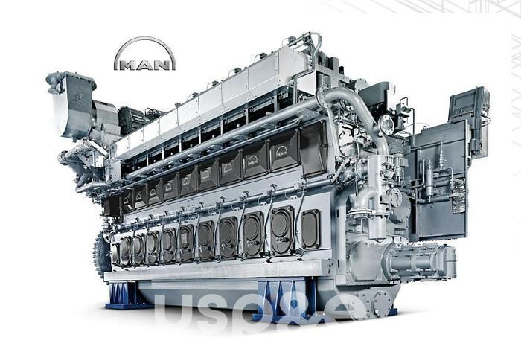

**TABLE OF CONTENTS**

## INTRODUCTION

1. **PERFORMANCE**
2. **SCOPE OF SUPPLY**
3. **PRICE**
4. **PAYMENT TERMS**
5. **DELIVERY TERMS**
6. **DELIVERY TIME**
7. **INSPECTION AND RESERVATION**
8. **WARRANTY PERIOD**
9. **VALIDITY**
10. **ATTACHMENTS**
11. **INTRODUCTION**

Dear Ladies and Gentlemen,

We are pleased to been given the opportunity to submit this budgetary proposal for power generation equipment and services for a compact modular power plant according to the scope of supply described in this proposal.

**The general compilation consists of 34 units of MAN Diesel engines 18V32/40**. The gross electrical output of this plant is approximately 9 MW each specified at the generator terminals. **In this offer the auxiliary is listed for 34 units, so the descriptions refer to 34 units only.**

Based on the limited information available the price is of budgetary nature. Price is based on several assumptions that need to be confirmed/updated before a firm offer can be made.

## PERFORMANCES

Preliminary performance data

Gross Electrical Power: 9 kWe, specified at the generator terminals * Gross Heatrate: 7,832 kJ/kWh, specified at the generator terminals *

* Given at +25°C, 30% RH and 100masl ambient conditions with ±0% tolerance, 11kV generator voltage, Gas Methane Number >80, LHV >30MJ/Nm³, Gas pressure min 5 bar(g), Power Factor 0,8

Refer to Exhibit D for detailed performance figures. Kindly note that we provide performance figures with 0% tolerance.

## SCOPE OF SUPPLY

Based on the limited information available the scope of supply offered is given at a general level as described below. Refer to the scope off supply list attached.

**Scope typically including:**

* + Basic engineering of the plant
  + Detailed design of all MAN supplied equipment
  + Generating sets & automation/control system
  + Auxiliary equipment needed for the power generation
  + Medium voltage & Low voltage switchgears
  + Technical advisors for assistance during installation
  + Technical advisors for assistance during commission
  + Training on site
  + Plant operating manuals

**Scope typically excluding:**

* All civil material & work
* Installation and supervision
* All site management and site offices
* Piping material, cables & tanks
* Exhaust gas emission cleaning equipment (if required)
* Switchyard and step-up transformers
* Any other work or services not mentioned here

## PRICE

The sales price for equipment and services according to the enclosed scope of supply is consisting of equipment supply and related services from abroad.

is €3,590,000

Conversion to natural gas operation: €350, 000.

## PAYMENT TERMS

1. Signature of contract instant after successful inspection at MAN warehouse
2. LC payment accepted as follows:
   * 20% into escrow to remove units from market prior to inspection
   * 30% upon contract signing, before adapting the unit from 50Hz to 60Hz
   * 50% at notification of readiness of dispatch (approx. 1 month)
3. No moving or loading the units out of warehouse without receipt of 100% payment

## DELIVERY TERMS

Ex MAN warehouse, delivered to Antwerpen harbour (spec. dock)

## DELIVERY TIME

Delivery time will be conditional to equipment available in stock or production capacity.

The equipment is to prior sale and at availability the equipment will be ready for shipment from location approx.1 month after the date of receipt of advance payment.

## INSPECTION AND RESERVATION

I NSPECT I O N The equipment can be inspected after signing and deposit payment receipt.

In the event of purchase, we adapt 60Hz frequency voltage to extra cost free.

Does the customer not buy for reasons we are not responsible for to refund the cost for this adaption.

RESERVATI O N A reservation for 45 days is possible against payment (10%) of 300,000 EURO per unit. Should the customer decide against the purchase during this period, the payment is completely lost and will not be refunded; at purchase it will be offset.

SCO PE OF

SUPPLY

Only the given Scope of Supply list by MAN is valid!

## WARRANTY PERIOD

The warranty period with respect to the Equipment begins at the delivery of the engines and ends twelve (12) months from the date of the performance test certificate or eighteen (18) months from the date of the delivery of the engines, whichever first occurs.

## VALIDITIES

This Budgetary proposal is valid for twenty (20) days from the document creation date.

**Offer with reservation of error – subjects to prior sale!**

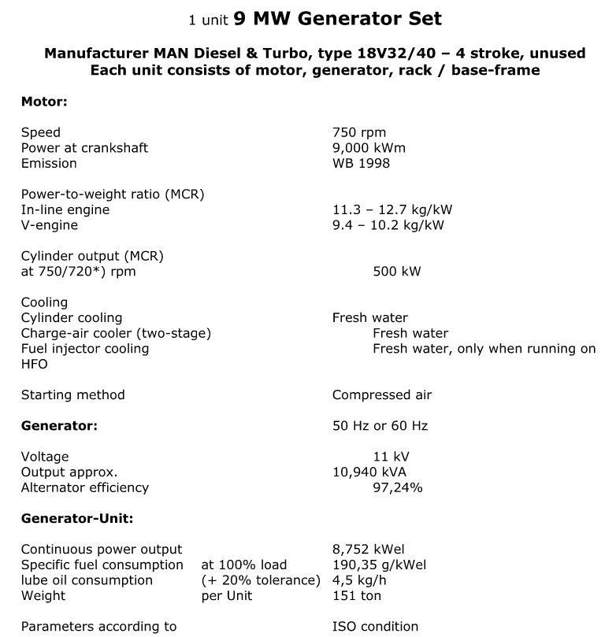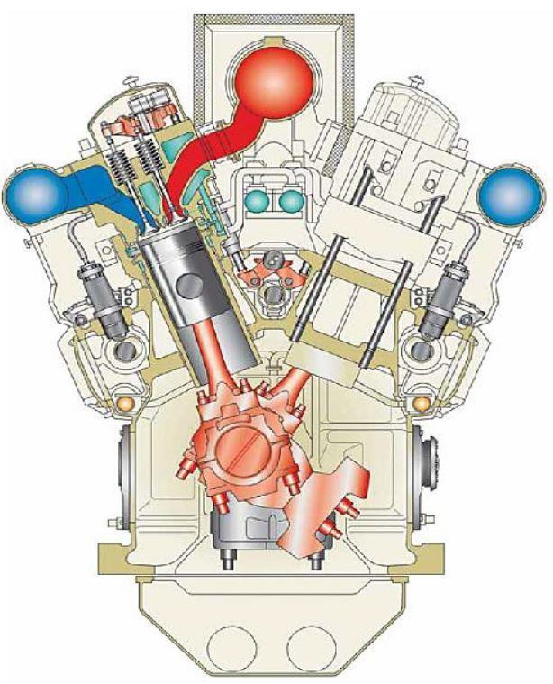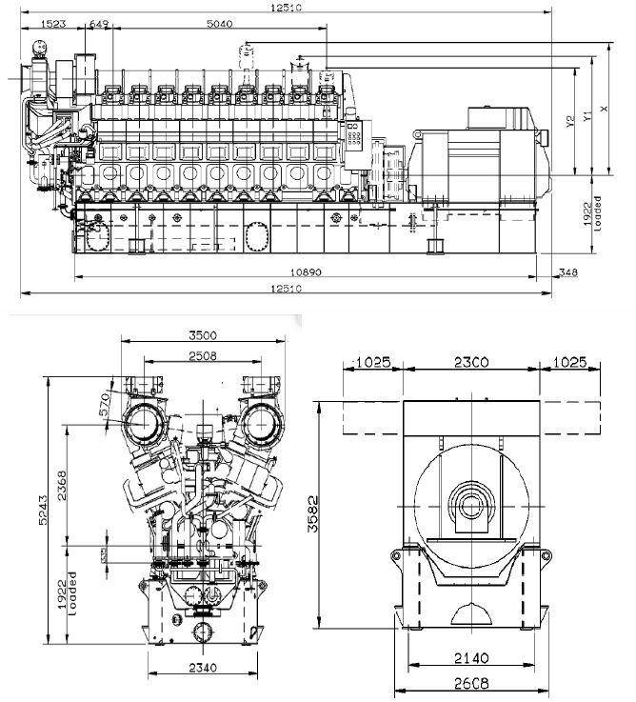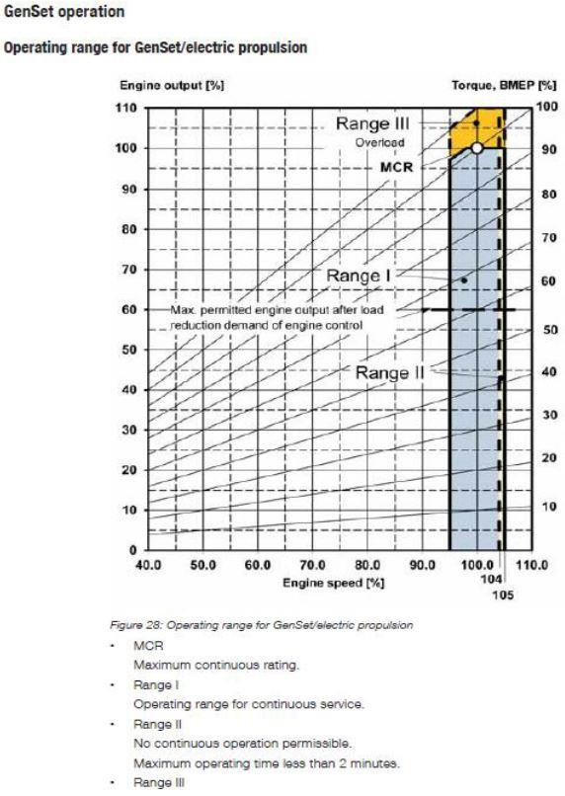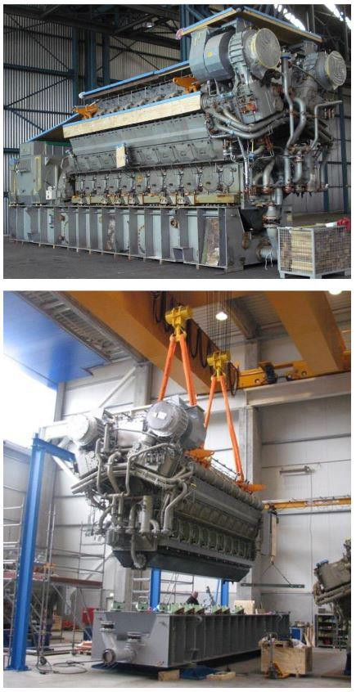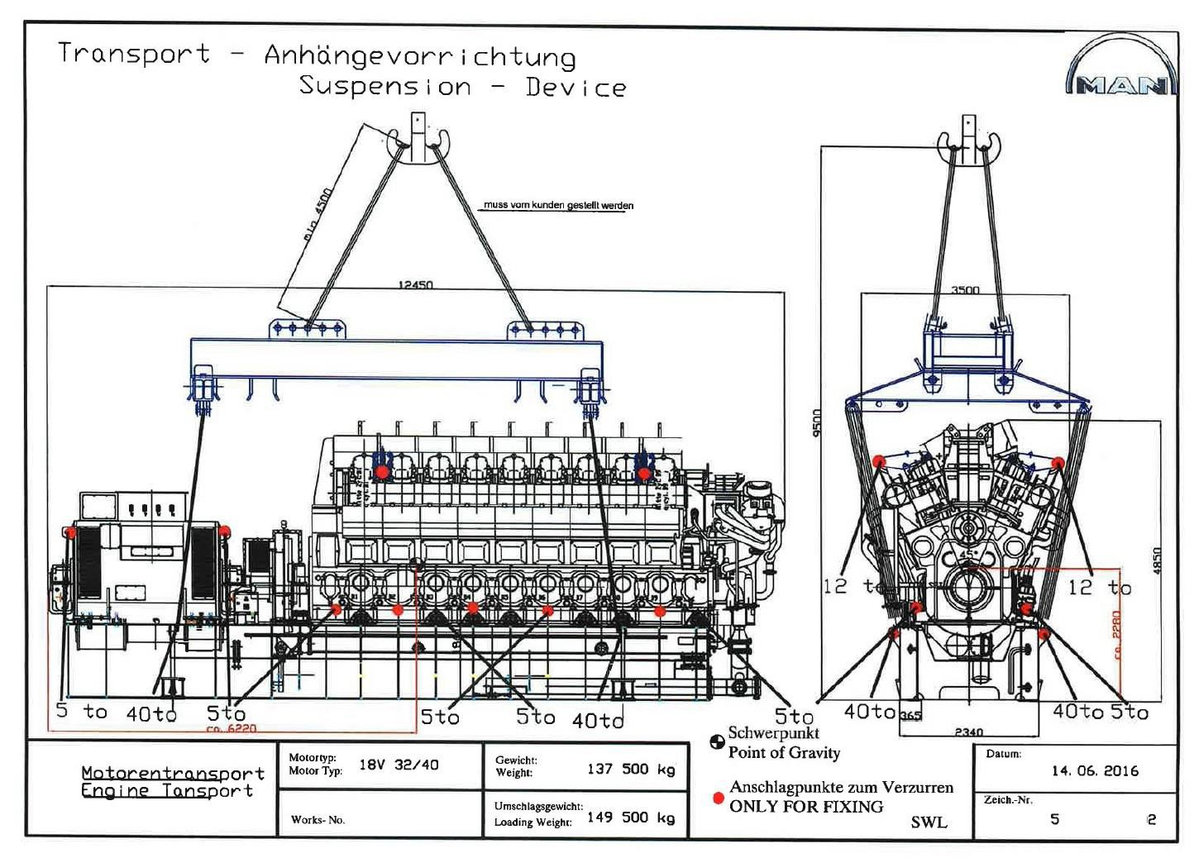

**See scope of supply list by MAN in the PDF file attached!**