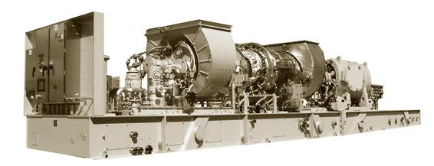

COMMERCIAL PROPOSAL

SOLAR MARS 100 SOLONOX VERSION 15000

TWO (2) 60HZ GENSET PACKAGES AVAILABLE

Scope of the technical proposal.

Supply Two Solar Brand Gas Turbines:

02 x Gas Turbine model MARS 100 SoLoNOx – Version 15000SAN, 14800 HP. These are used equipment, manufactured in 2011.

MAIN PLATES, ONE OF THEM

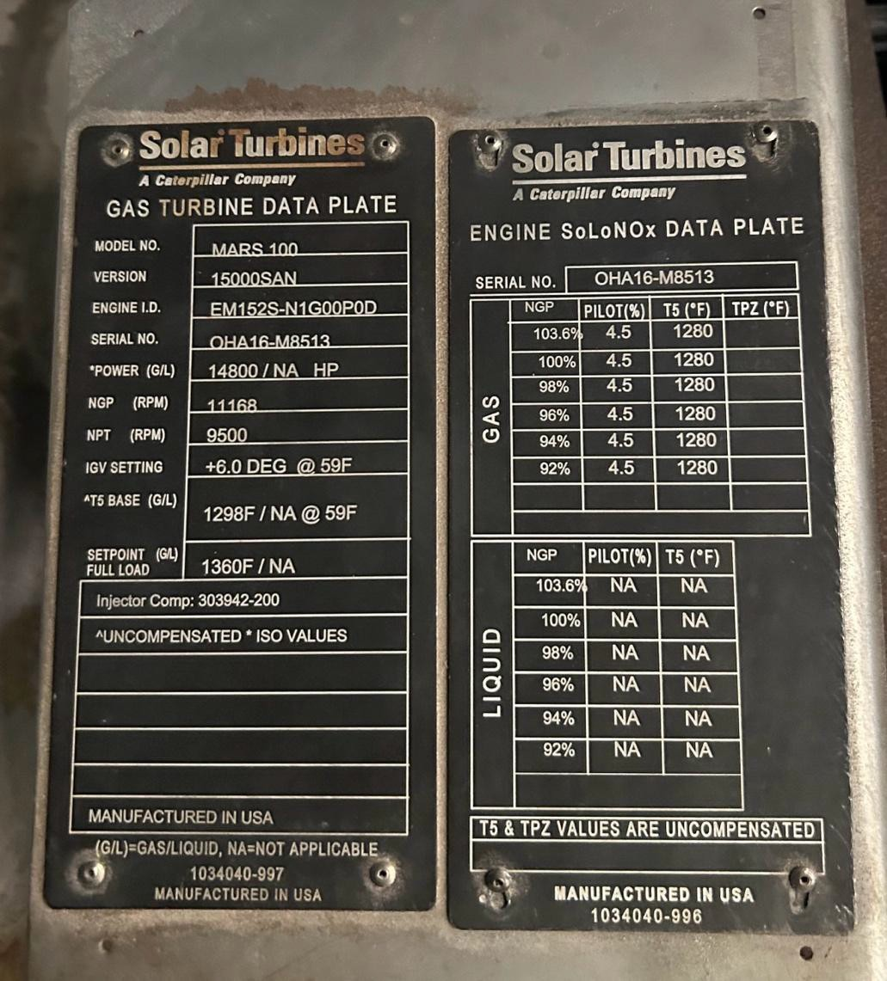

YOM | MAKE | MODEL | FREQUENCY | CONDITION | POWER HP | MW ISO | QUANTITY AVAILABLE
2011 | Solar | Mars 100 SoLoNOx | 60 Hz | Zero Hours - Refurbished | 14800 | 11.3 | 2

The technical characteristics of the turbines are shown in the attached table.

- Manufacturer: Solar Turbines.

- Manufacture year: 2011.

- Gas turbine model: Mars 100-Version 15000SAN. SoLoNOx

- Gas turbine power: 14800 HP.

- Gas turbine power: 11.3 MW.

- Gas turbine speed RPM: NGP 11168 NPT 9500 rpm.

- Fuel Type: Natural Gas Maximum Supply Pressure 500 psig (3450 kPag).

- Frequency: 60Hz

SCOPE of SUPPLY: Complete Gas Turbine including:

- Gas turbine (axial compressor, combustion chamber, and power turbine).

- Intake volute, inlet silencers

- Exhaust volute, exhaust silencers

- Lubricating oil system, oil tank, heater, main and auxiliary oil pumps (main mechanical, AC electric pre/post, DC electric backup), filter, 120V DC starter, pressure and temperature regulator, oil mist separator, ventilation flame arrester
- Starter motor

- Oil pressure regulation system

- Thermostat valve

- Duplex filter holder with its 6-way valve

- CO2 piping system, fire detection, and fire extinguishing system CO2

- Instrumentation associated with the turbine (pressure transmitters, vibration modules)

- Gas valves (primary, secondary, and PEC)

- IGV electro-actuator

- Oil supply and drainage hoses and pipes

- Enclosure with its panels and doors (enclosure) Local control panel with its PLC
- Cabin air intake duct with its fan, ventilation system

- Cabin air outlet ducts, ventilation system

- Filter house

- Damper with shutters for cabin insulation (cabin intake and discharge)

- Main oil tank

- Gas, flame, and heat detectors

- Thermocouples

- Skid internal pipes.

- Injectors

- Bleed valve

- Air and gas manifolds

- Electric Generator

Additional Scope of Supply:

- Zero hours of use, renewed within 90 calendar days, doing everything possible to meet the deadline.
- Type of fuel used: Natural gas.

- Type of compatible fuel: No.

- Permanent suspension of activity: March/2023.

- Reason for interruption: End of subsidy for the acquisition of fuel (natural gas).

PHOTOS

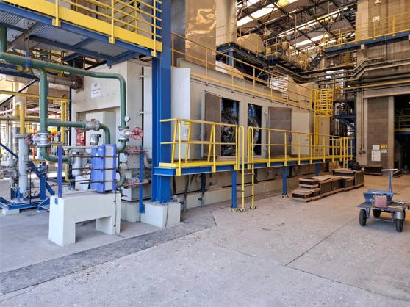

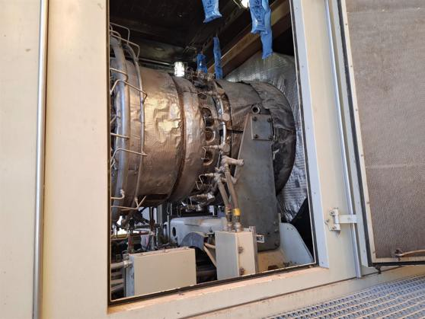

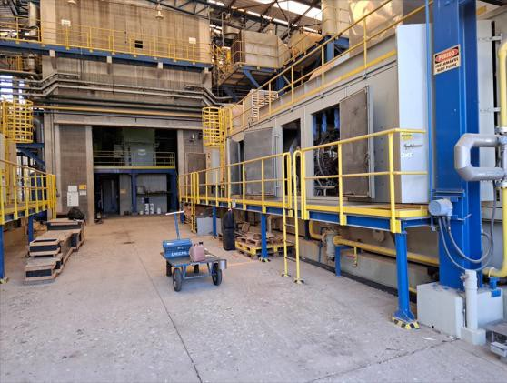

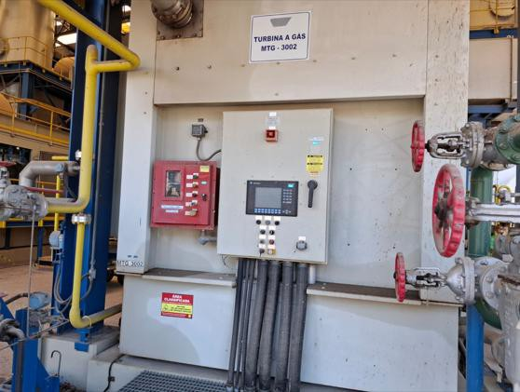

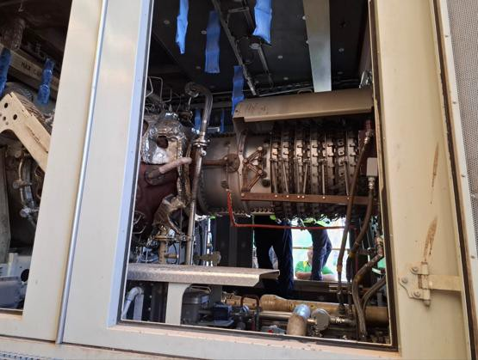

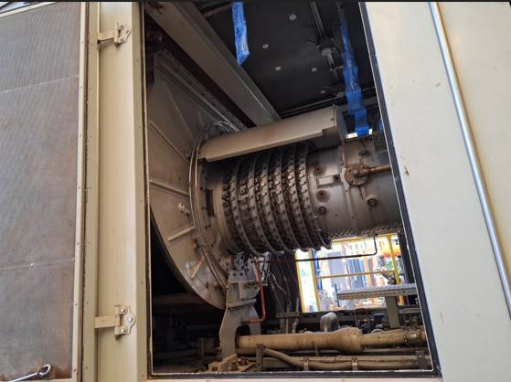

Prices

  - Each Solar Gas Turbine included an Electric Generator: US$ 6,250,000 (Six million two hundred & fifty thousand dollars).
  - The total price for two Solar Gas Turbines is US$12,500,000 (Twelve million, five hundred thousand dollars).

The Contract Price will be payable solely in US Dollars, the official currency of the United States of America.

Terms and conditions of payment

The following payment method is established.

- A down payment fee of $500,000.00, payable before the inspection visit with the signed Sale Contract, is required. This amount is to be paid into escrow, and serves as a security deposit, which is refundable if not utilized as presented.
- Balance paid with the official purchase order (P/O) five working days after the inspection visit.

Delivery

90 days for delivery, after passing inspection.

Houston TX Workshop: Overhaul and Upgrade Services

Delivery: EXW Incoterm (It can be FOB, but it is quoted separately) Certified and with a 12-month warranty (Refurbished Unit)
Offer Validity: This quotation is valid for 3 days. This offer does not include taxes.

Note:
- Equipment can be sold separately
- Attachment: Solar Mars 100 Brochure

