Soft Corporate Offer (SCO)

Dear Sir or Madam,
Modular Waste-to-Energy Plant – almost NEW – 3.000 h

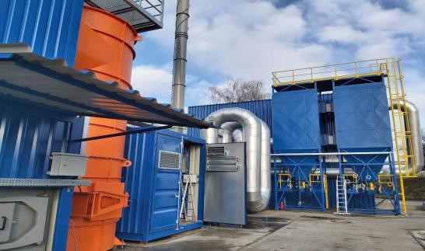
Subject to the conditions listed below we are pleased to offer the following for sale:

A Modular Waste-to-Energy Plant is a containerized waste-to-energy unit designed for municipalities, industry, and healthcare operators who need clean, on-site energy recovery.
The system converts mechanically treated municipal, industrial, and sterilized medical waste into
usable thermal energy or steam – all within a transportable modular footprint.

- Offer Scope
Manufacturing Year: 2019
Running Time: 3.000 h = ½ year
Modular Construction: Fully disassembled, ready for Transport
Waste treatment capacity: 2 400 t/year The calorific value of the treated waste: Max. 25 MJ/kg Annual working time fund: 7 200 h/year
Rated thermal output: 1,9 MW Steam production (155 °C, 12 bar(g)): 2,9 t/hr
Foundation Area: 1 024 m²
Automation: Full PLC control, remote monitoring
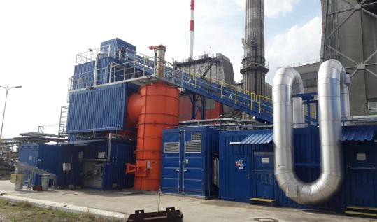
Emission compliance: Fully meets EU Directive 2010/75/EU

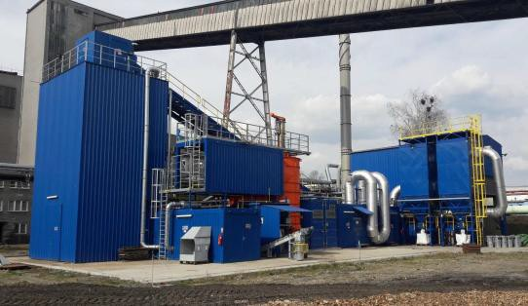

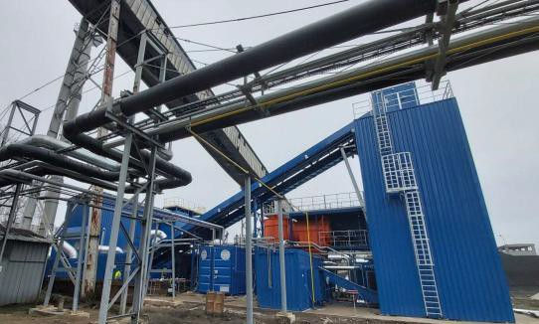

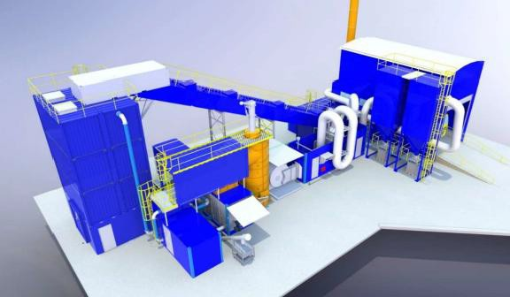

- Sales Price
€ 10.000.000 (Ten million, five hundred thousand Euro) EXW Central Europe (Factory Price New ~ 13 million €)

Not included:
European VAT (19%) if applicable, local import duties, taxes, or customs fees, civil/installation works at destination site and transport to be organized by buyer.

Total Price Estimate:
Purchase Price EXW | 10.000.000 €
Dismantling: | - € (fully disassembled, ready for transport)
Transport: | 100.000 €
Reassembly: | 400.000 €
Total Estimated Cost: | 10,600.000 €

Note: Prices are estimated and subject to final technical assessment and logistics confirmation.

- Availability: immediate, Central Europe

- Payment Terms

  - €2,500,000 Deposit into escrow to withdraw from market
  - 25% (twenty-five percent) of the total purchase price upon conclusion of the sales contract.
  - Balance of the total purchase price when ready for loading. The loading will be released immediately upon receipt of payment.

- Inspection
  - Pre-inspection is possible by buyer or third-party inspector (TPI).
  - The equipment will be made available for physical inspection upon confirmation of a deposit to be held in a mutually agreed escrow account.
  - Detailed documents, test data, and serial numbers available during inspection.
  - Inspection costs, including escrow account costs, borne by the buyer. The vendor absolutly must accompany the buyer at the inspection and cost to do so will be €10,000 to cover business class flight, hotel and out of pocket this will be deducted from the total cost if purchased if not purchase however this is not refundable.

- Validity
  - This offer is valid for 7 (seven) days as of today’s date.
  - The validity of the offer remains upon signing a Letter of Intent (LOI) within this period.

Detailed information, including technical specifications and serial number, will be made available after submission of a duly signed Letter of Intent (LOI) endorsed by a bank as confirmation of funds.

8. Disclaimer
This document is a non-binding offer. It does not constitute a legally binding agreement. Obligations only arise upon signature of a final purchase contract by both parties. This offer must be treated as confidential.
We appreciate your cooperation and look forward to your response.

