TECHNO-COMMERCIAL PROPOSAL

Page 2 of 9

Ref. No: True Blue .26.XXX Rev. 00 Date: 18th March 2026

Ref: Request for Quotation- LM2500 Gas turbine

Dear Sir,

We would like to thank you for your enquiry for the supply of GE LM2500 Gas Turbine Generator.

We are enclosing our Techno-Commercial Proposal for your kind review. We confirm, the quotation is pre- pared in accordance with the specifications provided and meeting your requirements.

In case of any queries or clarifications on the offer, please do not hesitate to contact us. We are happy to assist you on the same.

We look forward to hear from you soon and eager to associate on the same.

SCOPE OF WORK

Our scope includes the supply of a second-hand GE LM2500 Gas Turbine Generator.

SCOPE OF SUPPLY

Scope of Supply main Equipment:

Gas Turbine Model: LM2500 + SAC (Core Engine)

This includes Core gas turbine unit with SAC combustion system – LM2500 main components

Technical Specification:

Parameter | Value
Manufacturer | General Electric (GE)
Model | LM2500 + SAC (Core Engine)
Year of Manufacture | 2017
ISO Rated Power Output | 30.5 MW
Simple Cycle Thermal Efficiency | 39.0 %
Simple Cycle Heat Rate | 9,231 kJ/kWh
Exhaust Gas Temperature | 528 °C
Fuel Inlet Pressure | 3.5–4.0 bar
Exhaust Gas Flow | 83.15 kg/s
Exhaust Backpressure | < 1000 Pa
Power Turbine Inlet Temp. | 852 °C
Compressor Discharge Temp. | 497 °C
Generator Max Speed (Physical) | 10,100 rpm
Gas Generator Rated Speed | 9,680 rpm
Power Turbine Speed Range | 3,000 / 3,600 rpm
Vibration | < 50 μm
Major Overhaul Interval | 50,000 hours
Design Service Life | 30 years
Compressor Stages | 17
Compressor Pressure Ratio | 22.9
Combustion System | SAC
High-Pressure Turbine Stages | 2
Power Turbine Stages | 6
Gas Turbine Weight | 4.7 t
Overall Dimensions (L×W×H) | 4.9 × 1.5 × 1.6 m

Equipment Condition:

  - Fuel: Coke oven gas (after overhaul fuel system can be converted to natural gas)
  - Total Accumulated Operating Hours: 50,000 hours
  - Number of Major Overhauls: 0
  - Year of Manufacture: 2017

Inspection, Testing & Acceptance

  - Buyer / third-party inspection permitted
  - Pre-dispatch inspection
  - Complete documentation dossier

PRICE BASIS:

S. No | Description | Qty (No) | Unit Price (USD) | Total Price (USD)
1 | Supply of Second-hand GE Gas Turbine Generator LM2500 + SAC Gas Turbine Unit (without Overhaul –  Condition as it is) | 1 | 7,950,000 | 7,950,000
Total Amount (In words): Seven Million Six Hundred Forty Thousand Only |  |  |  | 7,640,000
OPTIONAL
1 | Supply of Second-hand GE Gas Turbine Generator LM2500 + SAC Gas Turbine Unit (with Overhaul – Con-  dition Reset to 0 hours) | 1 | 13,300,000 | 13,300,000
Total Amount (In words): Thirteen Million THree Hundred Thousand Only |  |  |  | 13,300,000

Notes:

- Price Basis: FOB, China

- VAT excluded.

- Export duties (if any): Seller’s scope

- Import duties, local taxes at destination: Buyer’s scope

- Buyer to provide End user signed forms duly filled for applying export license as required

- Demolition, packing, loading, and transport to nearest port are included

- Pre-Inspection cost and support will be available at cost to cover Accommodation, transport and actuals.

- Borescope Inspection can be carried out at Site for a Fee of $15,000 per unit as lumpsum

PAYMENT TERMS:

  - 30% of Total Price as advance payment upon signed Quotation acceptance / Purchase Order
  - 30% payment when overhaul starts at overhaul facility
  - 40% upon overhaul and final inspection completion Payment method: Bank wire transfer (SWIFT)

DELIVERY PERIOD

  - June 2026: The unit shall enter the designated overhaul facility to commence major overhaul work (If no Overhaul are needed, the product can be delivered directly）

  - December 2026: Completion of overhaul and readiness for shipment. Estimated delivery to Buyer after overhaul completion and acceptance.

WARRANTY

The Supplier guarantees the equipment for a period of whichever occurs first:

  - 8,000 running hours after overhaul, or
  - 18 months from delivery.

Warranty shall cover defects in workmanship and materials under normal operating conditions, sub- ject to the Seller’s standard warranty policy.

VALIDITY & CONFIDENTIALITY

  - Offer validity: 7 days from submission date
  - All technical and commercial information to be treated as confidential

ASSET PHOTOS

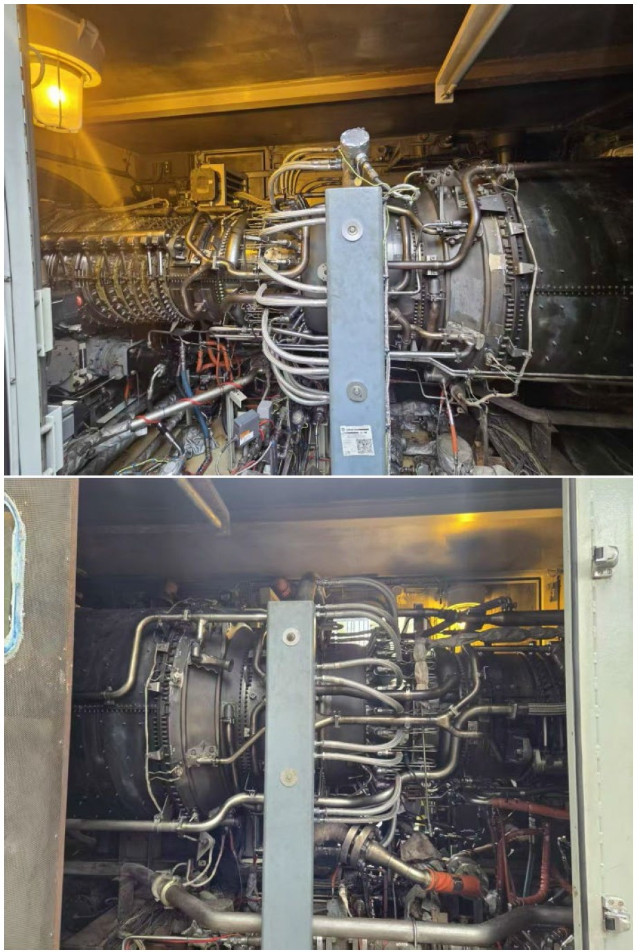

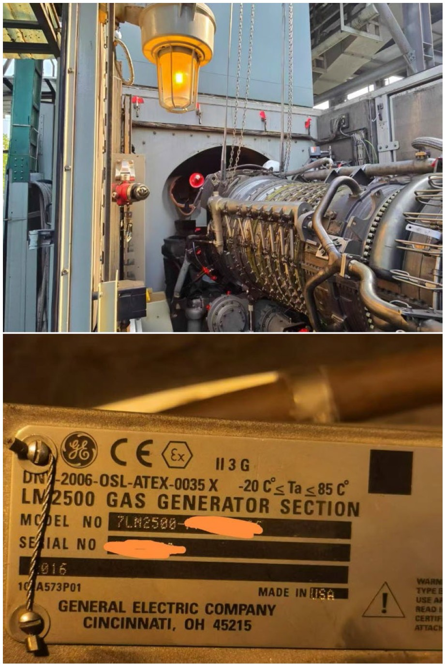

End of Document

