TECHNO-COMMERCIAL PROPOSAL

Ref. No: True Blue 26.XXX Rev. 00 Date: 18th March 2026

Ref: Request for Quotation Siemens SGT-400 Gas Turbine

Dear Sir,

We would like to thank you for your enquiry for the supply of Siemens SGT-400 Turbine Generator.

We are enclosing our Techno-Commercial Proposal for your kind review. We confirm, the quotation is prepared in accordance with the specifications provided and meeting your requirements.

In case of any queries or clarifications on the offer, please do not hesitate to contact us. We are happy to assist you on the same.

We look forward to hear from you soon and eager to associate on the same.

SCOPE OF WORK

Our scope includes the supply of a second-hand Siemens SGT-400 Turbine Generator.

PACKAGE DESCRIPTION

Performance Parameters of SIEMENS SGT-400 Gas Turbine:

SIEMENS SGT-400

SIEMENS SGT-400 Gas turbine performance parameter table
Equipment |  | Items | Units | Parameter value
 | (ISO) Power generation Power generation efficiency Year of Manufacture  Fuel |  | MW  %  -  - | 12.9  34.8 %  2014  Dual Fuel
 | Total Hours of Operation |  | - | ~6000 hours
 | Heat rate |  | kJ/kWh | 10354
 | Natural gas consumption |  | Nm ³/h | 3816
Gas turbine | Fuel intake pressure |  | Mpa | 3.5
 | Turbine speed |  | r/min | 9500
 | Pressure ratio |  | - | 16.9:1
 | Exhaust flow rate |  | kg/s | 40
 | Exhaust temperature |  | ℃ | 555
 | NOₓ Emission |  | mg/Nm³ | ≤30 (15% reference oxygen content, dry state)
 | Current Status |  | - | Shutdown

Performance parameters and curves are based on the following environmental conditions:

  - Ambient temperature 15℃
  - Relative humidity 60%
  - Sea level, natural gas saturated low calorific value LHV (44.194kJ/kg), NOx=25PPM or 51mg/NM3(DLE)
  - No pressure loss during intake/exhaust.
  - Configure variable intake guide vanes VIGV
  - This data is not guaranteed; specific data for each project may vary.

Scope of Supply:

S. No |  | Description of Goods | UOM | Qty.
1 | Gas Turbine Generator Set |  | Set | 1
2 | Generator Grid-Connection Cabinet |  | Unit | 1
3 | Turbine-Specific Tools (Partial Tools) |  | Set | 1
4 | MCC - Generator Set MCC Cabinet (MCC: Motor Control Center) |  | Set | 1
5 | Generator Neutral Point Lightning Arrester Box |  | Unit | 1
6 | Fire-Fighting Cabinet |  | Set | 1
7 | High-Pressure Gas Filter Element |  | Pcs | 1
8 | Gas Flow Meter |  | Pcs | 1
9 | Air Filter Element |  | Pcs | 1
10 | Oil Cooler |  | Unit | 1
11 | Buffer Tank |  | Pcs | 1
12 | Battery Charger |  | Unit | 1
13 | Equipment Installation, Dismantling and Hoisting Gears and Brackets |  | Set | 1
14 | Spare Parts for Commissioning and Trial Operation |  | Set | 1
15 | Gas Turbine Cleaning Truck |  | Unit | 1
16 | Screw Compressor |  | Unit | 1
17 | High-Pressure Pipeline Air Release Valve |  | Pcs | 1
18 | High-Pressure Pipeline Gas Shut-Off Valve |  | Pcs | 1
19 | DC Lubrication Motor Starter Box |  | Unit | 1
20 | Control and Monitoring System (Including Local & Remote Control with Chinese-English Display) |  | Set | 1
21 | Starter (Inverter) Motor Controller |  | Unit | 1
22 | Reduction Gearbox |  | Set | 1
23 | Gas Compressor |  | Unit | 2
24 | Auxiliary Power Cabinet |  | Unit | 1
25 | Electronic Signal Interface Cabinet |  | Unit | 1
26 | Nameplates, Certificates of Origin, Final Manual and All Manuals (if avail- able) |  | Unit | 1
27 | Other Types of Special Tools (if available) |  | Unit | 1
28 | Intake and Exhaust Systems and Auxiliary Equipment |  | Set | 1
29 | Gas Turbine Back-End Boiler |  | Unit | 1
30 | Gas Turbine-Related Supporting Facilities in the Control Room |  | Set | 1

Inspection, Testing & Acceptance

  - Buyer / third-party inspection permitted
  - Pre-dispatch inspection as required

PRICE BASIS:

S. No | Description | Qty (No) | Unit Price (USD) | Total Price (USD)
1 | Siemens SGT-400 Gas Turbine Generator Set Year 2014 | 1 | 7,950,000 | 7,950,000
Total Amount (In words): Seven Million Nine Hundred Fifty Thousand only |  |  |  | 7,950,000

Notes:

  - Price Basis: FOB Shanghai

  - VAT excluded.

  - Export duties (if any): Seller’s scope

  - Import duties, local taxes at destination: Buyer’s scope

  - Buyer to provide End user signed forms duly filled for applying export license as required

  - Pre-Inspection cost and support will be available at cost to cover Accommodation, transport and actuals.
  - Borescope Inspection can be carried out at Site for a Fee of 15,000 USD per unit as lumpsum

  - Demolition, packing, loading, and transport nearest port will be extra not included in above cost

PAYMENT TERMS:

- 100% before dismantling and to be paid before delivery Payment method: Bank wire transfer (SWIFT) via escrow if prfered

General:
- Offer is subject to prior sales and final sale & purchase agreement terms
- Inspection scheduling to be coordinated subject to site access and seller confirmation.

DELIVERY PERIOD

15-30 calendar days from the effective date of payment.

VALIDITY & CONFIDENTIALITY

- Offer validity: 7 days from submission date, stock subject to sale
- All technical and commercial information to be treated as confidential

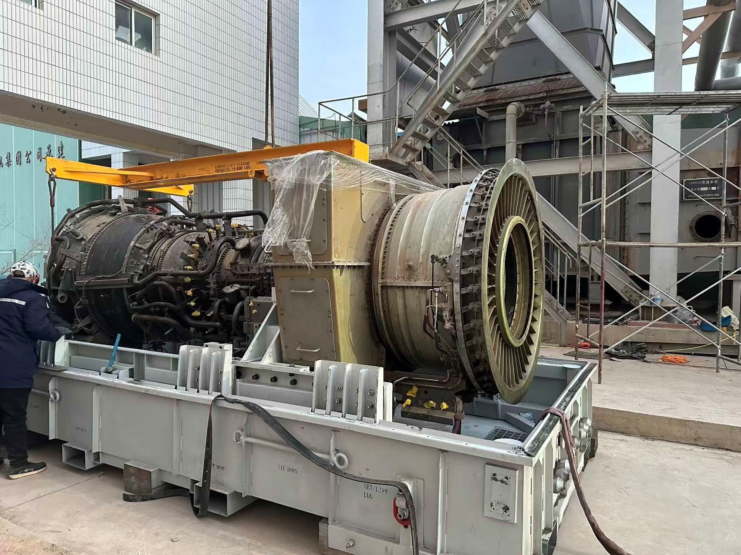
ASSET PHOTOS

End of Documents

