SUBJECT OF THE OFFER IS SUPPLY OF ONE GAS TURBINE SOLAR T70 AND GEARBOX AS PER BELOW SPECIFICATION
ITEM DESCRIPTION
1. GAS TURBINE #1
Model: SOLAR TAURUS T70
Manufacturer: OEM, SOLAR, A CATERPILLAR COMPANY
Unit output: 7.5 MW (ISO conditions) Fuel type: Natural gas
Unit operational data: The total operating time of the unit is 10.007 hours Including gearbox
GEARBOX info
Reduction gearbox ratio 10.09548 / Total service hours 10.007 hours on Gas / Zero Liquid fired hours

TOTAL PRICE: 8.250.000,00 EUR

PACKING / TRANSPORT /DISMANTLING
DISMANTLING OF UNIT TAURUS T70: Included in pricing* PACKAGING: Included in pricing, ready for transport

TRANSPORT: Not included in pricing / EXW Europe
- If during dismantling any part of the GT is damaged, dismantling company/seller is responsible for repairs or supply of new parts

PAYMENT TERMS
Payment is by bank transfer in EUR to Escrow
  - 20% Advance Payment / Booking fee – 825.000,00 EUR into escrow *
  - 50% Payment 30 days after Advance Payment
  - 30% Balance at ready for shipment
*After Advance payment / Booking Fee is paid, client has 30 days to perform Due Diligence if required

If during Due Diligence process client finds discrepancies between the shared and actual data (different EOH, type of GT or year of installation), escrow shall return to client the 10% Advance payment / Booking fee, latest in 5 working days after client releases discrepancies report.

PERIOD OF DELIVERY (DISMANTLING)
After client Due Diligence and Second milestone payment (50% 30 days after Advance Payment) is done, dismantling process will start and will take 4 weeks (holidays taken into account).
Client personnel is welcome to be present during dismantling period.
Two supervisors from EU will be present during complete period of dismantling.

ADDITIONAL NOTES:
Unit can be inspected after LOI, POF and NDA signature from client’s side, there is a small payment required for inspection of unit as required by the owner to have representative present .

Pricing is complete with GT, Gearbox, dismantling, packaging, repair and warranty 8.000 EOH or 1 year. Full operational history, OEM inspection and documents can be seen live at owners site.
Borescope pictures and reports of Taurus 70 and gearbox available to be checked at site.

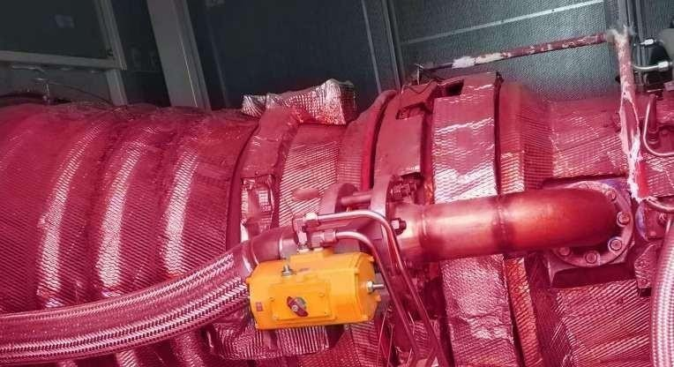
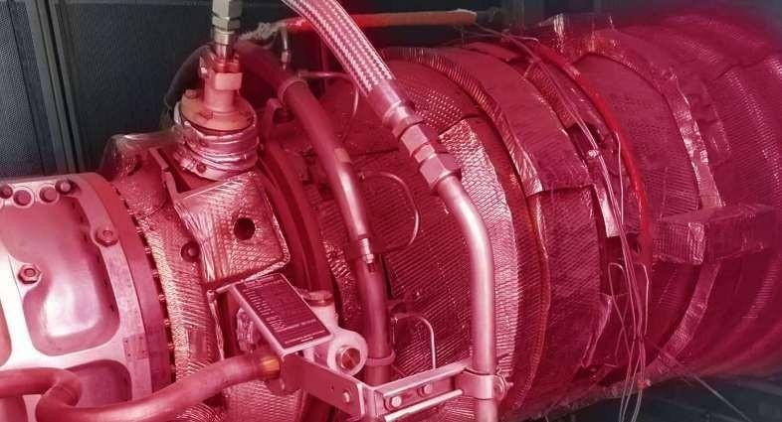
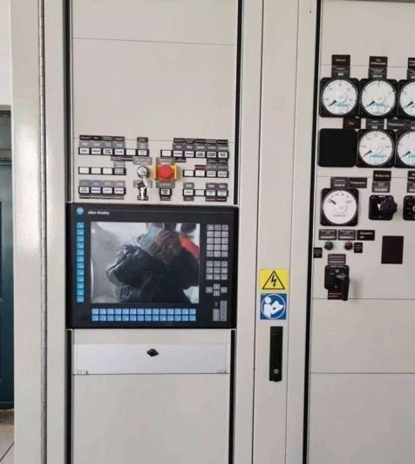
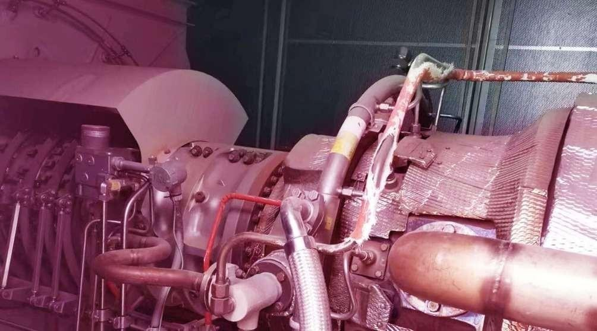
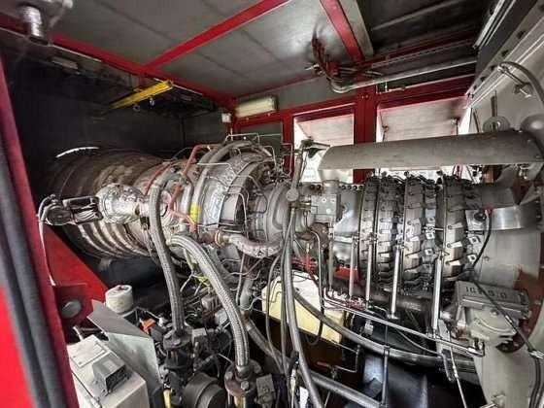
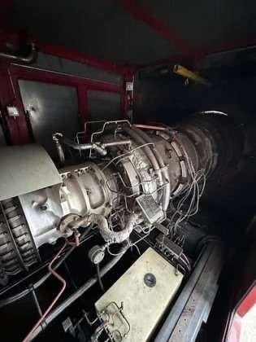
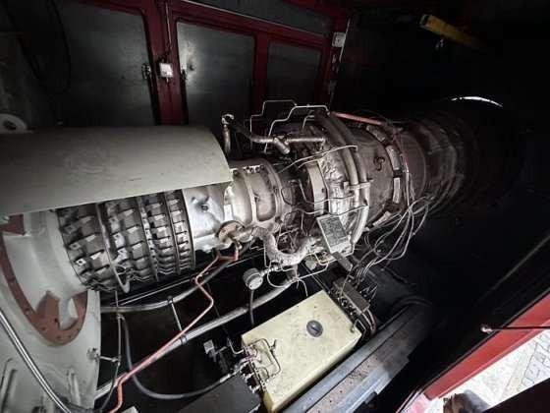
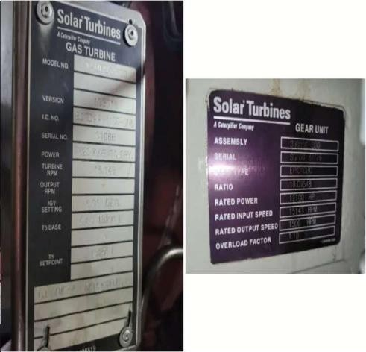

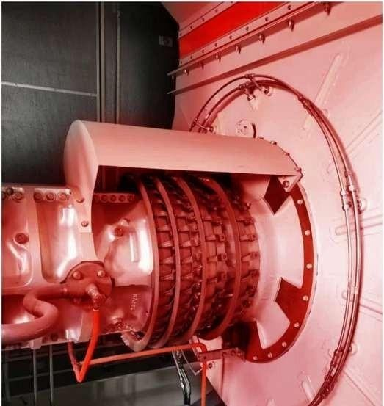

GEARBOX BOROSCOPE PICTURES
Reduction gearbox Taurus 70 cold end drive

