
AI Toys Quotation

Shenzhen Facstore Technology Co.,Ltd
F2, Longda Industrial Park, No. 5, Mabu Avenue, Baoyuan Community, Shiyan, Bao'an District, Shenzhen ，China
Product Name  产品名称 | Model #  型号 | Product Picture  产品图片 | Product Specification  产品规格 | Feature | MOQ  (License Brand) | Unit Price（USD）
AI TOYS | Fac-Ro1 |  | - 2.4G Wi-Fi + Bluetooth  - PRODUCT SIZE：  13.5cm*13.5cm*13.5cm  - Battery：1000mAh lithium-ionpouch  - Charging time：3 hours  - Operating system ：ATOS  - Loudspeaker ：8Ω3W  - Clock rate：400MHz  - Audio collection ：32khz  - indicator light：1power indicator+1conversation indicator  - frequency band：2.4~2.485GHz  - Accessories ：Charging cable; instruction manual  - The default language is English, and it supports 66+ languages | Basicfunctions  - Emotional expression based on user mood  - Multi-language dialogue  - Long-term memory  - Multiple roles  - Voice cloning (China）  - Touch Sensor  - Chat summaries ,can be viewenytime.  Emotionalcompanionship:  - Learning guidance  - Story resonance  - Heart-to-heart dialogue  - Broadcastnews  LifeAssistant  - Creative recipes,personalized healthy meals  - Pushing outfit and makeup tips  - Analyze health control and customize weight management plans  - Push the current season's fashion trend report  - Tailor-made scientific fitness program | 3K | $25.50
AI TOYS | Fac-Ro1 |  | - 2.4G Wi-Fi + Bluetooth  - PRODUCT SIZE：  13.5cm*13.5cm*13.5cm  - Battery：1100MAH lithium-ion pouch  - Charging time：5 hours  - Operating system ：ATOS  - Loudspeaker ：4R 3W  - Clock rate：400MHz  - Audio collection ：32khz  - indicator light：1 power indicator light  - frequency band：2.4~2.485GHz  - 5 color (Pinkish purple/ Warm yelllow  /Sky blue/ Leaf green / Turquoise green)  - Accessories ：Charging cable; instruction manual  - The default language is English, and it supports 66+ languages | Basicfunctions  - Emotional expression based on user mood  - Multi-language dialogue  - Long-term memory  - Multiple roles  - Voice cloning (China）  - Touch Sensor  - Chat summaries ,can be viewenytime.  Emotionalcompanionship:  - Learning guidance  - Story resonance  - Heart-to-heart dialogue  - Broadcastnews  LifeAssistant  - Creative recipes,personalized healthy meals  - Pushing outfit and makeup tips  - Analyze health control and customize weight management plans  - Push the current season's fashion trend report  - Tailor-made scientific fitness program  - Promote disease prevention and teach Traditional Chinese Medicine health preservation | 3K | $26.00
AI Smart Plush Toy | Fac-Ro2 | 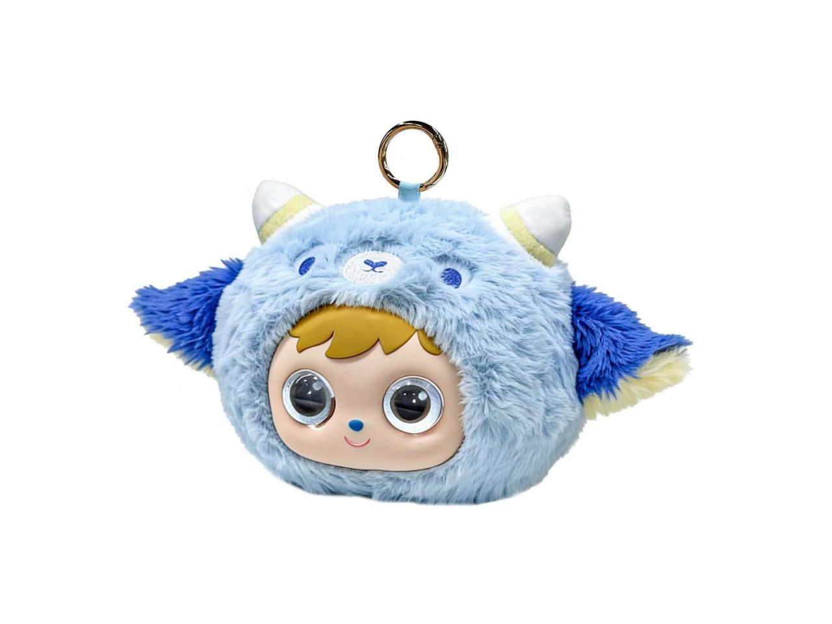 | Speaker Power: 5W Input: DC 5V,1A Driver: 52mm speaker  WiFi Specification: Supports 2.4G Transmission Distance: 10M External interface: USB Type-C Battery capacity: 3.7V/1200mAh Weight: Approximately 308g Product size: 235*235*140 mm | - AI CONVERSATION  - TOUCH SOUND EFFECT  - RECHARGEABLE BATTERY | 3K | $27.50
AI Toy-Night Owl | Fac-Ro3 | 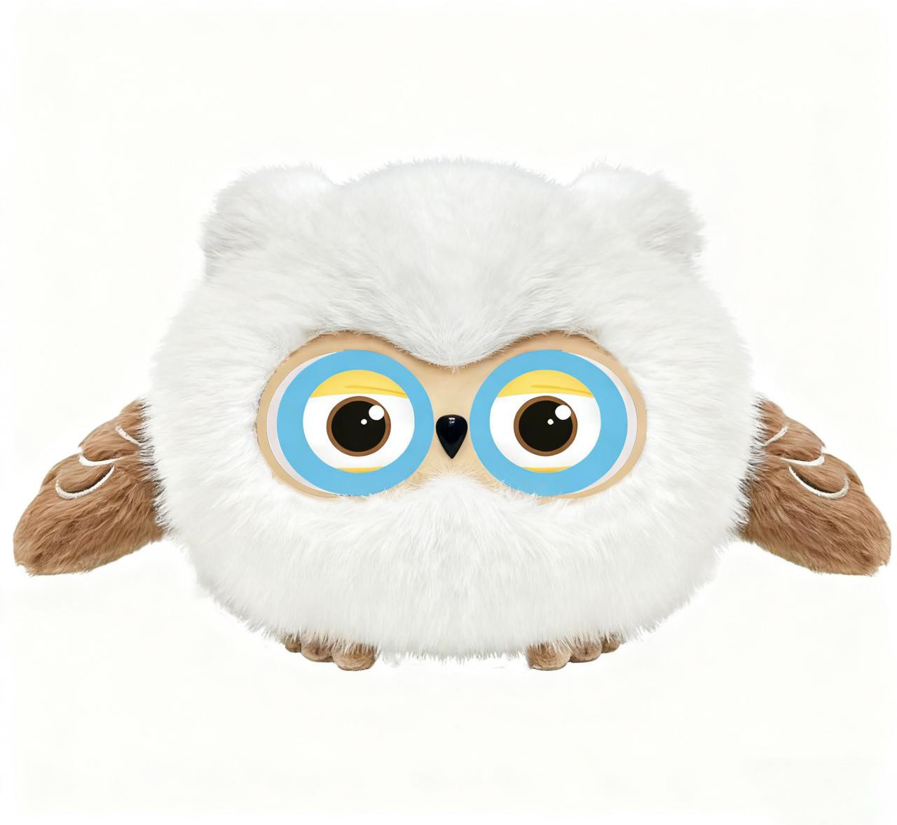 | - Chip ：T5 module  - Battery: YQ 632838 1000mAh  - battery voltage: 3.7-4.2V  - maximum power: 5W  - Charging way : USB  - Charging time: 2 hours  - Charging input: 5V 2A  - Loud speaker :5V 3W  - Clock rate: 400MHz  - GPIO: 48 pieces  - QSPI: Two  - Audio collection: 32khz  - indicator light: 2 indicator lights (power/conversation status)  - Key: 3 buttons (switch/reset button/switch mode)  - frequency band: 2.4~2.485GHz  - product material: Plush fabric made of 100% polyester fiber, Filling layer silicone, filling material cotton, Plastic movement, electronic components.  - Accessories:Charging cable;  instruction manual | - Emotional expression based on user mood  - Multi-language dialogue  - Game interaction  - Long-term memory  - Multiple roles  - Voice cloning  - Learning guidance  - Emotional companionship  - Broadcast news  - Chat summary sent to parent side, check child's mood  - tell a story  - Can sing | 3K | $31.00


AI-Desk Cute Ball | Fac-Ro4 | 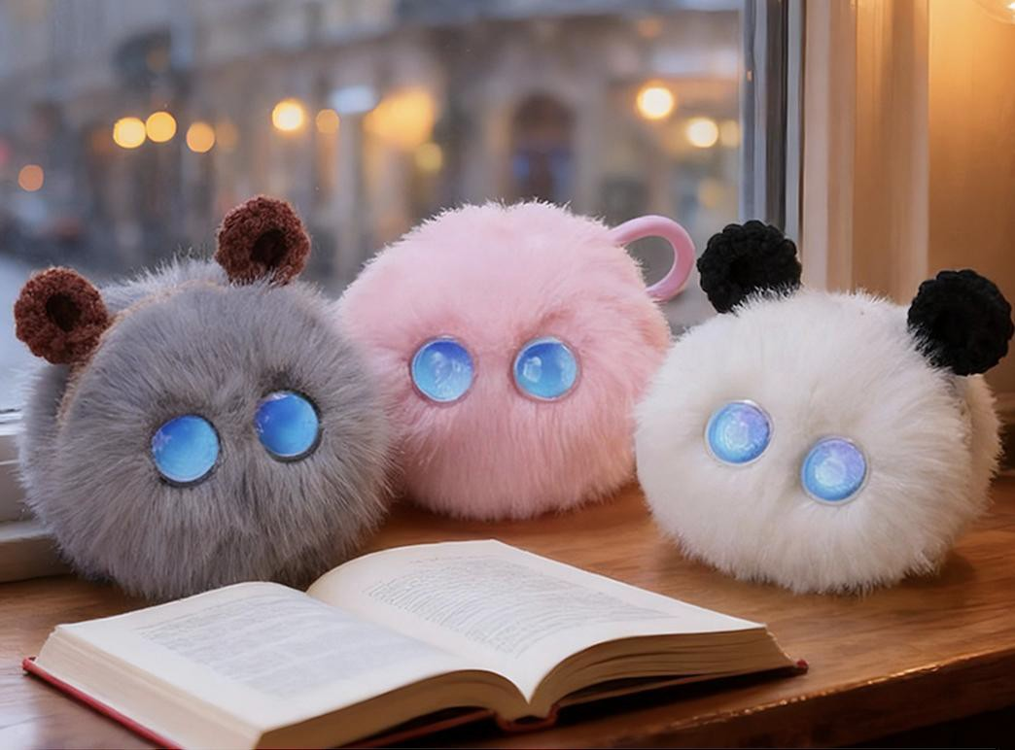 | - Chip ：T5 module  - Battery: 1000mAh  - battery voltage: 3.7-4.2V  - maximum power: 5W  - Charging way : USB  - Charging time: 2 hours  - Charging input: 5V 2A  - Loud speaker :5V 3W  - Audio collection: 32khz  - indicator light: 2 indicator lights (power/conversation status)  - Key: 3 buttons (switch/reset  button/switch mode)  - product material: Plush fabric made of 100% polyester fiber, Filling layer silicone, filling material cotton, Plastic movement, electronic components.  - Accessories:Charging cable;  instruction manual | Basic Functions  - Emotional expression based on user mood  - Multi-language dialogue  - Long-term memory  - Multiple roles  - Voice cloning (China）  - Touch Sensor  - Chat summaries ,can be viewenytime.  Emotional companionship:  - Learning guidance  - Story resonance  - Heart-to-heart dialogue  - Broadcastnews  Life Assistant  - Creative recipes,personalized healthy meals  - Pushing outfit and makeup tips  - Analyze health control and customize weight management plans  - Push the current season's fashion trend report  - Tailor-made scientific fitness program  - Promote disease prevention and teach Traditional | 3K | $28.00
AI Happy Ball | Fac-Ro5 | 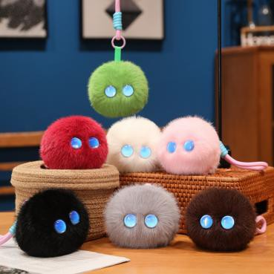 | - 2.4G Wi-Fi + Bluetooth  - PRODUCT SIZE：9*9cm  - Battery：1100MAH lithium-ion pouch  - Charging time：5 hours  - Operating system ：ATOS  - Loudspeaker ：4R 3W  - Clock rate：400MHz  - Audio collection ：32khz  - indicator light：1 power indicator light  - frequency band：2.4~2.485GHz  - 5 color (Pinkish purple/ Warm yelllow  /Sky blue/ Leaf green / Turquoise green)  - Accessories ：Charging cable; instruction manual  - The default language is English, and it supports 66+ languages | Basicfunctions  - Emotional expression based on user mood  - Multi-language dialogue  - Long-term memory  - Multiple roles  - Voice cloning (China）  - Touch Sensor  - Chat summaries ,can be viewenytime.  Emotionalcompanionship:  - Learning guidance  - Story resonance  - Heart-to-heart dialogue  - Broadcastnews  LifeAssistant  - Creative recipes,personalized healthy meals  - Pushing outfit and makeup tips  - Analyze health control and customize weight management plans  - Push the current season's fashion trend report  - Tailor-made scientific fitness program  - Promote disease prevention and teach Traditional | 3K | $25.50
AI Night Owl Shape 2 | Fac-Ro6 |  | - 2.4G Wi-Fi + Bluetooth  - PRODUCT SIZE：28*22cm  - Battery：1100MAH lithium-ion pouch  - Charging time：5 hours  - Operating system ：ATOS  - Loudspeaker ：4R 3W  - Clock rate：400MHz  - Audio collection ：32khz  - indicator light：1 power indicator light  - frequency band：2.4~2.485GHz  - 5 color (Pinkish purple/ Warm yelllow  /Sky blue/ Leaf green / Turquoise green)  - Accessories ：Charging cable; instruction manual  - The default language is English, and it supports 66+ languages | Basicfunctions  - Emotional expression based on user mood  - Multi-language dialogue  - Long-term memory  - Multiple roles  - Voice cloning (China）  - Touch Sensor  - Chat summaries ,can be viewenytime.  Emotionalcompanionship:  - Learning guidance  - Story resonance  - Heart-to-heart dialogue  - Broadcastnews  LifeAssistant  - Creative recipes,personalized healthy meals  - Pushing outfit and makeup tips  - Analyze health control and customize weight management plans  - Push the current season's fashion trend report  - Tailor-made scientific fitness program  - Promote disease prevention and teach Traditional | 3K | $29.00
AI Husky | Fac-Ro7 |  | - 2.4G Wi-Fi + Bluetooth  - PRODUCT SIZE：10*12cm  - Battery：1100MAH lithium-ion pouch  - Charging time：5 hours  - Operating system ：ATOS  - Loudspeaker ：4R 3W  - Clock rate：400MHz  - Audio collection ：32khz  - indicator light：1 power indicator light  - frequency band：2.4~2.485GHz  - 5 color (Pinkish purple/ Warm yelllow  /Sky blue/ Leaf green / Turquoise green)  - Accessories ：Charging cable; instruction manual  - The default language is English, and it supports 66+ languages | Basicfunctions  - Emotional expression based on user mood  - Multi-language dialogue  - Long-term memory  - Multiple roles  - Voice cloning (China）  - Touch Sensor  - Chat summaries ,can be viewenytime.  Emotionalcompanionship:  - Learning guidance  - Story resonance  - Heart-to-heart dialogue  - Broadcastnews  LifeAssistant  - Creative recipes,personalized healthy meals  - Pushing outfit and makeup tips  - Analyze health control and customize weight management plans  - Push the current season's fashion trend report  - Tailor-made scientific fitness program  - Promote disease prevention and teach Traditional | 3K | $27.00

AI Pink Bunny | Fac-Ro8 |  | - 2.4G Wi-Fi + Bluetooth  - PRODUCT SIZE：10*12cm  - Battery：1100MAH lithium-ion pouch  - Charging time：5 hours  - Operating system ：ATOS  - Loudspeaker ：4R 3W  - Clock rate：400MHz  - Audio collection ：32khz  - indicator light：1 power indicator light  - frequency band：2.4~2.485GHz  - 5 color (Pinkish purple/ Warm yelllow  /Sky blue/ Leaf green / Turquoise green)  - Accessories ：Charging cable; instruction manual  - The default language is English, and it supports 66+ languages | Basicfunctions  - Emotional expression based on user mood  - Multi-language dialogue  - Long-term memory  - Multiple roles  - Voice cloning (China）  - Touch Sensor  - Chat summaries ,can be viewenytime.  Emotionalcompanionship:  - Learning guidance  - Story resonance  - Heart-to-heart dialogue  - Broadcastnews  LifeAssistant  - Creative recipes,personalized healthy meals  - Pushing outfit and makeup tips  - Analyze health control and customize weight management plans  - Push the current season's fashion trend report  - Tailor-made scientific fitness program  - Promote disease prevention and teach Traditional | 3K | $27.00
AI Kitty | Fac-Ro9 | 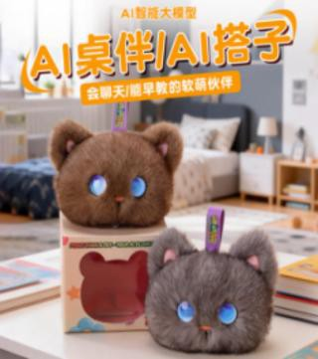 | - 2.4G Wi-Fi + Bluetooth  - PRODUCT SIZE：10*12cm  - Battery：1100MAH lithium-ion pouch  - Charging time：5 hours  - Operating system ：ATOS  - Loudspeaker ：4R 3W  - Clock rate：400MHz  - Audio collection ：32khz  - indicator light：1 power indicator light  - frequency band：2.4~2.485GHz  - 5 color (Pinkish purple/ Warm yelllow  /Sky blue/ Leaf green / Turquoise green)  - Accessories ：Charging cable; instruction manual  - The default language is English, and it supports 66+ languages | Basicfunctions  - Emotional expression based on user mood  - Multi-language dialogue  - Long-term memory  - Multiple roles  - Voice cloning (China）  - Touch Sensor  - Chat summaries ,can be viewenytime.  Emotionalcompanionship:  - Learning guidance  - Story resonance  - Heart-to-heart dialogue  - Broadcastnews  LifeAssistant  - Creative recipes,personalized healthy meals  - Pushing outfit and makeup tips  - Analyze health control and customize weight management plans  - Push the current season's fashion trend report  - Tailor-made scientific fitness program  - Promote disease prevention and teach Traditional | 3K | $27.00
AI Alien | Fac-Ro10 | 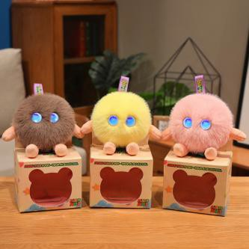 | - 2.4G Wi-Fi + Bluetooth  - PRODUCT SIZE：10*12cm  - Battery：1100MAH lithium-ion pouch  - Charging time：5 hours  - Operating system ：ATOS  - Loudspeaker ：4R 3W  - Clock rate：400MHz  - Audio collection ：32khz  - indicator light：1 power indicator light  - frequency band：2.4~2.485GHz  - 5 color (Pinkish purple/ Warm yelllow  /Sky blue/ Leaf green / Turquoise green)  - Accessories ：Charging cable; instruction manual  - The default language is English, and it supports 66+ languages | Basicfunctions  - Emotional expression based on user mood  - Multi-language dialogue  - Long-term memory  - Multiple roles  - Voice cloning (China）  - Touch Sensor  - Chat summaries ,can be viewenytime.  Emotionalcompanionship:  - Learning guidance  - Story resonance  - Heart-to-heart dialogue  - Broadcastnews  LifeAssistant  - Creative recipes,personalized healthy meals  - Pushing outfit and makeup tips  - Analyze health control and customize weight management plans  - Push the current season's fashion trend report  - Tailor-made scientific fitness program  - Promote disease prevention and teach Traditional | 3K | $27.00
AI Panda | Fac-Ro11 |  | - 2.4G Wi-Fi + Bluetooth  - PRODUCT SIZE：10*12cm  - Battery：1100MAH lithium-ion pouch  - Charging time：5 hours  - Operating system ：ATOS  - Loudspeaker ：4R 3W  - Clock rate：400MHz  - Audio collection ：32khz  - indicator light：1 power indicator light  - frequency band：2.4~2.485GHz  - 5 color (Pinkish purple/ Warm yelllow  /Sky blue/ Leaf green / Turquoise green)  - Accessories ：Charging cable; instruction manual  - The default language is English, and it supports 66+ languages | Basicfunctions  - Emotional expression based on user mood  - Multi-language dialogue  - Long-term memory  - Multiple roles  - Voice cloning (China）  - Touch Sensor  - Chat summaries ,can be viewenytime.  Emotionalcompanionship:  - Learning guidance  - Story resonance  - Heart-to-heart dialogue  - Broadcastnews  LifeAssistant  - Creative recipes,personalized healthy meals  - Pushing outfit and makeup tips  - Analyze health control and customize weight management plans  - Push the current season's fashion trend report  - Tailor-made scientific fitness program  - Promote disease prevention and teach Traditional | 3K | $27.00


AI Couple Bear |  | Fac-Ro12 | 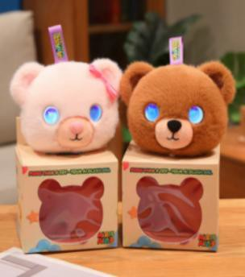 | - 2.4G Wi-Fi + Bluetooth  - PRODUCT SIZE：10*12cm  - Battery：1100MAH lithium-ion pouch  - Charging time：5 hours  - Operating system ：ATOS  - Loudspeaker ：4R 3W  - Clock rate：400MHz  - Audio collection ：32khz  - indicator light：1 power indicator light  - frequency band：2.4~2.485GHz  - 5 color (Pinkish purple/ Warm yelllow  /Sky blue/ Leaf green / Turquoise green)  - Accessories ：Charging cable; instruction manual  - The default language is English, and it supports 66+ languages | Basicfunctions  - Emotional expression based on user mood  - Multi-language dialogue  - Long-term memory  - Multiple roles  - Voice cloning (China）  - Touch Sensor  - Chat summaries ,can be viewenytime.  Emotionalcompanionship:  - Learning guidance  - Story resonance  - Heart-to-heart dialogue  - Broadcastnews  LifeAssistant  - Creative recipes,personalized healthy meals  - Pushing outfit and makeup tips  - Analyze health control and customize weight management plans  - Push the current season's fashion trend report  - Tailor-made scientific fitness program  - Promote disease prevention and teach Traditional Chinese Medicine health preservation | 3K | $29.00
AI Robot Dog(Shooting Gun Version) |  | FAC-8006 |  | Main unit: 3.7V rechargeable battery; Remote control: 3 x 1.5V AAA batteries 35.5*18.5*20.5  1.25kg | - Functions  Forward, Left Turn, Right Turn  - Actions  Swimming, Sit Down, Lie Down, Act Cute, Somersault, Push-ups, Patrol, Launch, Pee, Bless, Greet, Program, Sleep  - Entertainment  Kung Fu, Dancing, Songs  - Unique Functions: WIFI Connection AI Interactive Communication  AI Emotional Expression  AI Encyclopedic Learning  AI Intelligent Question Answering | 1K | $42.00
AI Robot Dog  （Hanger Version) |  | FAC-8008 |  | Main unit: 3.7V rechargeable battery; Remote control: 3 x 1.5V AAA batteries 39.5*17.2*19  1.8kg | - Functions  Forward, Left Turn, Right Turn  - Actions  Swimming, Sit Down, Lie Down, Act Cute, Somersault, Push-ups, Patrol, Launch, Pee, Bless, Greet, Program, Sleep  - Entertainment  Kung Fu, Dancing, Songs  - Unique Functions: WIFI Connection AI Interactive Communication  AI Emotional Expression  AI Encyclopedic Learning  AI Intelligent Question Answering | 1K | $42.00
AI Robot Dog(Regular Version |  | FAC-8002 | 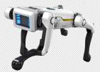 | Main unit: 3.7V rechargeable battery; Remote control: 3 x 1.5V AAA batteries 44*19*30  1.2kg | - Functions  Forward, Left Turn, Right Turn  - Actions  Swimming, Sit Down, Lie Down, Act Cute, Somersault, Push-ups, Patrol, Launch, Pee, Bless, Greet, Program, Sleep  - Entertainment  Kung Fu, Dancing, Songs  - Unique Functions: WIFI Connection AI Interactive Communication  AI Emotional Expression AI Encyclopedic Learning  AI Intelligent Question Answering | 1K | $39.00
Trade Terms  贸易条款 |  | FOB China
Payment Terms  付款方式 |  | Prepay 30% of the contract amount as the deposit, and pay the remaining 70% before shipment.
Others  其它说明 | Delivery Lead Time  交货期 | Buyer should confirm the delivery date with seller before placing an order.  请买方下单前与卖方确认交货日期 。
Others  其它说明 | Packing  包装 | This quotation is based on the packaging of standard products，for customized packaging will need to be quoted separately.  此报价基于公版包装 ，如买方需要定制包装 ，请买方提供定制要求后 ，卖方按需求评估另行报价 。
Others  其它说明 | Test、 Inspection  测试、验货等 | This quotation is based on the standard products of the seller. If the Buyer has additional requirements for testing, inspection, certification or factory audit qualification, etc. The seller will update the quote accordingly based on buyer's requirement.  此报价为卖方公版产品的标准报价 ，若买方有额外的测试 、验货、认证或审厂资质要求等 ，卖方按需评估后 ，另行报价 。
Others  其它说明 | After Service  售后 | 1、Warranty Period：12 months after delivery.
Others  其它说明 | After Service  售后 | 2、 Within the warranty period, when the buyer receives the defective product from consumer, buyer shall collect the serial number, picture or video of the defective product and submit
Others  其它说明 | After Service  售后 | them to the seller for confirmation. After the seller identifies the defective product, it shall provide the replacement in the next order.  3、 This quotation does not include additional after-sales spare parts. If there is demand for after-sales spare parts, Seller will update the quote accordingly based on buyer's requirement. 1、质保期限 ：出货后的 12个月。
Others  其它说明 | After Service  售后 | 2、在质保期内 ，买方收到客退不良品后 ，需收集不良品的序列号 、失效现象 、图片或视频给卖方确认 ，卖方认定不良后 ，在下批订单中提供补货 。
Others  其它说明 | After Service  售后 | 3、此报价不含额外售后备品 ，如有售后备品需求 ，请买方提供售后备品要求后 ，卖方另行报价 。
Others  其它说明 | Remark | The buyer confirms that this quotation is highly confidential information of the seller, and the buyer shall not copy, publish or disclose this quotation and will keep it strictly confidential.
Others  其它说明 | Remark | 买方确认此报价是卖方的高度机密信息 ，买方不得复制 、发布或披露此报价 ，并将严格保密 。
Others  其它说明 | 备注 | If the exchange rate changes by more than 2% , the seller has the right to negotiate with the buyer about the quotation.
Others  其它说明 | 备注 | 若汇率变动超过 2%，卖方有权与买方协商报价 。

