Quotation Sheet

ASIAN DRAGON ENTERPRISES LIMITED
Contact: Ms. Myla Baracina
Date: 23-06-2016

No. | Description | Deteails | Photo | Unit price (USD)
1 | Portable Under Verhicle Survelliance System Modle: AT3000 (Black & white) | - Black and white Scanning unit (mounted on the ground)  - Transit Aluminum Case, with monitor.  - Image software  - Capture Camera ( 1 piece)  - Others | 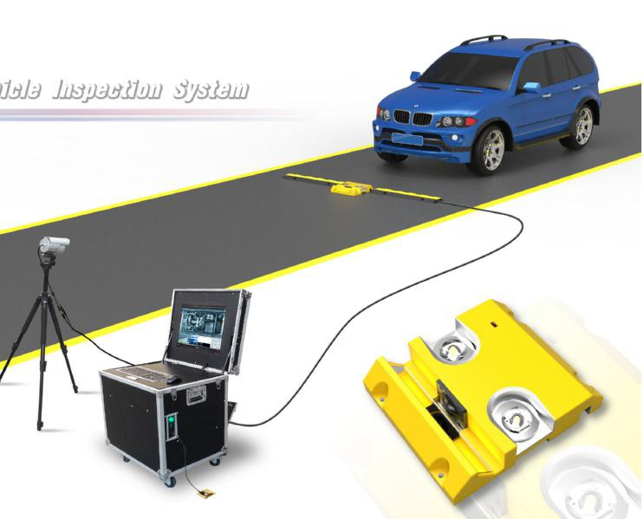 | $12,000.0
2 | Portable Under Verhicle Survelliance System Modle: AT3000 (COLOR) | - Color Scanning unit (mounted on the ground)  - Transit Aluminum Case,with monitor.  - Image software  - Capture Camera ( 1 piece)  - Others |  | $14,000.0
3 | Embeded Under Verhicle Survelliance System Modle: AT3300(Black & white) | - Embeded Black and white Scanning unit  - Induction Loop  - Distribution Box  - Operation console with computer and monitor  - Image software  - Capture Camera ( 1 piece)  - Others | 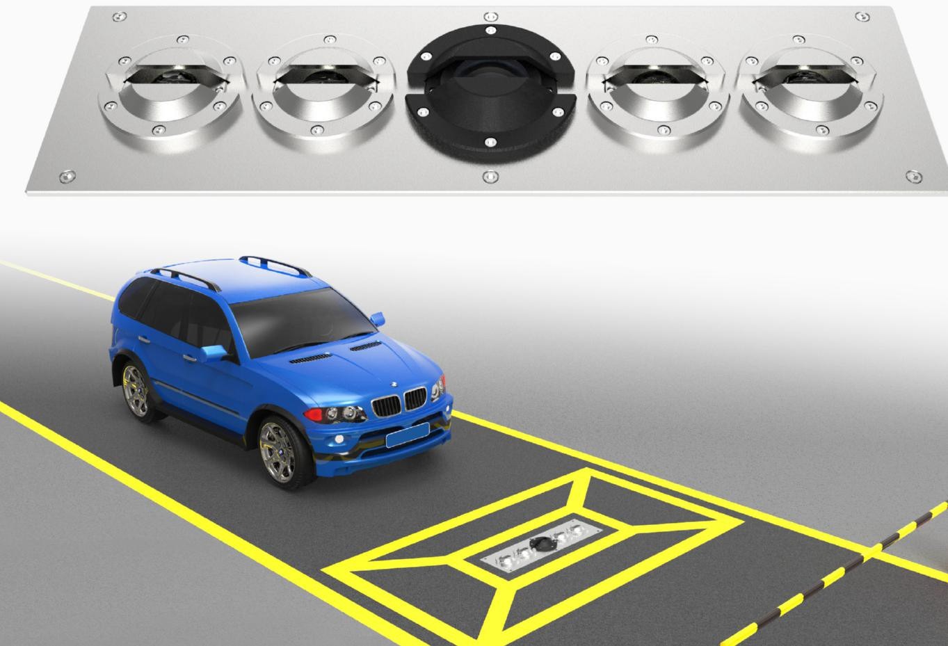 | $15,500.0
4 | Embeded Under Verhicle Survelliance System Modle: AT3300 (COLOR) | - Embeded Color Scanning unit  - Induction Loop  - Distribution Box  - Operation console with computer and monitor  - Image software  - Capture Camera ( 1 piece)  - Others |  | $17,500.0
Optional Fits for Under Verhicle Survelliance System (UVSS)
5 | Number Plate Recognise System (NPRS) | For (Correct rate up to 80% ) | / | $3,000.0
6 | 1 piece Camera | Camera ( for scene/ entrance / exit) Fit for model AT3300 | / | $290.0
7 | DVR 4 lines | Must add DVR if more camera is required. Fit for model AT3300 | / | $400.0
Remarks:

Delivery : 15 days after receipt of a Purchase Order;
- Validity : 60 days from the date of this quotation。
- Payment ：50% deposit, 50% before shipment.
- Warranty : 18 months from a successful Site Acceptance Test or 18 months from delivery whichever is the sooner.

