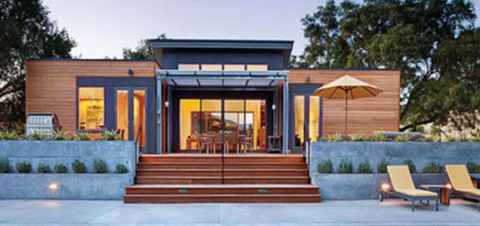
MATERIAL LIST
Project Name |  |  |  | 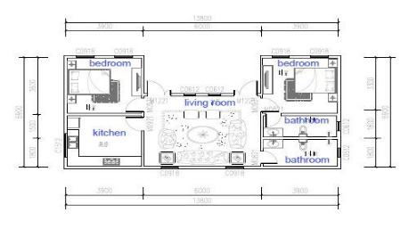
85.72m2 Light steel Villa |  | Unit Price |  | Quantity (Units) | Total Building Area(m2) | Total price (USD)
 |  | FOB Tianjin |  | 1 | 85.72 | US$34,510.00
Material List
NO. | Items | Specification |  | Units | Quantity
1 | Main structure | Galvanized Light steel structure | 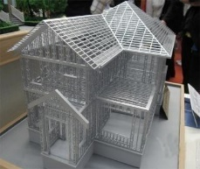 | m2 | 85.72
2 | Exterior Wall | coating+waterproof putty | 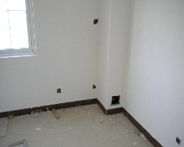 | m2 | 127.94
 |  | 12mm gypsum board | 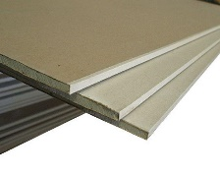
 |  | 75mm,16K/m3 glass wool | 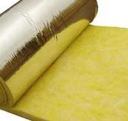
 |  | 10mm calcium silicate board | 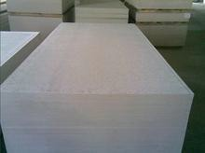
 |  | waterproof paper | 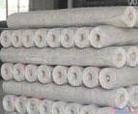
 |  | ventilated steel keel | 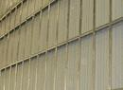

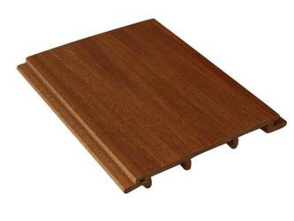
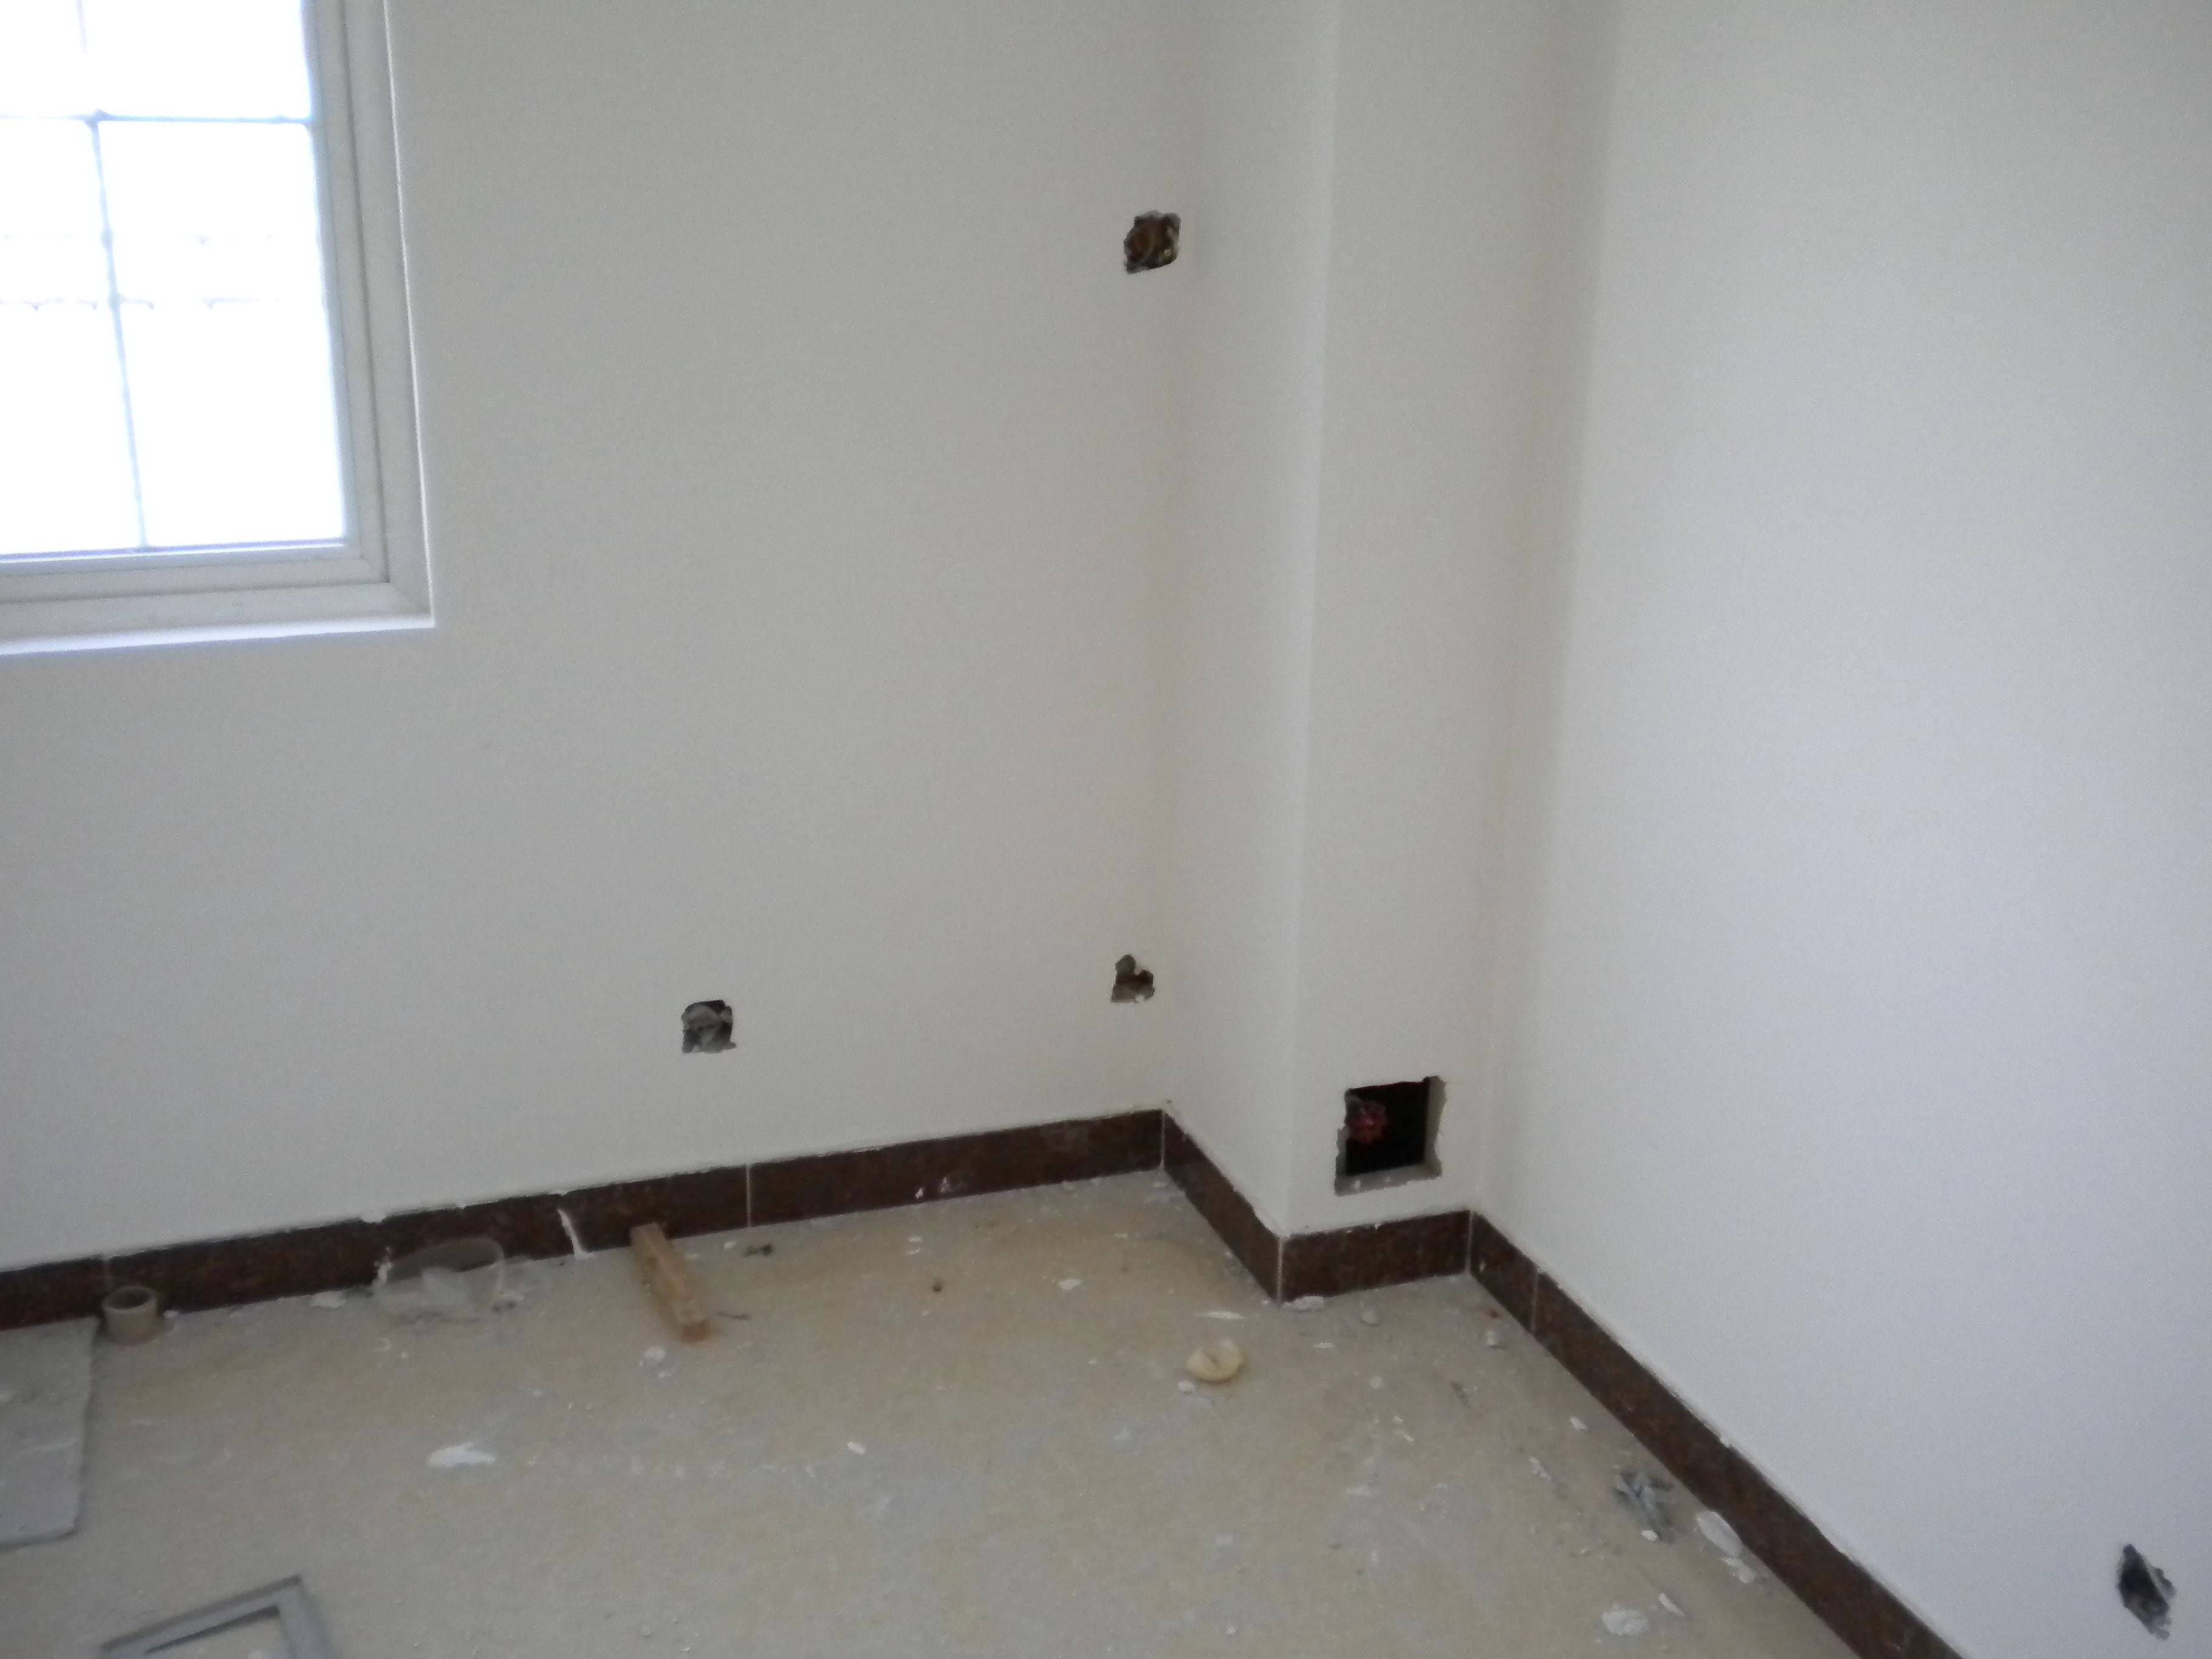
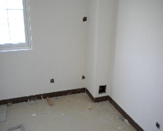
Material List
NO. | Items | Specification |  | Units | Quantity | Price/m2 | Sub-total price
 |  | WPC cladding panel/aluminous gusset plate
3 | Interior wall of normal rooms | coating+waterproof putty |  | m2 | 22.43
 |  | 2 layers of 12mm gypsum board
 |  | structure steel stud | 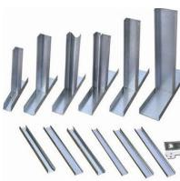
 |  | 75mm,16K/m3 glass wool
 |  | 2 layers of 12mm gypsum board
 |  | waterproof putty+coating
4 | Interior wall of kitchen/bathroo | structure steel stud |  | m2 | 97.77
 |  | 75mm,16K/m3 glass wool
 |  | calcium silicate board

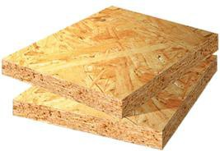
Material List
NO. | Items | Specification |  | Units | Quantity
 | m | steel mesh | 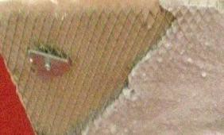
 |  | JS waterproof layer(coating height 1800/300mm) | 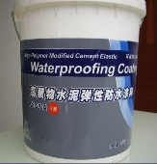
 |  | glazed tile | 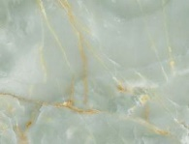
5 | plane roof | 3mm SBS waterproof roll | 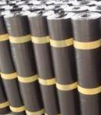 | m2 | 99.89
 |  | 18mm structure board
 | Pitched roof | structure board
 |  | 3mm SBS waterproof roll
 |  | 20*30 counter batten+20*30 roof batten | 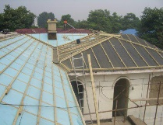
 |  | stone-coated metal roofing tile | 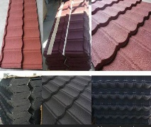
6 | Parapet | inside：steel struture+10mm calcium silicate board+3mm SBS waterproof roll+75mm/16K glass wool+10mm calcium silicate board+waterproof paper+ventilated steel keel+WPC cladding panel | Pls refer to the above related pictures | m2 | 16.48
7 | Cornice | steel struture+10mm calcium silicate board+waterproof putty+coating | Pls refer to the above related pictures | m2 | 15.90

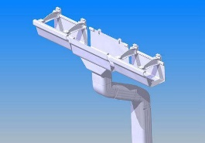
Material List
NO. | Items | Specification |  | Units | Quantity
8 | Gutter | aluminium alloy |  | m | 62.40
9 | Floor of normal rooms | floor tile | 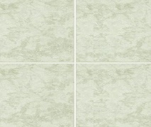 | m2 | 62.51
 |  | waterproof plastic film+10mm composite wood floor | 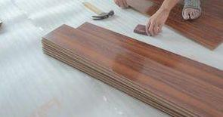
 |  | 5mm foamed plastic cushion+waterproof plastic film | 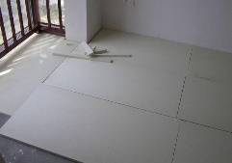
10 | Floor of kitchen/bathroo m | non-slippery tile | 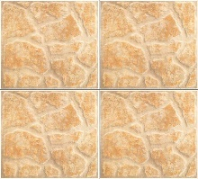 | m2 | 23.21
 |  | JS painting waterproof layer | 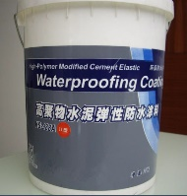
 |  | waterproof plastic film | 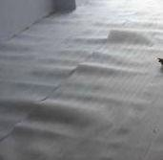
 |  | light steel ceiling | 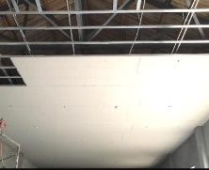
 |  | 75mm,16K/m3 glass wool

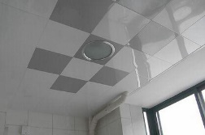
Material List
NO. | Items | Specification |  | Units | Quantity
11 | Ceiling of normal rooms | waterproof paper |  | m2 | 62.51
 |  | 9.5mm gypsum board
 |  | waterproof putty+coating | 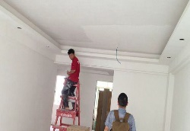
12 | Ceiling of kitchen/bathroo m | light steel ceiling+75mm/16K glass wool+moistureproof film | Pls refer to the above related pictures | m2 | 23.21
 |  | PVC panel
13 | Outside door | sliding door | 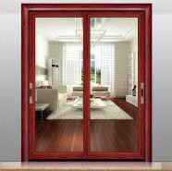 | m2 | 12.60
14 | Outdoor steps and floor | non-slippery tile | 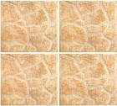 | m2 | 41.90
15 | Inside door | paint-free door | 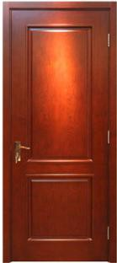 | m2 | 9.03
16 | Window | single-glass plastic steel window | 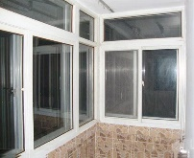 | m2 | 11.28
17 | Windowsill | manu-marble | 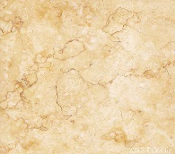 | m | 6.90

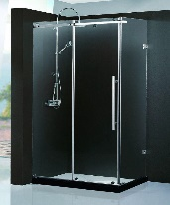
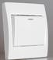
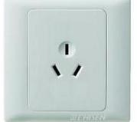
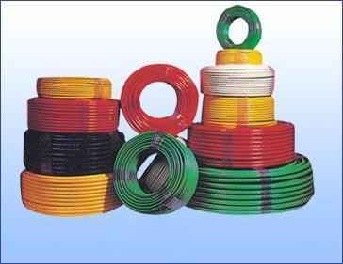
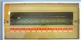
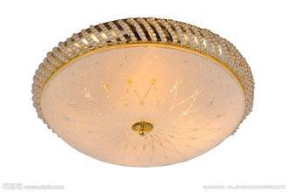
Material List
NO. | Items | Specification |  | Units | Quantity
18 | Sanitary appliance | toilet | 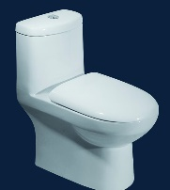 | m2 | 85.72
 |  | shower
 |  | basin with pedestal | 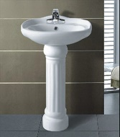
19 | Water supply and drainage | indoor water pipe+valve+watermiter | 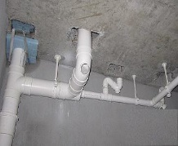 | m2 | 85.72
 |  | water heater | 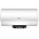
20 | Electrical system | swith+faceplate+line pipe+lamp+distribution box |  | m2 | 85.72
21 | Lightning- protection system |  |  | m2 | 85.72
22 | Light-current system | for TV,telephone,network |  | m2 | 85.72
23 | Packing charge |  |  | m2 | 85.72
24 | shipment Load
25 | Total price of materails |  |  |  |  |  | US$34,510.00

Material List
NO. | Items | Specification |  | Units | Quantity
Note:
- This quotation is based on the design drawings, including the cost of the main building materials above the foundation; 2.This quotation doesn't include the following:
  - outdoor plinth materials;
  - materials used for foundation, like cement,sand,reinforced bar,stone,mortar, auxiliary materials of concrete,additive,admixture,glue etc.; (3)charge of installation guide in the construction site.
- The quotation should be adjusted accordingly to actual situation if necessary.
- The material pictures is just for reference, more options will be supplied before the production.

