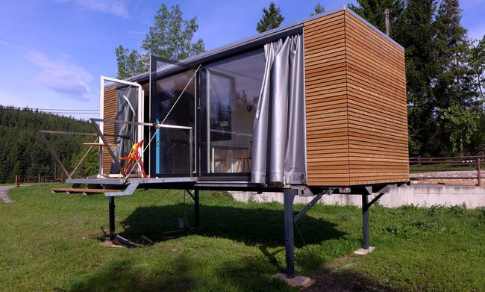
West Port of Pipeline Corridor Project, Offshore Oil Drilling Platform etc. a number of high quality projects

Product Introduction
Container mobile house, also known as camping house, container apartment housing, is adopt container technology( also can adopt market standard steel material as main skeleton).Taking sandwich panel with the wall panel standard modulus standard as space assembled. combine the components by welding and bolts.

Container bottom is made by abrasion resistant fiber material with fireproof and moistureproof technology.At the same time, tile can be used on surface decoration to enlighten and tidy the internal space.

That is the new concept of green-economy container. And it is also convenient to lift and transport quickly to accomplish the common standard of temporary structure.

Assimilate the environmental protection and energy conservation and high efficient concept to build the temporary house into the one can be developed , made and equipped with supplying field, and also can be stocked and recycled.

Feature
(1) Active,moveable,and recycle
(2) Quickly assemble to finish in a very short time, no basement
(3) Safe, light-steel structure,anti-typhoon,earthquake resistant
(4) Durability,corrosion resistant,anti-rust, the service period is over 20 years
(5) Noise and heat insulation,air cooling design
(6) Lower cost,high quality
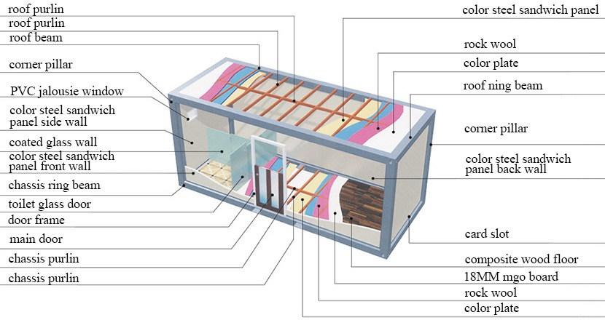
(7) Be able to Stack three stories
Application
(1) Booth, canteen, mobile store,mobile toilet
(2) Motels, hotels, restaurants and residential area etc.
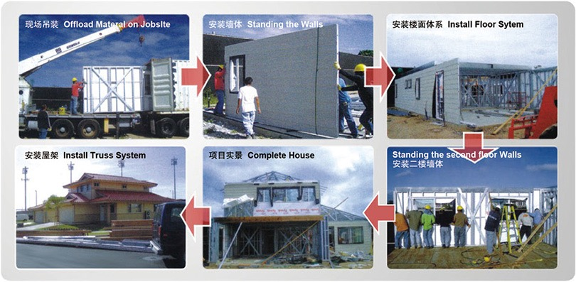
(3) Project construction office and residence place
(4) Temporary Emergency rescue command center,hospital, canteen,school
(5) Temporary Industry office, warehouse,canteen equipment control room
(6) Site and outdoor work industry

Introduction Steps
Dismantled container before deliver to the customers.all the main components,window and door,bolts etc have been packed into the small container.Before assembling,open the container according to the instruction steps to work on it.Easil and quickly assemble,only need 2-3 people to finish.
Service Process
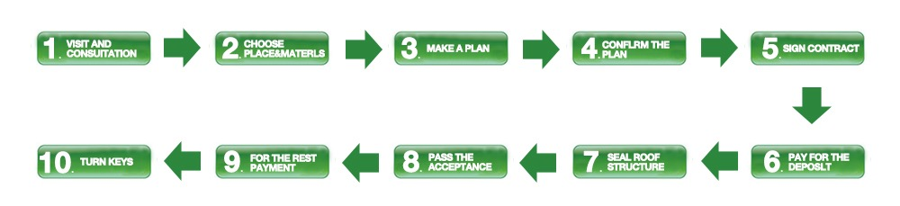
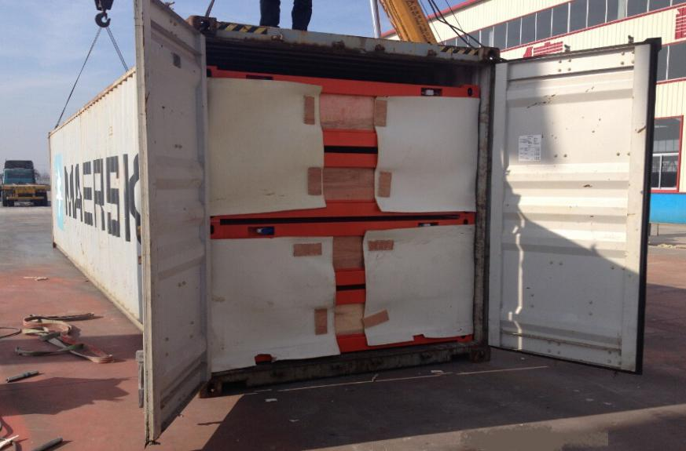
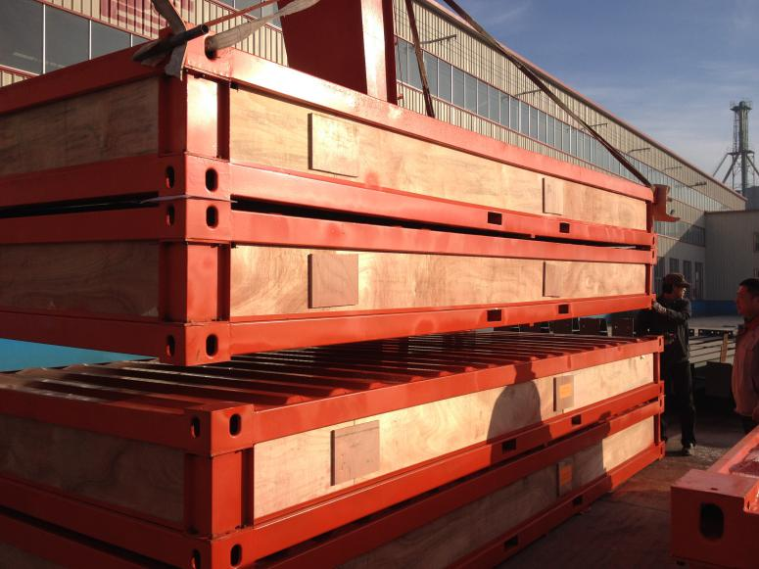
Packaging and Transportation.
Standard Configuration
Corner Pillar | 2.3mm | L=2510(with L type connector 12mm) | Color Steel Sandwich Panel | 950*50*2526mm | inside 0.35/outside0.4 one side coating rock wool 50kg volume weight
Chassis Ring Beam | 2.3mm | L=5680 |  | 950*50*800mm
Chassis Ring Beam | 2.3mm | L=2680 |  | 950*50*565mm
Roof Ring Beam | 2.3mm | L=5680 | Card Slot | 50mm u50*24*0.9
 | 2.3mm | L=2680 | Door Frame | 40*20*1.0*6000
Color Steel Panel | 5680*1000*0.5mm |  | Main Door | 2050*930mm*90*0.4mm
Hexagon Socket Bolts | 14*30mm |  | PVC Jalousie Window | 930*930mm*80*1.6mm
Roof Purlin | 40*60*1.0*6000(mm) |  | Shade Horn Line | L=2460 | 0.35white grey bending piece
 | 30*50*1.0*6000(mm) |  | Pulling Rivet | 5*16mm
 | 20*40*1.0*6000(mm) |  | Hexagon Tail Screw | 48*75mm
 | 20*20*1.0*6000(mm) |  |  | 48*25mm
Chassis Purlin | 40*80*1.2*6000 |  | Flat Tail Screw | 4.2*16mm
Rock Wool | 50mm |  |  | 4.2*25mm
PVC Roof | 5890*200*1.0mm |  | Glue 201
PVC Pipe | 46mm |  | PVC Lumber Line | L=1950*75*15 | white
MGO Board | 1160*2800*15mm |  |  | L=1950*75*15 | brown

