Integrated pressurized type

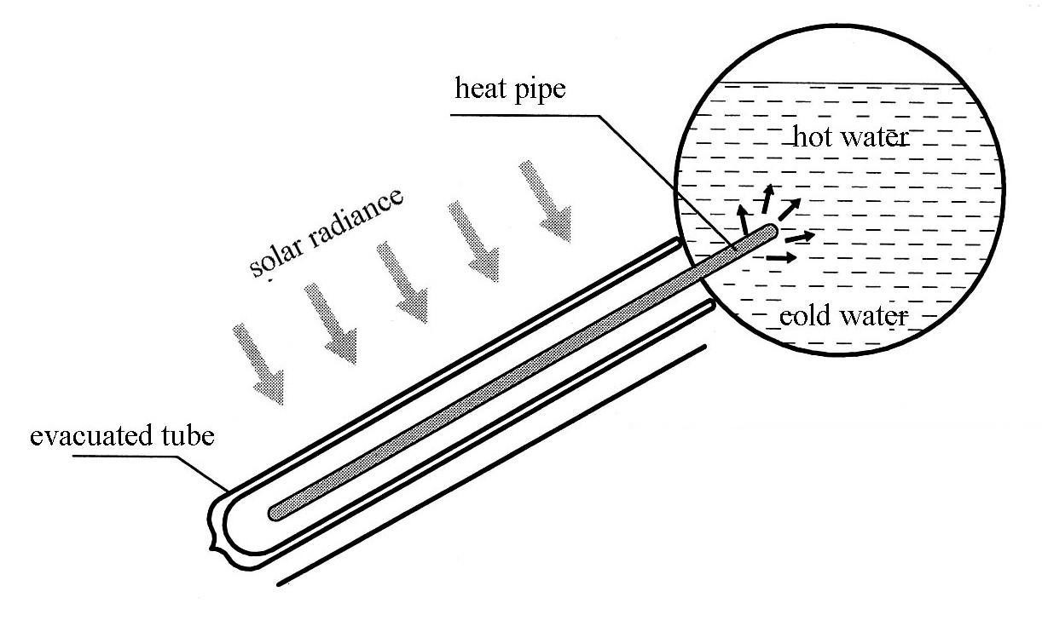

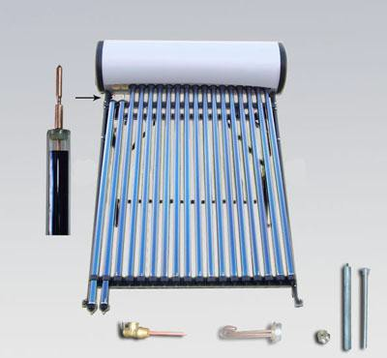Insulating layer: foaming polyurethane, thickness: 50-55mm Thermal conductivity: 0.022w/m.k
Inner tank: stainless steel (SUS 304 2B or 316L stainless steel) Thickness: I type 1.2-1.5mm; II type 1.0-1.2mm
Sealing rubber: 110 methyl silicone rubber with vinyl Dustproof rubber: EPDM
Frame: Color steel, Stainless steel or Aluminum alloy Collector tilt angel: I type 30- 40°; II type 20° Tailstock: Nylon
Daily efficiency: > 50%

Outer tank

Heat loss coefficient: 10W/㎡ Working pressure: I type 0.9MPa
II type 0.6MPa Electric booster: Optional 1500-2500W

P/T Valve
Electric heating

Magnesium anode

Heat pipe

- Type -

Model  Central distance of holes is 80mm | Pack Size (cm) (L×W×H) |  | Capacity (L) | Qty. per 20’  / 40’  Container |  | Price(USD)
 |  |  |  |  |  | Outer tank  & frames  color steel | All stainless steel
SPP-470-H58/1800-12-I | Water tank | 114×51×51 | 115 | 60 | 139 | 341.7 | 352.3
 | Vacuum tube | 194×28×25
 | Frame | 152×13×14
SPP-470-H58/1800-15-I | Water tank | 138×51×51 | 145 | 50 | 115 | 384.1 | 398.9
 | Vacuum tube | 194×34×25
 | Frame | 166×13×14
SPP-470-H58/1800-18-I | Water tank | 162×51×51 | 165 | 41 | 95 | 431.8 | 444.5
 | Vacuum tube | 194×34×25
 | Frame | 190×13×14
SPP-470-H58/1800-20-I | Water tank | 178×51×51 | 190 | 38 | 87 | 461.5 | 484.8
 | Vacuum tube | 194×28×25
 | Frame | 206×13×14
SPP-470-H58/1800-24-I | Water tank | 210×51×51 | 220 | 32 | 74 | 529.3 | 560
 | Vacuum tube | 2*194×28×25
 | Frame | 198×13×14
SPP-470-H58/1800-30-I | Water tank | 256×51×51 | 265 | 25 | 57 | 619.4 | 665
 | Vacuum tube | 2*194×34×25
 | Frame | 244×13×14

- Type – special for tropical zone such as Mexico, Brazil, India and so on

Model  Central distance of holes is 100mm Frame angel 20° | Pack Size (cm) (L×W×H) |  | Capacity (L) | Qty. per 20’  / 40’  Container |  | Price(USD)
 |  |  |  |  |  | Outer tank  & frames  color steel | All stainless steel
SPP-460-H58/1800-10-II | Water tank | 158×51×51 | 150 | 45 | 103 | 330.4 | 348.5
 | Vacuum tube | 194×34×18
 | Frame | 190×13×14
SPP-460-H58/1800-12-II | Water tank | 158×51×51 | 150 | 50 | 115 | 349.9 | 367.9
 | Vacuum tube | 194×28×25
 | Frame | 190×13×14
SPP-460-H58/1800-18-II | Water tank | 208×51×51 | 200 | 35 | 80 | 436.5 | 457.9
 | Vacuum tube | 2*194×34×18
 | Frame | 210×13×14
SPP-460-H58/1800-24-II | Water tank | 268×51×51 | 250 | 29 | 66 | 533.9 | 562.5
 | Vacuum tube | 2*194×28×25
 | Frame | 270×13×14

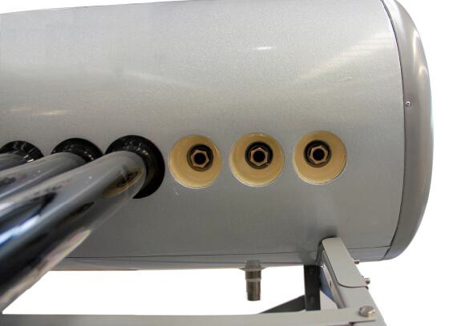

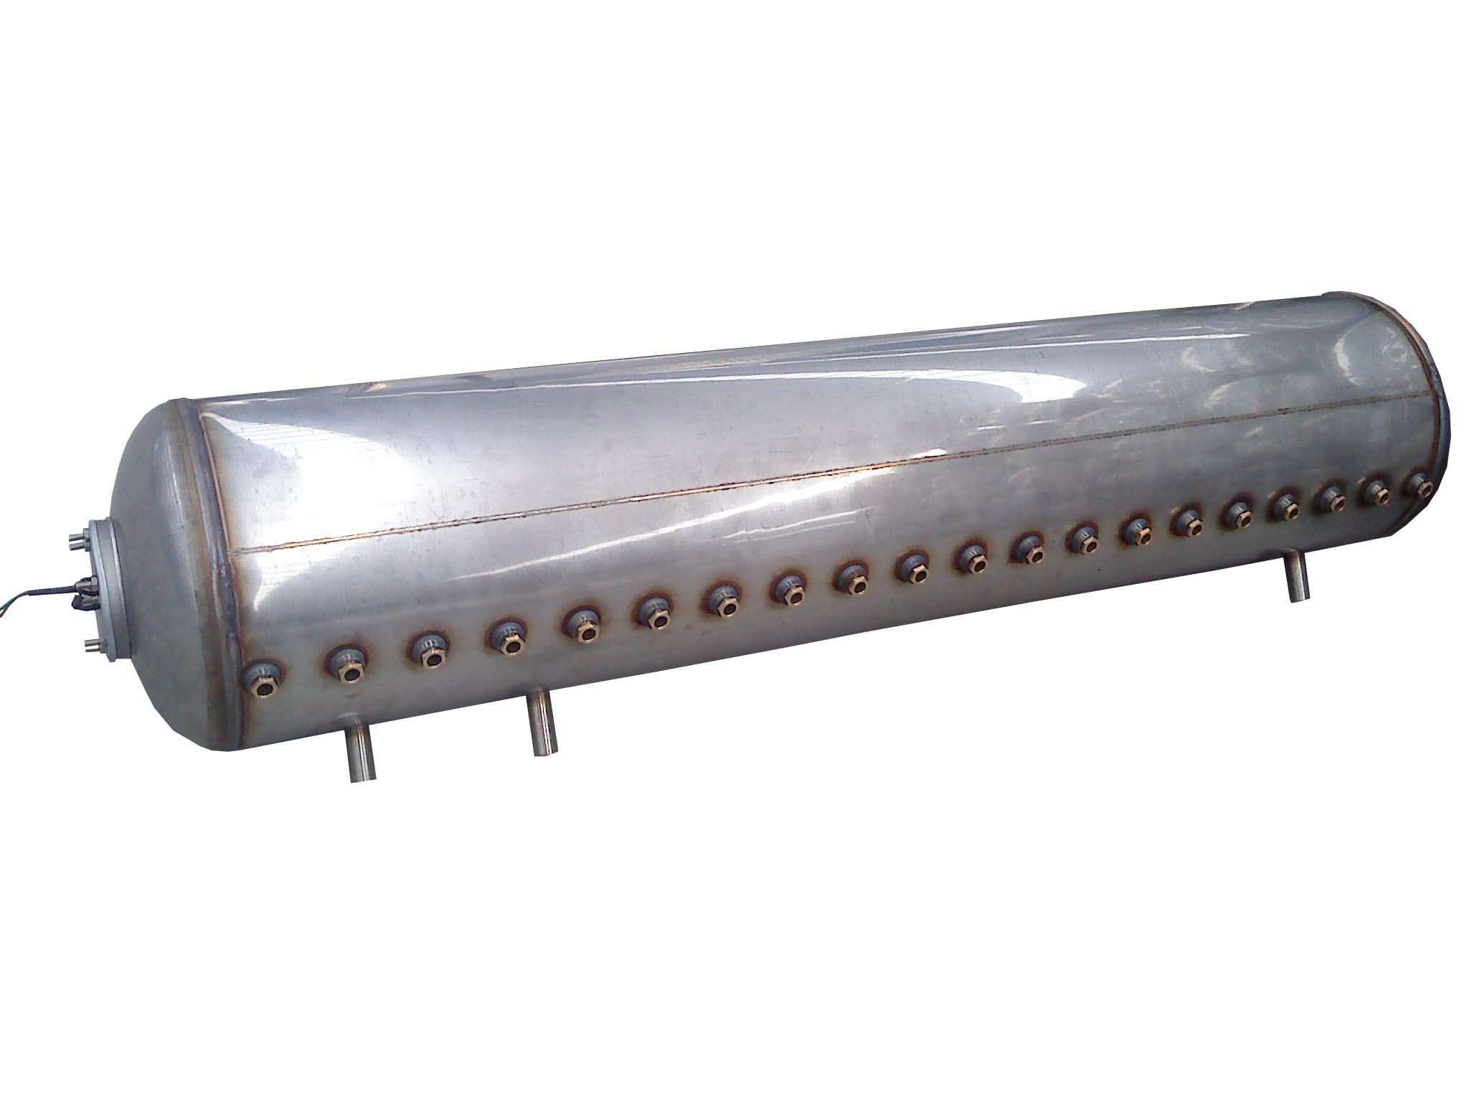Electric heaters Inner pressure tank

  - Inner tank adopts 1.0~2.0mm SUS3042B stainless steel and automatic wending technology, which decrease the corrosion and against the 0.9Mpa pressure. Outer tank use 0.4mm 201 BA stainless steel or color steel. Insulation adopts polyurethane which has good insulation efficiency, thickness is 50-55mm.

The tubes and supports are adjustable, power bearing is average and assure the tubes to use long time.

  - Whole vacuum tube adopts super borax and silica glass. Absorb rate≥96%, thermal radiationrate≤4%.

Resist 25mm hail, using life lasts 15-20 years.

It has advantages of no water in tube, no filthy, no broken tube which is anti-freeze, unlimited time of the inputting water and pressure operation.
Note：
- The price as mentioned above is FOB Shanghai and without reflector.
- Minimum order 1 x 20ft container (we wholesale only)

