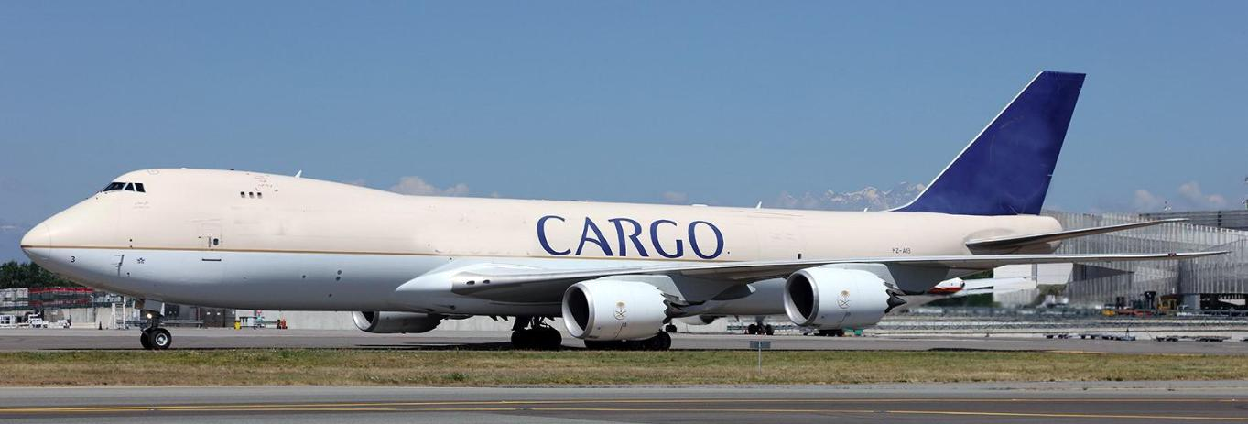

Aircraft Designation: | Boeing 747‐87UF
LN: | 1429
Date Delivered: | May 2013
In-Service Date: | 2013
TTSN: | 12,261
TCSN: | 1,903
Engines
Engine Type: | 4 x GEnx-2B67
Max Thrust: | 66,500lbs
Noise Level: | Stage 4

Engines Details and Current Status

 | Part No. |  | Serial No. | TSN | CSN | TBI | CBI
Engine #1 | GENX-2B67/PG01 |  | 959421 | 8845:01 | 1,405 | 8845:01 | 1,405
Engine #2 | GENX-2B67BG02 |  | 959153 | 8447:56 | 1,373 | 2273:56 | 431
Engine #3 | GENX-2B67BG02 |  | 959156 | 12900:29 | 2,048 | 6585:29 | 1,076
Engine #4 | GENX-2B67BG01 |  | 959170 | 13913:14 | 2,191 | 7646:14 | 1,230
APU
APU Type: | PW901C
SN: | PCE-900842
Maintenance Status
Latest C Check completed in Hamburg
Inspection commenced: |  |  | 22 April 2019
Completed and Returned to Service: |  |  | 5 June 2019
Entered into Starage Program: |  |  | 6 Jan 2020

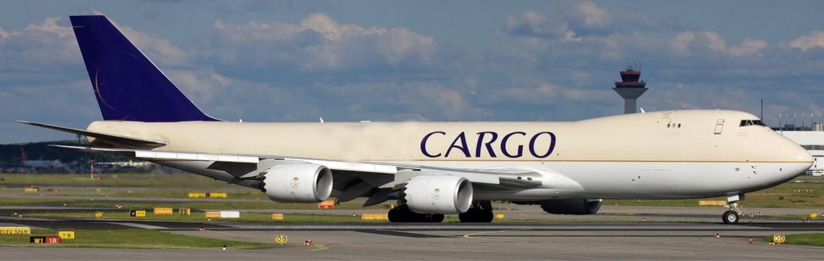

Aircraft Designation: |  |  | Boeing 747‐87UF
LN: |  |  | 1432
Date Delivered: |  |  | June 2013
In-Service Date: |  |  | 2013
TTSN: |  |  | 12,810
TCSN: |  |  | 2,057
Engines
Engine Type: |  |  | 4 x GEnx-2B67
Max Thrust: |  |  | 66,500lbs
Noise Level: |  |  | Stage 4
Engines Details and Current Status
 |  | Part No. |  |  | Serial No. | TSN | CSN | TBI | CBI
Engine #1 |  | GENX-2B67BG01 |  |  | 959294 | 14282:13 | 2,271 | 3063:23 | 580
Engine #2 |  | GENX-2B67BG02 |  |  | 959155 | 9410:15 | 1,518 | 1644:01 | 343
Engine #3 |  | GENX-2B67BG01 |  |  | 959252 | 11844:40 | 1,874 | 1292:12 | 268
Engine #4 |  | GENX-2B67BG02 |  |  | 959152 | 13078:51 | 2,106 | 7351:51 | 1,227
APU
APU Type: |  |  | PW901C
SN: |  |  | PCE-900816
Maintenance Status
Latest C Check completed in Hamburg
Inspection commenced: |  |  |  |  | 7 Jun 2019
Completed and Returned to Service: |  |  |  |  | 19 July 2019
Entered into Starage Program: |  |  |  |  | 1 Jan 2020

Generic Specifications for both Aircraft

Avionics
ACARS:

FANS (ATN/CNS):
TCAS:

Predictive Windshear:
Glass Cockpit:

Voice Comms:

Single

Yes
Yes

Dual
Yes

SATCOM

Dimensions

Length:
Wingspan:

Height:

250FT 2 in

224FT 5 in

63FT 6 in

Weights

Zero Fuel:
Taxi:

Landing:

Take-off:

727,000lbs

990,000lbs

763,000lbs

987,000lbs

Fuel Capacity:
Max Range:

59,568 Gal
4,390 Nm

Cargo Capacity
Main Deck Volume:

Lower Deck Volume:
Main Deck Cargo Hold Limit:

Lower Deck Cargo Hold Limit:

28,000 Cu.Ft

8,828 Cu.Ft
415,555lbs

147,800lbs
