**SPECIFICATIONS**

**BOEING B737-300SF (SPECIAL FREIGHTER)**

|  |  |  |  |  |
| --- | --- | --- | --- | --- |
| **A/C Type:** | **B737-300SF** |  | **Registration:** | **TBA** |
| **MSN:** | **TBA** |  | **APU Model:** | **GTCP85-129H** |
| **Owner:** | **TBA** |  | **Engine Designation:** | **CFM56-3C1** |
| **D/M:** | **1991** |  | **TSN:** | **56,050 FH** |
| **Data As per:** | **20-May-2020** |  | **CSN:** | **40,2753 FC** |

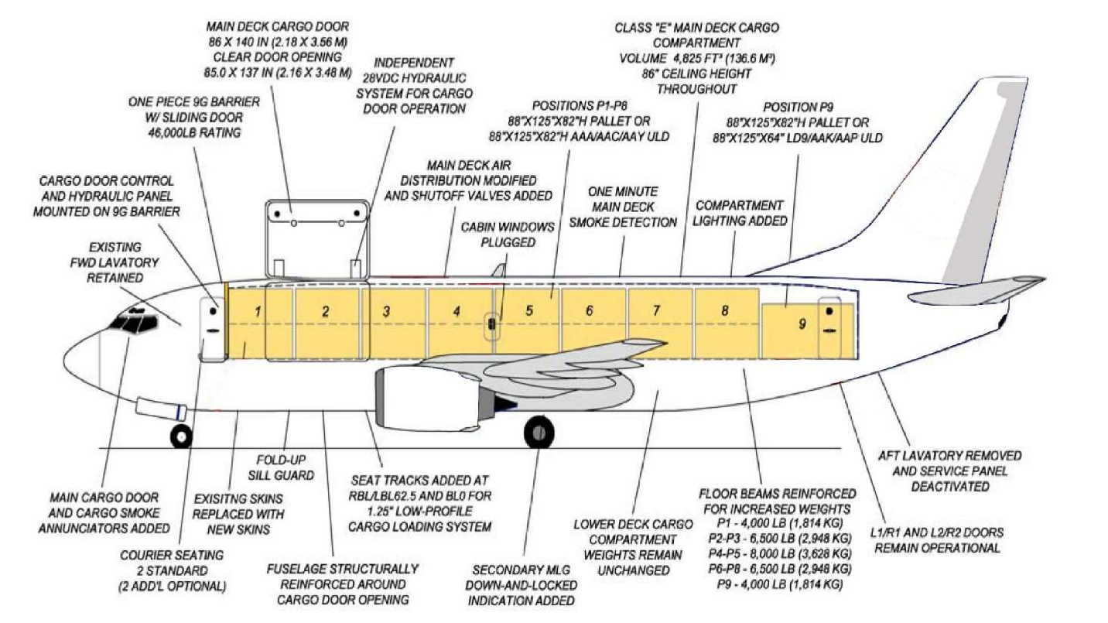

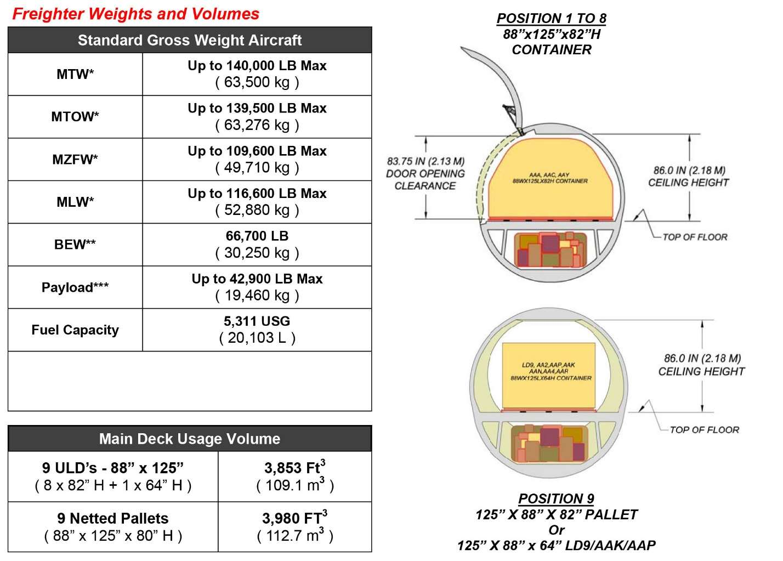

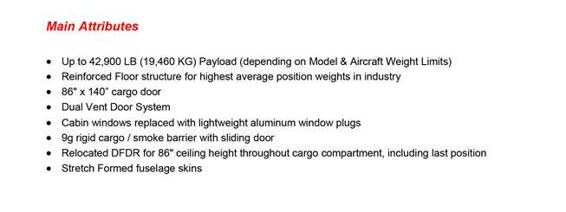

**AIRCRAFT SPECIFIC DATA**

|  |  |
| --- | --- |
|  | **Description:** |
| **Certification Basis** |  |
| 15 Knots Tailwind | Not compliant |
| **OPS Data** |  |
| Autoland Capabilities | Cat III |
| ETOPS | Not approved / Not maintained |
| Fuel flow & Fuel Qty Indication | Kg/Hr |
| RVSM | Compliant |
| Cockpit Indications Units of Measure | Imperial |
|  |  |
| **Additional Information** |  |
| Engine Thrust Rating – Customer Delivery | 20,000 lbs |
| Engine Thrust Rating – Current Operating | 20,000 lbs |
| Dual Advisory Ice Detection System | Not applicable |
| RVSM | Applicable |
| Sharklets/Winglets | N/A |
| Usable Fuel Capacity | 16000 kg |
| QNH/QFE | Installed |
| Metric Altitude on MCDU/CDU | Installed |
| TCAS-II Software version | 7 |

**AIRCRAFT MAINTENANCE STATUS**

|  |  |  |  |
| --- | --- | --- | --- |
| **Model:** | **B737-300SF** | **Maintenance plan:** | **Default** |
| **Manufacturer:** | **Boeing** |  |  |

|  |  |  |  |  |  |  |
| --- | --- | --- | --- | --- | --- | --- |
| **Check History** | **Perf date** | **FH** | **FC** | **Remaining** | | |
| **Days** | **Hours** | **Cycles** |
| A1 Check | 08.Jun.19 | 55938 |  |  | 150 |  |
| A2 Check | 24.Mar.19 | 55711 |  |  | 174 |  |
| A4 Check | 26.Sep.18 | 55296 |  |  | 258 |  |
| A8 Check | 26.Sep.18 | 55296 |  |  | 1,258 |  |
| C1 Check | 11.Dec.16 | 54386 |  |  | 1,174 |  |
| C2 Check | 18.Jan.14 | 50923 |  |  | 1,443 |  |

**ENGINE 1**

|  |  |  |  |  |
| --- | --- | --- | --- | --- |
| **Engine Model:** | CFM56-3C1 |  | **Serial No.:** | 726168 |
| **Manufacturer:** | CFM International |  | **Thrust level:** | 20,000 Lbs |
| **Status:** | On Aircraft |  |  |  |
| **Location:** | Left |  | **Status date** | 20-May-02 |

|  |  |  |  |
| --- | --- | --- | --- |
| **TSN** | **CSN** | **TSLSV** | **CSLSV** |
| 45,764 HRS | 35,698 CYL | 8,213 HRS | 6,053 CYL |

|  |  |  |  |  |  |  |  |  |  |
| --- | --- | --- | --- | --- | --- | --- | --- | --- | --- |
| **Description** | **Part No.** | **Serial No.** | **Limit** | | | **Total Cyl** | **Remaining** | | |
| **CAT A** | **CAT B** | **CAT C** | **CAT A** | **CAT B** | **CAT C** |
| BOOSTER SPOOL | 335-009-306-0 | DE690560 | 30,000 | 30,000 | 30,000 | 5,984 | 24,016 | 24,016 | 24,016 |
| FAN DISK | 335-014-511-0 | PA273662 | 30,000 | 24,900 | 20,100 | 5,984 | 24,016 | 19,933 | 16,091 |
| FAN SHAFT | 335-006-414-0 | DF962048 | 30,000 | 30,000 | 30,000 | 5,984 | 24,016 | 24,016 | 24,016 |
| FRONT SHAFT | 1275M37P02 | GWN06ET4 | 20,000 | 20,000 | 20,000 | 15,677 | 4,323 | 4,323 | 4,323 |
| SPOOL 1--2 | 1589M66G02 | GWN06MAP | 20,000 | 20,000 | 20,000 | 15,677 | 4,323 | 4,323 | 4,323 |
| DISK STG3 HPC | 1590M59P01 | XAE77023 | 20,000 | 20,000 | 20,000 | 15,677 | 4,323 | 4,323 | 4,323 |
| SPOOL 4--9 | 1588M89G03 | GWN065R2 | 20,000 | 20,000 | 15,800 | 15,677 | 4,323 | 4,323 | 3,415 |
| COMPR REAR AIR SEAL | 1319M25P02 | GFF5AFF7 | 20,000 | 18,000 | 15,000 | 15,677 | 4,323 | 3,891 | 3,242 |
| SHAFT FWD- HPT | 1385M90P04 | XAE64633 | 20,000 | 17,300 | 17,000 | 15,677 | 4,323 | 3,739 | 3,675 |
| FRONT AIR SEAL | 1282M72P05 | GWN05WT0 | 20,000 | 15,800 | 15,100 | 15,677 | 4,323 | 3,415 | 3,264 |
| HPT DISK | 1475M29P02 | GWN06FF5 | 20,000 | 18,500 | 16,600 | 15,677 | 4,323 | 3,999 | 3,588 |
| REAR SHAFT | 1864M91P02 | TMTTH133 | 20,000 | 20,000 | 20,000 | 15,677 | 4,323 | 4,323 | 4,323 |
| DISK STG1 LPT | 301-331-126-0 | BB974540 | 25,000 | 25,000 | 25,000 | 15,677 | 9,323 | 9,323 | 9,323 |
| DISK STG2 LPT | 301-331-227-0 | BB876940 | 25,000 | 25,000 | 25,000 | 15,677 | 9,323 | 9,323 | 9,323 |
| DISK STG3 LPT | 301-331-322-0 | BB974870 | 25,000 | 25,000 | 25,000 | 15,677 | 9,323 | 9,323 | 9,323 |
| DISK STG4 LPT | 301-331-429-0 | DC330946 | 25,000 | 25,000 | 25,000 | 15,677 | 9,323 | 9,323 | 9,323 |
| CONICAL SUPT | 305-056-116-0 | BA970397 | 25,000 | 25,000 | 25,000 | 21,577 | 3,423 | 3,423 | 3,423 |
| LPT SHAFT | 301-330-066-0 | PA675675 | 30,000 | 30,000 | 30,000 | 5,984 | 24,016 | 24,016 | 24,016 |
| LPT STUB SHAFT | 301-330-626-0 | BB927168 | 25,000 | 25,000 | 25,000 | 15,677 | 9,323 | 9,323 | 9,323 |

**ENGINE 2**

|  |  |  |  |  |
| --- | --- | --- | --- | --- |
| **Engine Model:** | CFM56-3C1 |  | **Serial No.:** | 726170 |
| **Manufacturer:** | CFM International |  | **Thrust level:** | 20,000 Lbs |
| **Status:** | On Aircraft |  |  |  |
| **Location:** | Right |  | **Status date** | 20-May-02 |

|  |  |  |  |
| --- | --- | --- | --- |
| **TSN** | **CSN** | **TSLSV** | **CSLSV** |
| 46 585 HRS | 35 067 CYL | 8 825HRS | 6 246 CYL |

|  |  |  |  |  |  |  |  |  |  |
| --- | --- | --- | --- | --- | --- | --- | --- | --- | --- |
| **Description** | **Part No.** | **Serial No.** | **Limit** | | | **Total Cyl** | **Remaining** | | |
| **CAT A** | **CAT B** | **CAT C** | CAT A | CAT B | **CAT A** |
| BOOSTER SPOOL | 335-009-306-0 | PA262008 | 30,000 | 30,000 | 30,000 | 6,183 | 23,817 | 23,817 | 23,817 |
| FAN DISK | 335-014-511-0 | BC061622 | 30,000 | 24,900 | 20,100 | 21,616 | 7,752 | 6,434 | 5,194 |
| FAN SHAFT | 335-006-414-0 | DD086797 | 30,000 | 30,000 | 30,000 | 11,884 | 18,116 | 18,116 | 18,116 |
| FRONT SHAFT | 1275M37P02 | GWN0438C | 20,000 | 20,000 | 20,000 | 18,687 | 1,313 | 1,313 | 1,313 |
| SPOOL 1--2 | 1589M66G02 | GWN04AC0 | 20,000 | 20,000 | 20,000 | 18,687 | 1,313 | 1,313 | 1,313 |
| DISK STG3 HPC | 1590M59P01 | XAE54323 | 20,000 | 20,000 | 20,000 | 18,687 | 1,313 | 1,313 | 1,313 |
| SPOOL 4--9 | 1588M89G03 | GWN04G3M | 20,000 | 20,000 | 15,800 | 18,687 | 1,313 | 1,313 | 1,037 |
| COMPRESSOR REAR AIR SEAL | 1319M25P02 | GFF59NKG | 20,000 | 18,000 | 15,000 | 18,687 | 1,970 | 1,873 | 1,727 |
| SHAFT FWD- HPT | 1385M90P04 | XAE64092 | 20,000 | 17,300 | 17,000 | 18,687 | 1,831 | 1,719 | 1,706 |
| FRONT AIR SEAL | 1282M72P05 | GWN0486W | 20,000 | 15,800 | 15,100 | 18,687 | 1,492 | 1,389 | 1,372 |
| HPT DISK | 1475M29P02 | GWN04CHP | 20,000 | 18,500 | 16,600 | 18,687 | 1,313 | 1,313 | 1,313 |
| REAR SHAFT | 9514M71P04 | DED23494 | 25,000 | 20,000 | 15,800 | 23,573 | 1,655 | 1,524 | 1,414 |
| DISK STG1 LPT | 301-331-126-0 | PA344508 | 25,000 | 25,000 | 25,000 | 6,183 | 18,817 | 18,817 | 18,817 |
| DISK STG2 LPT | 301-331-227-0 | BC917093 | 25,000 | 25,000 | 25,000 | 12,861 | 12,139 | 12,139 | 12,139 |
| DISK STG3 LPT | 301-331-322-0 | BB292142 | 25,000 | 25,000 | 25,000 | 13,373 | 11,627 | 11,627 | 11,627 |
| DISK STG4 LPT | 301-331-429-0 | DE986139 | 25,000 | 25,000 | 25,000 | 6,183 | 18,817 | 18,817 | 18,817 |
| CONICAL SUPT | 305-056-116-0 | DC055655 | 25,000 | 25,000 | 25,000 | 18,687 | 6,313 | 6,313 | 6,313 |
| LPT SHAFT | 301-330-066-0 | DC850114 | 30,000 | 30,000 | 30,000 | 6,183 | 23,817 | 23,817 | 23,817 |
| LPT STUB SHAFT | 301-330-624-0 | JN80195 | 25,000 | 25,000 | 20,000 | 18,559 | 3,347 | 3,347 | 2,678 |

**AUX POWER UNIT**

|  |  |
| --- | --- |
| **Manufacturer** | Honeywell |
| **Part number** | GTCP85-129(H) |
| **MSN** | P-100600 |
| **Time Since (TSN)** | 32146 |
| **Cycles Since New (CSN)** | 33681 |
| **Status Date** | 20-May-20 |
| **Last Heavy Shop Visit Date** | 29-Oct-18 |
| **Time Since Last Heavy Shop Visit** | 295 |
| **Operator`s Method of APU Time Calculation** | Hourmeter |

**LANDING GEARS**

|  |  |  |  |
| --- | --- | --- | --- |
| **POS** | **PART NO.** | **MO / CYL LIMIT** | **LAST OH** |
| **NLG** | 65-73762-21 | 120 MO / 21,000 CYL | 2019 |
| **MLG, LH** | 65-73761-107 | 120 MO / 21,000 CYL | 2019 |
| **MLG, RH** | 65-73761-108 | 120 MO / 21,000 CYL | 2019 |

**AVIONICS**

| **ATA** | **DESCRIPTION** | **ARLCODE** | **VENDOR PART NO.** | **SERIAL NO.** | **VENDOR** |
| --- | --- | --- | --- | --- | --- |
| 34 | COMPUTER - AIR DATA 1# | D006 | 501FAD1-1 | 1757 | SMITHS INDUSTRIES |
| 34 | COMPUTER - AIR DATA 2# | D006 | 501FAD1-1 | 2127 | SMITHS INDUSTRIES |
| 22 | AUTOTHROTTLE COMP | D007 | 755SUE2-4 | 6869 | SMITHS |
| 27 | DIGIT STALL WARN COMP1 | D008 | 65-52822-7 | D01600 | BOEING |
| 27 | DIGIT STALL WARN COMP2 | D008 | 65-52822-7 | D01470 | BOEING |
| 21 | CABIN TEMP CONTROL | D010 | 548376-6 | 074C-8593 | GARRET |
| 21 | PRESSURE CONTROL | D011 | 763810-1 | 89061877 | HAMITON |
| 34 | FLT MNGT COMP | D012 | 168925-07-01 | 1706 | SMITHS |
| 34 | FLT INSTR ACCESSORY UNIT | D013 | 65-52805-379 | D01644 | BOEING |
| 34 | IRS XFR RELAY NO 1 | D014 | 172938-001 | 8252 | LUCAS |
| 34 | IRS XFR RELAY NO 2 | D014 | 172938-001 | 8253 | LUCAS |
| 34 | ADAPTER DIGITAL ANALOG 1# | D015 | DG1035AB03 | 1184 | HONEYWELL |
| 34 | ADAPTER DIGITAL ANALOG 2# | D015 | DG1035AB03 | 325 | HONEYWELL |
| 77 | ENG VIB SIG COND | D016 | S360N021-202 | BM93 | ENDEVCO |
| 22 | FLT CTRL COMP 1 | D017 | 405/600-923 | 88051256 | HONEYWELL |
| 22 | FLT CTRL COMP 12 | D017 | 405/600-913 | 91052427 | HONEYWELL |
| 22 | COUPLER ASSY-YAW DAMPER | D018 | 4084042-911 | 99091776 | HONEYWELL |
| 23 | ACARS MANAGEMENT UNIT | NA | 65-0758-0010 | 3418 | HONEYWELL |
| 22 | AUTO FLT CTRL ACCY UNIT | D019 | 65-52817-9 | D01126 | BOEING |
| 23 | VHF COMM TRANSCEIVER 1# | D027 | 622-1396-101 | 10556 | COLLINS |
| 23 | VHF COMM TRANSCEIVER 2# | D027 | 622-1396-101 | 12215 | COLLINS |
| 23 | VHF COMM TRANSCEIVER 3# | NA | 064-50002-0101 | 818 | HONEYWELL |
| 23 | SEL CAL DCDR | D029 | N1401C | 706CSW0038 | MOTOROLA |
| 23 | REMOTE ELEX UNIT | D026 | 51401-1 | 1186 | AVTECH |
| 23 | PASS ADDRESS AMPLIFIER | D025 | 622-4096-001 | 6435 | COLLINS |
| 34 | DME 2 | D030 | 622-2921-006 | 13424 | COLLINS |
| 34 | DME 1 | D030 | 622-2921-006 | 15622 | COLLINS |
| 31 | DFDAU | D031 | 967-0212-002 | 2204 | HONEYWELL |
| 34 | ATC TRANSCEIVER 1# | D028 | 622-7878-201 | 79AM | COLLINS |
| 34 | EFIS GENERATOR | D032 | 622-9436-101 | 109106 | COLLINS |
| 34 | EFIS GENERATOR | D032 | 622-9436-101 | 196YR | COLLINS |
| 34 | MARK BEACON RECEIVER | D037 | 522-2996-011 | 18336 | COLLINS |
| 34 | ADF 2 | 36 | 777-1492-005 | 17737 | COLLINS |
| 34 | ADF 1 | D036 | 777-1492-005 | 17762 | COLLINS |
| 34 | EGPWC | D035 | 965-0976-060216-216 | 18470 | HONEYWELL |
| 34 | ATC TRANSCEIVER 2# | D034 | 622-78-18-201 | 9043 | COLLINS |
| 34 | RA TRANSCEIVER 1# | D033 | 622-3890-020 | 9548 | COLLINS |
| 34 | RA TRANSCEIVER 2# | D033 | 622-3890-020 | 6999 | COLLINS |
| 24 | TRANSFORMER - RECTF 1 | D039 | 080-20325-01 | 6387 | OECO |
| 24 | TRANSFORMER - RECTF 2 | D039 | 080-20325-01 | 6425 | OECO |
| 24 | TRANSFORMER - RECTF 3 | D039 | 080-20325-01 | 6426 | OECO |
| 24 | BATTERY CHARGER | D040 | 2-792-02 | 3053 | ELDEC |
| 24 | STATIC INVERTER | D041 | 3913168-1-C | 077C-2215 | BENDIX |
| 27 | AUTO SPEED BRAKE CTRL | D042 | 65-84209-21 | D01649 | BOEING |
| 32 | ANTI-SKID UNIT | D043 | 42-719-01 | 368 | CRANE |
| 21 | AIR CONDITION RELAY | D044 | 65-52810-57 | D03348 | BOEING |
| 78 | ENGINE ACCESSORY UNIT | D045 | 65-73606-149 | D02265 | BOEING |
| 26 | OVERHEAT DETECTION | D046 | 20-035008-300 | B0902 | FENWAL |
| 52 | MISC SOLID STATE SW | D047 | 65-52806-346 | D00957 | BOEING |
| 27 | FLAP & SLAT POS SW | D048 | 65-52807-39 | D02292 | BOEING |
| 49 | APU CONTROL | D049 | 65-52801-31 | D01697 | BOEING |
| 26 | FIRE DETECTOR | D050 | 472622 | 2350 | WALTER KIDDE |
| 30 | WINDOW HT CONT1 R SIDE | D051 | 83000-05601 | 3405 | KOITO |
| 30 | WINDOW HT CONT2 L FRONT | D051 | 83000-05602 | 5076B | KOITO |
| 30 | WINDOW HT CONT3 LSIDE | D051 | 83000-05602 | 5510 | KOITO |
| 30 | WINDOW HT CONT3 R FRONT | D051 | 83000-05604 | 5510C | KOITO |
| 34 | VHF NAV RECEIVER 1# | D052 | 622-3257-001 | 4157 | COLLINS |
| 34 | VHF NAV RECEIVER 2# | D052 | 622-3257-001 | 10034 | COLLINS |
| 23 | HF COMM | D056 | 622-5377-001 | 572 | COLLINS |
| 34 | TCAS COMPUTER UNIT | NA | 4066010-913 | 92010871 | ACSS |
| 34 | IRU 1 | D038 | HG1050AD04 | 3393 | HONEYWELL |
| 34 | IRU2 | D038 | HG1050AE09 | 99023234 | HONEYWELL |
| 27 | ACTUATOR - SPEED BRAKE | D001 | R5303M1 | 940207 | SMITHS |
| 34 | WEATHER RADAR | D002 | 622-5132-109 | 3789 | COLLINS |

**B737-300SF ACTUAL PHOTOS**

