**AIRCRAFT TECHICAL SPECIFICATION SUMMARY REPORT**

**14/May/2020**

Model: **Airbus A321-231**

Registration: **ES-MLS**

Currently operating for:

**AC ready for operation / EASA – August 2020.**

(Previously operated by Vietnam Airlines, currently under maintenance and painting to white)

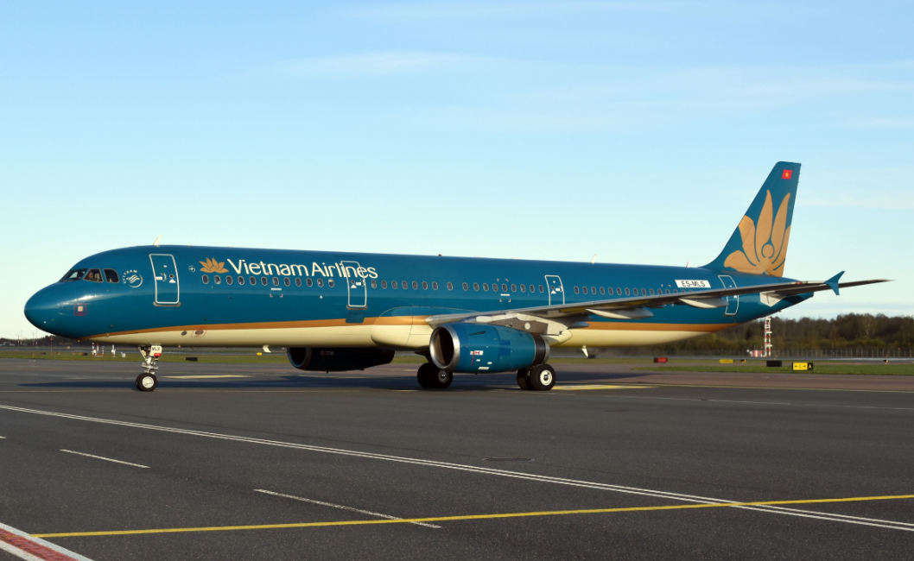

* 1. **General**

|  |  |
| --- | --- |
| **Type and Model** | **Airbus A321-231** |
| **Aircraft Serial Number (MSN)** | **2480** |
| **Date of manufacture (DOM)** | **May 2005** |
| **First flight date** | **21 May 2005** |
| **Current Registration Mark (Country)** | **ES-MLS (Estonia)** |

* 1. **Airframe Status**

|  |  |
| --- | --- |
| **Airframe Status** | |
| **Total Airframe Hours** | **35,338.95 FH** |
| **Total Airframe Cycles** | **23,888 FC** |
| **Ratio (FH/FC)** | **1.35** |
| **Status Date** | **14/May/2020** |

* 1. **Engines Status**

|  |  |
| --- | --- |
| **Engine No 1 – ESN V12665** | |
| **Total Hours** | **31,596.58** |
| **Total Cycles** | **18,123** |
| **Last SV** | **06 Feb 2017 – EGAT/ High time operation** |
| **Limiter - LLP** | **1473 FC for various LLPs** |
| **Last Full BSI information** | **No Limitations** |
| **EGT Margin** | **35 Deg. C** |
| **Engine No 2 – ESN V12767** | |
| **Total Hours** | **30906.59** |
| **Total Cycles** | **18,027** |
| **Last SV** | **25 Jan 2017 – IHI/ High time operation** |
| **Limiter - LLP** | **1973 FC for various LLPs** |
| **Last Full BSI information** | **Reduced inspection interval of 1500FH due to HPT1 Blade** |
| **EGT Margin** | **37 Deg C** |

* 1. **Maintenance Check Intervals**

|  |  |
| --- | --- |
| **Maintenance Check Intervals** | |
| **Base HM-check interval** | **7 500 FH/ 4500 FC/ 24 Month *(whichever comes first)*** |
| **A - Check interval** | **750 FH/ 750 FC/ 4 Month *(whichever comes first)*** |

**2.1. Airframe Maintenance Status**

|  |  |
| --- | --- |
| **Airframe Maintenance Status** | |
| **Last HM Check** | **13-Jun-2019 at *34,624 FH/ 23,420 FC*** |
| **Next HM Check Due** | **13-Jun-2021 at *42,124 FH*** |
| **Last A Check** | **Mar-2020** |
| **Last 6YR Check** | **07-Jun-2017 at *28,769 FH/ 19,640 FC*** |
| **Next 6YR Check Due** | **Jun-2023** |
| **Last 12YR Check** | **07-Jun-2017 at *28,769 FH/ 19,640 FC*** |
| **Next 12YR Check Due** | **Jun-2029** |

**2.2 Operational Weights**

**Weight Variant: WV000**

|  |  |  |
| --- | --- | --- |
| **Operational Weights** | **US** | **European** |
| **Maximum Taxi Weight (MTW)** | **197 093 (lbs)** | **89 400 (kg)** |
| **Maximum Take Off Weight (MTOW)** | **196 211 (lbs)** | **89 000 (kg)** |
| **Maximum Landing Weight (MLW)** | **166 449 (lbs)** | **75 500 (kg)** |
| **Maximum Zero Fuel Weight (MZFW)** | **157 630 (lbs)** | **71 500 (kg)** |
| **Maximum Usable Fuel Capacity (SG 0.8)** | **6350 U.S Gallons** | **24 037 Litres** |

**2.3 Aircraft Configuration Status**

|  |  |
| --- | --- |
| **Aircraft Configuration** |  |
| **Thrust Rating** | **V2533** |
| **Winglets (Sharklets)** | **No** |
| **Noise Category** | **Stage III iaw. ICAO Annex 16** |
| **Approach Category** | **CAT III** |
| **Current Interior Arrangement** | **Y207– 207PAX** |
| **Attendant Seats** | **8 (FWD-2; CABIN-2, AFT-4)** |
| **In Flight Entertainment** | **Yes (PSU)** |
| **Lavatories** | **4: FWD-LA; AFT-LD; LE; LH** |
| **Galleys** | **3: G1; G2; G5** |
| **TCAS 7.1** | **Yes** |
| **ADS B Out** | **Yes** |
| **CPDLC** | **Yes** |
| **VHF 8.33 Spacing** | **Compliant** |
| **Cargo Compartment Fire** | **Class C** |
| **Cargo Loading System** | **Installed** |
| **Livery** | **Full White** |

**3.1 Installed Landing Gear Status**

|  |  |  |  |
| --- | --- | --- | --- |
| **LDG Details** | **NLG** | **LH MLG** | **RH MLG** |
| **Part Number** | **D23757500-9** | **201585003-020** | **201585004-020** |
| **Serial Number** | **14B31805** | **M-DG-0444** | **M-DG-0445** |
| **Cycles Since New** | **7,242** | **22,725** | **22,725** |
| **Last Overhaul Date** | **22-Dec-2014 (New)** | **09-Feb-2015** | **09-Feb-2015** |
| **Cycles Since Overhaul** | **7,242** | **7,242** | **7,242** |
| **Overhaul Interval** | **20000 FC**  **or 10 Years** | **20 000 FC**  **or 10 Years** | **20 000 FC**  **or 10 Years** |

**3.2 Installed APU Status**

|  |  |
| --- | --- |
| **APU STATUS** | |
| **Manufacturer** | **Honeywell** |
| **Model** | **131-9A** |
| **Serial Number** | **P-4928** |
| **Total APU Time Since New** | **16,976 APU FH 16,976** |
| **Total APU Cycles Since New** | **15,708 APU FC** |
| **Last Hot Section SV Date** | **12-Aug-2016** |
| **APU Hours Since Last Shop Visit** | **8,047 APU FH** |
| **Cycles Since Last Shop Visit** | **6,307 APU FC** |
| **First Limiter** | **13,153 APU FC** |

**4.1 Installed Avionics Equipment Status**

|  |  |  |  |
| --- | --- | --- | --- |
| **MAJOR INSTALLED AVIONICS EQUIPMENT** | | | |
| **Description** | **Manufacturer** | **Part Number** | **qty** |
| **Flight Management Control Unit (FMGC)** | **Thales/GE** | **C13043BA08** | **2** |
| **HF TRANSCEIVER** | **Rockwell Collins** | **822-0990-003** | **2** |
| **EGPWS** | **Honeywell** | **965-1676-002** | **1** |
| **ADIRU** | **Honeywell** | **HG2030AD11 & HG2030AC11** | **3** |
| **Radio Altimeter Transceiver** | **Rockwell Collins** | **822-0334-020** | **3** |
| **VHF/COMM Transceiver** | **Thales** | **EVR750-03-0100A** | **3** |
| **MULTI Mode Receiver (ILS/GPS)** | **Thales** | **TLS755-01-0102A** | **3** |
| **TCAS 7.1** | **Honeywell** | **940-0351-005** | **1** |
| **ATC MODE S Transponder** | **Honeywell** | **066-01212-0102** | **2** |
| **DME Interrogator** | **Rockwell Collins** | **822-0329-020** | **2** |
| **VOR Marker Beacon Receiver** | **Rockwell Collins** | **822-0297-020** | **2** |
| **ADF Receiver** | **Rockwell Collins** | **822-0299-020** | **2** |
| **IFSAU** | **Rockwell Collins** | **65-52820-2** | **1** |
| **Weather Radar Transceiver** | **Rockwell Collins** | **822-1710-204** | **2** |
| **Printer** | **Honeywell** | **8055515-4501** | **1** |
| **EFIS Control Panel** | **Thales** | **C12850BC02** | **2** |
| **Flat Panel Display** | **Thales** | **3907130402** | **6** |
| **Solid State Flight Data Recorder** | **Honeywell** | **980-4700-042** | **1** |
| **Solid State Cockpit Voice Recorder** | **Honeywell** | **980-6022-001** | **1** |
| **SELCAL Decoder** | **TEAM - COBHAM AVIONICS** | **BC2065C** | **1** |
| **FMS - Control Display Unit** | **Thales** | **C12850BC02** | **2** |
| **Actuator Control Electronics Unit** | **BAE** | **488550-10-02** | **4** |
| **PFC Computer** | **BAE** | **49-177-12** | **3** |
| **ATSU** | **AIRBUS** | **LA2T0G20503B050** | **1** |

**5.1 ENGINE NO. 1 – ESN V12665 – LLP DATA**

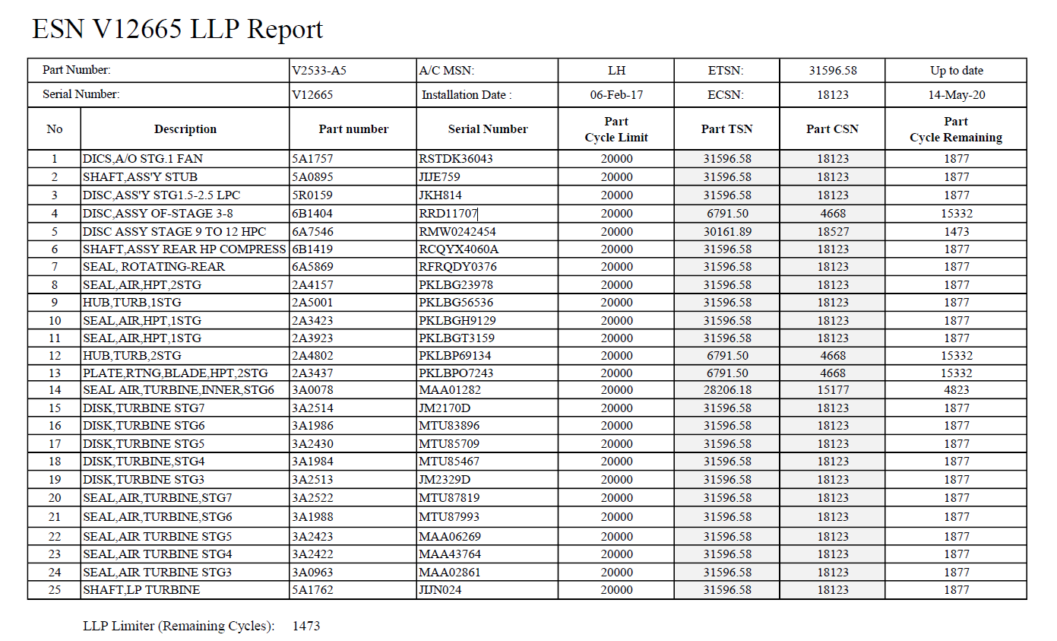

**5.2 ENGINE NO. 2 – ESN V12767– LLP DATA**

