To UBS AU 150,000MT SCO Switzerland 2020/09/26
(Valid 7 days after this issuing date)

To end buyer via Mr. DAN
Seller | UBS
Buyer | End buyer
Commodity | AU 12.5kg
Purity | 999,5%
Quantity | 150,000MT (First minimum tranche 5 MT)
Hallmark | UBS
Age | 5 years over
Price | LBMA Second Fixing Price
Discounts | Gloss 15% Net 12%
Consultant Fee | Consul Fee 3%
LOCATION | Security Warehouse Swiss
Delivery | Security Warehouse Swiss
Refining Certificates | UBS
Currency | US$ \
Payment | BANK to BANK via MT103
Note | Not liftable after change of ownership
Documentation
1 Certificates of Origin
2 International Assay Certificates LBMA approved
3 Certificates Ownership
4 DELIVERY Consultation
5 Annual Assay Report, Bullion Weight List GLD Bar List Seral numbers
List of Procedures
1 SCO from Seller
2 Buyer issues LOI and prepares POF DCL by Seller
3 TTM, showing POF from buyer and POP ,SKR from sellers
4 Both parties discuss transportation, warehousing and payments
5 SPA Contract
6 Bank Settlement
7 Commissions paid by Paymaster
8 Delivery of the Goods /Change of Title against Funds

Seller name UBS

Letter of Intent
(Purchase application)
Dear UBS

This Letter of Intent is intended to purchase the AU Bars proposed by seller under terms and conditions described hereafter
1 Quantity AU 150,000 MT (First Minimum Tranche 5 MT)
2 Delivery place Swiss Land
3 Quality 999.5 /1000
12,5kg
Mark UBS Assayed within 5 years over
4 Price LBMA 2nd fixing of previous day
5 Discounts Gloss 15% Net 12%
6 Consultant Fee Consul Fee 3 %
7 Payment US$ \
8 Buyer Information
Company Name
Name
Address
TEL
E: Mail
Passport NO (CEO) Color Copy 1
Bank Information
POF Letter（required）

Buyer Signature end buyer via Mr. DAN

Buyer Information
COMPANY NAME: | End buyer via Mr. DAN
COMPANY ADDRESS:
REG. NUMBER:
REPRESENTED BY:
TITLE:
PASSPORT NUMBER:
PASSPORT COLOR COPY
PASSPORT ISSUE DATA:
PASSPORT EXPIRY DATA:
COUNTRY OF ISSUE:
BANK NAME: ADDRESS
BANK ACCOUNT NO POF(required)
ACCOUNT NAME
BANK OFFICER NAME
BANK TEL ADDRES
E:MAIL (OFFICER)
PASPORT COPY
Please Fill in Blanks
Buyer Mandate Name xxxxxxxxxxxxxx Signature

Subject: AU Deal Process at UBS

To Whom It May Concern,

Thank you very much for waiting for a long time. I would like to inform you about the decision made by the Japanese side regarding the AU transactions on the UBS campus.

The Japanese side (SMBC; Sumitomo Mitsui Banking Corporation) will accept the AU purchase intention (LOI) that I, Yosuke Kudo, and your company have exchanged, and the bank will investigate it. If there are no particular problems (purchasing company, purchasing funds POF, bank information, etc.), they will send (e-mail) those documents to the department in charge of UBS in Switzerland. If there is no problem after investigating on the UBS side, UBS will send a Consultant Agreement document to me, Yosuke Kudo.

After I sign and return it to UBS, your Bank Officer in UBS will be contacted and normal on-site transactions will start. After that, both the Buyer and the Seller will complete the purchase transactions according to the instructions of UBS. The Time Schedule will be reported to you tomorrow, September 25th. Please note again that this transaction will take place on the UBS campus in Switzerland.

Sincerely yours,

Letter of Authorization

I, end buyer via Mr. DAN have duly authorized Mr. Yosuke Kudo described below as the Consulting between the Seller and the Buyer regarding the AU deal transactions this time.

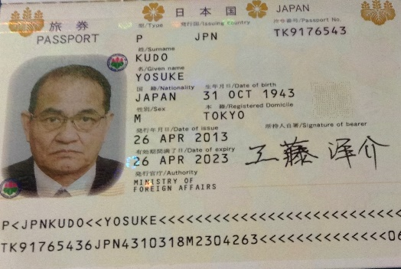 | Name Yosuke Kudo
 | Date of Birth Octo 31 1943
 | Passport No JPN TK9176543
Signature
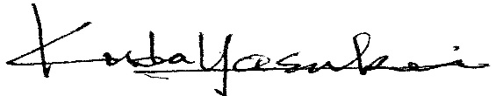

Date 26 September 2020

Name

Signature

