LED Solar Energy Light- Full Container Order Qty Price
No | Pictures | Model No | Description | Cover Color | Product Size (MM) | Power (W) | Volts | Luminous Flux(LM) | Color Temp.(K) | Unit Price (USD/PC) | IP Grade | LED  Type | LED Qty (PCS) | Power Source | Material | Battery
1 | 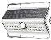 | TJ-MWS-White-F | Medium Solar Energy Light-White  *Flat cover  *3 modes by Dip Switch:100%，10%,  100%/10% | White | 182*132*44 | 1.2W | 3.7V | 230 | 3/4/6000K | $7.18 | IP65 | SMD2835 | 32 | solar- powered | High-quality ABS Material | 1 Lithium ion battery(3.7VDC 2000mA)
2 | 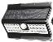 | TJ-MBS-Black-F | Medium Solar Energy Light-Black  *Flat cover  *3 modes by Dip Switch:100%，10%,  100%/10% | Black | 182*132*44 | 1.2W | 3.7V | 230 | 6000K | $7.18 | IP65 | SMD2835 | 32 | solar- powered | High-quality ABS Material | 1 Lithium ion battery(3.7VDC 2000mA)
3 |  | TJ-LWS-White-F | Large Solar Energy Light-White  *Flat cover  *3 modes by Dip Switch:100%，10%,  100%/10% | White | 300*132*44 | 2.4W | 3.7V | 465 | 6000K | $9.30 | IP65 | SMD2835 | 56 | solar- powered | High-quality ABS Material | 2 Lithium ion battery(3.7VDC 4000mA)
4 |  | TJ-LBS-Black-F | Large Solar Engergy Light-Black  *Flat cover  *3 modes by Dip Switch:100%，10%,  100%/10% | Black | 300*132*44 | 2.4W | 3.7V | 465 | 6000K | $9.30 | IP65 | SMD2835 | 56 | solar- powered | High-quality ABS Material | 2 Lithium ion battery(3.7VDC 4000mA)
5 | 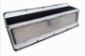 | TJ-LWS-White-L | Large Solar Energy Light-White  *Wave-Lens Style Cover  *3 modes by Dip Switch:100%，10%,  100%/10% | White | 300*132*44 | 2.4W | 3.7V | 465 | 6000K | $10.35 | IP65 | SMD2835 | 200 | solar- powered | High-quality ABS Material | 2 Lithium ion battery(3.7VDC 4000mA)
6 |  | TJ-LBS-Black-L | Large Solar Engergy Light-Black  *Wave-Lens Style Cover  *3 modes by Dip Switch:100%，10%,  100%/10% | Black | 300*132*44 | 2.4W | 3.7V | 465 | 6000K | $10.35 | IP65 | SMD2835 | 200 | solar- powered | High-quality ABS Material | 2 Lithium ion battery(3.7VDC 4000mA)
5 |  | TJ-LWS-White- L+R | Large Solar Energy Light-White  *Wave-Lens Style Cover  *3 modes by Dip Switch/Remoter:100%，  10%, 100%/10% | White | 300*132*44 | 2.4W | 3.7V | 465 | 6000K | $10.70 | IP65 | SMD2835 | 120 | solar- powered | High-quality ABS Material | 2 Lithium ion battery(3.7VDC 4000mA)
6 |  | TJ-LBS-Black-L+R | Large Solar Engergy Light-Black  *Wave-Lens Style Cover  *3 modes by Dip Switch/Remoter:100%，  10%, 100%/10% | Black | 300*132*44 | 2.4W | 3.7V | 465 | 6000K | $10.70 | IP65 | SMD2835 | 120 | solar- powered | High-quality ABS Material | 2 Lithium ion battery(3.7VDC 4000mA)

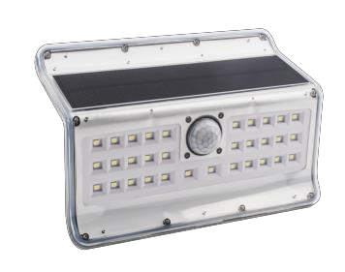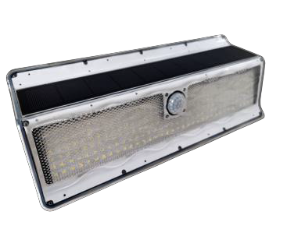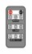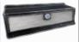Remarks
- MOQ: 1,000PCS/Model.
- Packing Prices including 4C printing color box according to our Standard. Non-standard packing will be charged
- Delivery Time: 30-40days after receive deposit and confirm graphic designs.
- Warranty:1 years

- Detection distance is 3-5M, three mode as below, all of them are work in night automatically, and stop working but charging by solar light in day time.

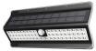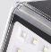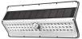
Mode one (100%):Turn on when people approach, 100% brightness. Turn off 30S later when people left the detection area.
Mode two(10%): Keep 10% brightness all the time in night time.
Mode three(100%/10%): Turn on automatically when people approach,be 100% brightness. Turn to 10% 30S later when people left the detection,circular like this.

Flat Cover

Wave-Lens Style Cover

