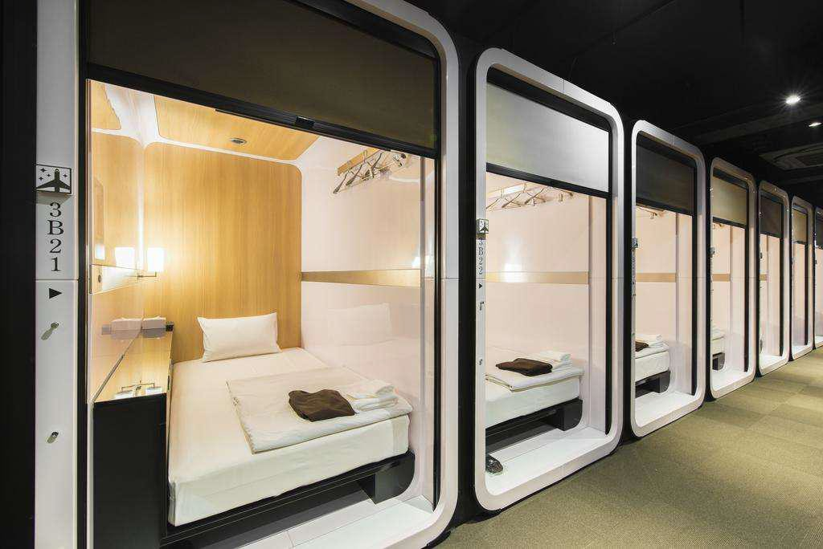
ADI Lic01,the price is usd$4,999 each one, the size is 1500*2100*2100mm,include lighting,venilation fan,table,mirror,bed,mattress

lighting,venilation fan,table,mirror,bed,mattress and air-conditioner

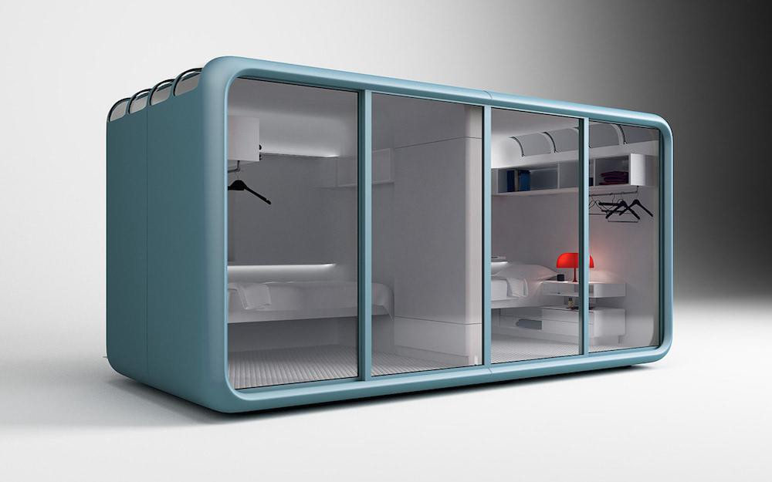

2100*1100*2400,include bed ,lighting,venilation socket,

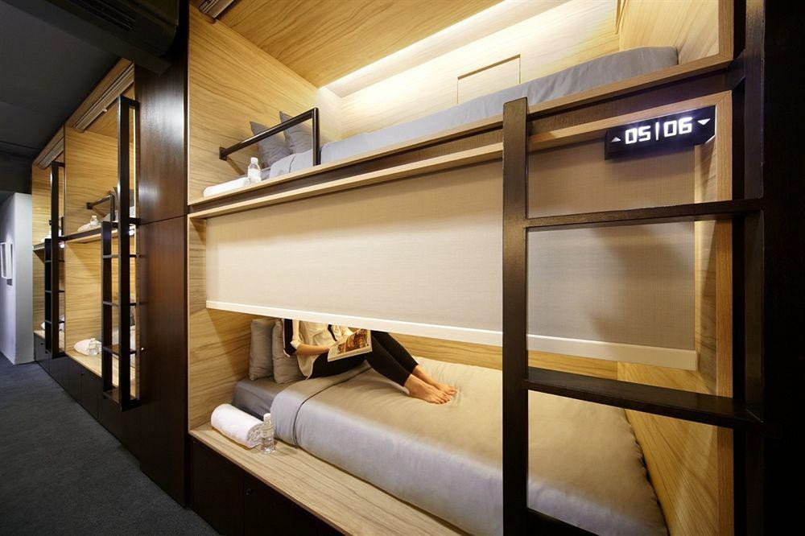

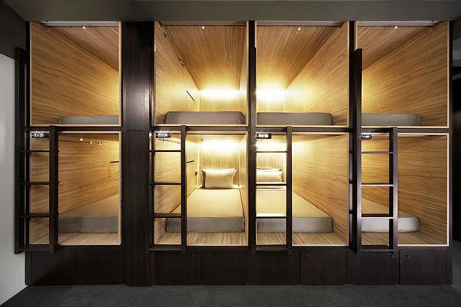

Can ship worldwide shipping cost depend on the quanlity and the discharge port

