AWB (if available)
Product Reference |  | 3M, 1860, N95, Face Mask
Product Origin |  | USA
Product Location |  | South Africa
Destination |  | Germany
VIA |  | Sea Freight or Airfreight
Actual Weight |  | 11.3g per face mask
Chargeable Weight |  | 2.20kg per carton
Shipment Information
No. of PCS | G.W. per PCS |  | L(cm) | W(cm) | H(cm)
120 | 2.02kg |  | 41.50 | 28.50 | 22
Commodity |  | 3M, 1860, N95, Face Mask
Expected Date of uplift |  | ASAP
Stackable (yes-no) |  | yes
Remarks |  | PPE
Conditions |  |  | Packed in sealed cartoons

- For the order of 4 Billion units of mask the number of cartoons will be 4,000,000,000 units / 120 cartoons = 33,333,334 cartoons.
- On a normal cargo plane we fit only 2.4 million Face Mask.
- Now you can do the calculations from this information.
- To fill an aircraft you won’t be able to put it on pallets, you will have lots of wasted space.
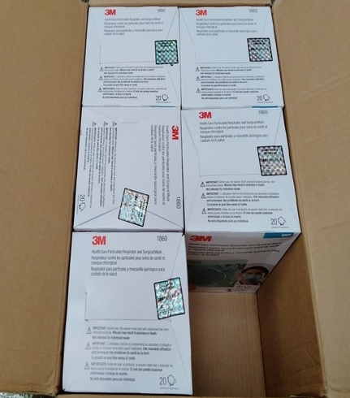
Picture of inside a case.

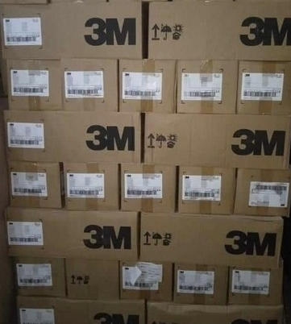
Picture of the case

