CONDITION OF SALE / SPECIAL INSTRUOCTINS:  This will be provided under separate cover. |  |  |  |  | Quotation
PRODUCT: OXYGEN CONCENTRATORS - 5L & 10L | APPLICATION: Medical
SALESPERSON | P.O. NUMBER | SHIP DATE |  | SHIP VIA | F.O.B. POINT | DELIVERY TERMS
Gerald Provost | TO BE PROVIDED | TBD |  | BUYER LOGISTICS | China: Outgoing port could be  Shanghai, Shenzhen,  GuanZhou or Hong Kong. | PER CUSTOMER
QUANTITY | DESCRIPTION |  | PACKAGING | UNIT PRICE | IMAGE
2000 | 5L Stationary Oxygen Concentrator  Capacity : 5 L  Purity Oxygen: ≥ 93%±3 ( V/V ) Flow rate: 1-5L/min Voltage:  AC220V±22V,50Hz±1Hz/AC110V±15  V,60Hz±1Hz  Output Pressure: 20kPa～60kPa  Sound Level: less than 45db  Power Consumption: 300watts  Guarantee: 12 months  Gross Weight：25kg  Package Size：55*33*65 |  CERTIFICATION  CE | FDA | ISO13485 |  | MOQ: N/A  Lead Time: 3-5 days Accessories included:  1 x Oxygen Concentrator  - x Humidifier Bottle  - x Nasal oxygen cannula  2 x First Filter  6 x Second Filter  1 x User Manual  1 x Warranty Card | $699.00 | FWB-WMC-01  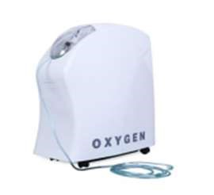
2000 | 5L Stationary Oxygen Concentrator  Capacity : 5 L  Purity Oxygen: ≥ 93%±3（V/V）  Flow rate:1-5L/min  Voltage：  AC220V±22V,50Hz±1Hz/AC110V±15  V,60Hz±1Hz  Output Pressure：20kPa～60kPa  Sound Level: less than 45db power  Consumption: 300VA  Gross Weight: 23kg  Package Size：44*39*69c CERTIFICATION  CE | FDA | ISO13485 |  | MOQ: N/A  Lead Time: 3-5 days Accessories included:  1 x Oxygen Concentrator  - x Humidifier Bottle  - x Nasal oxygen cannula  1 x First Filter  1 x HEPA Filter  1 x User Manual | $734.40 | FWB-WMC-02  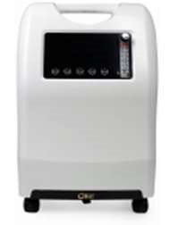
2000 | 5L Stationary Oxygen Concentrator  Capacity : 5 L  Purity Oxygen: ≥ 93%±3（V/V） Flow rate: 1-5L/min Voltage：  AC220V±22V,50Hz±1Hz/AC110V±15  V,60Hz±1Hz  Output Pressure：20kPa～60kPa  Sound Level: less than 45db  Power Consumption: 300VA  Gross Weight: 23kg  Package Size：44*39*69cm  CERTIFICATION  CE | FDA | ISO13485 |  | MOQ: N/A  Lead Time: 3-5 days Accessories included:  1 x Oxygen Concentrator  - x Humidifier Bottle  - x Nasal oxygen cannula  1 x First Filter  1 x HEPA Filter  1 x User Manual | $758.00 | FWB-WMC-03  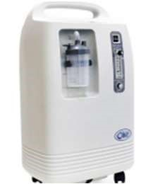

2000 | 10L Stationary Oxygen Concentrator  Capacity : 10 L  Purity Oxygen: ≥ 93%±3（V/V）  Flow Rate: 1-10L/min  Voltage：  AC220V±22V,50Hz±1Hz/AC110V±15  V,60Hz±1Hz  Output Pressure：20kPa～60kPa  Sound Level: less than 48db  Power Consumption: 550VA  Gross Weight: 28kg  Package Size：44*39*73cm  CERTIFICATION  CE | FDA | ISO13485 | MOQ: N/A  Lead Time: 3-5 days Accessories included:  1 x Oxygen Concentrator  - x Humidifier Bottle  - x Nasal oxygen cannula  1 x First Filter  1 x HEPA Filter  1 x User Manual | $921.40 | FWB-WMC-04  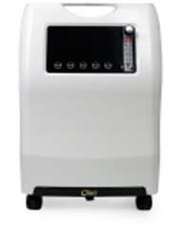
1000 | 10L Stationary Oxygen Concentrator  Capacity : 10 L  Purity Oxygen: ≥ 93%±3（V/V）  Flow Rate: 1-10L/min  Voltage：  AC220V±22V,50Hz±1Hz/AC110V±15 V,60Hz±1Hz  Output Pressure：20kPa～60kPa  Sound Level: less than 48db  Power Consumption: 550VA  Gross Weight: 28kg  Package Size：44*39*73c  CERTIFICATION  CE | FDA | ISO13485 | MOQ: N/A  Lead Time: 3-5 days Accessories included:  1 x Oxygen Concentrator  - x Humidifier Bottle  - x Nasal oxygen cannula  2 x First Filter  6 x Second Filter  1 x User Manual  1 x Warranty Card | $970.40 | 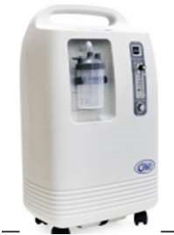
THANK YOU
FOR YOUR BUSINESS
ENDORSEMENTS
PROSPECTIVE CUSTOMER

Name
Managing Principal Title

