CONDITION OF SALE / SPECIAL INSTRUCTIONS:
This will be provided under separate cover.
PRODUCT: OXYGEN CONCENTRATORS - 5L | APPLICATION: Medical
SALESPERSON | P.O. NUMBER | SHIP DATE | SHIP VIA | F.O.B. POINT | DELIVERY TERMS
Gerald Provost | TO BE PROVIDED | TBD | BUYER LOGISTICS | China - Outgoing port could be  Shanghai, Shenzhen, GuanZhou or Hong Kong. | PER | CUSTOMER
QUANTITY | DESCRIPTION |  | UNIT PRICE | IMAGE | AMOUNT
2000 | 5L OXYGEN CONCENTRATOR (MODEL:8F-5AW)  POWER SOURCE：AC220V±22V，50Hz±1Hz  RATED POWER：350W  NOISE：＜58dB（A）  FLOW RANGE：1-5L/min  OXYGEN PURITY：1-5L/min≥90%  MAX OUTPUT PRESSURE：45KPa±4.5KPa  COMPRESSOR PROTECT PRESSURE：250KPa±25KPa  FLOW FLUCTUTION（UNDER BACK PRESSURE  7KPa）：0.7L/min  NEBULIZER FLOW：≥0.2mL/min  CONTINUOUS RUNNING TIME：24HOURS  CURRENT OVERLOAD PROTECTION SWITCH：5A，220V  PRODUCT WEIGHT：22 Kg  ENVIRONMENT TEMPERATURE：5℃~40℃  HUMIDITY RANGE：≤80%  ATMOSPHERIC PRESSURE RANGE：86KPa~106KPa  OCSI TEMPERATURE AND ATMOSPHERIC PRESSURE  RANGE：0~50℃；150KPa  OXYGEN PURITY WHEN ALERT FROM  OCSI：＜82%±1.5%（80.5%~83.5%）  ALTITUDE IN USING：USE UNDER THAN 1,828M  CERTIFICATION  Currently being used WHO and Red Cross |  | $734.40 | 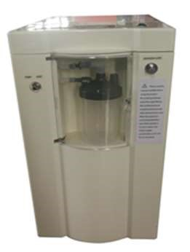
SUBTOTAL
TAX RATE
SALES TAX
OTHER

THANK YOU
FOR YOUR BUSINESS
PROSPECTIVE CUSTOMER

______________________________ ________________________________________________________________
Name
Managing Principal Title

