QUOTATION

Quotation # Date : 2nd August , 2021

Item No. | Picture | Product Description | Package List | Packing infio | U.pirce EXW factory
 |  |  |  |  |  | 101~1000 | 1001~3000
SLK-001 | 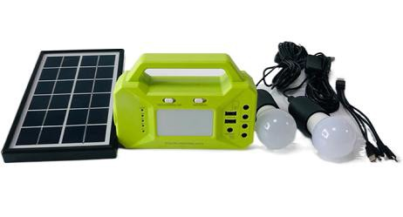 | 3W Solar Lighitng Kits  Solar Panel Power : 3W 6V with 3m cable wire Battery capacity : 3.2V 6000mAH Lithium  USB output : 5V DC output : 3.2V  Main Function : Flashlight, reading lamp, solar charging Application : charging phones, cameras, iPad , led bulb lighting | Solar panel *1 Solar Box *1 3W led bulb *2  LED bulb Cable with holder *2 1-4 mobile phone Charger *1 | Size : 280*160*100mm Weight : 1.5KG |  | $19.00 | $17.00
SLK-002 | 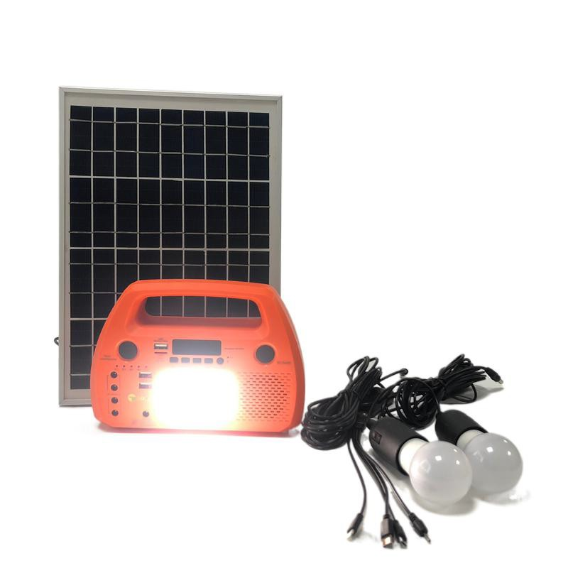 | 15W Solar Lighitng Kits  Solar Panel Power : 15W 18V with 5m cable wire Battery capacity : 12V 6AH Lithium  USB output : 5V DC output : 12V  Main Function : FM radio , Speaker , Buletooth , Flashlight, reading lamp, solar charging  Application : charging phones, cameras, iPad , led bulb lighting, play music , fan | Solar panel *1 Solar Box *1 3W led bulb *2  LED bulb Cable with holder *2 1-4 mobile phone Charger *1 | Solar main box Size: 280*160*100mm  Weight: 1.8kg  Solar Panel Size： 360*460*17  Weight: 1.9kg |  | $49.00 | $45.00
SLK-003 | 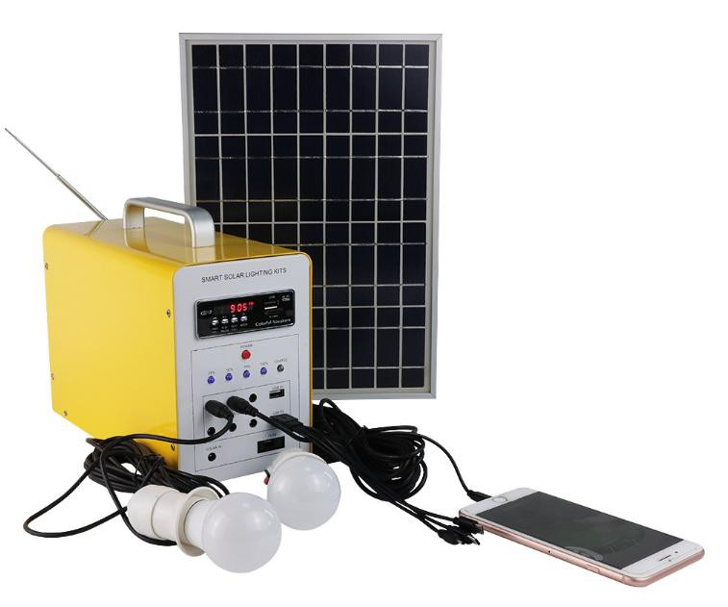 | 30W Solar Lighitng Kits  Solar Panel Power : 30W 18V with 5m cable wire Battery capacity : 12Ah 12V lithium  USB output : 5V DC output : 12V  Main Function : FM radio , Speaker , Buletooth ,solar charging Application : charging phones, cameras, iPad , led bulb lighting  play music , fan | Solar panel *1 Solar Box *1 3W led bulb *2  LED bulb Cable with holder *2 1-4 mobile phone Charger *1 | Solar main box Size: 300*180*340mm  Weight: 3.5kg  Solar Panel Size： 425*665*30mm  Weight: 3.5kg |  | $66.00 | $64.80
SLK-004 | 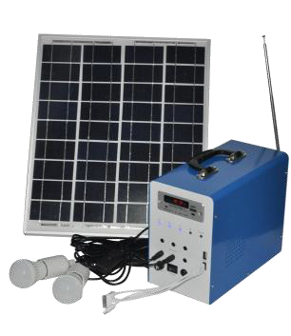 | 50W Solar Lighitng Kits  Solar Panel Power : 50W 18V with 5m cable wire Battery capacity : 24Ah 12V lithium  USB output : 5V DC output : 12V  Main Function : FM radio , Speaker , Buletooth ,solar charging Application : charging phones, cameras, iPad , led bulb lighting  play music , fan | Solar panel *1 Solar Box *1 3W led bulb *2  LED bulb Cable with holder *2 1-4 mobile phone Charger *1 | Solar main box Size: 300*180*340mm  Weight: 4.5kg  Solar Panel Size： 537*665*30mm  Weight: 4.3kg |  | $115.50 | $110.00
SLK-005 | 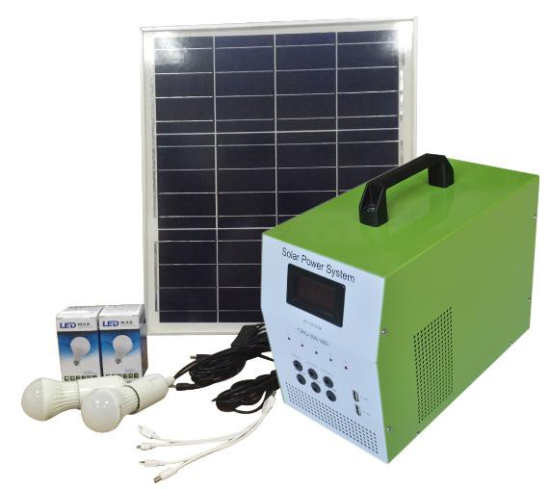 | 80W Solar Lighitng Kits  Solar Panel Power : 80W 18V with 5m cable wire Battery capacity : 38Ah 12V Lead acid  USB output : 5V DC output : 12V  Main Function : led screen , solar charging  Application : charging phones, cameras, iPad , led bulb lighting  fan , tv | Solar panel *1 Solar Box *1 3W led bulb *2  LED bulb Cable with holder *2 1-4 mobile phone Charger *1 | Solar main box Size: 460*300*440mm  Weight: 17Kg  Solar Panel  Size： 1030*665*30mm Weight: 8kg |  | $121.00 | $115.00
1 set Include: solar box * 1piece , solar panel * 1piece , LED bulb with cable*2pcs, USB cable *1piece Product specifications are subject to change without further notice.
Unit pricing : All above price is quoted on EXW factory Shenzhenzhen

Payment term: 100% TT payment as long as total payment reaching less than US$50,000 per order.
50% of down-payment on the date of purchasing order & 50% of balance before delivery once total payment reaches over U$50,000 per order

Delivery time: Within 20 days after payment received quantity less than 1000 units Within 30 days after payment received quantity less than 3000 units

THANKS YOUR SUPPORT

