Price list for Intelligent Solar LED lamps
Picture | Type | Parameters |  |  |  |  | Warranty | Unit Price
 |  | Lamp | LED  qty | Solar panel | LiFePO4  Lithium battery | Mounting height
All-in-two solar led street light
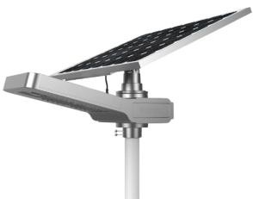 | AL-NH65 | 20W  3000-  3500LM | 105pcs | 18V/65W | 210WH | 5-6m/￠ 76mm | 3years | $223
 | AL-NH80 | 30W  4500-  5000LM | 105pcs | 18V/80W | 340WH | 7-8m/￠ 76mm | 3years | $280
 | AL-NH100 | 40W  6000-  6500LM | 105pcs | 18V/100 W | 420WH | 7-8m/￠ 76mm | 3years | $318
 | SC-NH150 | 50W  7200-  7500LM | 105pcs | 18V/150 W | 575WH | 8-10m/￠ 76mm | 3years | $452
 | AL-NH200 | 60W  8400-  9600LM | 105pcs | 18V/100  W*2pcs | 650WH | 8-10m/￠ 76mm | 3years | $554
All-in-one Solar led street light
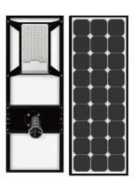 | ST2-20 | 20W  2600LM | 100pcs | 5V/36W | 192WH/60A H | 5-6m/￠ 60mm | 3years | $118
 | ST2-30 | 30W  3900LM | 100pcs | 5V/45W | 256WH/80A H | 5-6m/￠ 60mm | 3years | $142
 | ST2-40 | 40W  5200LM | 100pcs | 5V/60W | 320WH/100 AH | 7-8m/￠ 60mm | 3years | $158

 | ST2-60 | 60W  7800LM | 100pcs | 18V/80W | 512WH/160 AH | 7-8m/￠ 60mm | 3years | $236
 | ST2-80 | 80W  10400LM | 200pcs | 18V/110 W | 640WH/200 AH | 9-10m/￠ 76mm | 3years | $296
 | ST2-100 | 100W  13000LM | 200pcs | 18V/110 W | 768WH/240 AH | 9-10m/￠ 76mm | 3years | $310
Solar Beatle Light
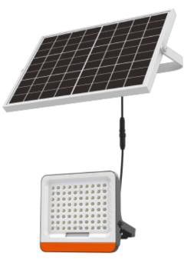 | AL-BL5000 | 5W  900-1000LM | 40pcs | 5V/15W | 35WH | 3-4m | 2years | $37
 | AL-BL30000 | 9W  1600-1700lm | 80pcs | 5V/30W | 76WH | 4-5m | 2years | $55
 | AL-BL40000 | 15W  2600-2700lm | 80pcs | 5V/40W | 128WH | 4-5m | 2years | $67
Solar LED Moon Light
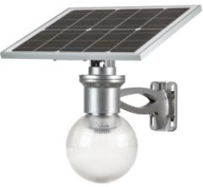 | AL-ML- H5000 | 8W  1200-  1440LM | 24pcs | 5V/20W | 52WH | 3-5m/￠ 60mm | 3years | $81
 | AL-ML-R40 | 12W  1500-  1800LM | 30pcs | 4.5V/40W | 105WH | 3-5m/￠ 60mm | 3years | $118

Remarks:
- Body material: aluminium alloy.
- High efficiency solar panel.
- Long lifetime lithium battery.
- Lighting time is about 5-10days. Solar battery charging.
- Sample Policy: Sample should be paid, delivery time within 3 workdays.
- Formal order 250 sets. Lead time will be 1-2weeks after receipt of deposit.
- The price is EXW.
- Payment term: T/T 50% in advance, balance before shipment
- Package: Standard carton box packing.

