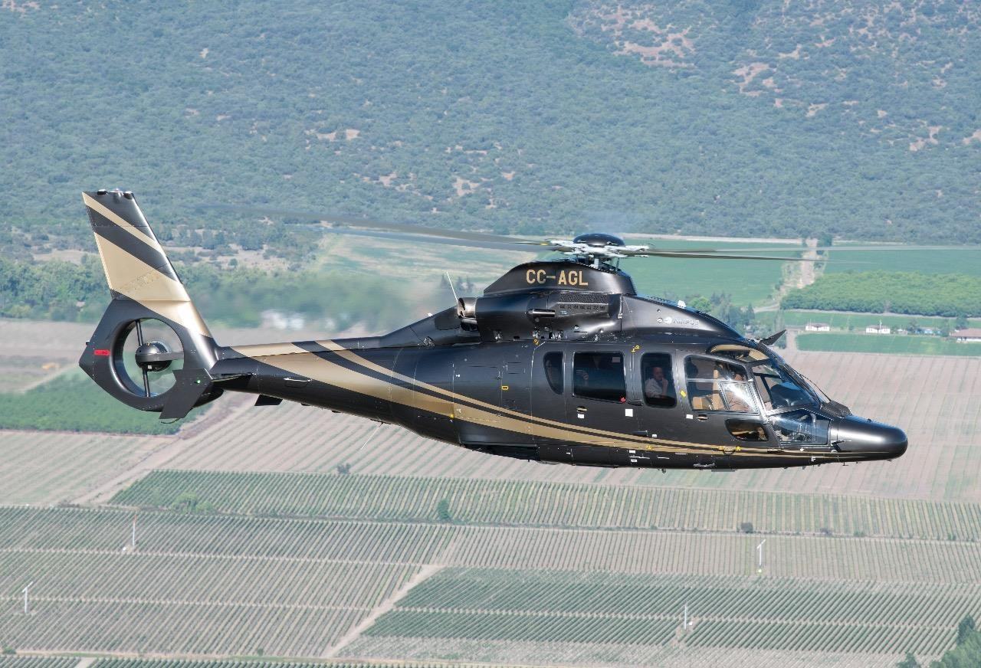***Model: EC155 B1***

***Registration: CC-AGL***

***Total flight hours: 755 hrs***

***Engine flight hours: 755 hrs***

***Engine Type: Arriel 2C2***

***Year 2012***

***Location: Santiago, Chile***

***Price: USD 6,500,000***

***Does not include IVA***

***Maintained at Airbus Helicopters Chile***

***Immediate delivery***

Main Rotor Blades X5 19.290 Hrs

Tail Rotor Blades X10 4.290 Hrs

Tail Gear Box 1.690 Hrs Main Servocontrol 2.290 Hrs Starter Generator X2 2.290 Hrs

Mast Bearing 1.790 Hrs

Tail Rotor Drive Shaft 2.090 Hrs

Module 1 2.790 Hrs Module 2 2.790 Hrs

Module 3 2.790 Hrs

Module 4 2.790 Hrs Module 5 2.790 Hrs

The Helicopter is owned by a third party and, as such, is subject to prior sale and price change. Data provided by the owner subject to verification by the buyer.

# Imagen que contiene exterior, pasto, coche, tabla Descripción generada automáticamente• Life Raft • 07 Lifejackets • 01 Electric Fuel Pump • 01 Fuel transport car 1500 liters • 01 Golf cart for trailer • 01 GPU Hobart • 01 portable GPU • 01 Nose Wheel • 01 Main Wheel • Tow bar • Battery 24 volt EC 155 B1

The Helicopter is owned by a third party and, as such, is subject to prior sale and price change. Data provided by the owner subject to verification by the buyer.

