QUOTE
06/12/2021
22001
within 14 days

Date: Order #: Valid Time:

LAYOUT : hospital buliding with 220 container modular (3215m2)
each container house size : 5.8*2.48*2.54m
Body house quotation

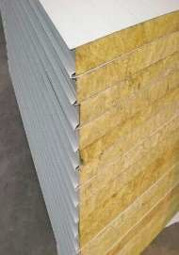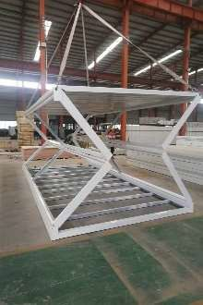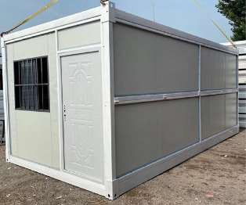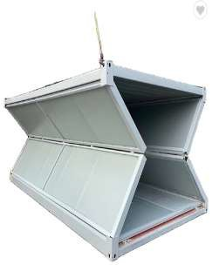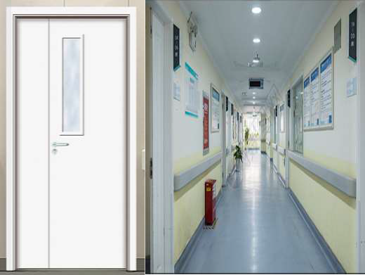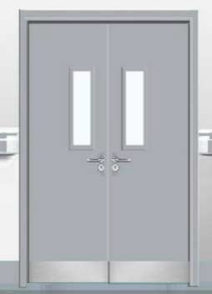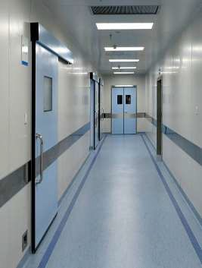
S/N | Material | Dimension | Specification | Quantity | Unit
1 | Integral folding room frame |  | galvanized steel & square tube welded & cement board floor 15mm &steel column & steel frame with glass wool roof and 50mm thickness rock wool sandwich panel wall 2480mm*5800mmx2540mm | 3164.5 | m2
2 | wall panel
3 | wood door for ward room |  | wood door 1200*2000mm | 119 | pcs
4 | metal double door for access |  | 1800x2000mm | 28 | pcs

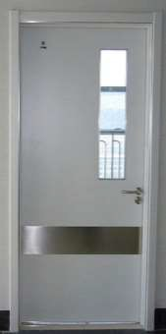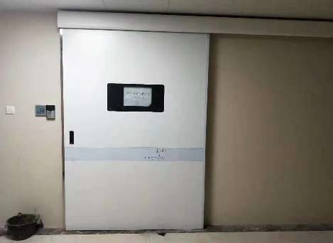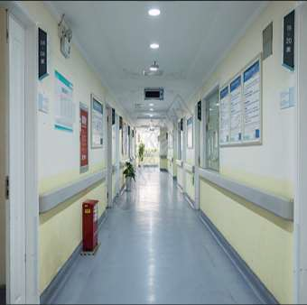
5 | wood single door |  | wood door 900x2000mm | 24 | pcs
6 | Sensor door Operating and ICU |  | metal with Auto-sensor 1800x2000mm | 19 | pcs
7 | PVC window for duty and dingding house | 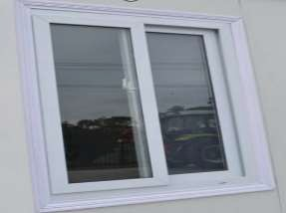 | PVC frame 930x925mm | 34 | pcs
8 | Iodine resistant rubber floor | 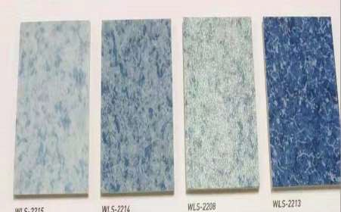 | 2mm thickness | 4746.7 | m2
9 | PVC ceiling | 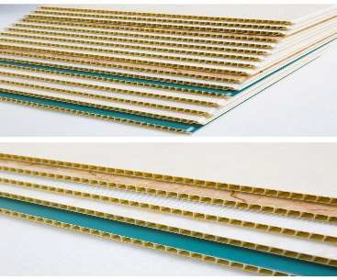 | for Access ceiling | 775.5 | m2

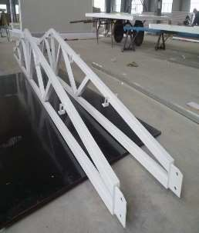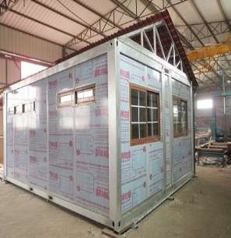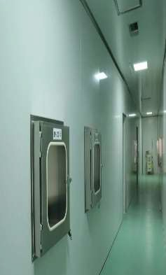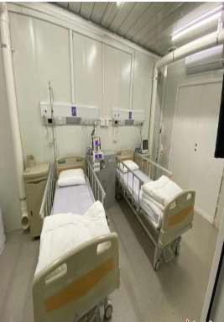

g
10 | truss and steel sheet of extra roof for each area |  | galvanized steel truss with galvanized steel sheet for extra roof |  | 4092.44 | m2
11 | All accessories part and hard fitting
12
Total 1set building
Option quotation
S/N | Material | Dimension | Specification | Quantity | Unit | price USD
1 | Negative pressure systems |  | each area 360m2 The nurse's station can be made at 5pa, a slight negative pressure -5pa for the corridor, ward room -10pa, bathroom -15pa | 2160.0 | 484
2 | Spray elimination channel with spray facility | 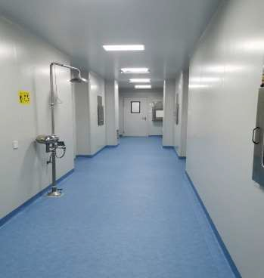 | 2x2.48x2.56m | 10.0 | 3226

3 | Hospital Auxiliary Supplies and Equipment | see attachment |  |  |  | 1,494,338
 | TOTAL 1set hospital building price |  | FOB USD | 3,367,002
 | sea freight Xingang China to Most safe world ports (to be confirmed) |  | USD | 700,000 | 49x40HQ
 | insurance |  | USD | 3330 | sea freight valid end of 15th  December 2021
one hospital building is 220units foldable container houses support 109beds |  |  | CIF USD | 4,070,332.00
Terms and conditions
1.price terms: CIF
2. order quantity: 220units container house with all equipment fit in 49x40HQ.
3.payment terms: Total by L/C ( irrevocable transferable letter of credit)
4.delivery term: within 15-25 days

