QUOTATION
Quotation #: ADIGT20220114 Date : 17th January, 2021

Item No. | Picture | Product Description | Package List | Packing infio | U.pirce EXW factory
 |  |  |  |  | MOQ 100 | 101~1000 | 1001~3000
TSolar/SPS-300 | 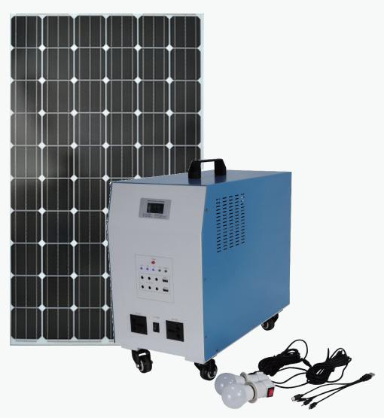 | 300W Solar Power System  Solar Panel Power : 80W 18V with 5m cable wire Built in inverter : 300W  Built in controller : 10A  Battery capacity : 38Ah 12V Lead acid AC ouput : 220V or 110V  USB output : 5V DC output : 12V  Main Function : led screen ,solar charging  Application : charging phones, cameras, iPad , led bulb lighting  laptop, fan,tv, | Solar panel *1 Solar Box *1 3W led bulb *2  LED bulb Cable with holder *2 1-4 mobile phone Charger *1 | Solar main box Size: 410*260*460mm  Weight: 24kg  Solar Panel Size：1030*665*30mm Weight: 8kg | $243.00 | $236.00 | $230.00
TSolar/SPS-500 |  | 500W Solar Power System  Solar Panel Power : 120W 18V with 5m cable wire Built in inverter : 500W  Built in controller : 10A  Battery capacity : 65Ah 12V Lead acid AC ouput : 220V or 110V  USB output : 5V DC output : 12V  Main Function : led screen ,solar charging  Application : charging phones, cameras, iPad , led bulb lighting  laptop, fan,tv, | Solar panel *1 Solar Box *1 3W led bulb *2  LED bulb Cable with holder *2 1-4 mobile phone Charger *1 | Solar main box Size: 560*300*490mm  Weight: 40kg  Solar Panel Size：1147*674*35mm Weight: 12kg | $351.00 | $347.00 | $331.00
TSolar/SPS-1000 |  | 1000W Solar Power System  Solar Panel Power : 200W 18V with 5m cable wire Built in inverter : 1000W  Built in controller : 20A  Battery capacity : 100Ah 12V Lead acid AC ouput : 220V or 110V  USB output : 5V DC output : 12V  Main Function : led screen ,solar charging  Application : charging phones, cameras, iPad , led bulb lighting  laptop, fan,tv,freezer | Solar panel *1 Solar Box *1 3W led bulb *2  LED bulb Cable with holder *2 1-4 mobile phone Charger *1 | Solar main box Size: 590*255*488mm  Weight: 53kg  Solar Panel Size：1320*992*35mm Weight: 16kg | $499.00 | $495.00 | $477.00
1 set Include: solar box * 1piece , solar panel * 1piece , LED bulb with cable*2pcs, USB cable *1piece Product specifications are subject to change without further notice.
Unit pricing : All above price is quoted on EXW factory Shenzhenzhen

Payment term:
50% of down-payment on the date of purchasing order & 50% of balance before delivery

Delivery time: Within 15 days after payment received quantity less than 500 units Within 25 days after payment received quantity less than 3000 units

OEM design : Any adjustment on the product , including appearance, model , brand , logo, label and others may lead a price change .

Issured by: Approved by:

