Solar LED Batten Light Kit Quotation Sheet
NO. | P/N | Picture | Product Description | Package | EXW (USD)
1 | 445-12W | 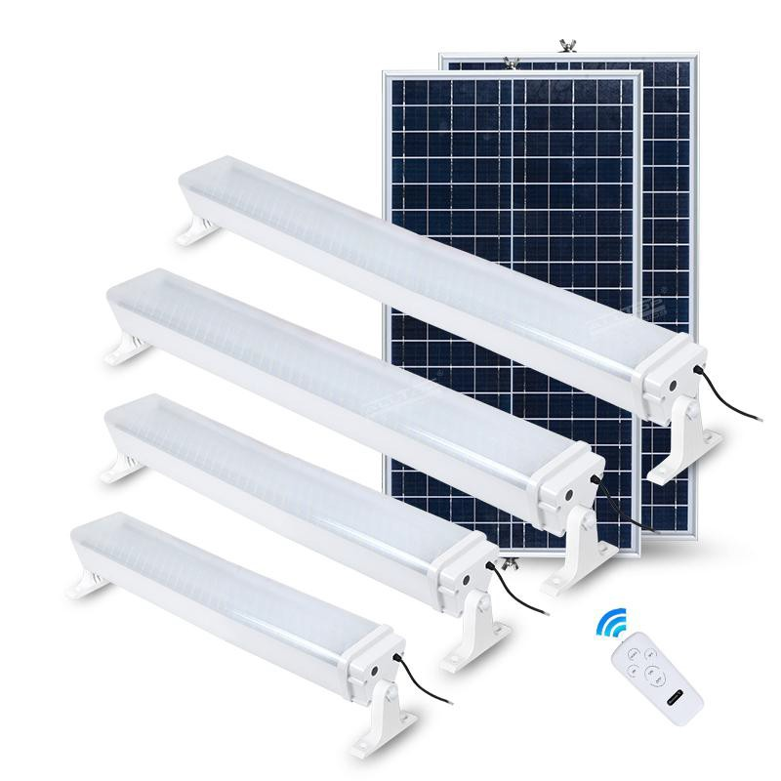 | 12W Solar LED Batten Light  LED Lamp: 2835 LED 120PCS 6000K  Solar Panel: 9V 22W, Mono-Crystalline Battery Type: LiFePO4 6.4V 12AH Charging Time: 6-8 hours  Discharging Time: 20-24 hours Material: Aluminum+PC  Cable Length : 5M Programmable by remote Product Size: 445*120*120 mm Warranty: 2 years | Qty/Carton: 8PCS  Solar panel: 37x37x35.5cm GW: 14KG  Lamp: 50.5x40.5x25.5cm GW: 15.5KG | $52.00
2 | 625-18W |  | 18W Solar LED Batten Light  LED Lamp: 2835 LED 180PCS 6000K  Solar Panel: 9V 27W, Mono-Crystalline Battery Type: LiFePO4 6.4V 18AH Charging Time: 6-8 hours  Discharging Time: 20-24 hours Material: Aluminum+PC  Cable Length : 5M Programmable by remote Product Size: 625*120*120 mm Warranty: 2 years | Qty/Carton: 8PCS  Solar panel: 43x35.5x38cm GW: 16KG  Lamp: 50.5x40.5x25.5cm GW: 16.8KG | $64.00
3 | 805-24W |  | 24W Solar LED Batten Light  LED Lamp: 2835 LED 240PCS 6000K  Solar Panel: 9V 36W, Mono-Crystalline Battery Type: LiFePO4 6.4V 24AH Charging Time: 6-8 hours  Discharging Time: 20-24 hours Material: Aluminum+PC  Cable Length : 5M Programmable by remote Product Size: 805*120*120 mm Warranty: 2 years | Qty/Carton: 6PCS  Solar panel: 55x27x38cm GW: 16.5KG  Lamp: 80.5x31x25.5cm GW: 18.5KG | $73.00
4 | 1035-30W |  | 30W Solar LED Batten Light  LED Lamp: 2835 LED 300PCS 6000K  Solar Panel: 9V 55W, Mono-Crystalline Battery Type: LiFePO4 6.4V 30AH Charging Time: 6-8 hours  Discharging Time: 20-24 hours Material: Aluminum+PC  Cable Length : 5M Programmable by remote Product Size: 1035*120*120 mm Warranty: 2 years | Qty/Carton: 4PCS  Solar panel: 78x18.5x38cm GW: 13.5KG  Lamp: 109x21x25cm GW: 19.5KG | $90.00
Remarks:
- 2 years warranty
- terms: 100% T/T when place the order.
- The prices are based on EXW.
- When the exchange rate fluctuates within 3%, our price remains the same, but when the exchange rate fluctuates more than 3%, we have to adjust the price. The adjustment part is half of each other. (The raw material price change range is 10%)
- The production time is average 30 working days after receiving the deposit.

