5X Zoom Low Power Consumption Battery Solar PTZ camera Model：Q08TB-5X

Product features:
App: SmartLife
Hardware: hi3516ev200 + gc2053 performance hardware, HD 1080p H.265 5X zoom,remote control,preset locations automatic zoom patrol view About 355 degrees, up and down 120 rotation, no dead angle monitoring
WiFi version domestic 4G all China Netcom Southeast Asia 4G version European 4G American 4G
18650 battery powered solar low power full duplex AI detection voice alarm video push motion detection remote wake up infrared night vision
- ultra low power performance hardware solution, ultra long standby;
AI detection, voice alarm: you have broken into the monitoring area, please leave immediately (support warning language customization);
- solar power supply, 6 18650 rechargeable lithium batteries can be installed, charging while using, intelligent sleep, ultra-low power consumption;
The combination of solar panel and fuselage, IP66 waterproof grade, can be used safely in the field.
Super long standby: Based on the capacity of a single 18650 battery of 3400mah, the total capacity of six batteries is 20400mah. High definition photosensitive chip, effective image quality: 2 million pixels, 1080p, clear and delicate image, good color restoration;
Customized ircut dual filter switch, automatic color to black, equipped with four low-power infrared lamps, can effectively improve the night vision clarity; The built-in low-power WiFi module is specially designed, which is more stable in receiving WiFi signals and does not drop the line;
Built in PIR infrared sensor alarm, after setting, it can detect the human body and immediately push the alarm information to the mobile app; Full duplex intercom, built-in pickup and speaker, users can monitor through mobile app, and realize real-time remote video voice intercom; Using high performance DSP codec chip, the host can deal with various complex situations and respond quickly;
Using P2P technology, through simple connection operation, the device can access the Internet, and the mobile app can set the device parameters remotely; Multi computer and multi-user, which can realize the management of multiple computers and multi-user at the same time, and the centralized management of TB intelligent platform is more convenient;
Maximum support 1TB TF card storage, even 24-hour uninterrupted video recording can also be recorded for 365 days, with low-power sleep technology, no matter what video recording sleep mode, one card can record for several years.
TB also supports cloud storage.

Household consumer security products, industrial standard design, products can be long-term, stable work, let users worry about; Built in user-friendly Chinese and English menu, fool like connection mode, convenient and quick to use;
No network, no power, suitable for outdoor scenes, WiFi version, domestic 4G version, foreign 4G version for your choice; Product parameters:
DSP | Hi3516EV200
Sensor | 1/2.9cmos Sensor:GC2053
system | LiteOS real-time operating system
connect | WIFI 2.4GHz IEEE 802.11b/g/n FTP/PPPOE/DHCP/DDNS/NTP/UPnP
 | WIFIQuick connect
 | QR Code
 | Smart Share
Video | 1920*1080/25fps
 | H.265 H.264
 | Adaptive code stream, adapt to a variety of network environment
Zoom | Support 5X zoom
audio frequency | Audio coding standards: AAG and G.726
 | Audio in / out: - 38dB microphone / built in speake
Networking Support | WIFI 2.4G
4G version available: domestic 4G all Netcom version, East Asia South 4G version, European 4G version and American 4G
version, other regions need to consult
4G protocol support | FDD-LTE，TDD-LTE，TD-SCDMA、HSPA+、HSUPA、HSDPA、UMTS、EVDO、EDGE、GPRS、GSM、CDMA1x
night vision | 4low power infrared lamps
 | Night vision distance 20m-30m
 | Color 0.01 Lux@F1.2 , black and white 0.08 Lux@F1.2 , 0 lux infrared on
Waterproof grade | IP66
Day night conversion  mode | Automatic switching of IR-cut dual filters
Work indicator | Green light on
 | The blue indicator lights up and enters the networking mode. After the networking is successful, the blue indicator flashes.

LENS | 2.0 MP HD
 | 6mm
 | 92 degree Perspective
Alarm mode | AI intelligent detection, motion detection, sound detection
 | On site voice alarm and remote app alarm
rotate | PTZ angle level 355 °， Vertical 120 °
 | Speed: level 55 °/ Second; Vertical 40 °/ second
voice | Built in mic
 | Built in speaker
 | Full duplex two way intercom with echo cancellation
Storage function | Support micro SD card storage, up to 1024gb, that is 1TB TF Card
videotape | Support local video on demand playback
 | Support device video on demand playback
 | motion detection trigger recording and app recording command recording
 | Cloud storage video
RESET | Support one click recovery of default configuration, support app removal device recovery
power supply | Solar panel power supply
 | It supports 6 18650 rechargeable batteries for 3.7V power supply
Standby | Light for 4 hours a day, normal use in intelligent sleep mode, no need to charge.
dormancy | Intelligent sleep no command automatic sleep standby
Enter the sleep time logic: WiFi version wakes up 20 seconds each time, and the device automatically sleeps; 4G version will go
to sleep one minute after each wake-up.
awaken | Streaming media intelligent voice wake up
 | AI Motion detection triggers wake up
 | App remote wake up
Start time | Within 600 ms of system startup
Message push time | Message push within 4 seconds
power waste | Maximum working power: daytime < 1.5W, night < 2.5W;

 | Standby power < 0.003w
Weight and dimension parameters | Total weight: 1.7Kg
 | Package size: 285*255*198mm
 | Packing quantity: 8 pcs
 | Packing weight: 16kg
 | Outer box size: 595*525*415mm
work environment | Working temperature - 20 ℃ ~ + 40 ℃, working humidity ≤ 65%

4G GSM SIM card version prices: Wireless WiFi version prices:
MOQ 100 pcs order unit price is 83USD 100 pcs order unit price is 85USD
500 pcs order unit price is 79USD 500 pcs order unit price is 72USD
1000 pcs order unit price is 77USD 1000 pcs order unit price is 65 USD

the above prices all based on EXW trade terms, not include batteries, we strongly recommend you to buy the batteries at your local market, because goods without batteries shipping rate is much more better.

One camera needs 6 pcs 18650 batteries, you can buy batteries from us,6 pcs batteries add 4USD for each camera,see batteries bellow:

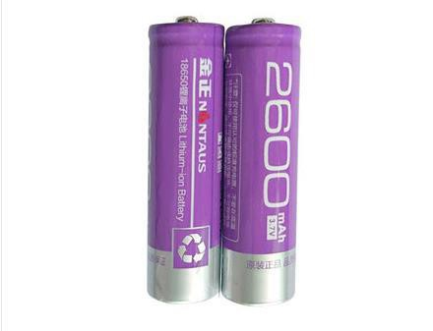

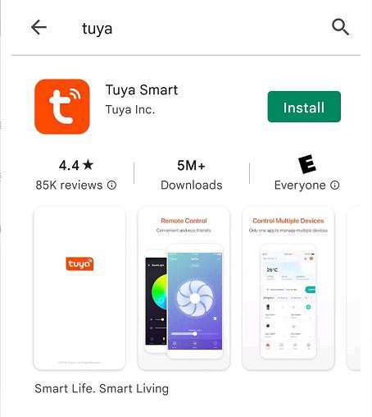

The APP is the biggest smart home platform on the earth, easy to find and download on google play store or IOS store, best APP for wireless cameras

How to ship goods ?

There are lots of shipping agents or forwarders in china,so we usually ship goods by forwarders. just tell us how many pcs you want for each model,then we will work out total weight and ask shipping cost from forwarders. forwarders can ship goods by express like DHL UPS etc,also can ship goods by air or by sea. sample orders usually sent by express, middle orders usually send by air (minimum weight by air is 45KG),big orders can by sea.

If you think shipping cost from our forwarders high, you can arrange shipping by yourself, we can send goods to your forwarders addresses

How to do businesses with you ?

We will send you products information for your reference. After studying, if you want to buy,tell us your order details
We will send you official proforma invoices with our accounts You confirm the PI and make payments to our accounts
We confirm money receiving and prepare your goods then send them out

If you buy bulk,we can give you the sole right for selling this product in your country.because we only want to serve one buyer in a country to make things simple and do long-term win-win businesses. We have our own office in Shenzhen and we are direct to the manufacturer we can arrange all in 100% total safety

