SOLAR TUBE LIGHT
No. | Model | Description |  | EXW Unit  Price
1 | 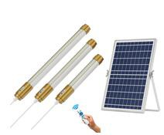 | Solar panel | 6W/5V,POLY, 187*270mm | US$10.60
 |  | Battery | 3.2V/4000mAh , LiFePO4,32650
 |  | Light source | White, 57pcs SMD3030
 |  | Power | 60W,600LM
 |  | Lighting time | 12hours+
 |  | CCT. | 6500K
 |  | Lamp size | φ40*300mm
 |  | Lighting area | 60m2
 |  | Cable | 30cm
 |  | Material | PC,PVC, Aluminum alloy
 |  | Remote control | ON/OFF,Brightness setting, Timing off
 |  | QTY/CTN. | 10
 | SID-60 | Carton G.W | 9.8KG
 |  | Carton size | 470*260*315mm
2 |  | Solar panel | 8W/5V,POLY, 350*235mm | US$12.50
 |  | Battery | 3.2V/6000mAh , LiFePO4,32650
 |  | Light source | White, 75pcs SMD3030
 |  | Power | 100W,800LM
 |  | Lighting time | 12hours+
 |  | CCT. | 6500K
 |  | Lamp size | φ40*380mm
 |  | Lighting area | 80m2
 |  | Cable | 5meters
 |  | Material | PC,PVC, Aluminum alloy
 |  | Remote control | ON/OFF,Brightness setting, Timing off
 |  | QTY/CTN. | 10
 | SID-100 | Carton G.W | 13.5KG
 |  | Carton size | 470*310*395mm
3 |  | Solar panel | 15W/5V,POLY, 350*300mm | US$16.30
 |  | Battery | 3.2V/12000mAh , LiFePO4,32650
 |  | Light source | White, 108pcs SMD3030
 |  | Power | 200W,1500LM
 |  | Lighting time | 12hours+
 |  | CCT. | 6500K
 |  | Lamp size | φ40*430mm
 |  | Lighting area | 120m2
 |  | Cable | 5meters
 |  | Material | PC,PVC, Aluminum alloy
 |  | Remote control | ON/OFF,Brightness setting, Timing off
 |  | QTY/CTN. | 10
 | SID-200 | Carton G.W | 18KG
 |  | Carton size | 470*380*485mm
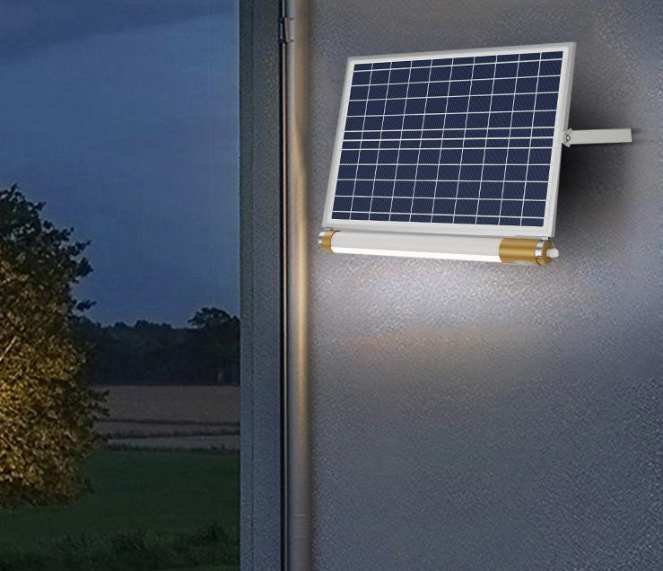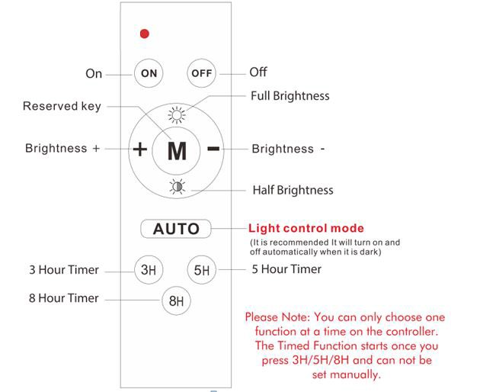
4 |  | Solar panel | 20W/5V,POLY, 350*450mm | US$25.10
 |  | Battery | 3.2V/18000mAh , LiFePO4,32650
 |  | Light source | White, 126pcs SMD3030
 |  | Power | 300W,2000LM
 |  | Lighting time | 12hours+
 |  | CCT. | 6500K
 |  | Lamp size | φ40*480mm
 |  | Lighting area | 200m2
 |  | Cable | 5meters
 |  | Material | PC,PVC, Aluminum alloy
 |  | Remote control | ON/OFF,Brightness setting, Timing off
 |  | QTY/CTN. | 10
 | SID-300 | Carton G.W | 25KG
 |  | Carton size | 470*440*585mm
PACKING
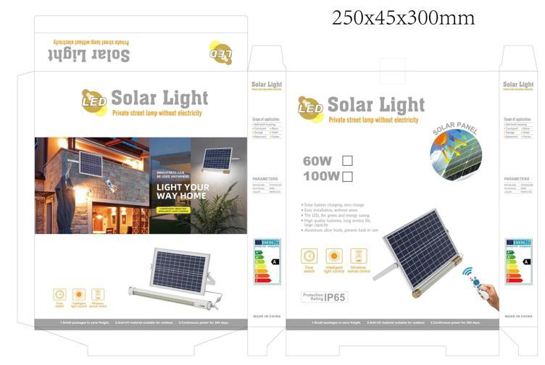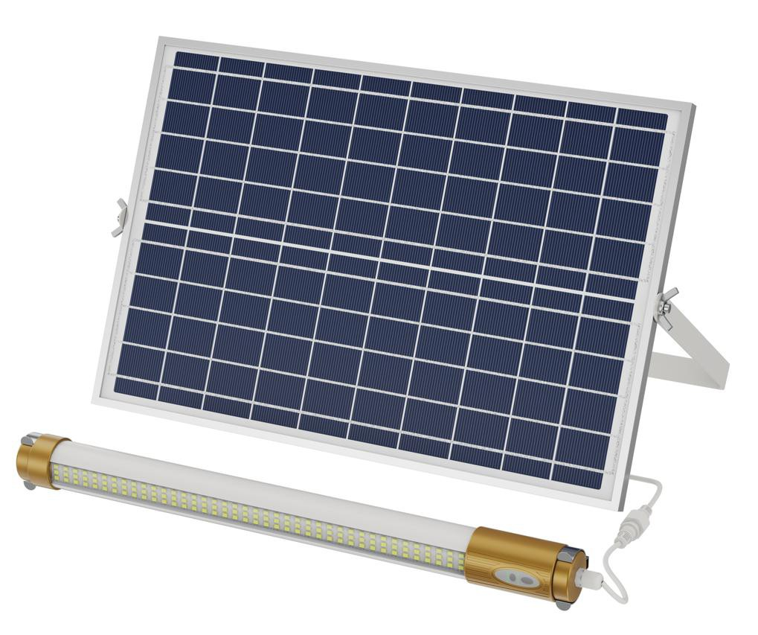

Remark
1. MOQ:1,000pcs.
2.The price is based on EXW SHENZHEN,CHINA.
3.Lead time:10-20days depend on different quantity.
4.Warranty: 2years.
5.The price is valid in 15days

