CONTENTS

PRODUCT NAME
PAGE

Military Jacket 1

Camouflage Uniform 2

Military Headwear 4

Other Military Garments 5

Bulletproof Helmet 6

Bulletproof Vest 7

Tactical Vest 8

Military Backpack 9

Other Outdoor Items 10

Military Boot 11

Military shoes 12

Police Anti-riot Suit 13

Other Police Anti-riot Equipment 14

Unparallel Advantage 15

FAQ 16

Military Jacket

Specifications

Material: T/C; N/C; CVC ,customized
Color: Olive green ; Camouflage , customized Style: M65 ; ECWCS ,and other military style Feature: Breathable, Eco-friendly, Windproof, Warm
Test Standard: by SGS(color fastness,composition,tear strengh,etc) Inspection: can be third party such as AI
Model Number: HNXX-A001

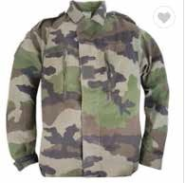

HNXX-A002
HNXX-A003
HNXX-A004
HNXX-A005
HNXX-A006

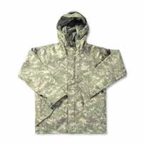
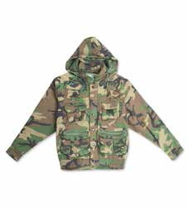
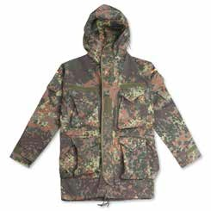
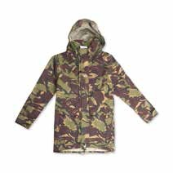
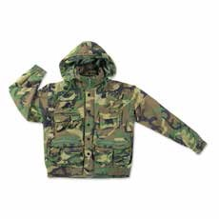
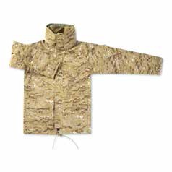
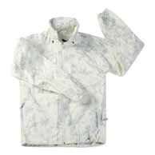
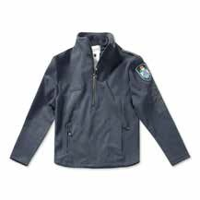
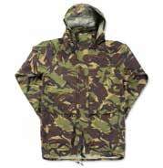
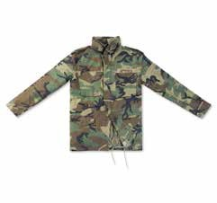
HNXX-A008 HNXX-A009 HNXX-A010 HNXX-A011
HNXX-A007
1

Camouflage Uniform

Specifications
Material: T/C; N/C; CVC ,customized
Color: Olive green ; Camouflage , customized
Style: BDU; F1; F2; TAP; ACU; BCU or any other style Feature: Breathable, Eco-friendly, Windproof, Warm
Test Standard: by SGS(color fastness,composition,tear strengh,etc) Inspection: can be third party such as AI
Model Number: HNXX-B001

HNXX-B002
HNXX-B003 HNXX-B004 HNXX-B005 HNXX-B006

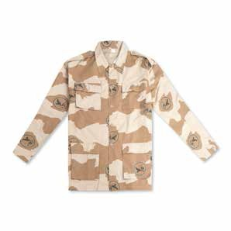
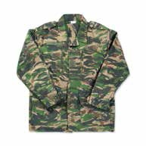
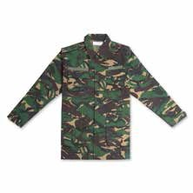
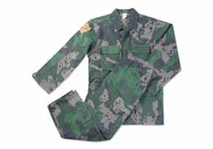
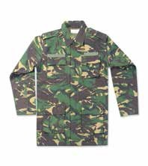
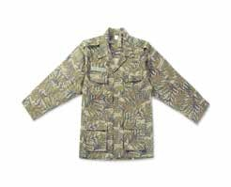
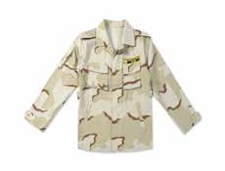
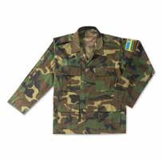
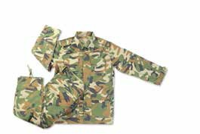
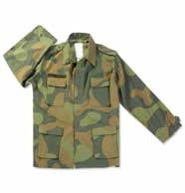
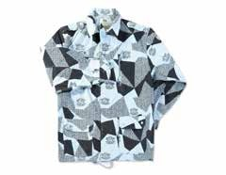

HNXX-B007 HNXX-B008 HNXX-B009 HNXX-B010 HNXX-B011
2

Camouflage Uniform

Specifications
Material: T/C; N/C; CVC ,customized
Color: Olive green ; Camouflage , customized
Style: BDU; F1; F2; TAP; ACU; BCU or any other style Feature: Breathable, Eco-friendly, Windproof, Warm
Test Standard: by SGS(color fastness,composition,tear strengh,etc) Inspection: can be third party such as AI
Model Number: HNXX-C001

HNXX-C002
HNXX-C003 HNXX-C004 HNXX-C005 HNXX-C006

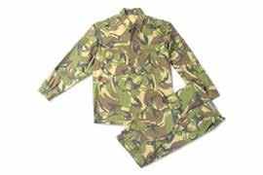
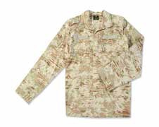
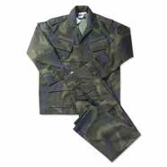
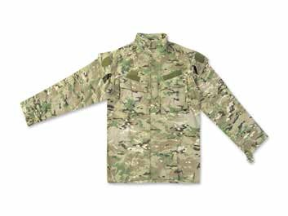
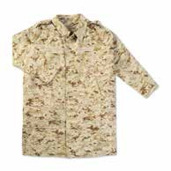
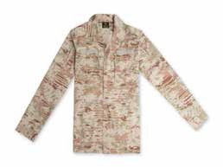
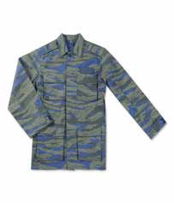
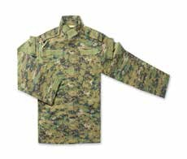
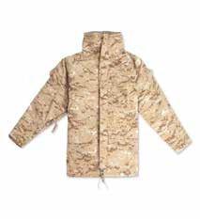
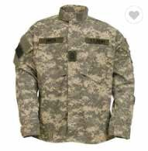
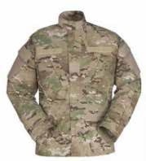

HNXX-C007 HNXX-C008 HNXX-C009 HNXX-C010 HNXX-C011
3

Military Headwear

Specifications
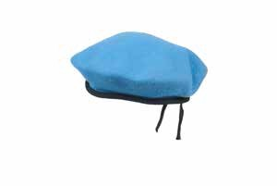
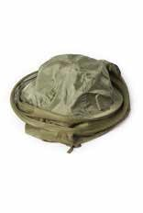
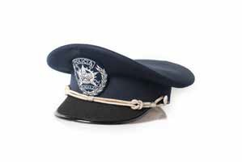
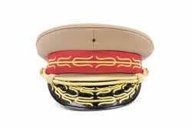
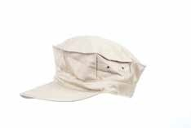
Material: T/C; N/C; CVC ,Wool ,customized Color: Olive green ; Camouflage , customized
Style: Benni cap ;Baseball cap ;BDU cap ;Police cap ;Beret ,etc Test Standard: by SGS(color fastness,composition,tear strengh,etc) Inspection: can be third party such as AI
Model Number: HNXX-MH01

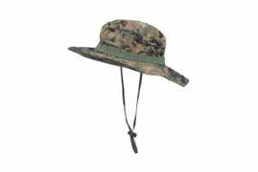
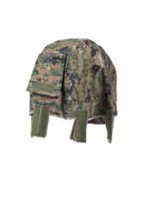
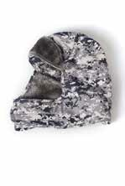
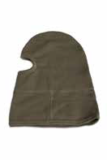
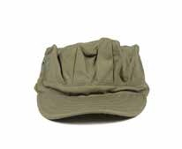
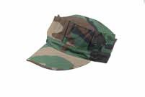
HNXX-MH02 HNXX-MH03
HNXX-MH04
HNXX-MH05
HNXX-MH06
HNXX-MH09
HNXX-MH10
HNXX-MH11

HNXX-MH07 HNXX-MH08

4

Other Military Garments

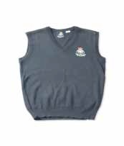
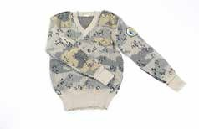
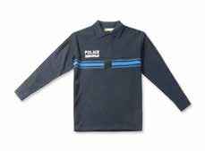
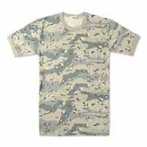
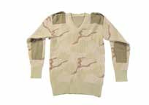
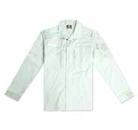
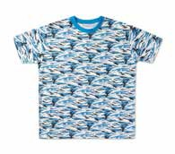
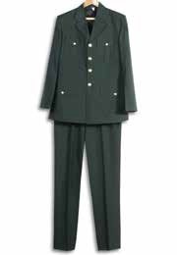
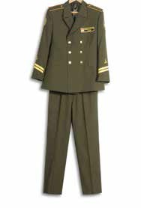
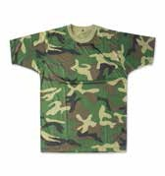
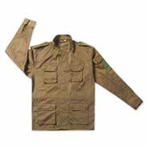
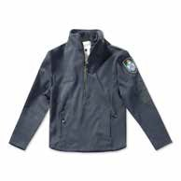
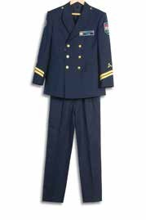
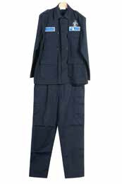
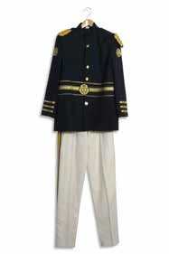
HNXX-D001 HNXX-D002 HNXX-D003 HNXX-D004 HNXX-D005

HNXX-D006 HNXX-D007 HNXX-D008 HNXX-D009 HNXX-D010

HNXX-D011 HNXX-D012 HNXX-D013 HNXX-D014 HNXX-D015

5

Bulletproof Helmet

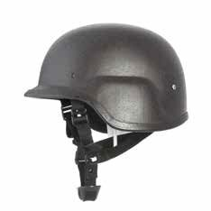

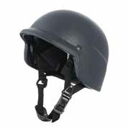

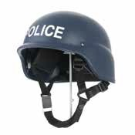
HNXX-BH02
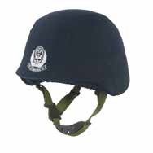
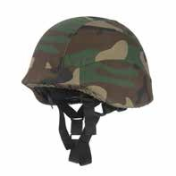
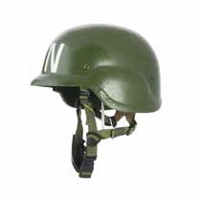
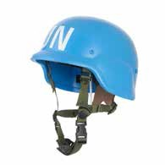
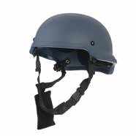
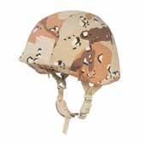
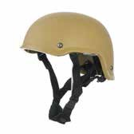
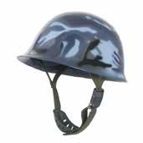
HNXX-BH07
HNXX-BH03
HNXX-BH04
HNXX-BH05
HNXX-BH06
HNXX-BH08
HNXX-BH09
HNXX-BH10
HNXX-BH11
6

Specifications
Material: Kevlar authorized by Du pont Color: Black ;Green ;Navy blue ,customized Style: FAST ;PASGT ;etc
Bulletproof Level: NIJ IIIA
Model Number: HNXX-BH01

Bulletproof Vest

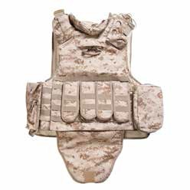
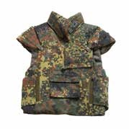
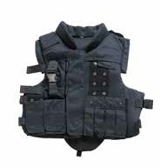
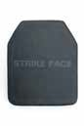
Out Shell: Cordura nylon ;polyester oxford Chin material: durable PE UD ;Aramid Color: Black ;Green ;Navy blue ,customized
Specifications
Style: MOLLE Vest ;normal tactical style ,jacket or vest Protect area: 0.2-0.6m²
+
Bulletproof level: NIJ IIIA-IV
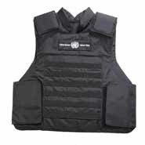
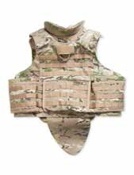
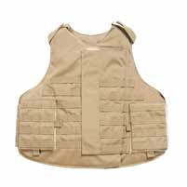
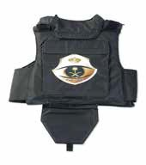
Material of plate: Ceramic ;Silicon Carbide PE ,etc Model Number: HNXX-BV01
HNXX-BV04
HNXX-BV09

HNXX-BV06

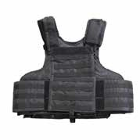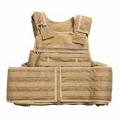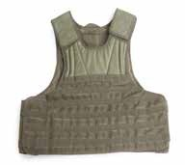
HNXX-BV02
HNXX-BV03
HNXX-BV05

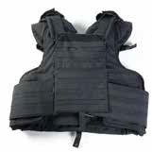
HNXX-BV07 HNXX-BV08
7
HNXX-BV10 HNXX-BV11

Tactical Vest

Specifications

Material: durable polyester oxford ;nylon

Color: Black ;Green ;Navy blue ;Camouflage ,customized Style: MOLLE Vest ;normal tactical style ; jacket or vest Feature: multi-functional vest hung many small bags
Model Number: HNXX-TV01

HNXX-TV02
HNXX-TV03 HNXX-TV04
HNXX-TV05
HNXX-TV06

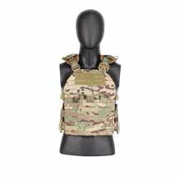
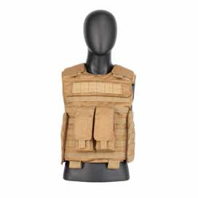
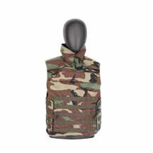
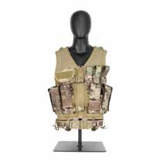
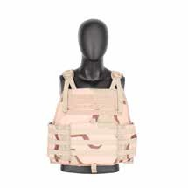
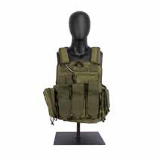
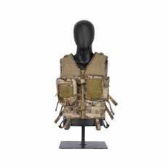
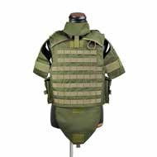
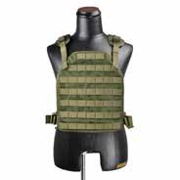
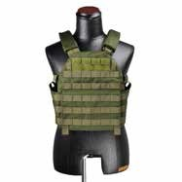
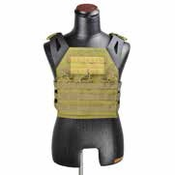

HNXX-TV07 HNXX-TV08 HNXX-TV09 HNXX-TV10 HNXX-TV11
8

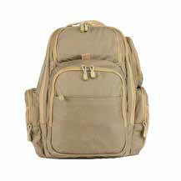
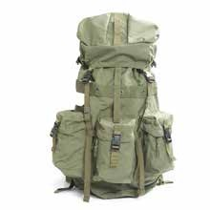
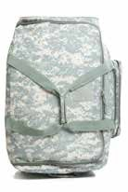
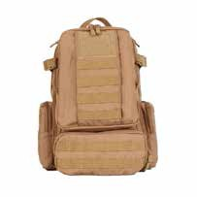
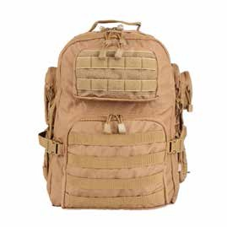
Military Backpack

Specifications

Material: durable polyester oxford ;nylon ;canvas cotton Color: Black ;Green ;Navy blue ;Camouflage ,customized Style: rucksack ;backpack ;shoulder bag ;etc
Feature: durable use in all kinds of environment
Model Number: HNXX-MB01

HNXX-MB02

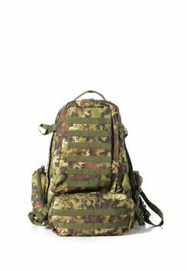
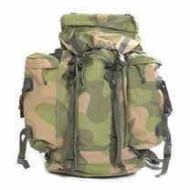
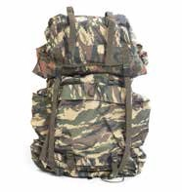
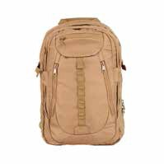
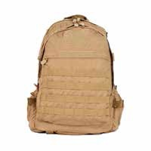
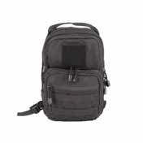
HNXX-MB03
HNXX-MB04
HNXX-MB05
HNXX-MB06
HNXX-MB09
HNXX-MB10
HNXX-MB11

HNXX-MB07 HNXX-MB08
9

Other Outdoor Items

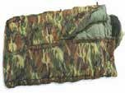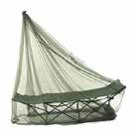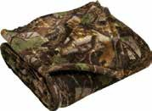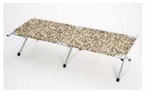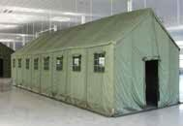
HNXX-OI01 HNXX-OI02 HNXX-OI03 HNXX-OI04 HNXX-OI05

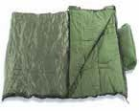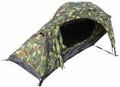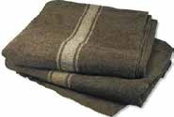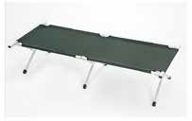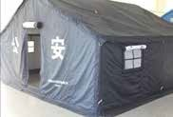

HNXX-OI06 HNXX-OI07 HNXX-OI08 HNXX-OI09 HNXX-OI10

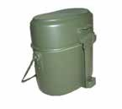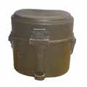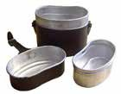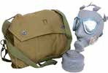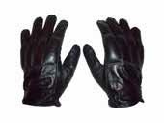

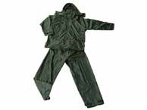
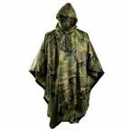
HNXX-OI11

HNXX-OI18
HNXX-OI12
HNXX-OI13
HNXX-OI15

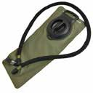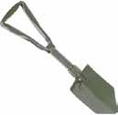

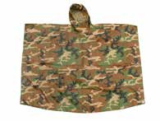
HNXX-OI16 HNXX-OI17
HNXX-OI14
10
HNXX-OI19 HNXX-OI20

Military Boot

Specifications
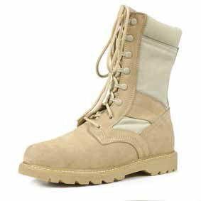
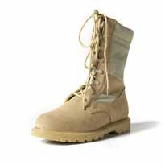
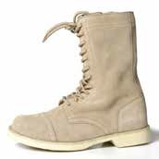
Leather: full grain leather ,second layer leather ;suede leather Lining: leather or cotton fabric
Sole: EVA + rubber Dyestuff: AZO free Copper Buckle: anti-rust Eyelet: anti-rust
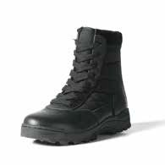
Hardening agent: German BAYER Lace: Nylon ;Cotton ;Polyester Model Number: HNXX-MB01
HNXX-MB04

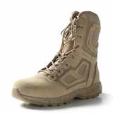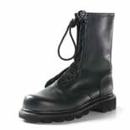

HNXX-MB02
HNXX-MB03
HNXX-MB06

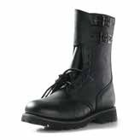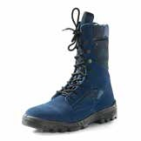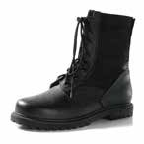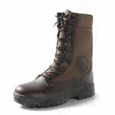
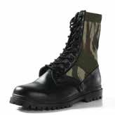
HNXX-MB07 HNXX-MB08 HNXX-MB09 HNXX-MB10 HNXX-MB11
HNXX-MB05
11

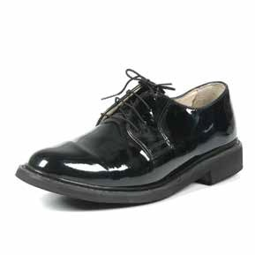
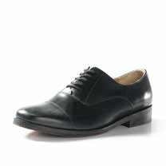
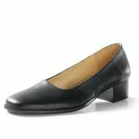
Military Shoes

Specifications
Leather: full grain leather ,second layer leather ;suede leather Lining: leather or cotton fabric
Sole: EVA + rubber Dyestuff: AZO free Copper Buckle: anti-rust Eyelet: anti-rust
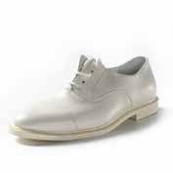
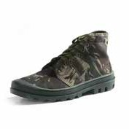
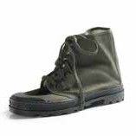
Hardening agent: German BAYER Lace: Nylon ;Cotton ;Polyester Model Number: HNXX-MS01

HNXX-MS02
HNXX-MS03 HNXX-MS04 HNXX-MS05 HNXX-MS06

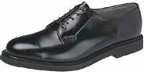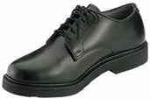

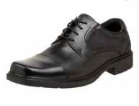
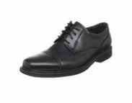
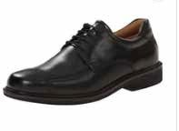
HNXX-MS07 HNXX-MS08
HNXX-MS10
HNXX-MS11

HNXX-MS09

12

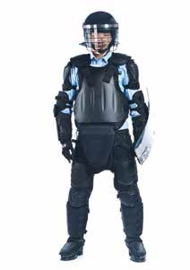
Police Anti-riot Suit

Specifications
Material: High-performance project plastic high molecular weight polythene non-fiber cloth Weight: 6.5KG
Protect Area: ＞1.2m²

Model Number: HNXX-PA01

Part of Anti-riot Suit

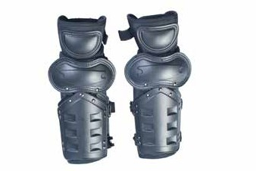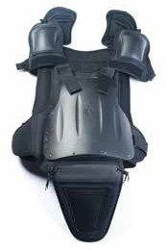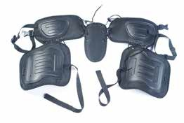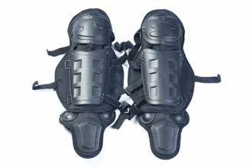

Chest Protector Upper Leg Protector Leg Protector Arms protector

13

Other Police Anti-riot Equipment

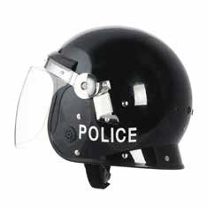

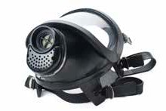
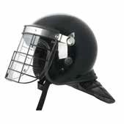
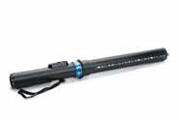
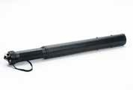
HNXX-PA03
HNXX-PA04
HNXX-PA05

Specifications

Product Name: Anti-riot Safety Helmet Material: 100% Impact-resistant PC Visor: PC(thickness 3mm)
Model Number: HNXX-PA02

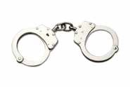

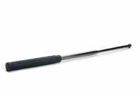
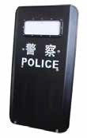
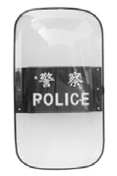
HNXX-PA07
HNXX-PA06

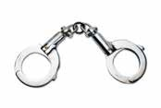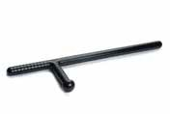

HNXX-PA08 HNXX-PA09 HNXX-PA10 HNXX-PA11 HNXX-PA12
14

Unparallel Advantage

State-owned company with enough currency for big order and L/C payment term

Cooperated with the multinational defense departments, and has a very good reputation in the world

20 years export experiences for tactical items ,we have a mature technology and R & D team

100 skilled workers and 10 quality production lines

15

FAQ

Q1: Are you a factory or trading company ?
A: we are factory supplier with export authority ,office located in Hainan which near Guangzhou port.

Q2: What's your MOQ? OEM or ODM accept?
A: MOQ depend on some RTS items . OEM or ODM accept. And also we have many designs to let you choose.

Q3: May I ask for sample ?
A:Of course yes ,depend on some situations ,you just need to afford freight.

Q4: Can you provide third party test report ?
A : yes, all our items provide test report from third party such as SGS.

Q5: what’ s your payment term ?
A: L/C ;T/T.

Q6: Do you have after-sale services about quality ?
A: yes, we support 6 months after-sale services start from shipment.

16

