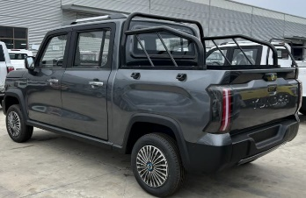
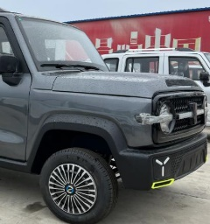
 | VEHICLE SPEC.
Product Name | Pickup P5 Electrical Vehicle
Item | Specification | Reference Pictures
Overall Size | 4000×1600×1700mm | 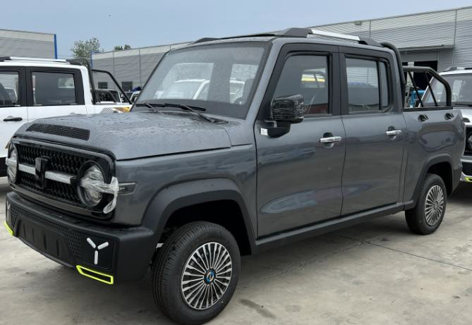  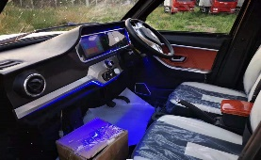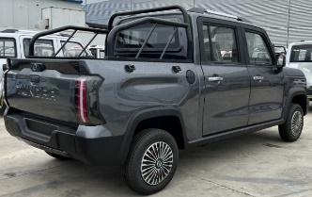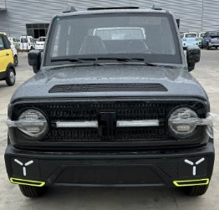
Seats Capacity | 4 Seats
Curb Weight | 670Kg(with battery)
Engine Power | 60V4000W Motor
Battery | 60V 103AH, Lead acid Battery (not included)
Controller | Special Controller
Charger Type | Normal type
Driving Mode | Rear Mounted / Rear Drive
ear Damping system | Integrated axle+ washer bone
Car Body Structure | Frame type + Stamping
Display Instrument | Liquid Crystal Electronic Digital Display 7  Inch
Brake System | F Disc / R Disc
Brake Type | Pedal Oil Brake
Tyre | 185/70R-14 Tubeless Tires
Wheel Hub | Iron+cover
Maximum Speed | 51KM/H
Charging Time | 8~10Hours (General)
Endurance Mileage | about 100 km-110km
So;ar pannel | With (increase about 30-40km mileage per day)
Driving&Copilot Seats | Manual Adjusted Seats, Two Directions
Headrest | no adjustable
Central Lock | Yes with Remote key
Intelligent Remote Key | Yes
Cooling System | Air conditioner
Security System | Backup Camera +MP5
Entertainment System | MP5 Multimedia Player, Stereo Speaker MP5
Light Combination | ①LED Headlamp,LED ②Standalone Steering Lamp, ③Taillight, ④High- mount Stop Lamp,
Other Configuration | ①Windshield Wiper ②Power Windows, ③Folding & Adjustable Rearview Mirror
Color options | ①White ② Red ③Blue ④Pink
Container Load | 3 Sets CBU in 40HQ
Shipment Port | Lianyungang Port or other port
Remarks | *1. About this Quotation, Barring special circumstances, the above quotations valid in 15 workdays.  *2. About Packaging, Standard export packing, or customized packing as your request.  *3. About Payment, By T/T: 50% amount in advance, 50% amount paid before delivery.  *4. About Delivery time, Based on actual quantity, 25 working days in general after payment receipt confirmed.  *5. About Quality Guarantee,12 months for Main Parts, include motor/controller/frame/battery

( Please sign back when confirmed )

