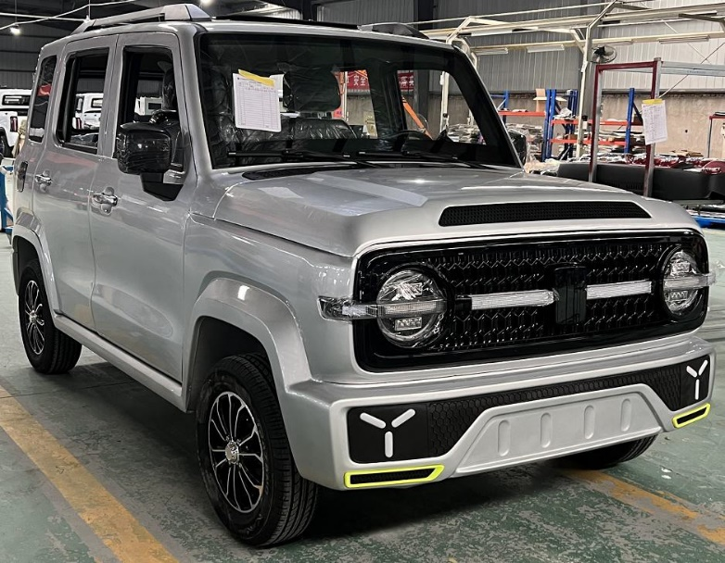
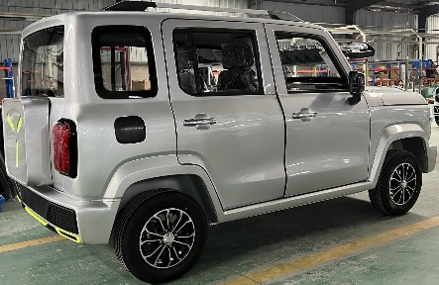
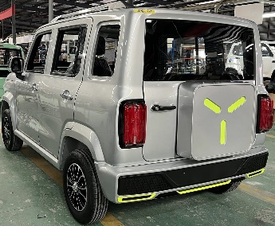
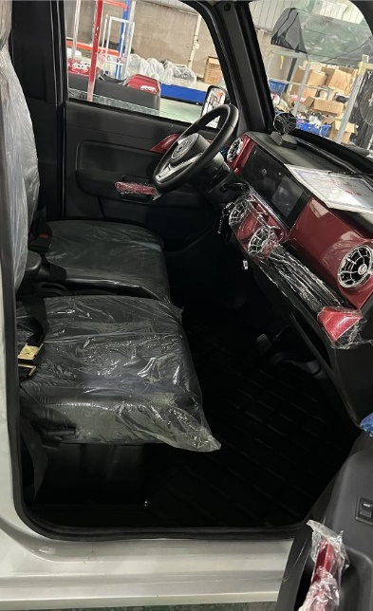
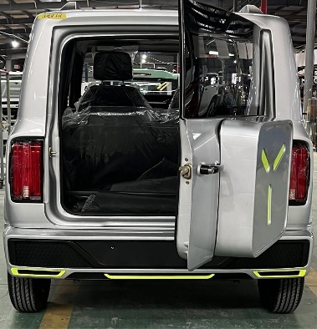
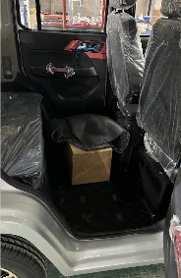
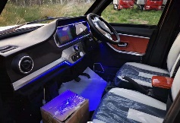
SPEC
G2 VEHICLE SPEC

Product Name |  | Terriitori G2 Passenger Electrical Vehicle JEEP
Item |  | Specification | Reference Pictures
Overall Size |  | 3300×1600mm×1700mm
steering wheel |  | LHD(Left side steering wheel)&RHD
Seats Capacity |  | 4 Seats
Curb Weight |  | 645Kg(with battery)
Engine Power |  | 60V4000W Motor 60V 4000W
Battery |  | 60V 103AH, Lead acid Battery Recommend
Controller |  | Special Controller
Charger Type |  | Vehicle-mounted
Driving Mode |  | Rear Mounted / Rear Drive
Damping system F |  | Integrated Front Axle + longitudinal arm torsion beam Non-independent suspension
Damping system R |  | Integrated Axle + longitudinal arm torsion beam Non-independent suspension
Car Body Structure |  | Frame type+ Stamping
Display Instrument |  | Liquid Crystal Electronic Digital Display 7 Inch +MP5
Brake System |  | F Disc / R Disc
Brake Type |  | Pedal Oil Brake
Tyre |  | 165/70R 12 Vacuum Tires
Wheel Hub |  | Iron hub + cover
Maximum Speed |  | 50 Km/H
Charging type& Time |  | China type, 8~10Hours (General)
Endurance Mileage |  | about 100-120km
Driving&Copilot Seats |  | Manual Adjusted Seats, Two Directions
Headrest |  | not adjustable
Central Lock |  | Yes with Remote key
Intelligent Remote Key |  | Yes
Cooling System |  | with air conditioner
Security System |  | Backup Camera +MP5
Entertainment System |  | MP5 Multimedia Player, Stereo Speaker MP5
Light Combination |  | ①LED Headlamp,LED ②Standalone Steering Lamp, ③Taillight,④ High-mount Stop Lamp,
Other Configuration |  | ①Windshield Wiper, ②Power Windows, ③Folding & Adjustable Rearview Mirror
Color options |  | ①White ② Red ③Blue ④Pink
Container Load |  | CBU 4 Sets in 40HQ
Shipment Port |  | Qingdao/Shanghai/Lianyungang Port
Remarks |  | *1. About this Quotation, Barring special circumstances, the above quotations valid in 15 workdays.  *2. About Packaging, Standard export packing, or customized packing as your request  *3. About Payment, By T/T: 50% amount in advance, 50% amount paid before delivery.  *4. About Delivery time, Based on actual quantity, 25 working days in general after payment receipt confirmed.  *5. About Quality Guarantee,12 months for Main Parts, include motor/controller/frame/battery.

( Please sign back when confirmed )

