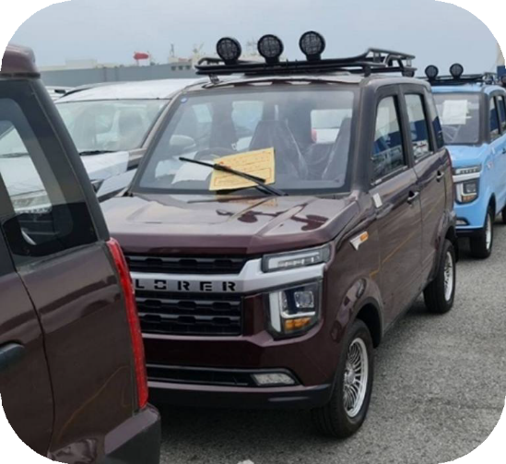
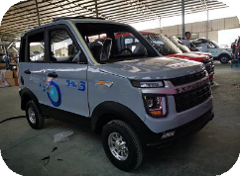
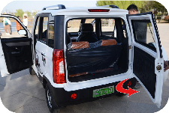
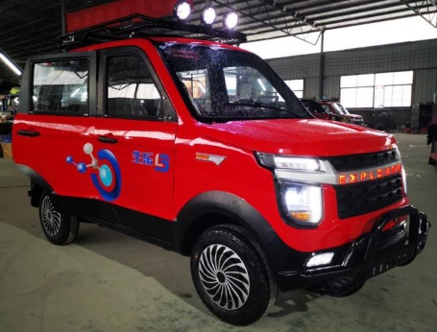
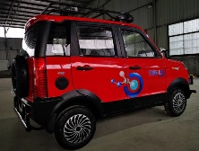
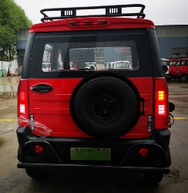
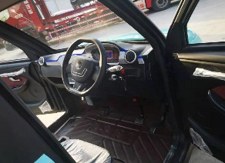
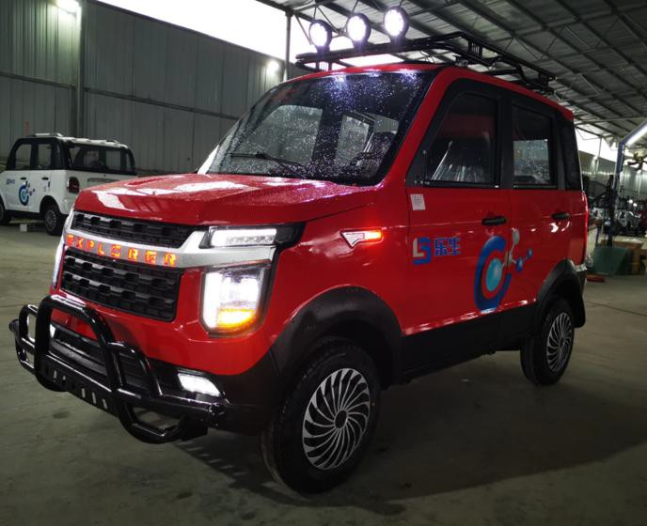
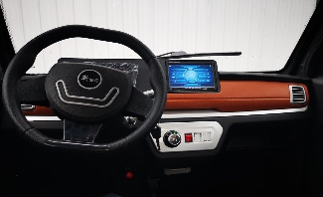
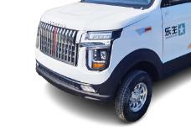
EVPORER SPEC
VEHICLE SPEC.

Product Name | Territori Explorer V8 Passenger Electrical Vehicle
Item | Specification | Reference Pictures
Overall Size | 2850×1400×1650mm
Seats Capacity | 4 Seats
Curb Weight | 630Kg(with battery )
Engine Power | 60V4000W PMSM Motor 60V 4000W
Battery | 60V 100AH, Lead-acid Battery
Controller | Special Controller
Charger Type | Vehicle-mounted
Driving Mode | Rear Mounted / Rear Drive
Damping system | Integrated Front Axle + longitudinal arm torsion beam Non-independent suspension
Damping system R | Integrated Axle + longitudinal arm torsion beam Non-independent suspension
Car Body Structure | Frame type + Stamping
Display Instrument | Liquid Crystal Electronic Digital Display 7 Inch
Brake System | F Disc / R Disc
Brake Type | Pedal Oil Brake
Tyre | 145/70R 12 Tubeless Tires
Wheel Hub | Iron+wheel hub
Maximum Speed | 50-52Km/H IN GPS
Charging Time | 8~10Hours (General)
Endurance Mileage | About 100 Km
Driving&Copilot Seats | Manual Adjusted Seats, Two Directions
Headrest | Not adjustable
Central Lock | Yes with Remote key
Intelligent Remote Key | Yes
Cooling&Warm System | Natural Wind&Heater
Security System | Backup Camera +MP5
Entertainment System | MP5 Multimedia Player, Stereo Speaker MP5
Light Combination | ①LED Headlamp,LED②Standalone Steering Lamp ③Taillight,④ High-mount Stop Lamp,
Other Configuration | ①Windshield Wiper ②Power Windows,③Folding & Adjustable Rearview Mirror
Color options | ①White ② Red ③Blue ④Pink
Container Load | 5 Sets in 40HQ (to be confirmed)  ）
Shipment Port | Qingdao/Shanghai/Lianyungang Port
Remarks | *1. About this Quotation, Barring special circumstances, the above quotations valid in 15 workdays.  *2. About Packaging, Standard export packing, or customized packing as your request  *3. About Payment, By T/T: 50% amount in advance, 50% amount paid before delivery.  *4. About Delivery time, Based on actual quantity, 15 to 20 working days in general after payment receipt confirmed.  20  *5. About Quality Guarantee,12 months for Main Parts, include motor/controller/frame/battery.

( Please sign back when confirmed )

