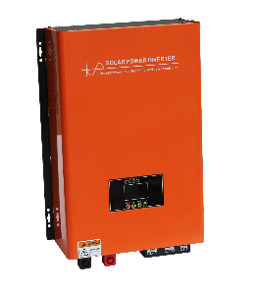
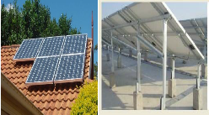
4KW/96V Off Grid Solar Power System
Name And Image | Features | Quantity
Monocrystalline silicon photovoltaic panel  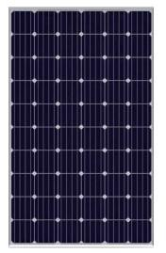 | Rated power (Pmax):350W  Maximum operating voltage (Vmp):32.7V Maximum operating current (Imp):10.4A Open circuit voltage (Voc):38.8V  Short circuit current (Isc):11.2A Size :1698*1002*35MM  Weight: 21.5KG | 10
Inverter & control all-in- one machine | Solar inverter & control all-in-one machine (with mains electricity charging function)  4000W-96VDC 220VAC 50Hz  Rated output power: 4000W DC input voltage: 96VDC  built-in MPPT Solar controller Specifications :96V/50A Output voltage: 220VAC 50Hz  Dimensions: 553mm*411mm*175mm | 1
Lead-acid battery  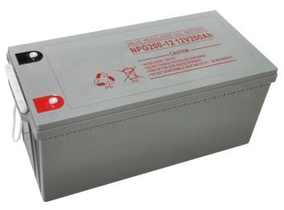 | Voltage: 12VDC Capacity: 100AH  Type: Fully sealed colloid battery life: 6-8 years  Size: 330*173*215mm | 8
Solar Panels Brackets | Sloped roof/flat roof/floor (optional)  anodized aluminum alloy bracket including complete screws and fittings.  Good bearing capacity, no deformation, corrosion resistance, no maintenance cost.  Can carry 10 pieces of 350W solar panel system configuration: 1 set of bracket for each system | 1
Batteries Cables and Solar Panels Cables  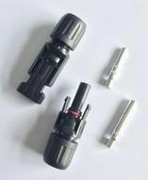 | Battery cable: 10mm² 25cm long 7 pcs battery cables: 10mm² 2m long 2 pcs  solar panel cables: 4mm² Red and black 40m each  MC4 connectors: 2 pairs | 1
The system allows a maximum total load power of 4KW. This system generates about 17.5KWH per day. unit price is 3,488USD per set/kit MOQ 4 sets

