LAYOUT : 6.96*4.1*2.8/2.6m
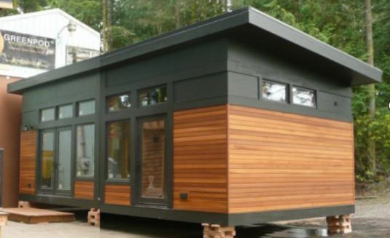

Body house quotation
S/N | Material | Dimension | Specification | Quantity | unit
1 | Glavanized steel base with guie rail |  | glavanized steel & C-type 2mm & MGO board floor 15mm &steel sheet channel 6960*4100mm (L*W) | 28.5 | m2

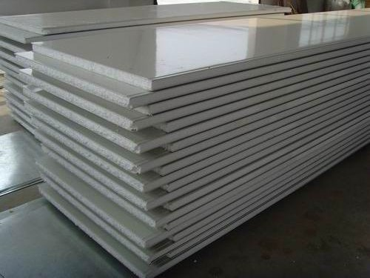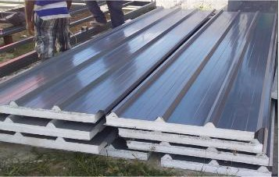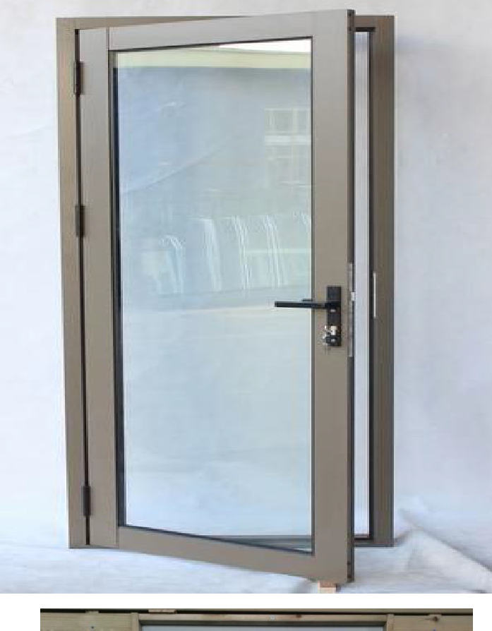
2 | Glavanized steel column | 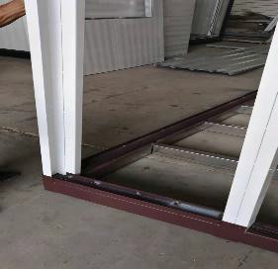 | U type welding 80*40*2mm 2800mm &2600mm (H) | 4 | pcs
3 | EPS sandwich wall panel |  | steel sheet+75mm EPS foam+steel sheet | 82 | m2
4 | EPS sandwich roof panel |  | steel sheet+75mm EPS foam+steel sheet | 33 | m2
5 | Aluminum silver sliding door | 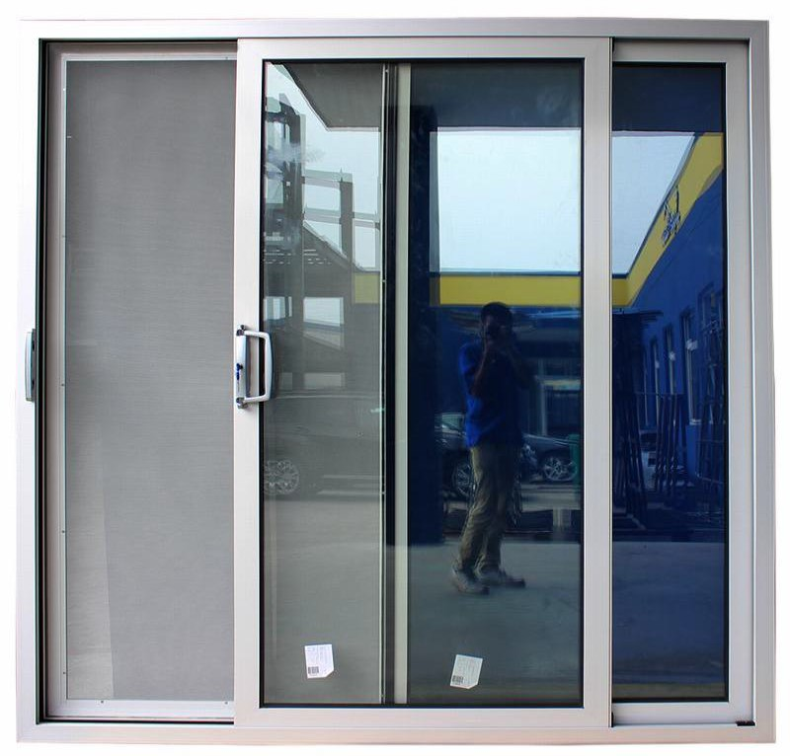 | aluminum silver frame with double glass 1500*2500mm | 1 | pcs
6 | aluminum single door |  | aluminum silver frame with double  glass930*2500mm | 1 | pcs

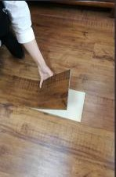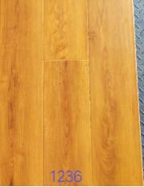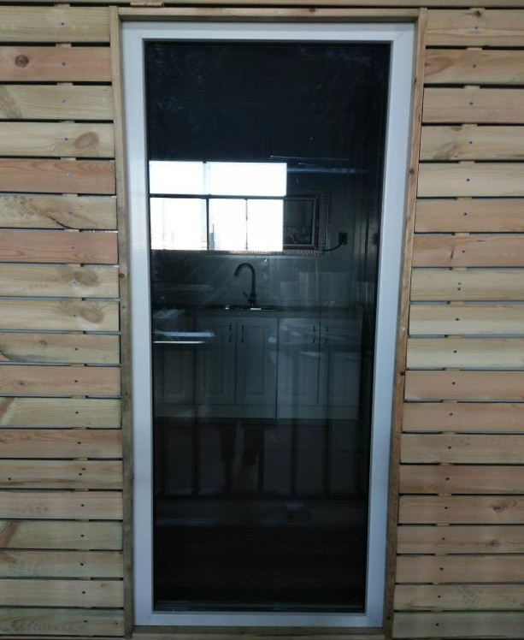
7 | aluminum long window |  | aluminum silver frame with double glass650*2500mm |  | 2 | pcs
8 | aluminum narrow window | 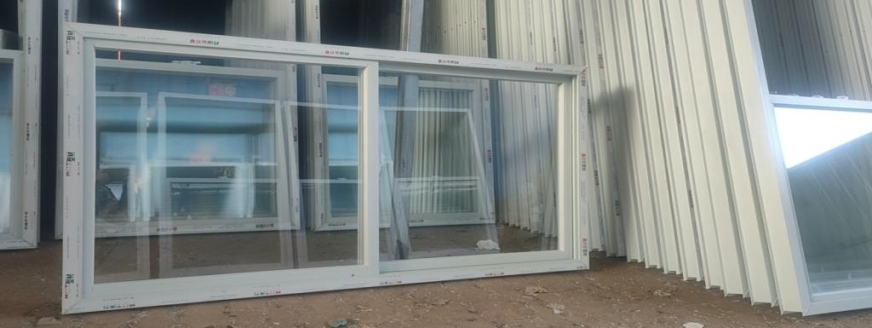 | aluminum sliver frame with double glass1400*600mm |  | 4 | pcs
9 | inside door for bedroom and bathroom | 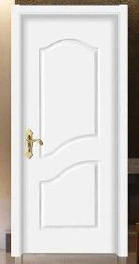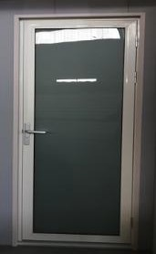 | two inside door800*2000mm/750*2000mm |  | 2 | pcs
10 | connecting by bolts and nails |  |  |  | 1 | set
11 | Accessories parts |  | 0.5mm steel sheet cover for top wall and ground channel |  | 1 | set
12 | FOB cost | from xingang port to our factory and back to Xingang port
Total 1set body empty house FOB Xingang China FOB USD |  |  |  |  | 5708
Option quotation
S/N | Material | Dimension | Specification | Quantity | Unit | price USD
1 | composite floor |  |  | 31 | m2 | 251

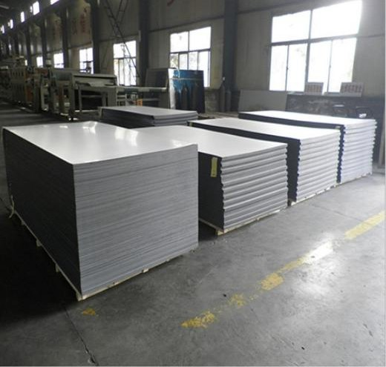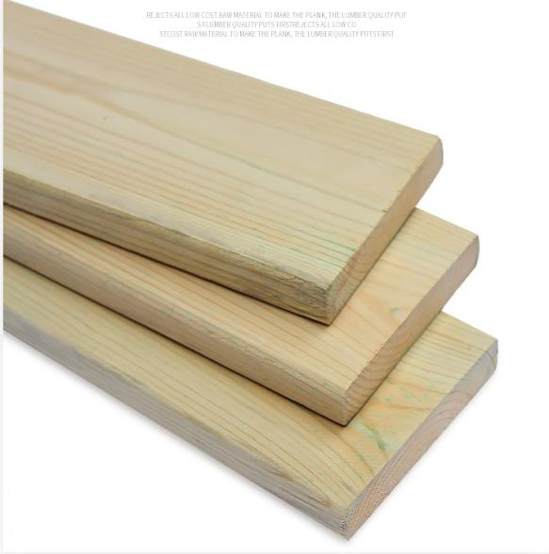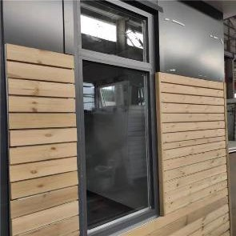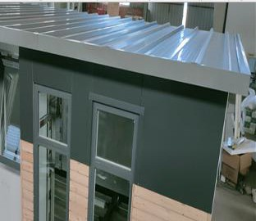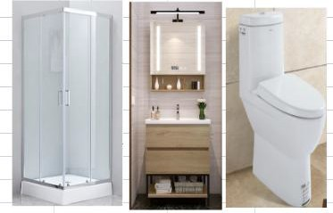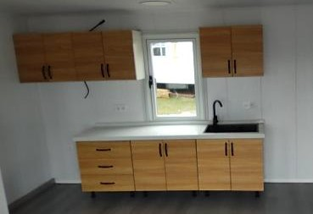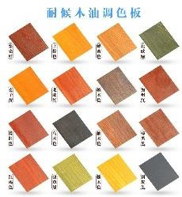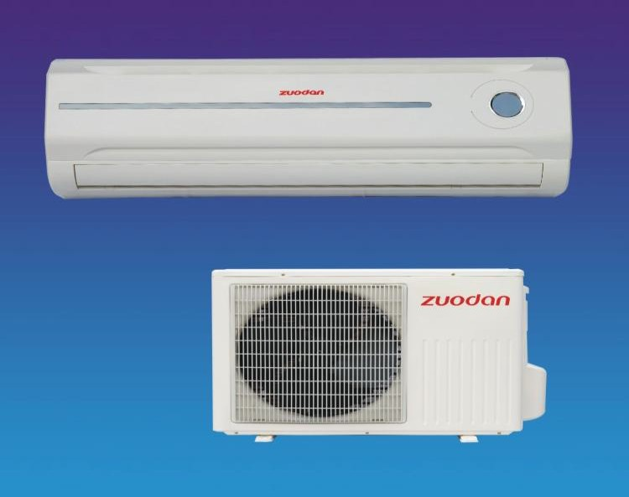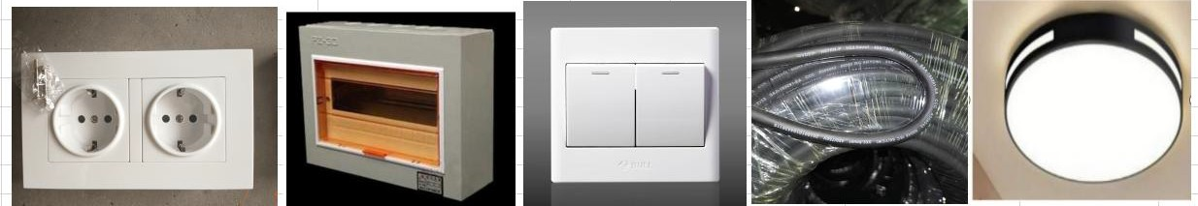

Perserving wood outside wall
2
cladding 38 m2 566

aluminum board for cover
3
outside winodw 24 m2 440

4 sanitary fitting 1 set 490

1.5x0.5x0.85m/ top
5 kitchen cabinet
1.5x0.3x0.5m 1 set 405

- electrical fitting soeckets/switches/distribution
box 1 set 450

- aire-conditioner 9000BTU 1 set 380

8 | PVC ceiling | 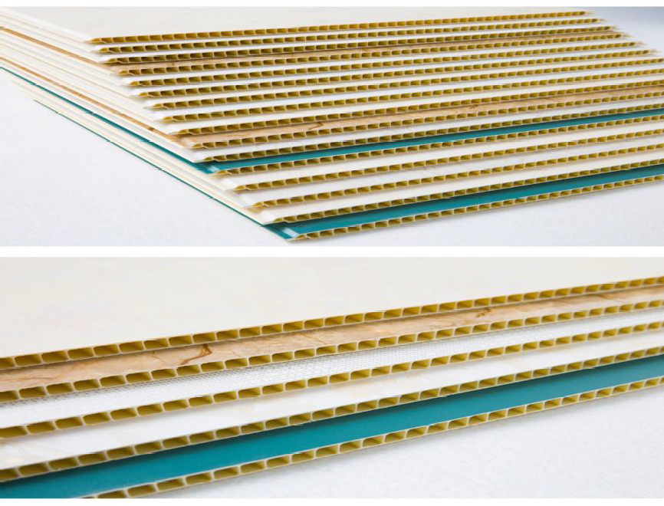 |  | 38 | m2 | 226
9 | precast wire in the wall | 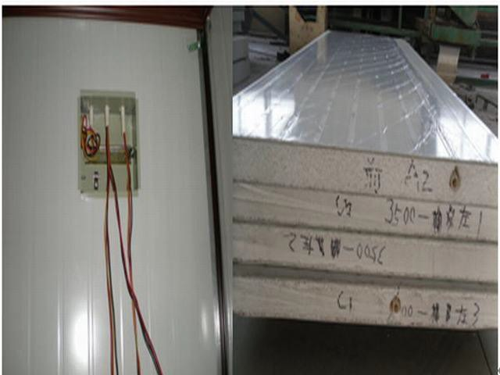 |  | 1 | set | 250
 | total option price |  |  |  |  | 3,958
 | Total 1set house price |  | FOB USD | 9,666.00
 | Total 50 sets house price |  | FOB USD | 483,300
 | sea freight from Xingang of China to Mersin Port TURKEY 39days arrive |  |  | 39,100
 | insurance |  |  | 510
 | total 50 sets houses | CIF USD |  | 522,910
Terms and conditions
1.price terms: CIF
2. order quantity: 50 sets (Loading: 50sets in 13x40HQ container.)
3.payment terms: Total by T/T. 50%deposit in advance, 50% the balance before shipment.
4.delivery term: within 35 days after receiving deposit.

