15KW Off-grid (with grid switch) Solar System Quotation |  |  |  | Ref No.: OFF-SGHP-15KW
System Basic Information: | Suggested for 24hrs Power Consumption: Rated Loads Capacity: | 40KWH  15KW |  | 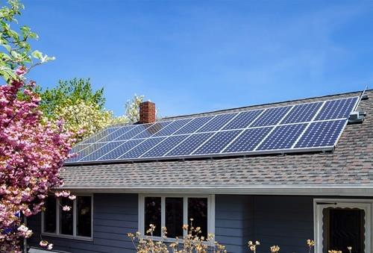
Solar Panel | Type: Half-cell Monocrystalline PV Module Max Power: 550W  Size: 2278*1134*35mm  25 years power output lifespan | QTY: | 18 pcs
PV Array Combiner  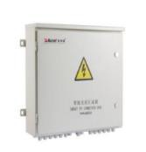 | Simplify wiring between PV array and controller, protections to controller, features:  - Wide range of DC input voltage  - IP65 guard level, suitable for outdoor  - Reliable thunderstorm & surge protection  - Multiple PV strings inputs | QTY: | 1 pcs | System Working Principle:
This system uses batteries to store the solar energy, at the same time, the system can be connected with the grid for utilization of grid power optionally. The system uses battery power in priority, but when sunshine is not so good or loads consumption is too big which caused the battery power inadequacy, then the system can switch automatically to grid power supply. When the batteries restore capacity, the system can switch back to battery power source.

Terms and conditions:
- Price: EXW price in USD (MOQ: 5 sets)
- Payment: Full payment or 50% by T/T, balance by T/T before shipment
- Package: Export standard package suitable for tough handling and sea transport.
- Delivery: Goods to be ready within 15~30 days depending on order quantity.
- Warranty: 5 years for solar panel, 2 years for controller/inverter/battery.
- Certification: CE,ROHS
- Validity: 15 days.
Controller  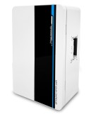 | PV Charging Controller 96V 100A;  MPPT charging type, LCD display, intelligent control. Temperature compensation; Protections: short circuit, deep discharge, input surge voltage, over current. | QTY: | 1 pcs
Inverter  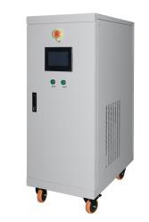 | Rated DC96V input, AC220V 1-phase output; Frequency: 50/60Hz +/- 0.5%  Rated Output Capacity: 15KW  True sine-wave, off-grid type; LCD display of operating parameters;  - Protections: Short circuit, overload, surge current, over temperature, over/under voltage, over/under frequency, lightning, phase imbalance, reverse polarity | QTY: | 1 pcs
Battery  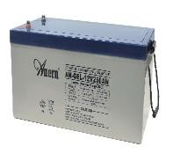 | 12V 250AH per piece  GEL valve-regulated lead-acid battery, fully sealed, deep cycle, free maintenance type  Service Life: 5~6 years | QTY: | 16 pcs
Solar Panel Rack  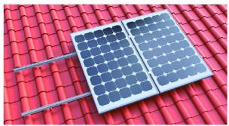 | Roof type mounting rack including complete fittings,  (Rack can be customized per request) | QTY: | 1 set
Cables  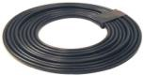 | International standard, with specification suitable for solar system, PV1-F-1*4 series | QTY: | 150 m
Cables | International standard, with specification suitable for solar system, BVR-1*10 series | QTY: | 100 m
Circuit Breaker&MC4  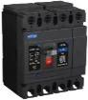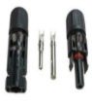 | Circuit Breaker: 4P/1200V 140A(Battery) 2pcs MC4 Solar PV Connectors: male & female 3pcs | QTY: | 1 set
EXW Price (USD/Set): |  | US$14,954.00

20KW Off-grid (with grid switch) Solar System Quotation |  |  |  | Ref No.: OFF-SGHP-20KW
System Basic Information: | Suggested for 24hrs Power Consumption: Rated Loads Capacity: | 60KWH  20KW
Solar Panel | Type: Half-cell Monocrystalline PV Module Max Power: 550W  Size: 2278*1134*35mm  25 years power output lifespan | QTY: | 28 pcs
PV Array Combiner  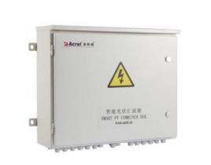 | Simplify wiring between PV array and controller, protections to controller, features:  - Wide range of DC input voltage  - IP65 guard level, suitable for outdoor  - Reliable thunderstorm & surge protection  - Multiple PV strings inputs | QTY: | 1 pcs | System Working Principle:  This system uses batteries to store the solar energy, at the same time, the system can be connected with the grid for utilization of grid power optionally. The system uses battery power in priority, but when sunshine is not so good or loads consumption is too big which caused the battery power inadequacy, then the system can switch automatically to grid power supply. When the batteries restore capacity, the system can switch back to battery power source.  Terms and conditions:  - Price: EXW price in USD (MOQ: 4sets)  - Payment: Full payment or 30% by T/T, balance by T/T before shipment  - Package: Export standard package suitable for tough handling and sea transport.  - Delivery: Goods to be ready within 15~30 days depending on order quantity.  - Warranty: 5 years for solar panel, 2 years for controller/inverter/battery.  - Certification: CE,ROHS  - Validity: 15 days.
Controller  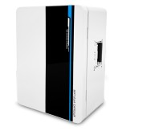 | PV Charging Controller 192V 80A;  MPPT charging type, LCD display, intelligent control.  Temperature compensation; Protections: short circuit, deep discharge, input surge voltage, over current. | QTY: | 1 pcs
Inverter | Rated DC192V input, AC220V 1-phase output; Frequency: 50/60 Hz +/- 0.5%  Rated Output Capacity: 20KW  True sine-wave, off-grid type; LCD display of operating parameters;  - Protections: Short circuit, overload, surge current, over temperature, over/under voltage, over/under frequency, lightning, phase imbalance, reverse polarity | QTY: | 1 pcs
Battery | 12V 200AH per piece  GEL valve-regulated lead-acid battery, fully sealed, deep cycle, free maintenance type  Service Life: 5~6 years | QTY: | 32 pcs
Solar Panel Rack | Roof type mounting rack including complete fittings,  (Rack can be customized per request) | QTY: | 1 set
Cables | International standard, with specification suitable for solar system, PV1-F-1*4 series | QTY: | 200 m
Cables | International standard, with specification suitable for solar system, BVR-1*16 series | QTY: | 150 m
Circuit Breaker&MC4 | Circuit Breaker: 4P/1200V 140A(Battery) 2pcs MC4 Solar PV Connectors: male & female 4pcs | QTY: | 1 set
EXW Price (USD/Set): |  | US$19,951.00

30KW Off-grid (with grid switch) Solar System Quotation |  |  |  | Ref No.: OFF-SGHP-30KW
System Basic Information: | Suggested for 24hrs Power Consumption: Rated Loads Capacity: | 90KWH  30KW
Solar Panel | Type: Half-cell Monocrystalline PV Module Max Power: 550W  Size: 2278*1134*35mm  25 years power output lifespan | QTY: | 42 pcs
PV Array Combiner | Simplify wiring between PV array and controller, protections to controller, features:  - Wide range of DC input voltage  - IP65 guard level, suitable for outdoor  - Reliable thunderstorm & surge protection  - Multiple PV strings inputs (4 strings) | QTY: | 1 pcs | System Working Principle:
This system uses batteries to store the solar energy, at the same time, the system can be connected with the grid for utilization of grid power optionally. The system uses battery power in priority, but when sunshine is not so good or loads consumption is too big which caused the battery power inadequacy, then the system can switch automatically to grid power supply. When the batteries restore capacity, the system can switch back to battery power source.

Terms and conditions:
- Price: EXW price in USD (MOQ: 2sets)
- Payment: Full payment or 30% by T/T, balance by T/T before shipment
- Package: Export standard package suitable for tough handling and sea transport.
- Delivery: Goods to be ready within 15~30 days depending on order quantity.
- Warranty: 5 years for solar panel, 2 years for controller/inverter/battery.
- Certification: CE,ROHS
- Validity: 15 days.
Controller | PV Charging Controller DC384V 80A;  MPPT charging type, LCD display, intelligent control. Temperature compensation; Protections: short circuit, deep discharge, input surge voltage, over current. | QTY: | 1 pcs
Inverter | Rated DC384V input, AC220V 1-phase output; Frequency: 50/60 Hz +/- 0.5%  Rated Output Capacity: 30KW  True sine-wave, off-grid type; LCD display of operating parameters;  - Protections: Short circuit, overload, surge current, over temperature, over/under voltage, over/under frequency, lightning, phase imbalance, reverse polarity | QTY: | 1 pcs
Battery | 12V 250AH per piece  GEL valve-regulated lead-acid battery, fully sealed, deep cycle, free maintenance type  Service Life: 5~6 years | QTY: | 32 pcs
Solar Panel Rack | Roof type mounting rack including complete fittings, aluminum alloy  (Rack can be customized per request) | QTY: | 1 set
Cables | International standard, with specification suitable for solar system, PV1-F-1*4 series | QTY: | 300 m
Cables | International standard, with specification suitable for solar system, BVR-1*16 series | QTY: | 150 m
Circuit Breaker&MC4 | Circuit Breaker: 4P/1200V 140A&250A each 1pcs MC4 Solar PV Connectors: male & female 4pcs | QTY: | 1 set
EXW Price (USD/Set): |  | US$26,645.00

