20ft foldable READY container house outside size: 5800mm*2480mm*2560mm / 20ft foldable house inside size : 5640mm*2320mm*2420mm
each packaged size : 5800*2480*420mm/ each house weight : 1300kgs
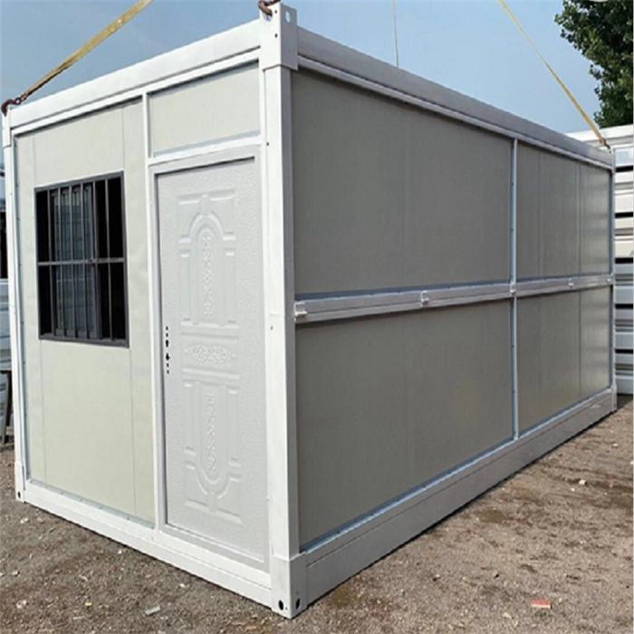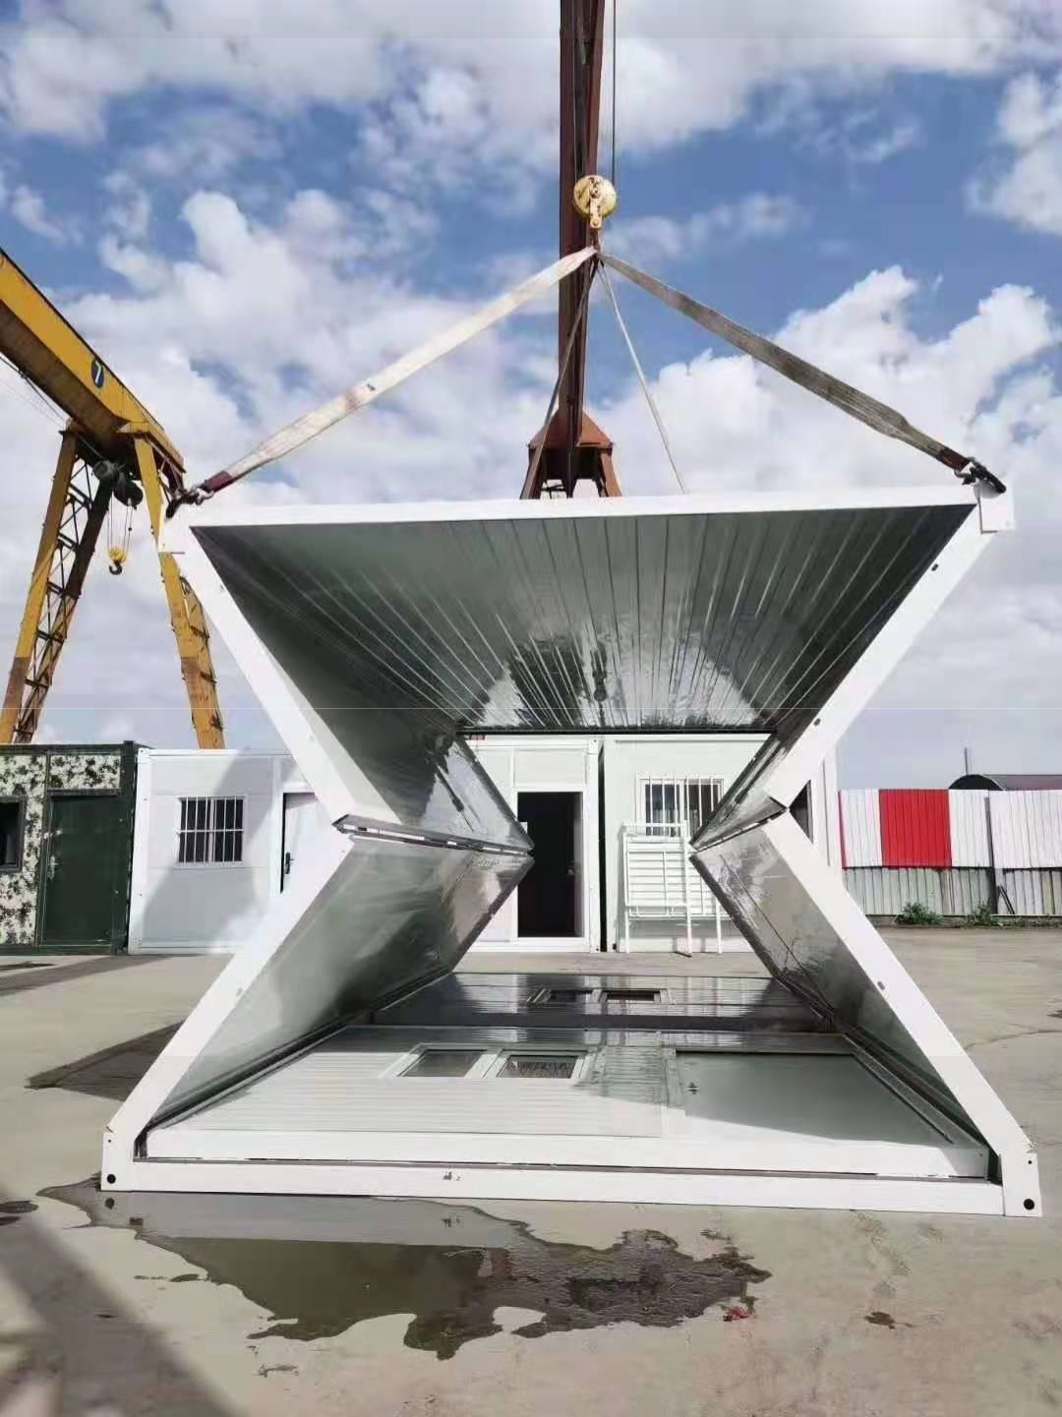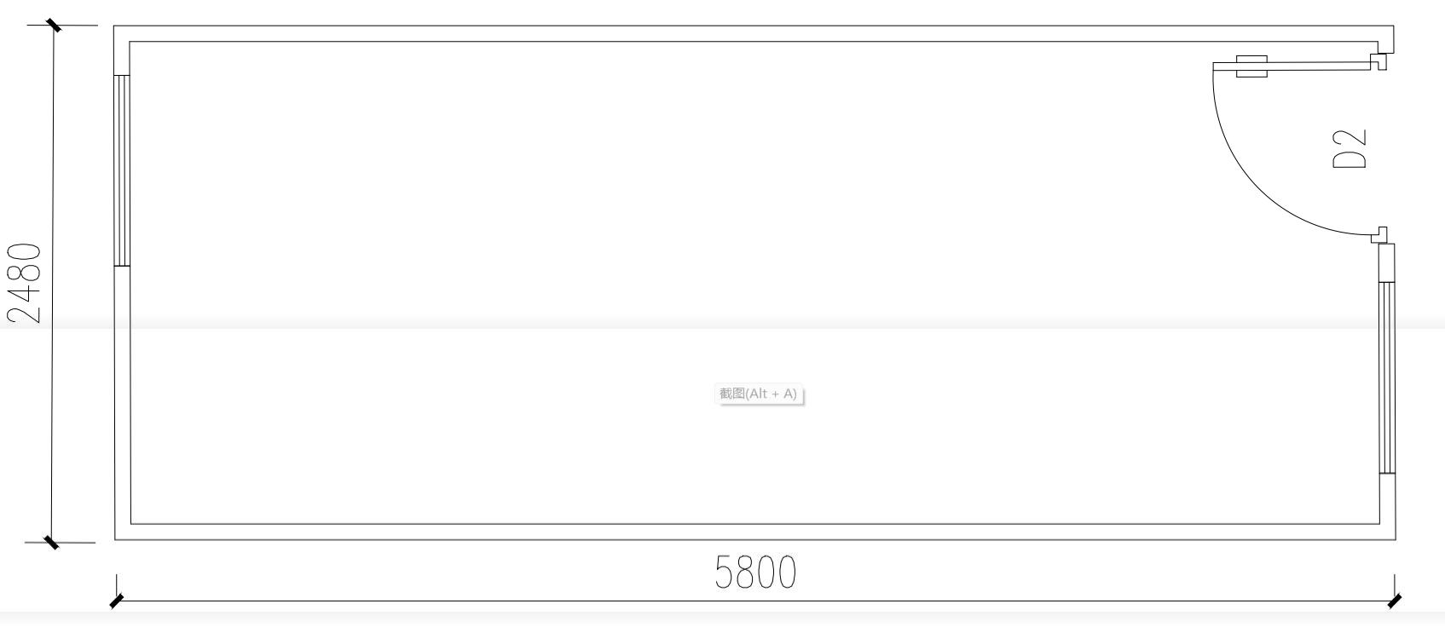
Body house quotation

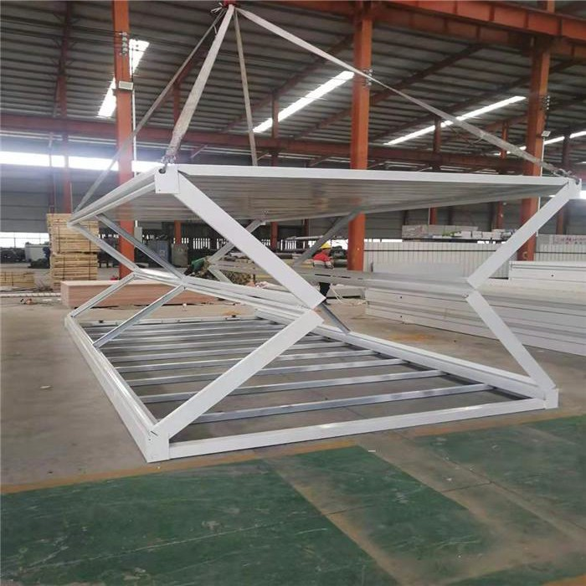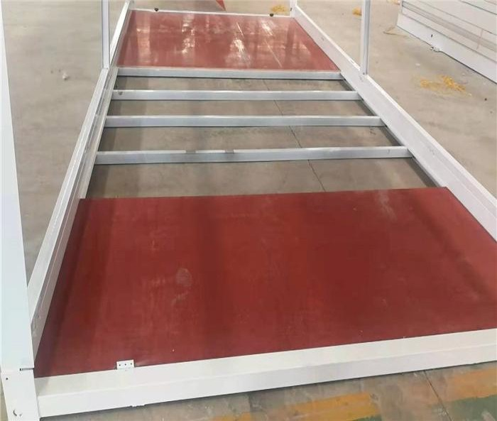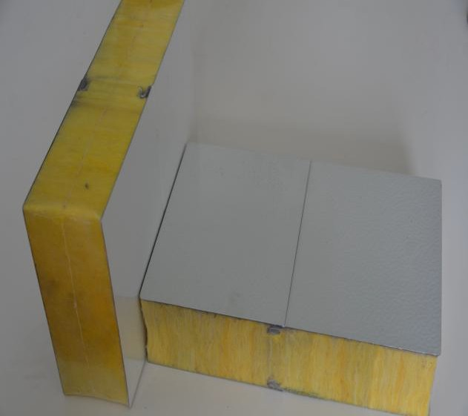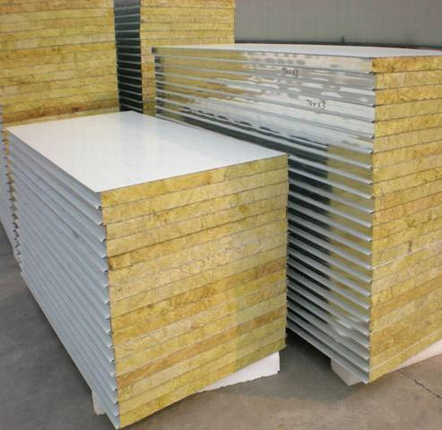
S/N | structure | part name | Specification
1 | Framework structure for whole house | Top Side Beam |  | Q235B galvainzed steel square tube 80×80 mm
 |  | Bottom side beam |  | Q235B rectangular tube 80×80 mm
 |  | Side beam |  | Q235B galvainzed steel square tube 40×80mm
 |  | Side wall frame |  | Q235B galvainzed steel square tube 40×80mm
 | Framework structure for whole house | Bottom load |  | Q235B galvainzed steel square tube 40×60mm
 |  | Second framework |  | Q235B galvainzed steel square tube 40×80mm
 |  | Hanging head |  | Q235B Connectors stamped steel three-way connector
 |  | Folding hinge |  | Galvanized hinge 13 mm
2 | roof insualtion | External roof | 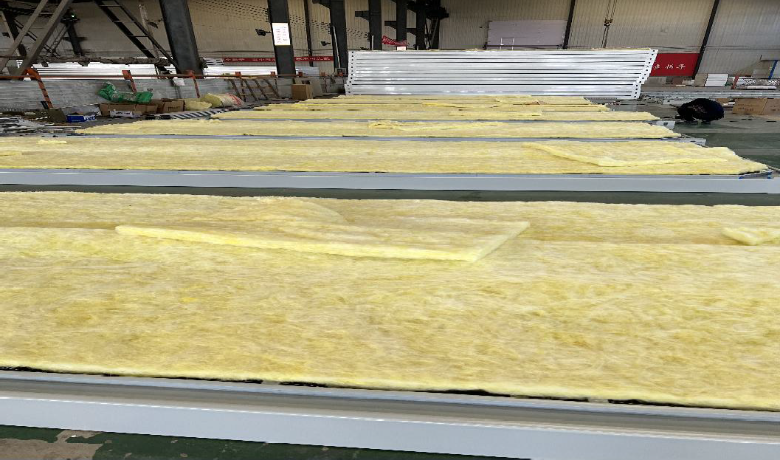 | Galvanized steel sheet
 |  | insulation roof |  | glass wool 65mm A level fireproof
 |  | Internal ceiling |  | Color steel V/910/0.25mm
3 | wall insulation | sandwich panel |  | 50mm thickness glass wool sandwich panel A level fireproof
4 | floor | fiber cement board |  | fiber cement board 15mm thickness
5 | Hardware fittings |  |  | Expansion Anchor bolts

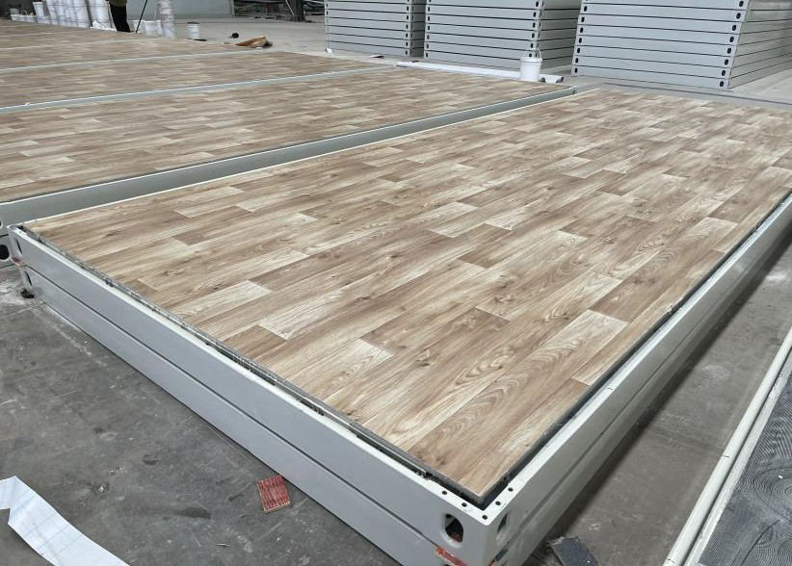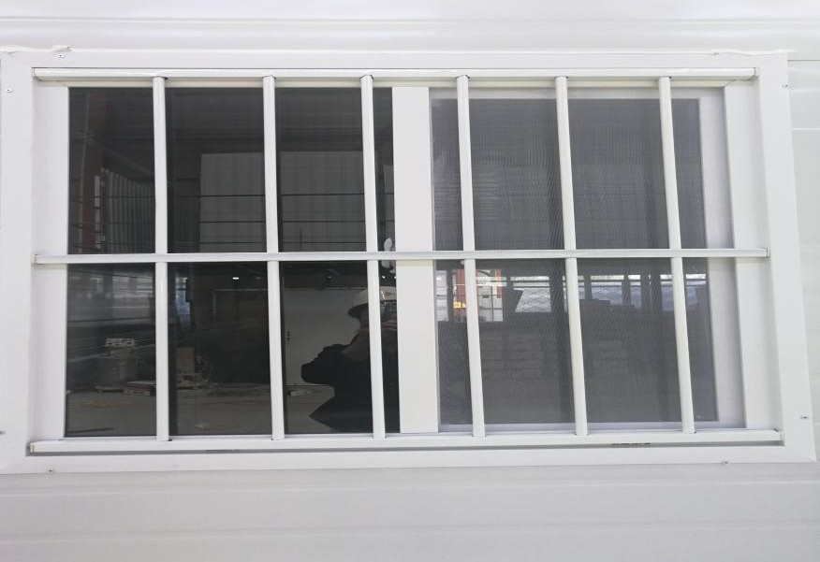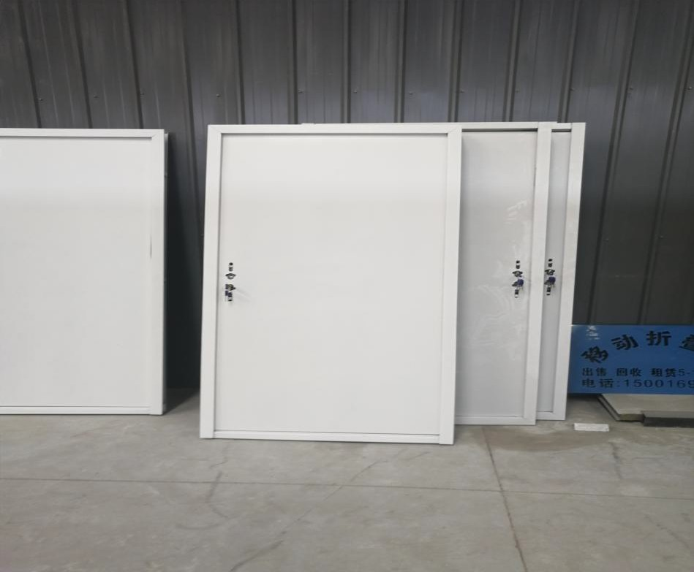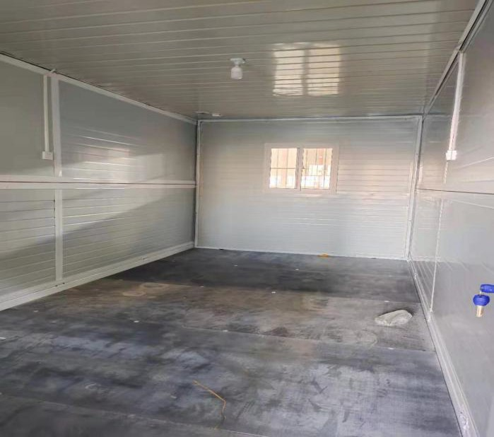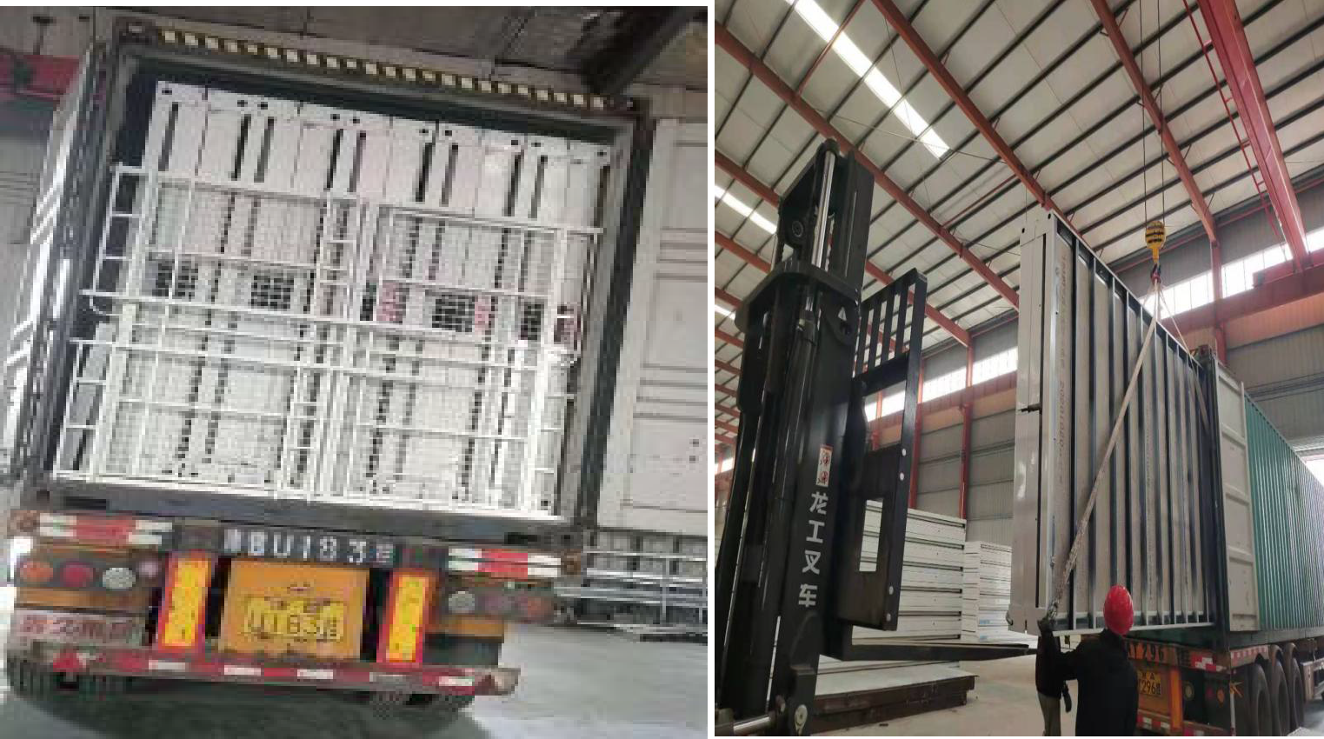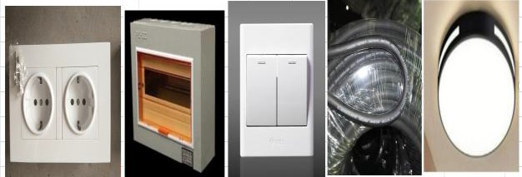

Security door 970*1970mm security door-1pcs

- PVC window 920*920mm PVC frame with double glazed 0.4mm thickness--2pcs

FOB cost empty body no option items 10sets fit in 1x40HQ
total 1 set body house price FOB USD 1580
option

NO. name spcification quantity unit total price USD

1 Electricity distribution box/socket 3pcs/switch 1pcs
1 set 120

2 vinyl floor 1 set 120

3 laoding 10UNITS LOADED IN 1X40HQ

total option price 240

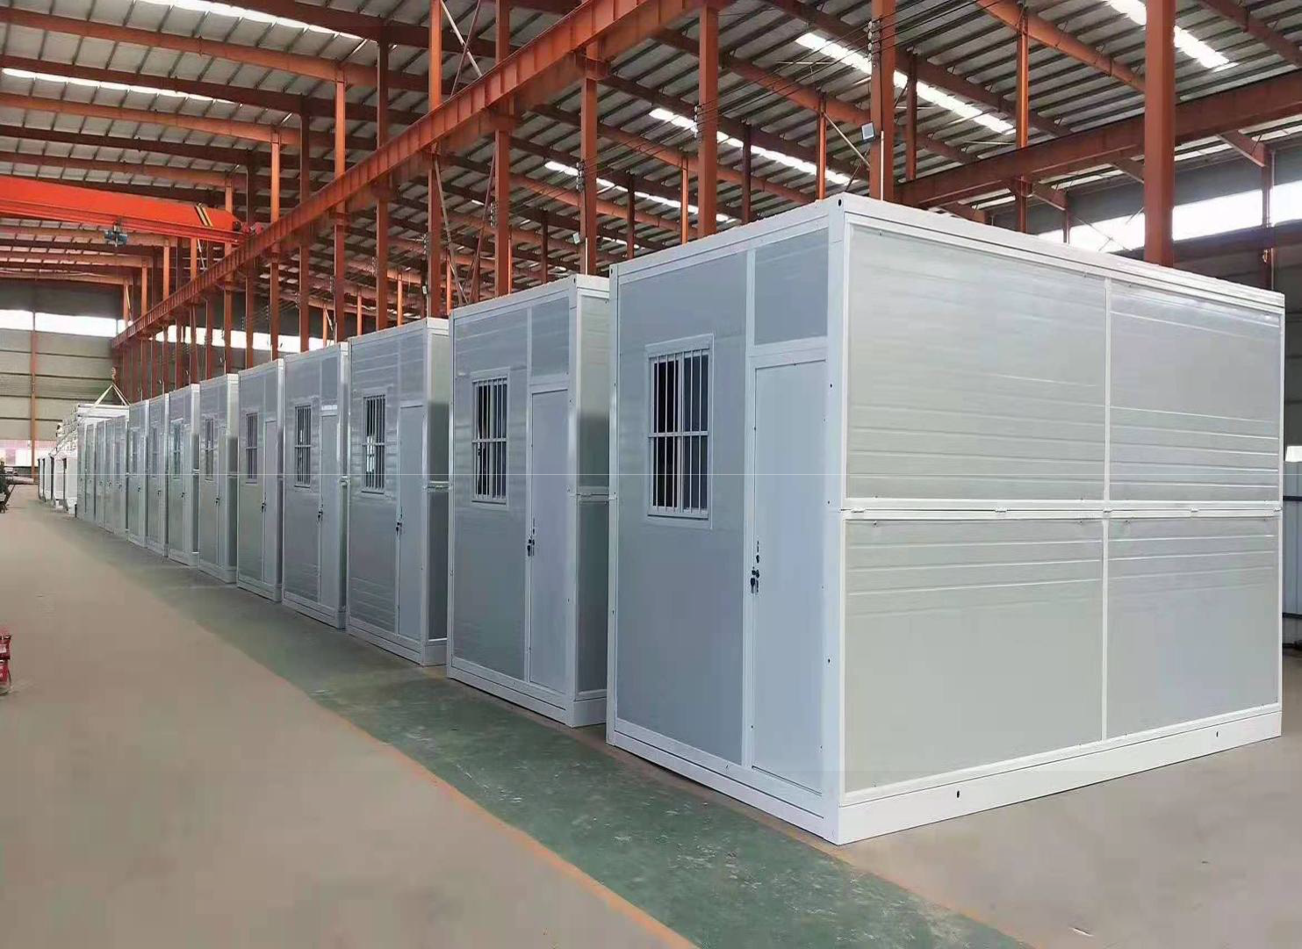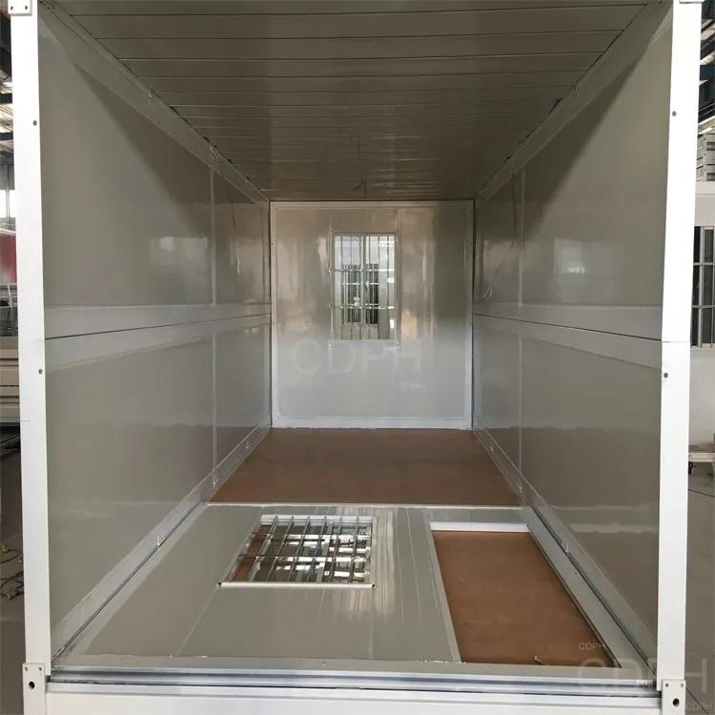
total 1 set house with option price | FOB USD |  | 1820
total (500 sets) | FOB USD |  | 910,000
sea freight from Xingang China to MERSIN TURKEY |  | USD | 142500
insurance 50x40HQ |  | USD | 940
Grand total 500 sets houses CIF |  | USD | 1,053,440.00
TERMS AND CONDITIONS
1. Price terms: CIF
2. Payment terms: TT 50% deposit in advance, the balance will be paid before loading.
3. Delivery date: Within 30 days after receipt of deposit.
4. 500 sets loaded in 50 x 40 HQ shipping container
