Quotation for expandable container house

No | item | specification | picture | loading quantity | price
1 | DRF-1 | open room with steel door 1)openable size 5850mm*6085mm*2500mm Closed size: 5850mm*2250mm*2500mm) 2)75mm eps sandwich panel for wall and roof  3)16mm reinforced MGO board+1.6mm pvc tile for floor 4)with 1 steel  door(930*2030mm), 8 pvc double glazed sliding windows  （930*930mm);  5)with electricity, DB box, switch, sockets, A/C sockets, wires, etc.; | 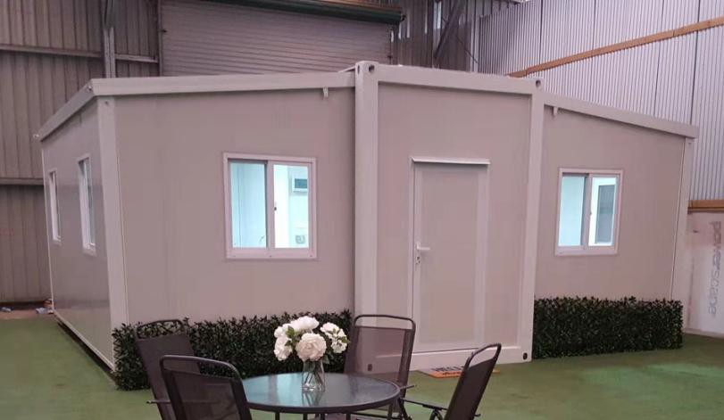 | 1*40HC container can load 2 units | DISCOUNT  PRICE:USD7,700/  UNI T EXW

2 | DRF-2 | open room with sliding door 1)openable size 5850mm*6085mm*2500mm Closed size: 5850mm*2250mm*2500mm) 2)75mm eps sandwich panel for wall and roof  3)16mm reinforced MGO board+1.6mm pvc tile for floor 4)with 1 aluminum hinged door door(W1300*H2000mm),8 pvc double glazed sliding windows  （930*1130mm);  5)with electricity, DB box, switch, sockets, A/C sockets, wires, etc.; | 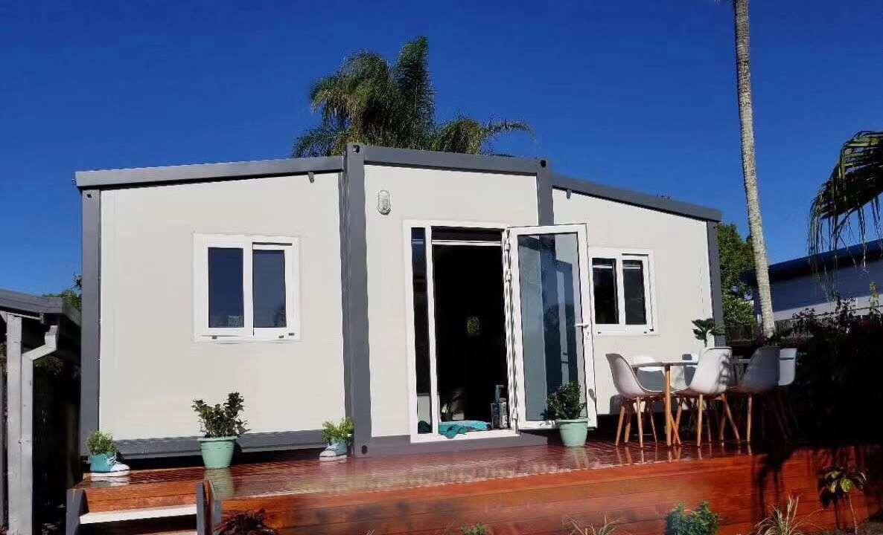 | 1*40HC container can load 2 units | DISCOUNT PRICE:USD7,990/  UNIT EXW
3 | DRF-3 | Open Space with a Toilet Layout  1)openable size 5850mm*6085mm*2500mm Closed size: 5850mm*2250mm*2500mm) 2)75mm eps sandwich panel for wall and roof  3)16mm reinforced MGO board+1.6mm pvc tile for floor 4)with 1 aluminum double glazed hinged door(W1300*H2000mm), 8 pvc double glazed sliding windows  （930*930mm), 1 bathroom exhaust fan ;  - with electricity, DB box, switch, sockets, A/C sockets, wires, etc.;  - with bathroom(shower  ,shower tray,seat toilet,wash basin,plumbing) | 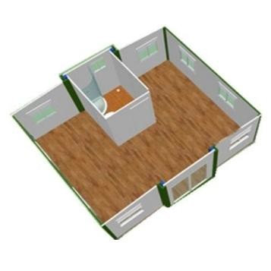 | 1*40HC container can load 2 units | DISCOUNT PRICE  USD8,810/UNIT EXW

4 | DRF-4 | 1 Bedroom Layout 1)openable size 5850mm*6085mm*2500mm Closed size: 5850mm*2250mm*2500mm) 2)75mm eps sandwich panel for wall and roof  3)16mm reinforced MGO board+1.6mm pvc tile for floor 4)with 1 aluminum double glazed hinged door(W1260*H2000mm), 8 pvc double glazed sliding windows  （930*930mm), 1 bathroom exhaust fan ;  - with electricity, DB box, switch, sockets, A/C sockets, wires, etc.;  - with bathroom(shower  ,shower tray,seat toilet,wash basin,plumbing)  - with one bedroom 8)with 1.8m long kitchen | 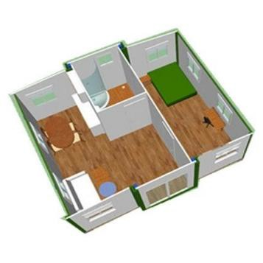 | 1*40HC container can load 2 units | DISCOUNT PRICE  USD8,979/UNIT EXW
5 | DRF-5 | 2 Bedroom Layout 1)openable size 5850mm*6085mm*2500mm Closed size: 5850mm*2250mm*2500mm) 2)75mm eps sandwich panel for wall and roof  3)16mm reinforced MGO board+1.6mm pvc tile for floor 4)with 1 aluminum double glazed hinged door(W1260*H2000mm), 8 pvc double glazed sliding windows  （930*930mm), 1 bathroom exhaust fan ;  - with electricity, DB box, switch, sockets, A/C sockets, wires, etc.;  - with bathroom(shower  ,shower tray,seat toilet,wash basin,plumbing)  - with two bedrooms 8)with 1.8m long kitchen | 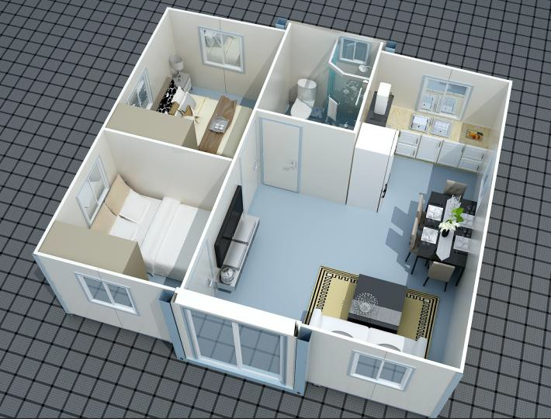 | 1*40HC container can load 2 units | DISCOUNT  PRICE:USD8,999/  UNIT EXW
remark

payment terms:50% deposit by T/T,50% balance before shipment
valid time:in 7 days
lead time:45 days
one 40HC container can load 2 units

material list for expandable container house with bathroom and kitchen
Project name: |  |  |  |  |  |  | Project No.:
Specification: |  |  |  | 5850mm*6085mm*2500mm |  |  | Area: | 35.5 | m2
NO | ITEM |  | SPECIFICATION |  | UNIT | QUANT ITY |  |  | PICTURE
1 | middle frame( our frame is thicke r than others  ) | top main beam |  | 120*42*5mm thickness channel beam welded 60*2.3mm steel plate and 135*25*40*2.3mm channel |  |  |  |  | 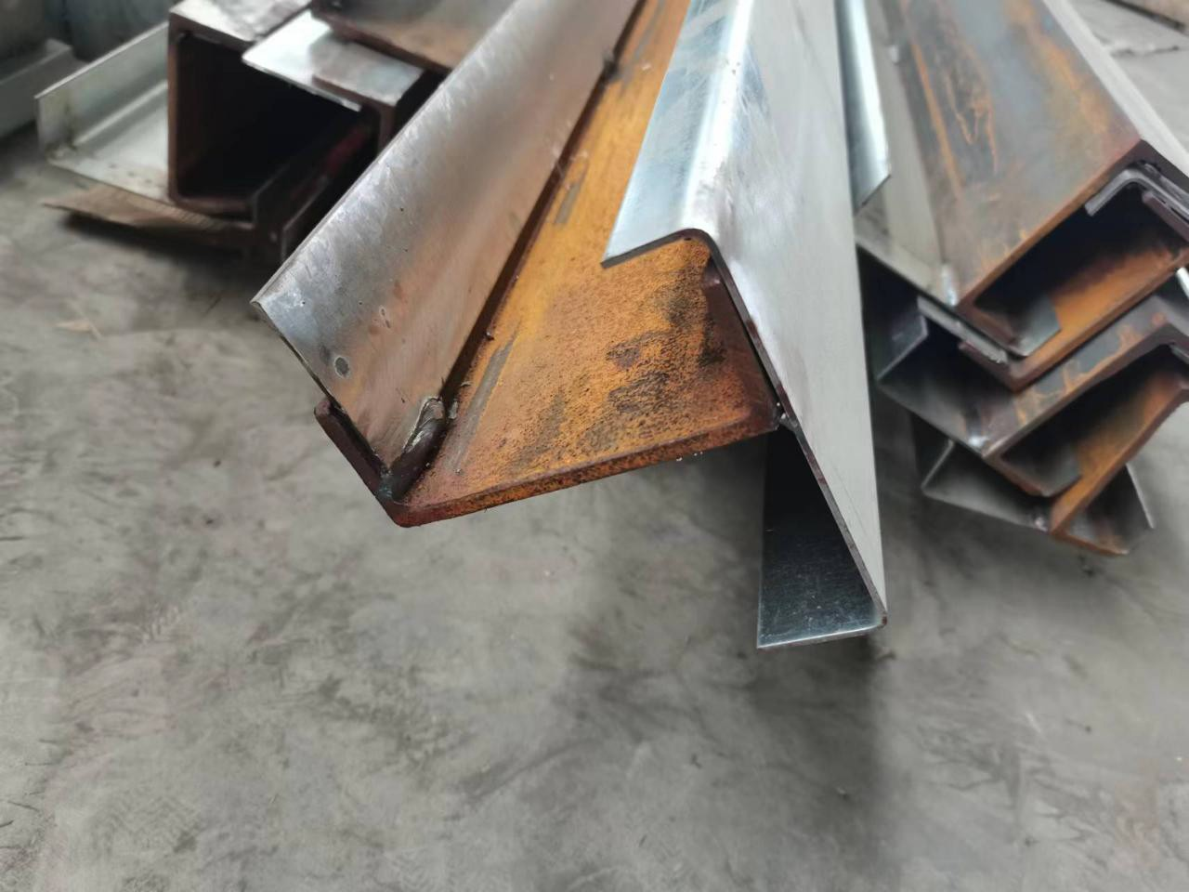
2 |  | corner |  | the same size as shipping container,8.6KG/P CS |  |  |  |  | 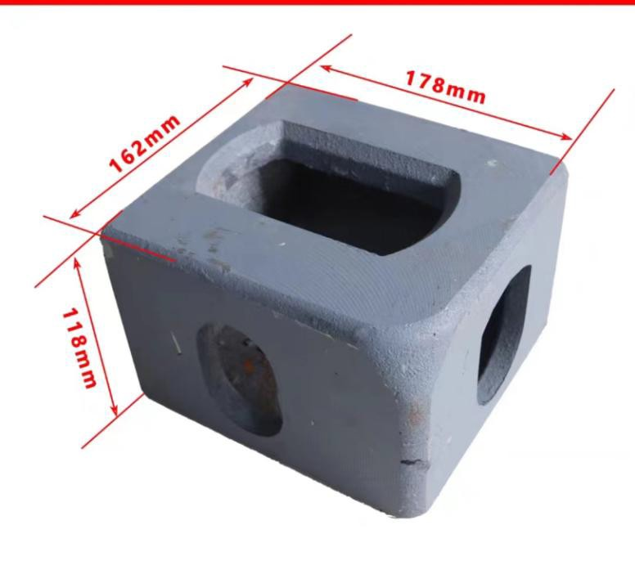
3 |  | bottom secondary beam |  | 100*50*1.5mm galvanized tube steel |  |  |  |  | 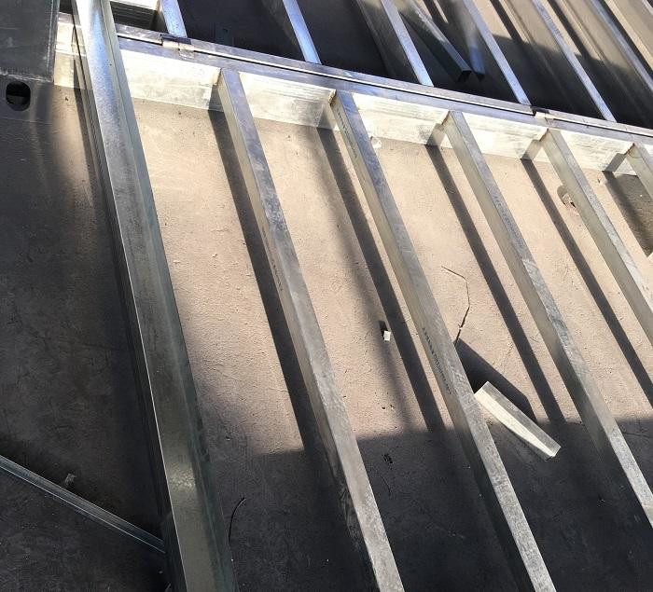
4 |  | top secondary beam |  | 40*60*1.5mm and 30*30*1.5mm galvanized tube steel |  |  |  |  | 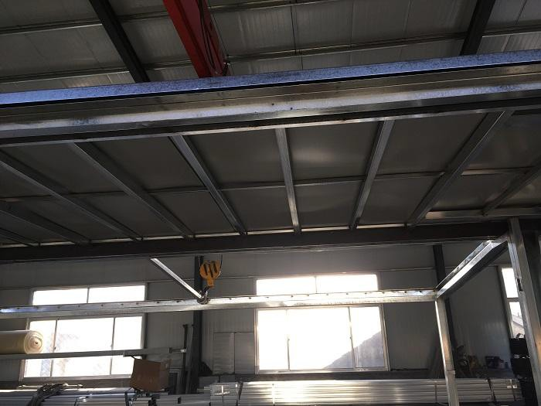

5 |  | bottom main beam | bended galvanized steel 2.3mm thickness | SET | 1.0 |  |  | 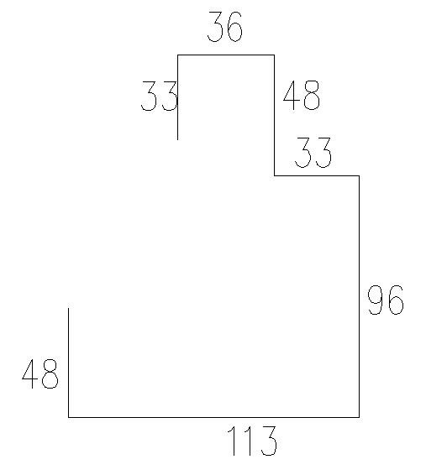
6 |  | column | bended galvanized steel 2.3mm thickness |  |  |  |  | 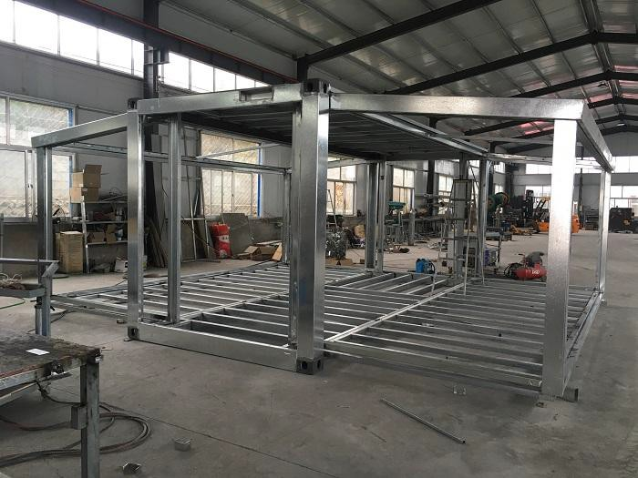
7 | two sides frame( our frame is thicke r than others  ) | roof frame | bended galvanized tube steel 77*50*1.8mm
8 |  | wall frame | bended galvanized tube steel 77*50*1.8mm
9 |  | floor frame | 100*50*1.5mm and 50*50*1.5mm galvanized tube steel
10 | other access ories | hook and hinges | steel |  |  |  |  | 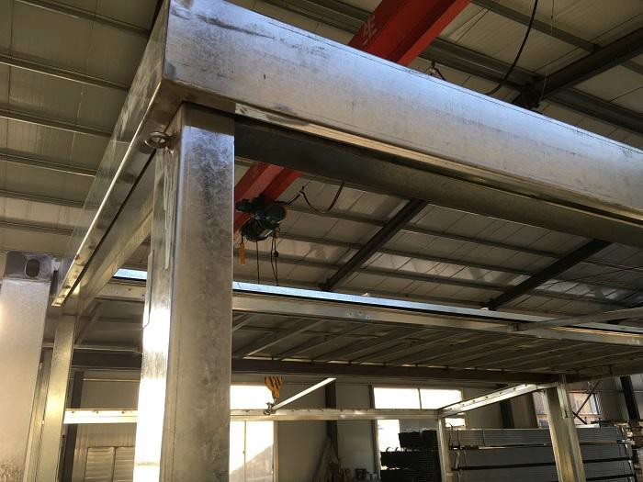
11 | wall(ot her comp any's wall is just 50mm  ) | exterior | 75mm eps sandwich panel,outer skin 0.4mm,10KG/M3 |  |  |  |  | 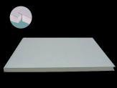
12 |  | interior | 50mm eps sandwich panel,outer skin 0.4mm,10KG/M3
13 | roof(ot her comp | roof of expandable part | 75mm eps sandwich panel,outer skin 0.4mm,10KG/M3

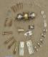
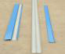
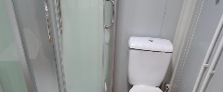
14 | any's  roof is just 50mm  ) | roof of main part | 0.4mm thickness steel sheet+50mm eps sandwich panel | SET | 1.0 |  |  | 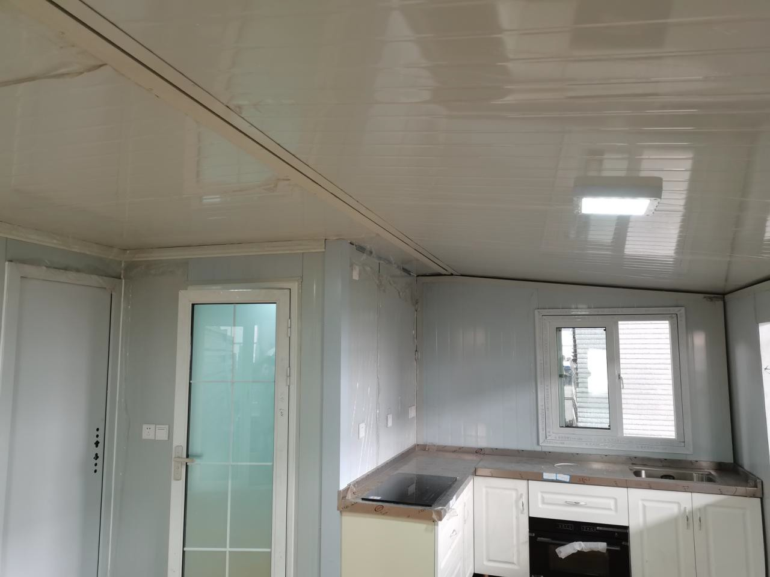
15 |  | acceossorie s | edge cover,bolt sealant
16 | floor | sub floor | 15mm thickness MGO board |  |  |  |  | 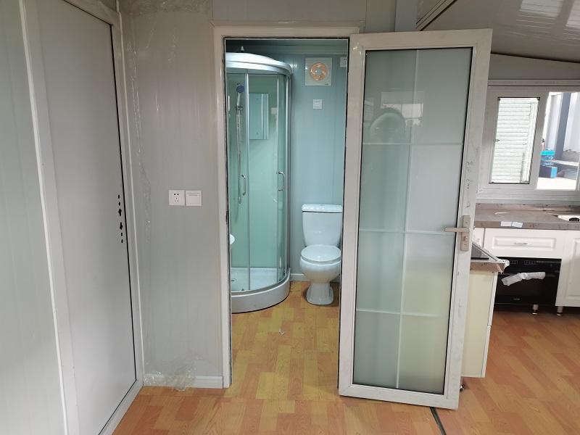
17 |  | surface floor | 1.6mm thickness pvc floor tile
18 |  | electricity | DB box, switch, sockets, A/C sockets, wires, etc |  |  |  |  | 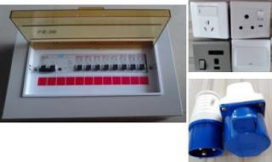
19 | windo w | pvc sliding window double glazed | 8pcs 930*930mm |  |  |  |  | 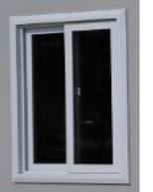
20 | door | exterior | aluminum hinged door double glazed 1260*2000mm |  |  |  |  | 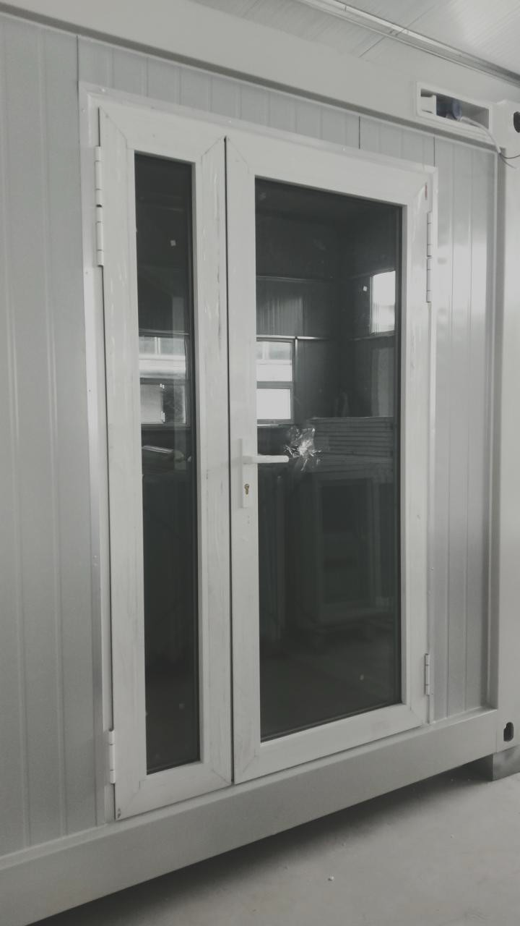
21 | plumbi ng | pre-installed |  | SET | 1.0 |  |  | 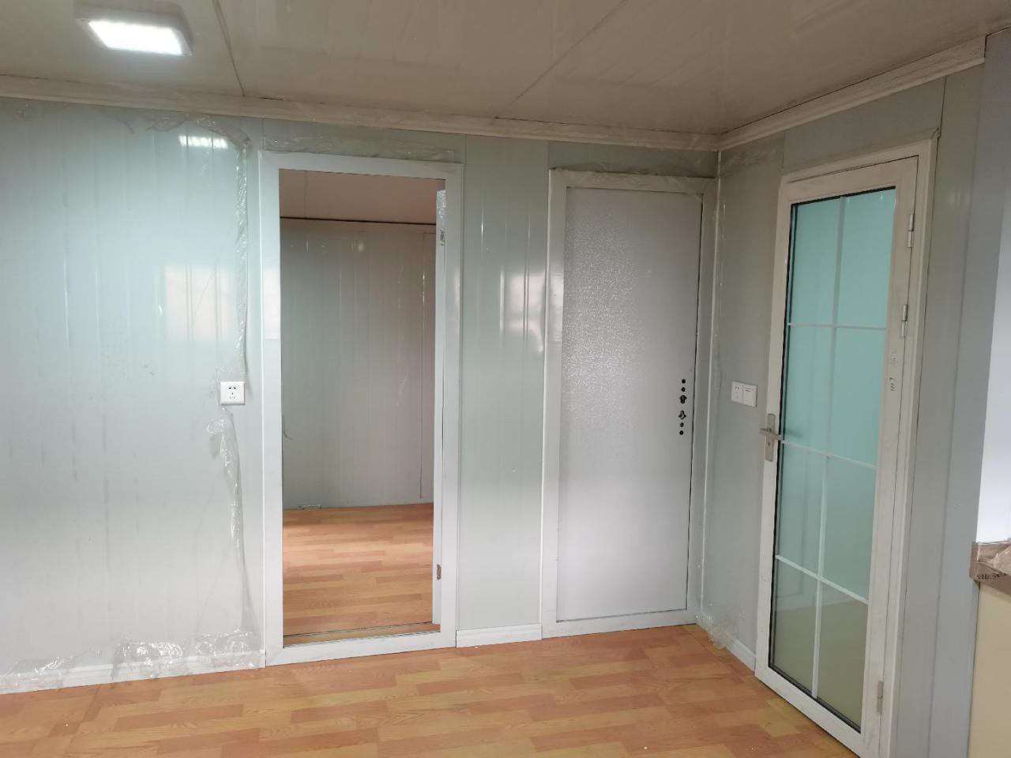
22 | bathro om partitio n |  | sandwich panel+one door+extra corner decoration | set | 1.0
23 | glass showe r cabin |  |  | set | 1.0 |  |  | 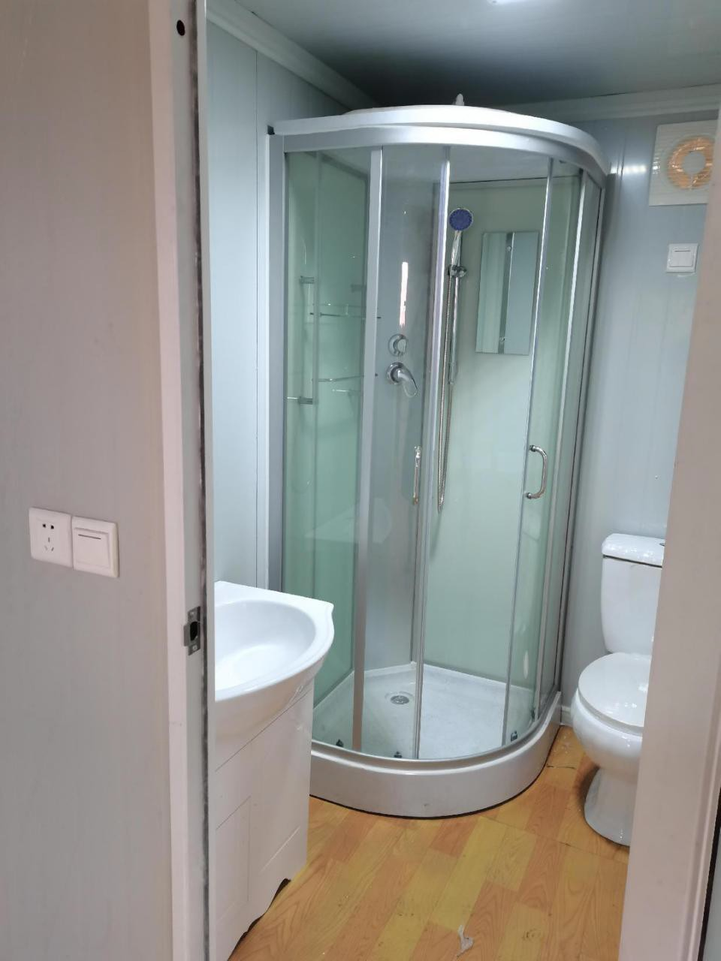
24 | toilet | ceremic seat toilet | universal standard | set | 1.0

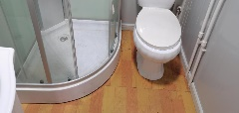
25 | wash basin | with faucet etc accessories | universal standard | set | 1.0
26 | kitche n | with bottom cupboard,st ainless  steel countertop | 1.8m long | set | 1.0 |  |  | 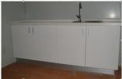
27 | bedroo m partitio n | 75mm eps sandwich panel | double skin 0.4mm,10KG/M3 | set | 1.0
28
29 | Subtotal |  | EXW |  |  |  | 8,999

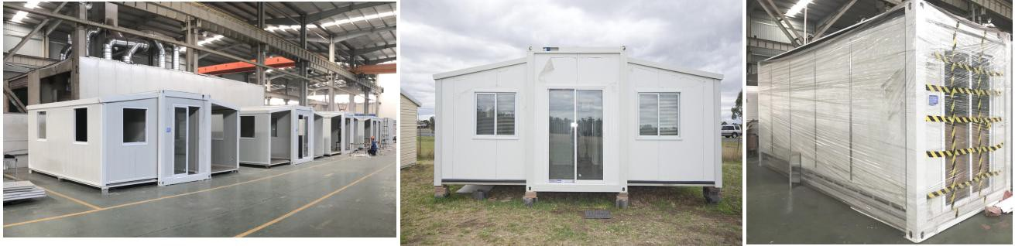

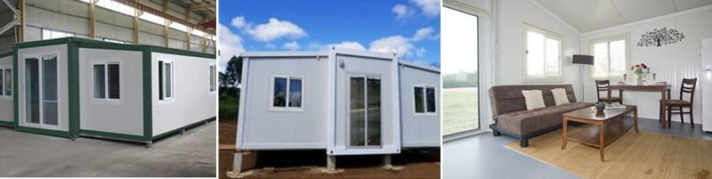

Furniture NOT included

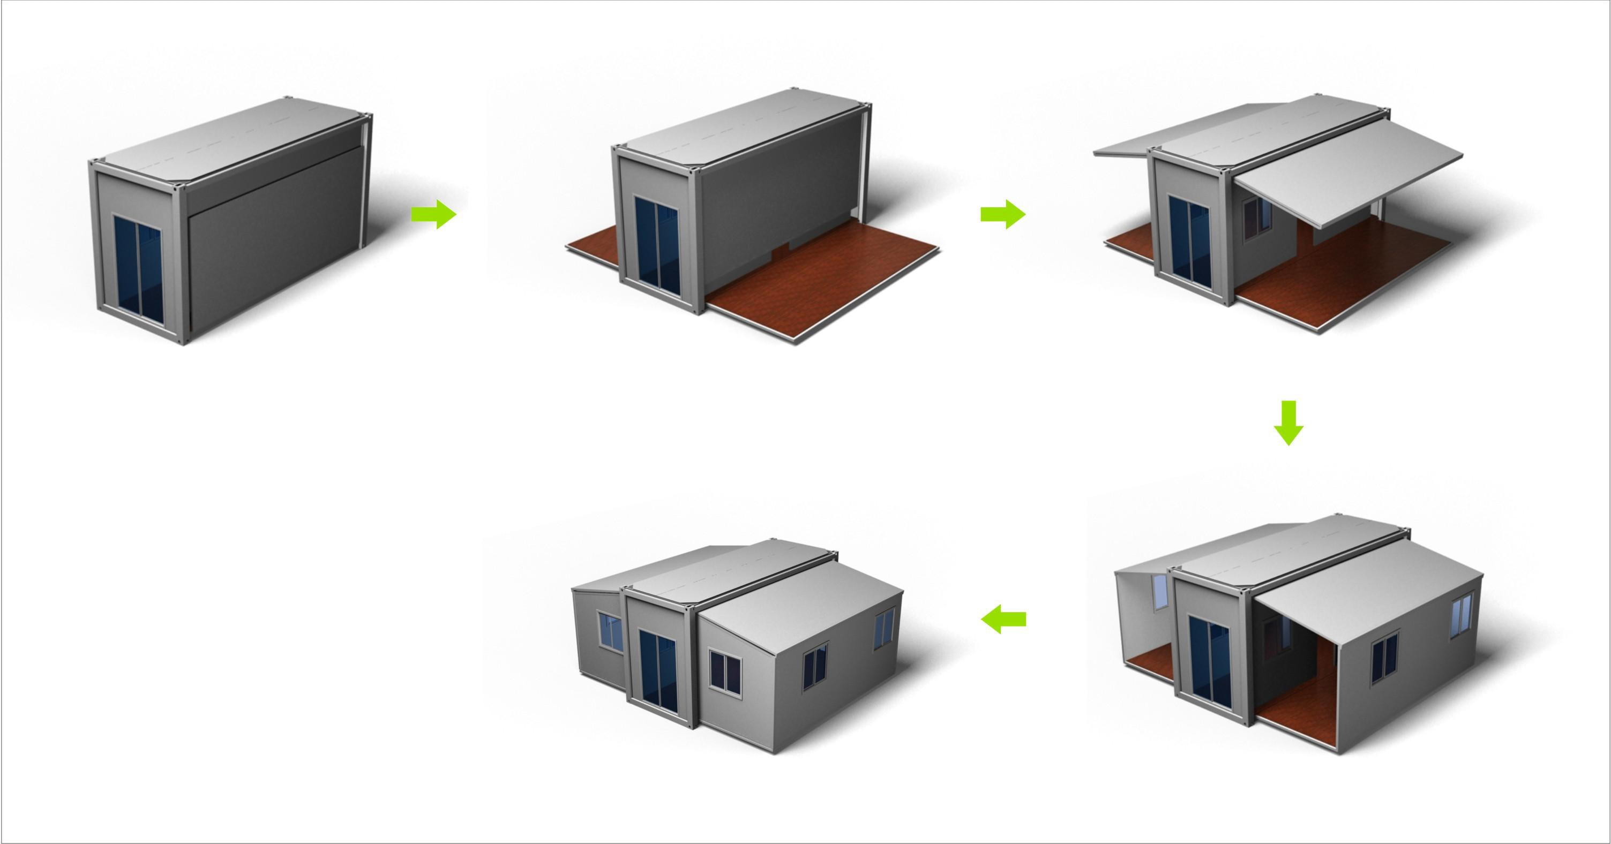

drawing

