Quotation for container house

the advantage of our company and folding container house is as follows
- modular house manufacture with CE and ISO certificate, with professional QC and after sale team to ensure the quality
- fast installation, can be installed in 10 minutes
- save storage space, if you don't need to use it, can fold it .it can be unfolded and folded more than 200 times
- competitive price with good quality: we lower the price without lower the quality to give distributor more profit to do bigger business together
- galvanized frame+painting,hard to rust. wall and roof with 50mm eps insulation
- modular design, stacked 2 levels
- easy to load and unload in container, because will add wheels on bottom.one 40HC container can load 10 units

No | item | specification | picture | unit price | options
1 | folding container house | Size:L5800mm*W2480mm*H2 470mm(folding size 5800mm*2485mm*460mm,inte rior size 5607mm*2275mm*2265mm) galvanized frame+powder coating  with one steel security door door two windows sliding window  50mm thickness sandwich panel for wall  steel sheet+50mm glass wool insulation+steel ceiling for roof 15mm MGO board for floor with electricity |  | USD 2099/UNIT EXW 1*40HC  container can load 10 units(our frame is bigger and thicker,so we can only load 10 units  instead of 12 units) | change 50mm thickness insulation to 75mm plus USD 300  add pvc floor plus USD 200
remark
payment terms:50% deposit by T/T,50% balance before shipment
valid time:in 7 days
lead time:30-40 days

the quotation is EXW price,fob charges for 1*20ft container is USD 800,

fob charges for 1*40HC container is USD 900

material list for folding container house
Project name: |  |  |  |  |  |  | Project No.:
Specification: |  |  |  | L5800mm*W2480mm*H2470mm |  |  | Area: | 14.4 | m2
NO | ITEM |  | SPECIFICATION |  | UNIT | QUANTI TY |  |  | PICTURE
1 |  | bottom main frame(other s is smaller size frame and thickness just 1mm) |  | 200mm*100mm*2  .5mm L=5768mm galvanized steel+powder coating | pcs | 2.0 |  |  | 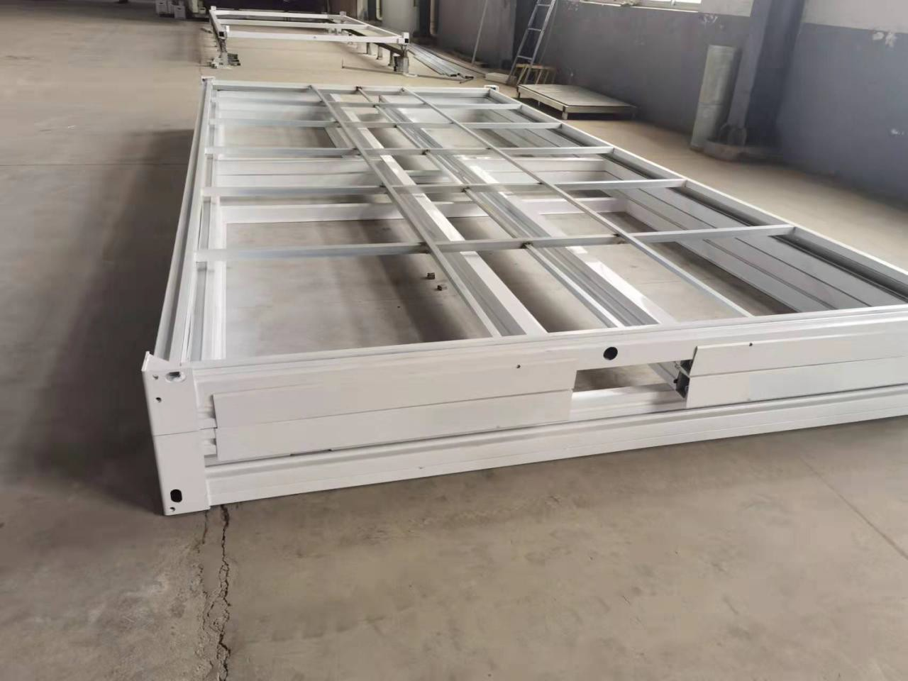  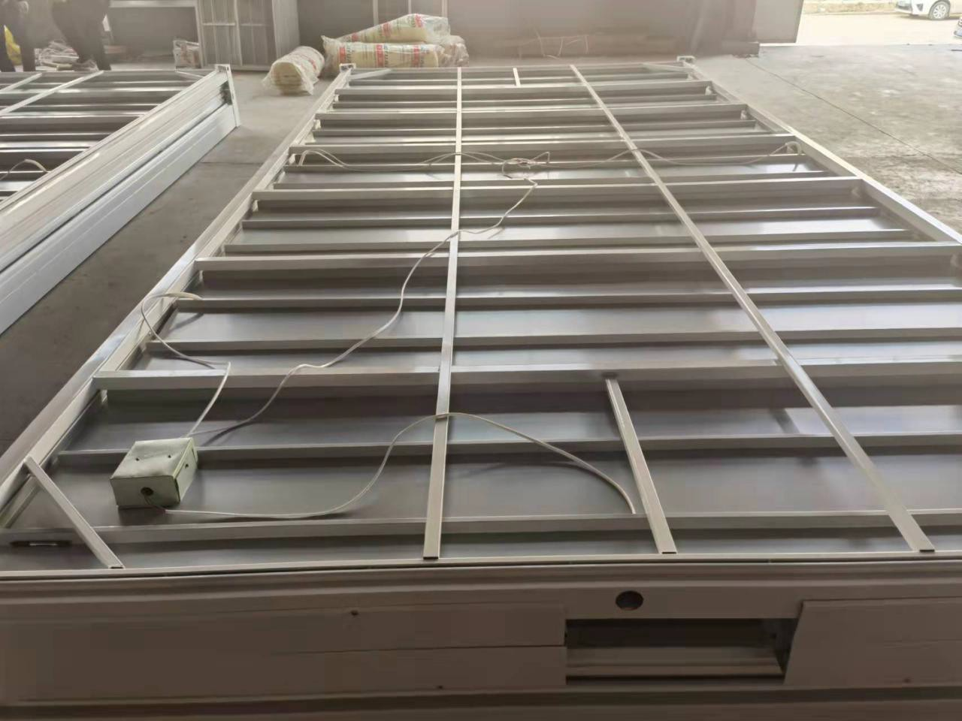  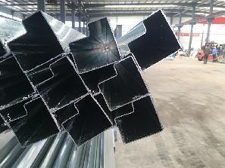
2 |  |  |  | 80*80*1.5mm L=2448mm not regular shape galvanized tube steel+powder coating | pcs | 2.0
3 |  | bottom secondary beam(other s frame thickness is just 1mm) |  | 80*80*1.5mm L=2448mm not regular shape galvanized tube steel+powder coating | pcs | 9.0
4 |  | column(oth ers is smaller size frame and thickness just 1mm) |  | 80*80*1.5mm L=975mm not regular shape galvanized tube steel+powder coating | pcs | 4.0
5 |  |  |  | 80*80*1.5mm L=935mm not regular shape galvanized tube steel+powder coating | pcs | 4.0
6 |  | Column |  | 2.5mm thickness steel+powder coating L=1115mm | pcs | 2.0

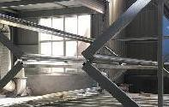

frame
7
8
9
10
11
12
13
14
15

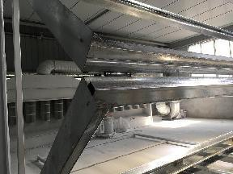

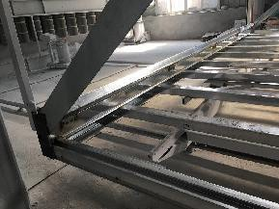
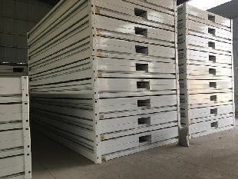
US$2,499 US$2,499
baffle | 2.5mm thickness steel+powder coating L=1075mm | pcs | 2.0
long side wall(others is smaller size frame and thickness just 1mm) | 80*80*1.6mm L=5768mm not regular shape galvanized tube steel+powder coating | pcs | 8.0
short side wall(others is smaller size frame and thickness just 1mm) | 80*80*1.5mm L=2275mm not regular shape galvanized tube steel+powder coating | pcs | 4.0
 | 80*80*1.5mm L=2150mm not regular shape galvanized tube steel+powder coating | pcs | 4.0
top main beam(other s is smaller size frame and thickness just 1mm) | 80*80*1.6mm L=5768mm not regular shape galvanized tube steel+powder coating | pcs | 2.0
 | 80*80*1.6mm L=2290mm not regular shape galvanized tube steel+powder coating | pcs | 2.0
top secondary beam | galvanized tube steel+powder coatiing | set | 1.0
lifting point top | 175*115*97*8mm | pcs | 4.0
lifting point bottom | 285*115*97*8mm | pcs | 4.0

16 |  | hinge(other s hinge is not so much thickness is thinner) |  | 2.5mm thickness | pcs | 34.0
17 | top(others top panel is 0.4mm,ceiling is cheaper ceiling) |  | 0.5mm steel sheet+50mm glass wool insulation+0.3mm steel ceiling |  | set | 1.0 |  |  | 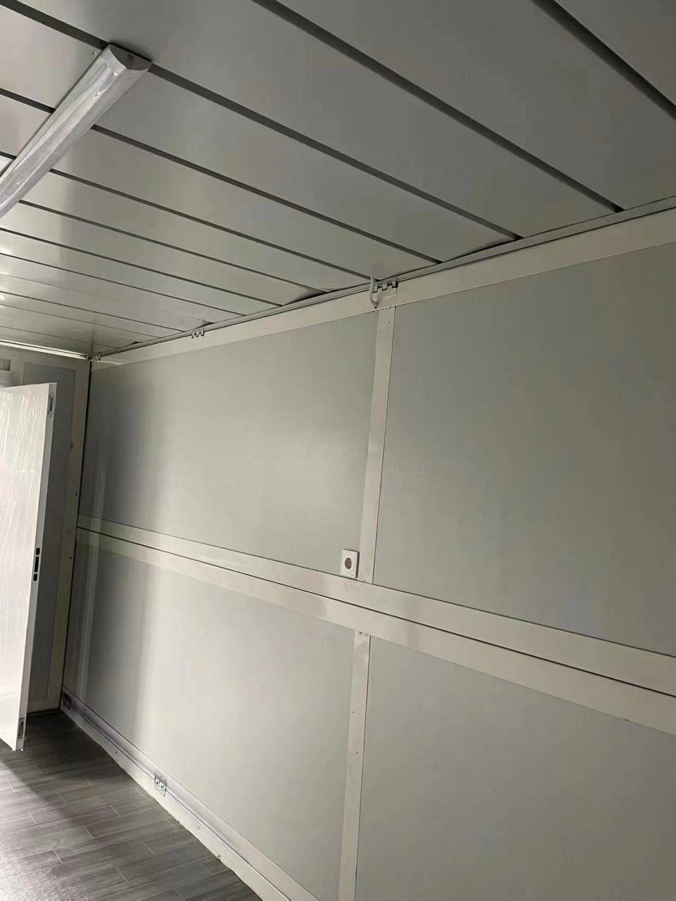
18 | wall panel |  | 50mm thickness sandwich panel |  | set | 1.0 |  |  | 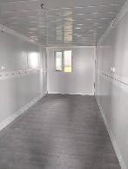
19 | floor board |  | 15mm MGO board |  | set | 1.0
20 | steel door(others door is cheaper quality door) |  | one set steel security door size 930*2030mm |  | pcs | 1.0
21 | sliding window |  | two sets sliding window size 970*1100 |  | pcs | 2.0 |  |  | 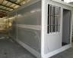
22 | TOTAL |  |  | EXW |  |  |  | US$2,499

