Electric Car Quotation Description: Right Hand Drive Electric Car
Model: TBIEC-340

2024

Model | EC340-128KM | EC340-220KM | EC340 -Fast Charge
Vehicle Body Size L*W*H (mm) | 3444*1550*1535
Wheel Base (mm) | 2350
Wheel Track (mm) | 1360/1342
Climbing Capacity（%） | ≥25% | ≥25% | ≥30%
Ground Clearance (mm) | 180
Maximum Speed（km/h） | 100km/h
Maximum Traveling Range ( km ) | 128km | 219km | 210km
Driver Position | Left hand steering
NO.of Seats | Four seats/ 3 doors
Location of Charging Port | Front Grille,Built in Type
FOB PRICE
FOB QINGDAO | USD 7500 | USD 8500 | USD 8800
Motor Information
Motor Power (KW) | Front/rated 2KW Peak 4KW; Rear/rated 12KW Peak 25KW
Motor Type | AC Motor
Driving Type | 4WD
Minimum Turning Diameter | ≤9.5m
Ready Quality/Full Load Quality | 840kg/1100kg
Battery Information
Battery Type | Li battery
Battery Capacity | 10.24KW/h | 18.43KWh | 17.9km/h
Number of Battery | 1
Normal Charge Times（hr） | 4h | 8h | 1h
Chassis & Steering
Front Suspension Type | Mcpherson Independent Suspension
Rear Suspension Type | Trailing-Arm
Body Type | Unibody
Brake System & Wheels
Front Brake Type | Disc Brake
Rear Brake Type | Drum Brake
Steering Gear | EPS
Tyre Size | 175/55R15
Wheel Hub Type | Aluminium alloy

Safety Configuration & Driving Assistance
ABS | ●
EPS | ●
Rear View Camera | ●
Safety Belt | Front/ Rear
Tire Pressure Monitoring | ●
Rear Parking Radar | ●
Driving Mode Selection | Economy/sports
Uphill Aid | ●
Automatic Driving Lock | ●
Roof Rack | ●
Roof Trunk | ○
Roof Lights | ●
Car Central Control Lock | ●
Remote Key | ●
Keyless Start Function | ●
The Luggage Compartment Opens | ●
Interior Collocation
All-liquid Crystal Instrument | ●
Liquid Crystal Instrument Dimensions | 5 Inch
Seat Material | PU
Main/passenger Seat Adjustment | Anteroposterior adjustment/ Backrest adjustment
Steering Wheel Material | PU
Lamp Configuration
Daytime Running Lamps | ●
Steering Lamp | ●
Fog Light | ●
Clearance Lamp | ●
Combination Headlight | ●
Combination Tail Lamp | ●
High brake light | ●
Reversing Light | ●
Multimedia & Air-conditioning
Multimedia Touch Screen | 9 Inch
Local Video Player | ●
Local Music Player | ●
Radio | ●
Phone Charging Interface | ●
Bluetooth Music/ Phone | ●
Mobile Internet | ●
Mobile Wifi | ●
GPS | ●
USB | 2
Multilingual Menu Operation | ●
Air-Conditioning | ●

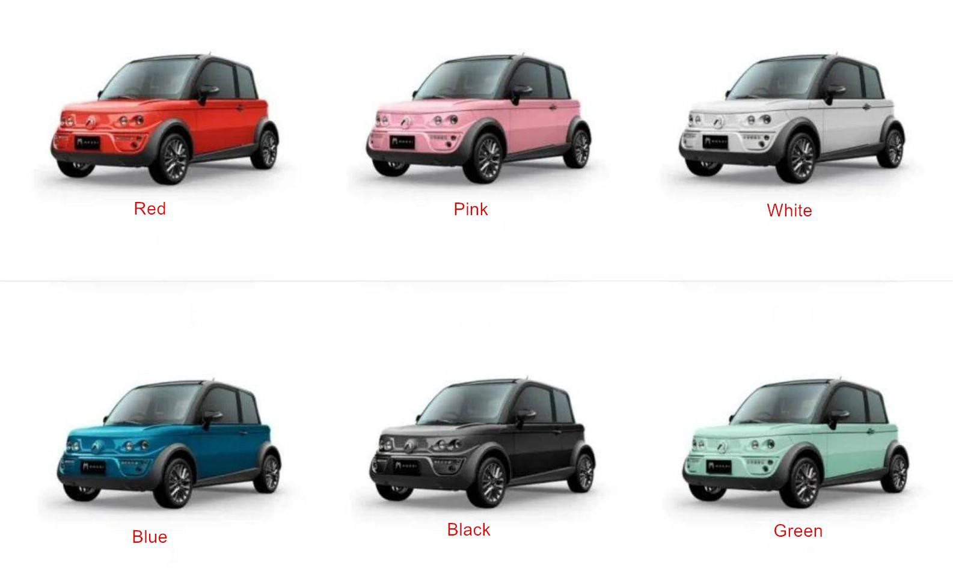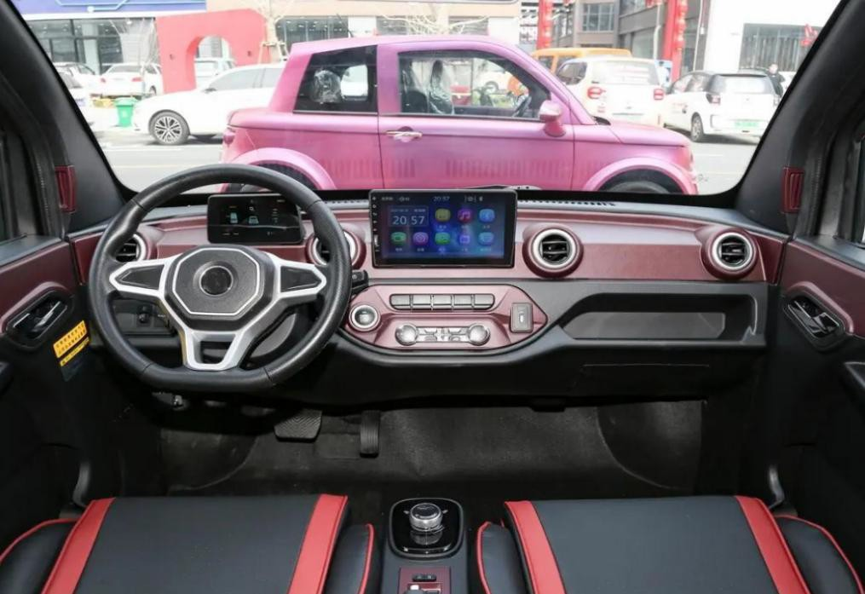

Color Option

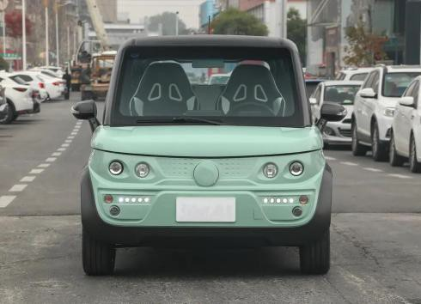

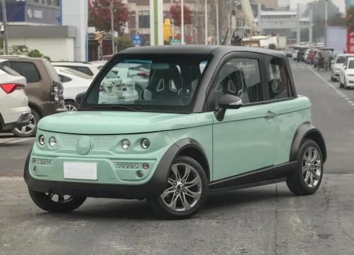Front Front Side

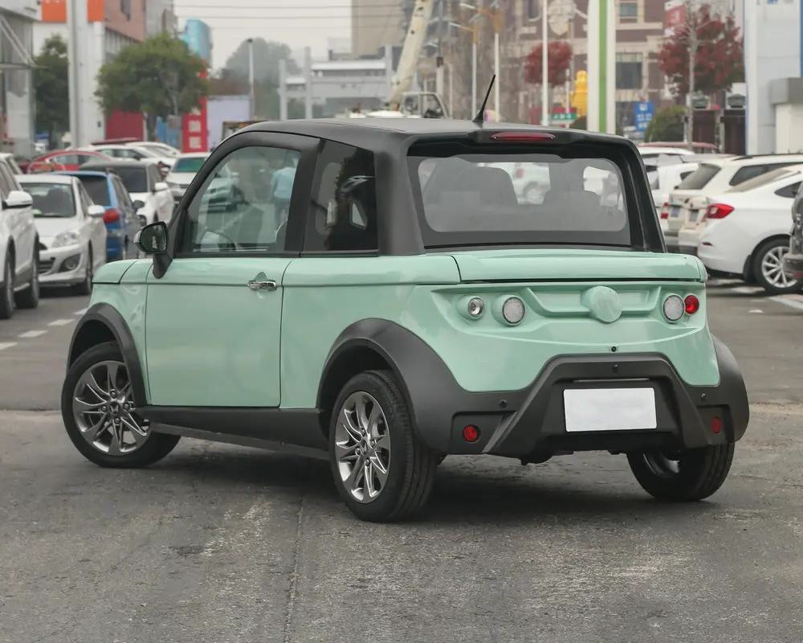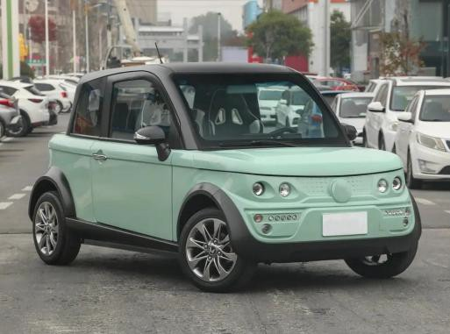

Front Side Rear

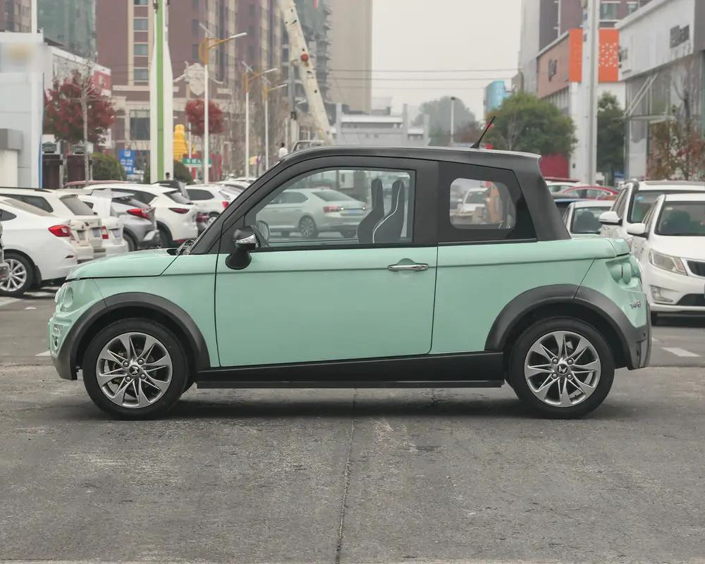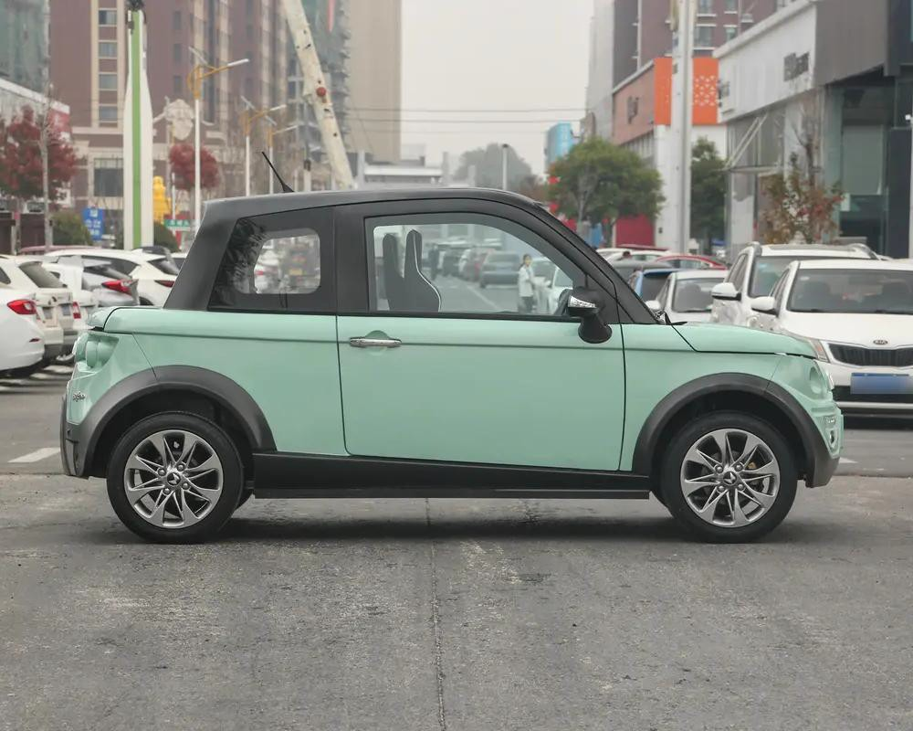

Side Side

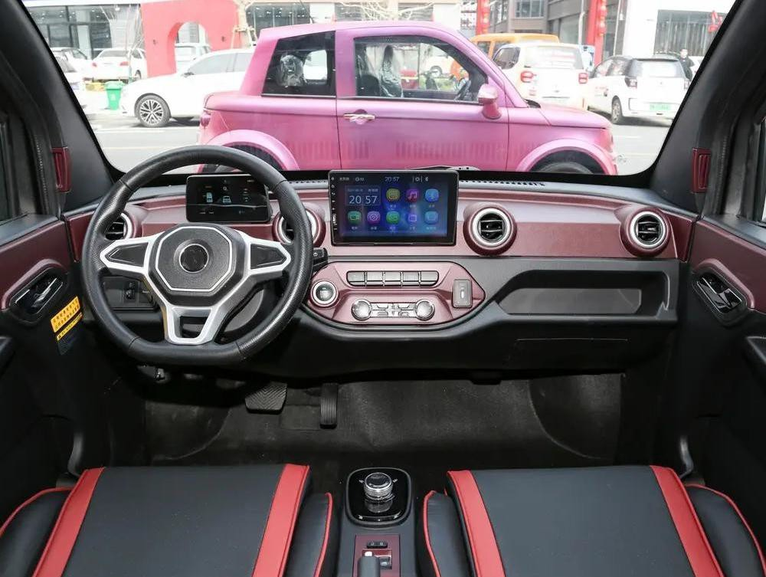

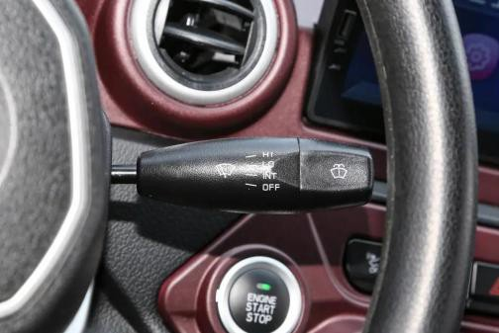Dash Board Streeing Wheel

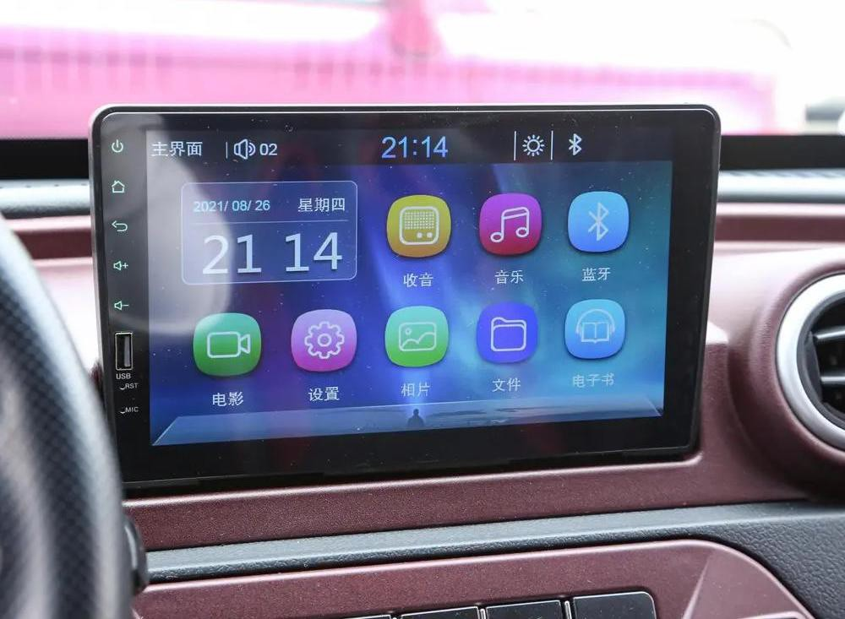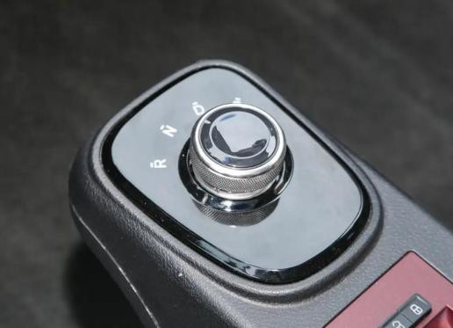

Gear Switch Display Screen

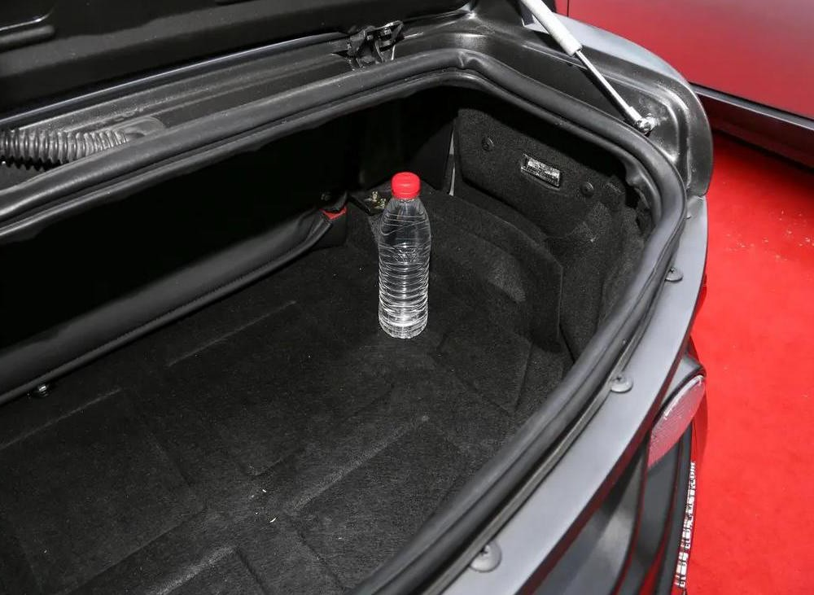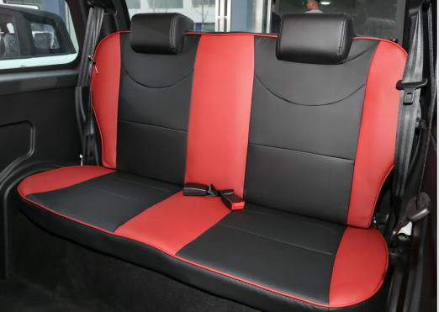

PU Seats Trunk

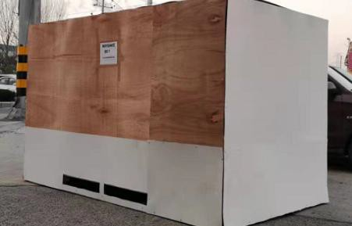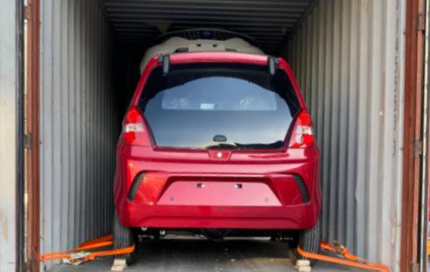
LCL (Less Than Container Load) if only one sample required add $1,000 this will be deductible when you place MOQ order

Package Size: |  | Gross Weight:
Package Way |  | Fixed inside steel frame,then covered with plywood.

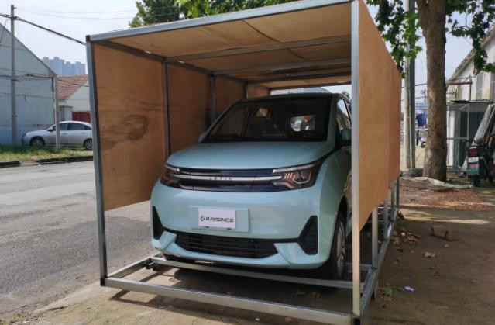

Full Container Loading
20 ft container |  | 40 ft container
Package Way |  | Fixed by steel frame,then fixed on the container ground with nylon tape.

