QUOTATION
Description: Four Wheel Electric Mini Car
Model NO.: TBIA-520 2024
Electrial System
Controller | 60V Intelligent Controller
Storage Battery | 12V*5PCS,80 AH
Motor Power | 2200 W
Traveling Range | 80-100km
Battey charger | On board Charger
Charger Voltage | Single phase,220V(110V)
Charging Time | 8-10Hours
GW | 380 KGS
Technicial Data
Overall Size | 2500*1202*1625mm(L*W*H)
Seating Capacity | 2-3 Seats/ 2 Doors
Speed Range | 25km/h or 45km/h
Climbing Capacity | 25%
Body Material | Injection molding plastic
Chassis Material | Metal
Braking Length | ≤ 5 Meters
Min.Turning Tadius | 8500 MM
Rear Tracks | 1000 MM
Wheel Base | 1742 MM
Car Body System
Steering System | Handle steering
Seat Material | Imitation leather (PU)
Instrument Panel | Combined Instrument（front/back signal,light,trumpet,dump energy,current speed display）
Lighting System | Combined type front light and back light,braking light,front/back turning light
Switch System | Light switch,main power switch,electric horn,wiper switch.
Entertainment System | Digital LCD panel,Radio,USB Port,Speaker, Bluetooth,Backup Camera,Built-in Antenna
Car Body Painting | Color can be customized.
Safety Performance | Hill assist,Safety belts,Remote control key, Electric window, Warm wind,Sky window.
Chassis System
Drive System | Rear-drive motor,Controller adjusted automatically
Braking System | Disk Brake
Wheel Details | Front: 125/65 R12, Rear: 135/70 R12, Aluminium alloy.
Vehicle Structure | Load-supporting body frame
Front Suspension | MacPherson independent suspension
Rear Suspension | Trailing arm drive axle
FOB PRICE
FOB QINGDAO | USD 3200 / SET ( MOQ 10 SETS)  USD 3100 / SET (11-100 SETS) USD 2950 / SET (101 ≤ SETS)
- Warranty: One years warranty for the electric car, replacement parts can be offered for free during warranty, lifelong time after sales service.
- Payment Terms:
50% Prepayment by T/T to start produce, balance paid before loading container.
- Package Info: By seaworthy case, or by steel plate, then loading by container.
- Delivery Time: Within 20 days after getting 30% prepayment.
- Validity: The quotation is valid within 20 days.

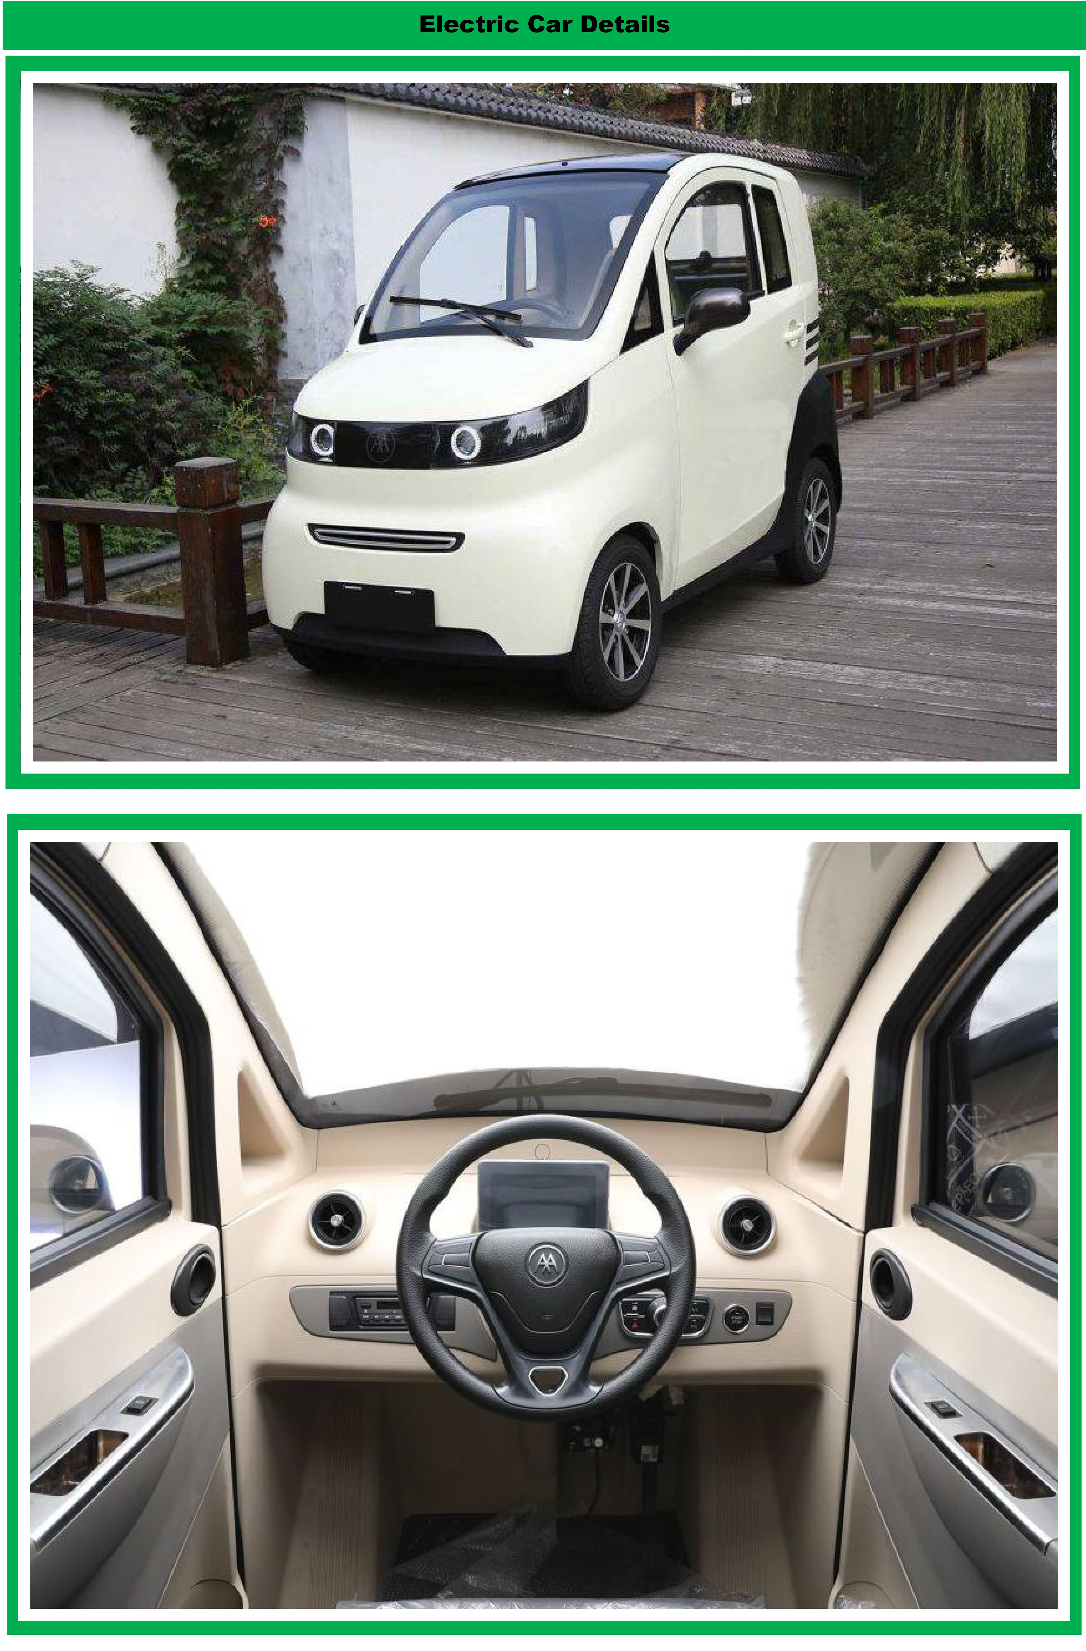

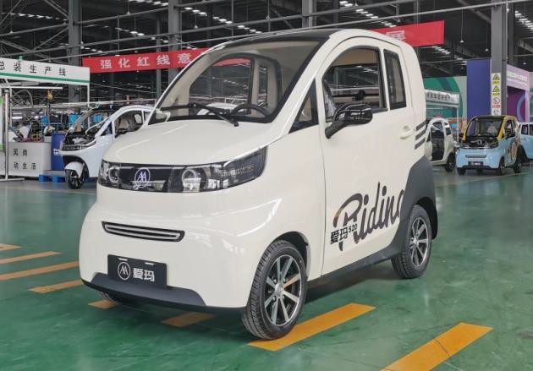

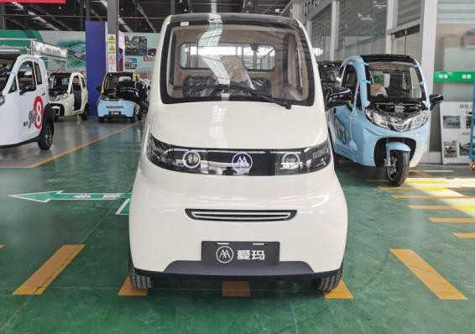Front Front-left

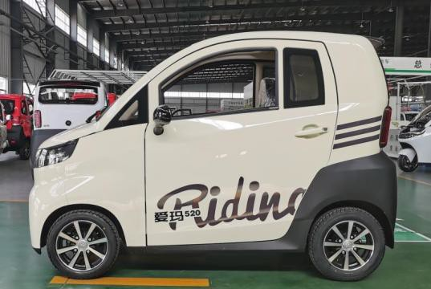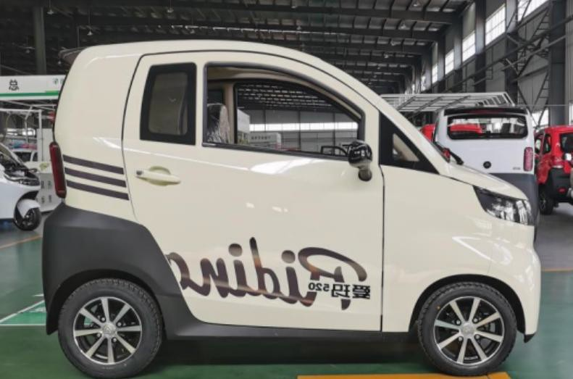

Side Side

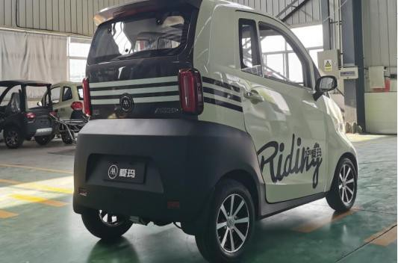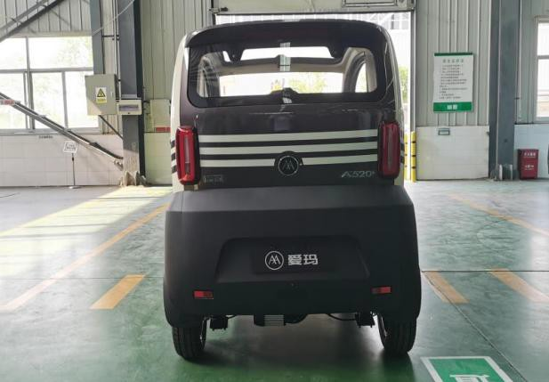

Rear Rear-right

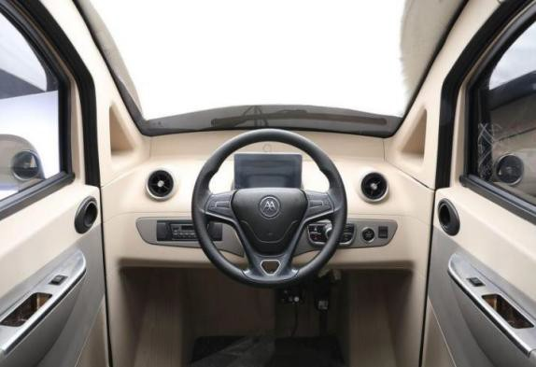

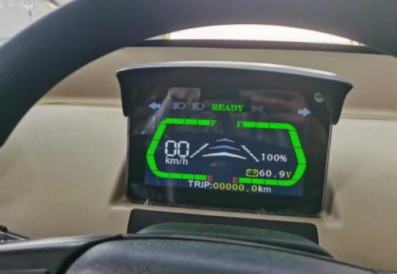Cockpit Instrument

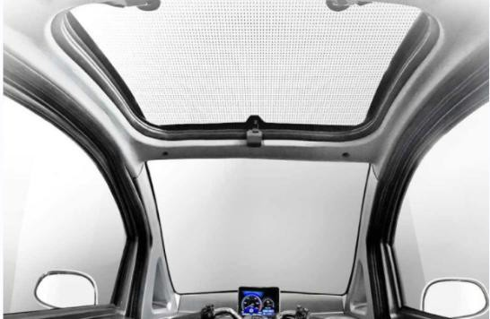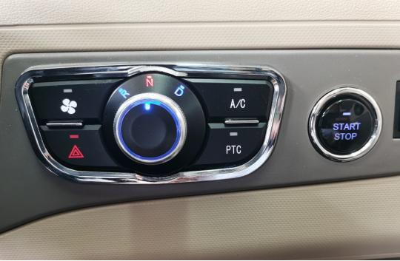

Gear Switch Panoramic Sunroof

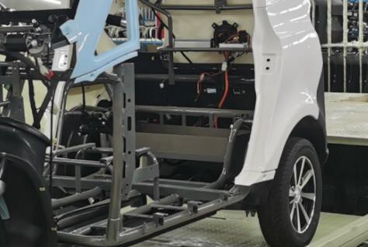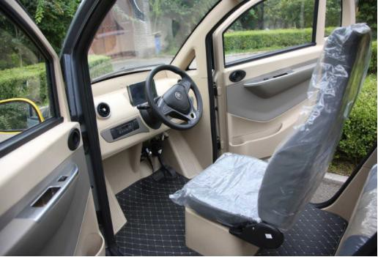

Front Seats Load-supporting Frame

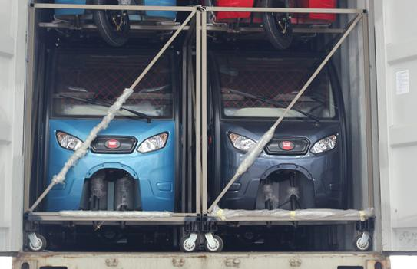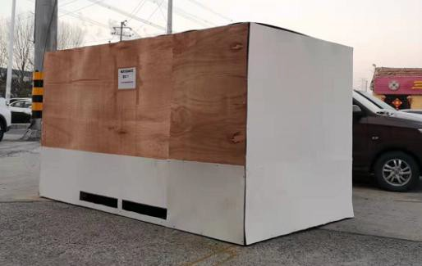
LCL (Less Than Container Load) if only one sample required add $1,000 this will be deductible when you place MOQ order

Package Size: | 2600*1300*1800mm | Gross Weight: | 450 kgs
Package Way | Fixed inside steel frame,then covered with plywood.

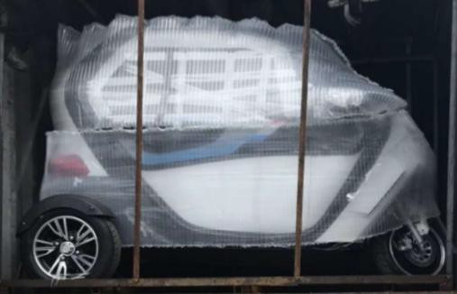

Full Container Loading
20 ft container | 2 pcs | 40 ft container | 9 pcs
Package Way | Fixed by steel frame,then fixed on the container ground with nylon tape.
