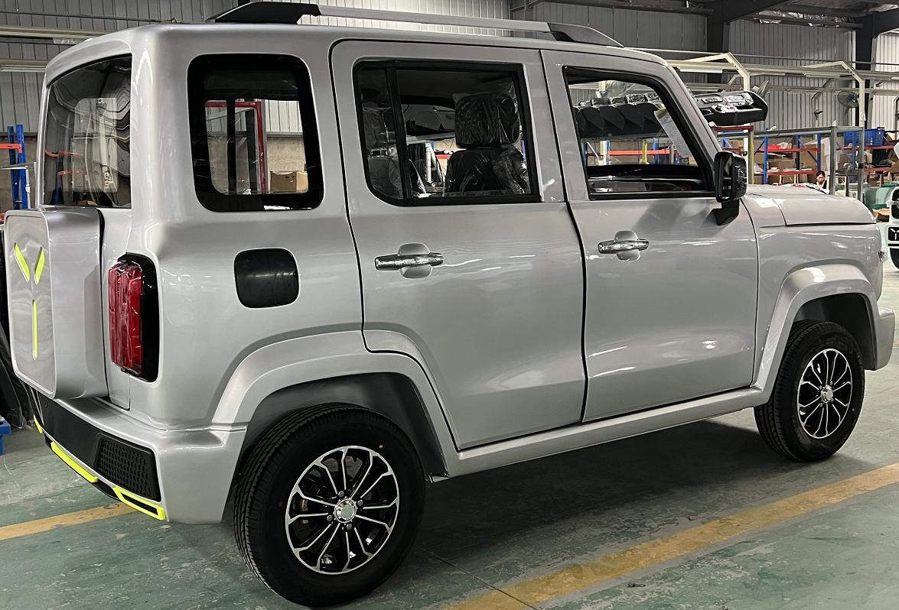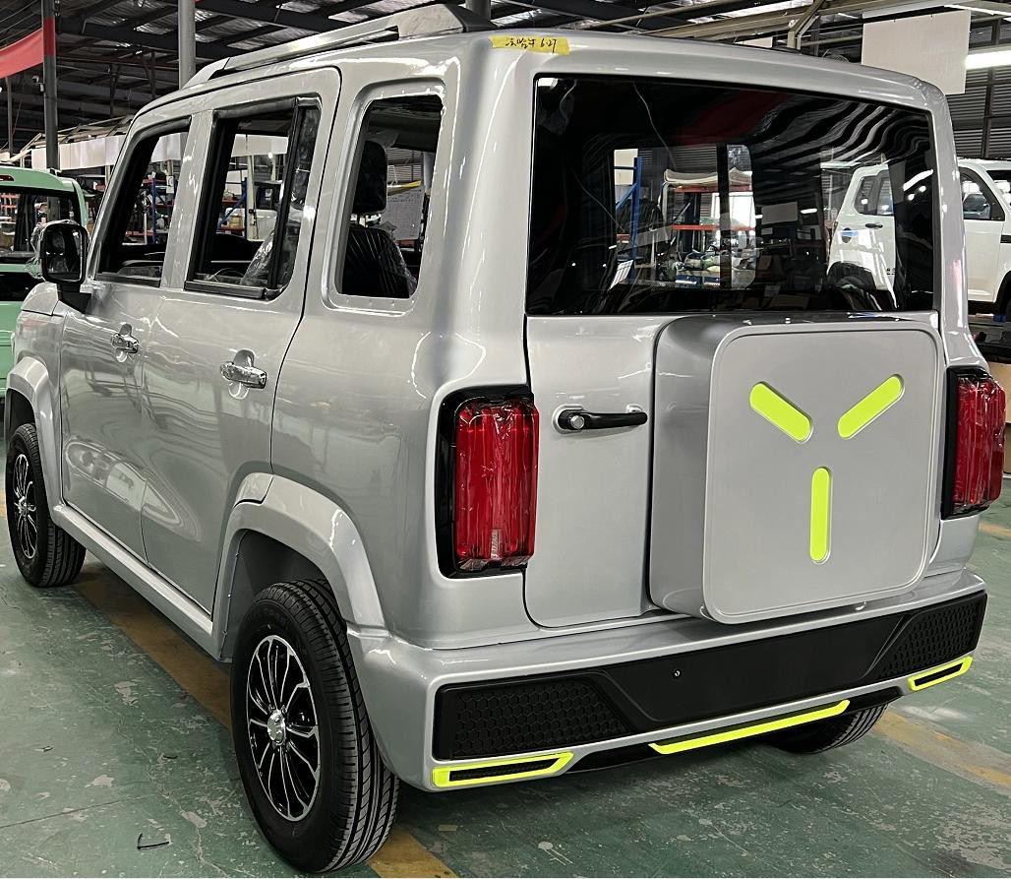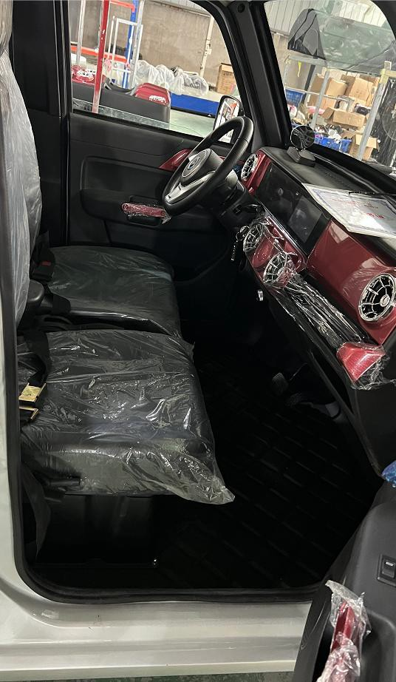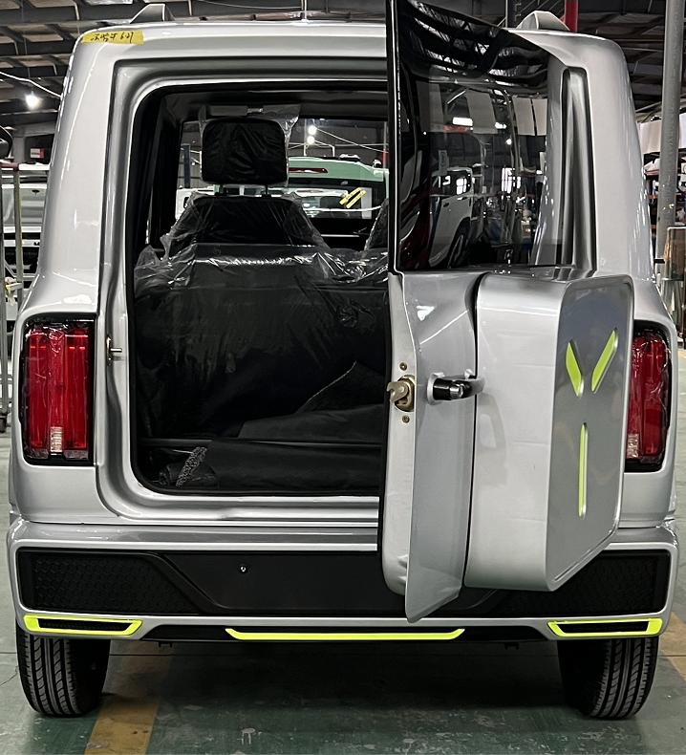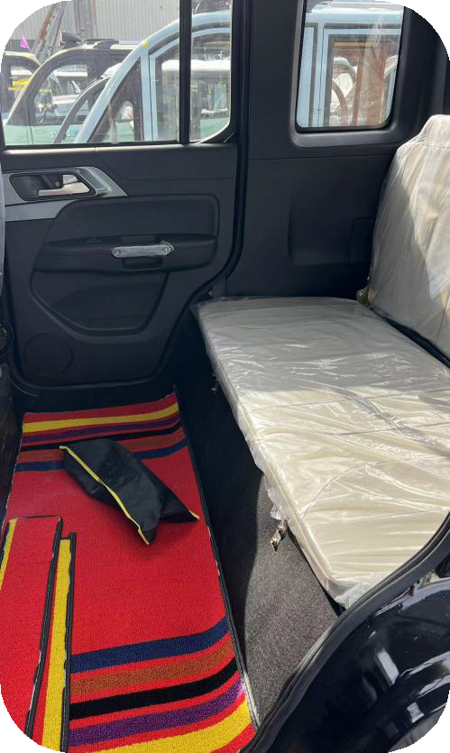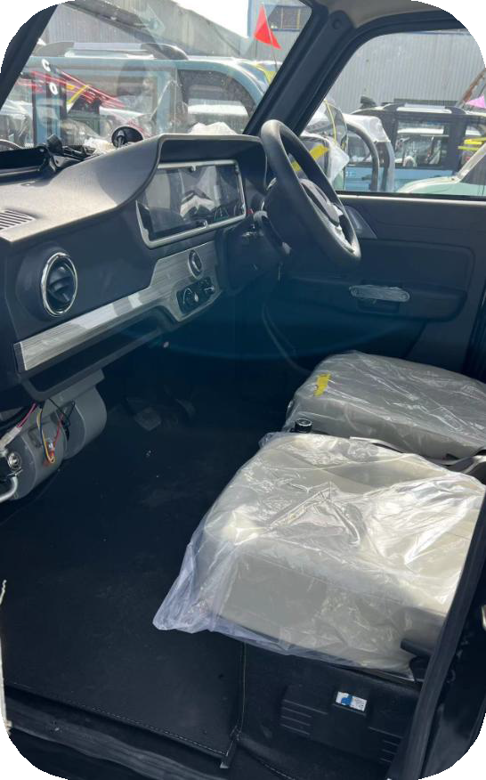
Product Name 产  品名称 | ROUGE Passenger Electrical Vehicle JEEP
Item 项目 | Specification参数 | Reference Pictures
Overall Size整体尺寸 | 3300×1600mm×1700mm | 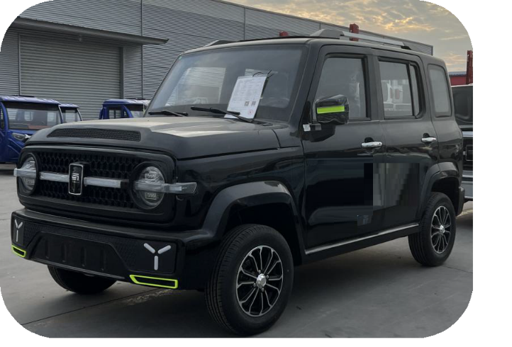
方向盘 steering wheel | RHD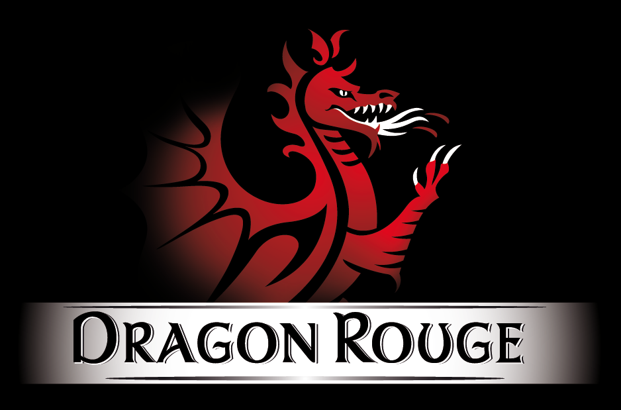
Seats Capacity座椅 | 4 Seats
Curb Weight 车重 | About 665Kg(with battery)
Engine Power电机 | 60V4000W Motor 60V 4000W
Battery 电池 | 60V 100AH, Lead acid Battery Recommend
Controller 控制器 | Special Controller 专用控制器
Charger Type 充电类型 | Vehicle-mounted 车载式
Driving Mode 驱动方式 | Rear Mounted / Rear Drive 后驱动
Damping system F 前减震 系统 | Integrated Front Axle + longitudinal arm torsion beam Non-independent suspension  纵臂扭转梁式非独立悬挂
Damping system R 后减 震系统 | Integrated Axle + longitudinal arm torsion beam Non-independent suspension 纵臂扭 转梁式非独立悬挂
Car Body Structure车身 | Frame type+ Stamping 框架+冲压
Display Instrument  显示屏 | Liquid Crystal Electronic Digital Display 7 Inch +MP5
Brake System 刹车系统 | F Disc / R Disc 前后碟刹
Brake Type 刹车类型 | Pedal Oil Brake 踏板 油压
Tyre 轮胎 | 165/70R 12 Vacuum Tires 真空
Wheel Hub 轮毂 | Alloy
Maximum Speed  最大速度 | 45 Km/H
Charging type& Time 充电  类型&时间 | China type, 8~10Hours (General)
Endurance Mileage 里程数 | about 110km, if AC on about 90km
Driving&Copilot Seats 主 | Manual Adjusted Seats, Two Directions  手动调节，两个方向
Headrest 头枕 | not adjustable不可调节
Central Lock 中控锁 | Yes with Remote key 中控锁
Intelligent Remote Key 智  能遥控钥匙 | Yes 是
Cooling System 制冷系统 | 带空调 with air conditioner
Security System 安全系统 | Backup Camera 倒车影像 +MP5
Entertainment System 娱 乐系统 | MP5 Multimedia Player, Stereo Speaker MP5 多媒体播放器，立体音响
Light Combination  灯组和 | ①LED Headlamp,LED车头灯 ②Standalone Steering Lamp,转向灯 ③Taillight,尾灯 ④ High-mount Stop Lamp, 停车灯
Other Configuration | ①Windshield Wiper雨刮器, ②Power Windows,  电动升降窗 ③Folding & Adjustable Rearview Mirror可折叠后视镜
Color options颜色选配 | ①White ② Red ③Blue ④Pink 白红蓝粉
Container Load 集装箱 | MOQ CBU 4 Sets in 40HQ
Shipment Port 发运港口 | Qingdao/Shanghai/Lianyungang Port  青岛上海连云港
REMARK
Remarks | *1. About this Quotation, Barring special circumstances, the above quotations valid in 15 workdays. 报价有效期15天  *2. About Packaging, Standard export packing, or customized packing as your request.标准出口包装  *3. About Payment, By T/T: 50% amount in advance, 50% amount paid before delivery. 预付50%， 再付50%  *4. About Delivery time, Based on actual quantity, 25 working days in general after payment receipt comfirmed. 生产周期： 25个 工作日天  *5. About Quality Guarantee,12 months for Main Parts, include motor/controller/frame/battery. 质保： 主要产品12月， 包括电机/ 控制器/车架/电池

( Please sign back when confirmed )

