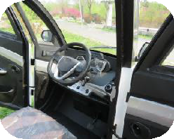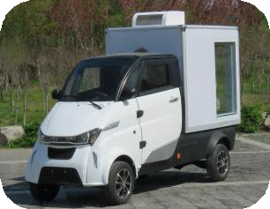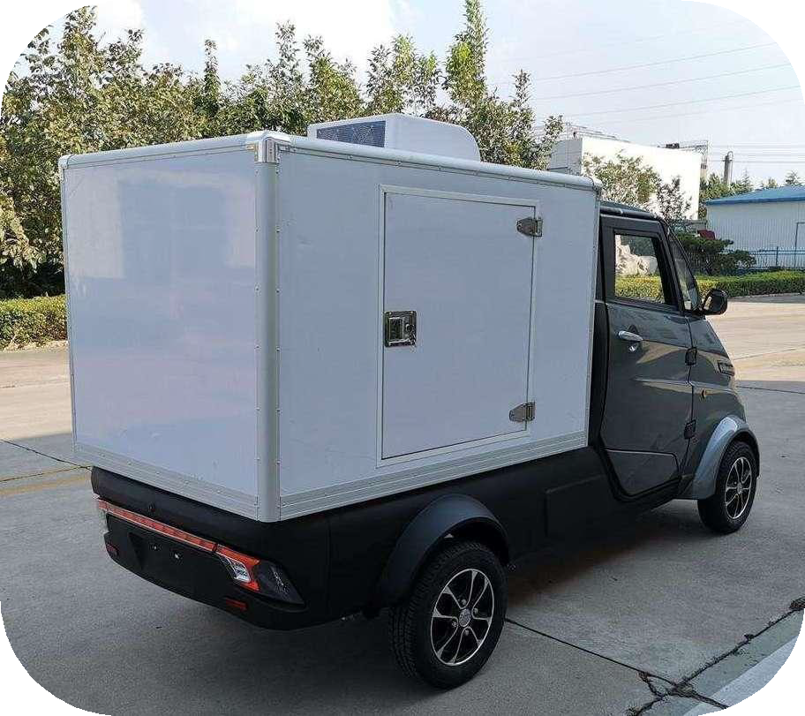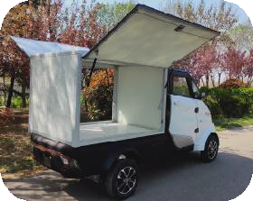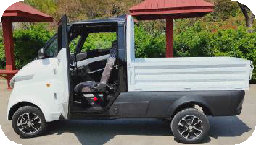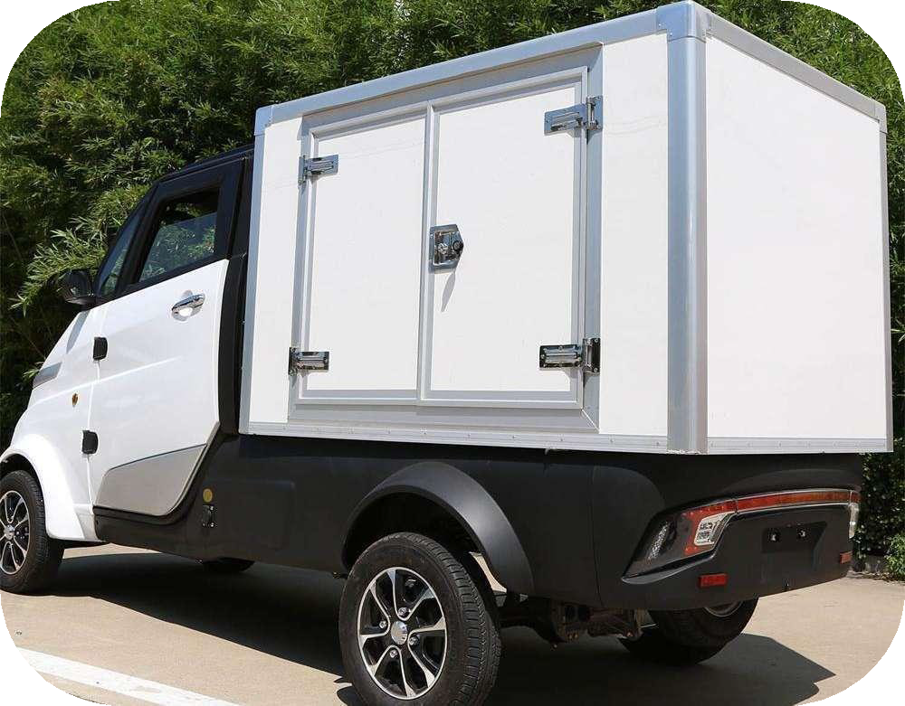
To: |  |  |  |  | Invoice No. | TBIRH2024031401
Address: |  |  |  |  | Date: | 2024.03.14
 |  |  | Email:
TBI J2-P with EEC L7e BU
No  . | Model with standard |  |  | FOB unit | QTY(Unit) | Totally
1 | TBIJ2-P Electric Vehicle  （206Ah LiFePo4 Battery with BMS & Fast charging system +5000W Motor） |  |  | $8,000.00 | 8 | $64,000.00
2 | Iron package frame |  |  | $100.00 | 8 | $800.00
Optional Items & price
1 | 105Ah LiFePo4 Battery Battery with BMS& Fast charging system (3-5 hours) |  |  | -1500 USD
2 | Air conditioner |  |  | +430 USD
3 | Hopper 1635*1150*370mm |  |  | -300USD
4 | Insulation box 500*40*30mm |  |  | +25 USD
5 | Cargo box with cooling system -5℃ |  |  | +500 USD
6 | Cargo box with cooling system -18℃ |  |  | +600 USD
7 | 4000W Motor |  |  | -300 USD
8 | Rear Disc Brake |  |  | +50 USD
9 | Fan |  |  | +30 USD
10 | 1:8 rear axle for high speed（Max speed 60km/hour） |  |  | +90USD
11 | Solar panel |  |  | +500 USD
12 | Trailer hook |  |  | +100USD
13 | Swivel Driver's Seat |  |  | +100USD
 | Total FOB Qingdao Price |  |  |  |  | $
Not e | 1.The price is based on FOB Qingdao price.And the rate between USD to RMB is subject to 1USD≈7.10CNY.
 | 2.Payment Term: 50% advance payment, the balance will be paid before delivery.
 | 3.Delivery Time: 30 days after receive the advance payment.
 | 4.Packing: MOQ 4 units for 1*40GP, 8Units for 1*40HQ.
Standard Configuration
No  . |  | Item |  |  | J2-P
1 | Parameter | L*W*H （mm) |  |  | 3600*1345*1765
2 |  | Wheel Base(mm) |  |  | 2375
3 |  | Min.Ground Clearance (mm) |  |  | 160
4 |  | Curb Weight（kg） |  |  | 500
5 |  | Max. Speed(km/h) |  |  | 52
6 |  | Max. Range (km) |  |  | 160
7 |  | Capacity (person) |  |  | 1
8 |  | Cargo Box Size(mm) |  |  | 1635*1150*1058
10 |  | Rated Load(kg) |  |  | 550
11 |  | Steering Mode |  |  | Middle Steering Wheel
12 | Power System | A/C Motor |  |  | 60V 5000W
13 |  | Lithium Battery |  |  | 206Ah LiFePo4 Battery
14 |  | Charhing Time |  |  | 4-6 hrs (220V)
15 |  | Charger |  |  | Intellengent Charger
16 | Brake System | Type |  |  | Hydraulic System
17 |  | Front |  |  | Disc
18 |  | Rear |  |  | Disc
19 | Suspension System | Front |  |  | Independent Double Wishbone
20 |  | Rear |  |  | Integrated Rear Axle
21 | Wheel Suspension | Tyre |  |  | Front 135/70-R12 Rear145/70-R12
22 |  | Wheel Hub |  |  | Aluminum Alloy Hub

23 | Function Device | Mutil-media | MP3+Reverse Camera
24 |  | Electric Heater | 60V 800W
25 |  | Central Lock | Auto Level
26 |  | One Button Start | Auto Level
27 |  | Electric Door & Window | 2
28 |  | Skylight | Manual
29 |  | Seats | Leather
30 | Kindly Note that all configuration is only for your reference in accordance with EEC homologation.
1

